

Requirement & Design Specification

**Restaurant Platform System (RPS)**

**Version: 1.0**

–Da Nang, September 2025 –

# Team Member

| Họ và Tên | Mã SV |
| --- | --- |
| Nguyễn Hồng Phúc | DE190234 |
| Trần Kim Thắng | DE180020 |
| Phan Thành Tài | DE190491 |
| Đặng Văn Công Danh | DE180814 |

# Record of Changes

| **Date** | **A* M, D** | **In charge** | **Change Description** |
| --- | --- | --- | --- |
| 24-09-25 | A | PhucNH | Created initial draft of RDS document structure (cover page, table of contents, versioning table). |
| 25-09-25 | A | DanhTQ | Wrote Section II.1 – Product Overview and context of the Restaurant Booking Platform. |
| 26-09-25 | A | ThangTK | Added main Use Cases (UC-01 to UC-06): Register, Login, View Menu, Search Restaurant, Book Table, Manage Profile. |
| 27-09-25 | A | TaiPT | Added Section II.2.2 – Actors and Use Case Descriptions for customer & admin roles. |
| 28-09-25 | A | PhucNH | Designed Context Diagram and Level-0 Data Flow Diagram based on restaurant system flow. |
| 29-09-25 | A | DanhTQ | Added UC-07 to UC-12 (Manage Booking, Cancel Booking, View History, Rate Restaurant). |
| 30-09-25 | A | ThangTK | Added Business Rules BR-01 to BR-15 related to Booking and Payment processes. |
| 01-10-25 | A | PhucNH | Created Class Diagram and Entity Relationship Diagram (Users, Restaurants, Tables, Bookings). |
| 02-10-25 | A | TaiPT | Updated Data Dictionary and Field Definitions for all entities. |
| 03-10-25 | A | DanhTQ | Added Sequence Diagrams for “Booking Table” and “Payment Confirmation”. |
| 04-10-25 | M | PhucNH | Modified Non-Functional Requirements to include security, scalability, and availability aspects. |
| 05-10-25 | A | ThangTK | Added new Use Cases UC-13 to UC-18: View Dashboard (Admin), Manage Restaurant Info, Manage Users, View Reports. |
| 06-10-25 | A | TaiPT | Added Business Rules BR-16 to BR-30 covering voucher usage and cancellation conditions. |
| 07-10-25 | A | DanhTQ | Added Section 3.1 – System Authorization and Actor Permissions Matrix. |
| 08-10-25 | M | PhucNH | Revised Use Case Diagram and updated connections between admin and customer flows. |
| 09-10-25 | A | ThangTK | Added Non-screen Functions and updated Process Specifications for booking and payment modules. |
| 10-10-25 | A | TaiPT | Added additional Use Cases UC-19 to UC-24 (View Revenue, View Reports, Generate Monthly Statistics). |
| 11-10-25 | M | DanhTQ | Updated BR section with new rules for booking validation and refund policy (BR-31 to BR-40). |
| 12-10-25 | A | PhucNH | Added Level-1 DFD for Booking and Payment Subsystems. |
| 13-10-25 | A | ThangTK | Added Section 5 – Application Messages, UI mockups and sample screen layouts. |
| 14-10-25 | A | TaiPT | Added UC-25 to UC-30 related to voucher redemption and review management. |
| 15-10-25 | M | PhucNH | Finalized and reviewed all sections; merged feedback from team members, formatted document for submission. |

*A - Added M - Modified D - Deleted

**Record of Changes** **2**

**I. Overview** **20**

1. User Requirements 20

1.1 Actors 20

1.2 Use Cases 20

a. Diagram(s) 20

b. Descriptions 21

2. Overall Functionalities 24

2.1 Screens Flow 24

2.2 Screen Descriptions 24

2.3 Screen Authorization 27

2.4 Non-UI Functions 29

3. System High Level Design 30

3.1 Database Design 30

a. Database Schema 30

b. Table Descriptions 30

3.2 Code Packages 36

**II. Requirement Specifications** **38**

1.Authentication 38

1.1 UC-01: User Registration 38

a. Functional Description 38

b. Business Rules 39

1.2 UC-2_Login System 40

a. Functional Description 40

b. Business Rules(Done) 41

1.3 UC-05_Reset Password 42

a. Functional Description 42

b. Business Rules(Done) 43

1.4 UC-03: Google OAuth Integration 44

a. Functional Description 44

b. Business Rules 45

1.5 UC-04: Logout 46

a. Functional Description 46

b. Business Rules 47

1.6 UC-06: View Profile 48

a. Functional Description 48

b. Business Rules 49

2. Restaurant Discovery 49

2.1 UC-07: Search Restaurant 49

a. Functional Description 49

b. Business Rules 50

2.2 UC-08: View Restaurant List 51

a. Functional Description 51

b. Business Rules 52

2.3 UC-09: Restaurant Details View 53

a. Functional Description 53

b. Business Rules 54

3. Table Browsing & Management 55

3.1 UC-10: View Table (Availability) 55

a. Functional Description 55

b. Business Rules 56

3.2 UC-11: Add Table (Availability) 56

a. Functional Description 56

b. Business Rules 58

3.3 UC-12: Update Table 59

a. Functional Description 59

b. Business Rules 62

3.4 UC-13: View Table List 63

a. Functional Description 63

b. Business Rules 66

4. Menu Management 67

4.1 UC-14: Create Menu 67

a. Functional Description 67

b. Business Rules 70

4.2 UC-15: View Menu 70

a. Functional Description 70

b. Business Rules 74

4.3 UC-16: Update Menu 75

a. Functional Description 75

b. Business Rules 78

5. Booking Management 79

5.1 UC-17: Booking (Create) 79

a. Functional Description 79

b. Business Rules 79

5.2 UC-18: Update Booking (done) 80

a. Functional Description 80

b. Business Rules 80

5.3 UC-19: Cancel Booking (done) 81

a. Functional Description 81

b. Business Rules 81

5.4 UC-20: View Booking List 82

a. Functional Description 82

b. Business Rules 82

5.5 UC-21: Approve Booking 82

a. Functional Description 82

b. Business Rules 83

5.6 UC-22: Reject Booking 83

a. Functional Description 83

b. Business Rules 84

6. Waitlist 84

6.1 UC-23: Join Waitlist 84

a. Functional Description 84

b. Business Rules 85

7. Payment & Deposits 85

7.1 UC-24: Deposit 85

a. Functional Description 85

b. Business Rules 86

8. Voucher & Promotions 86

8.1 UC-25: Create Voucher 86

a. Functional Description 86

b. Business Rules 89

8.2 UC-26: View Voucher List 90

a. Functional Description 90

b. Business Rules 93

8.3 UC-27: Update Voucher 94

a. Functional Description 94

b. Business Rules 97

8.4 UC-28: Apply Voucher 98

a. Functional Description 98

b. Business Rules 98

9. Reviews & Feedback 99

9.1 UC-29: Review Restaurant 99

a. Functional Description 99

b. Business Rules 99

9.2 UC-30: View Feedback List 100

a. Functional Description 100

b. Business Rules 103

10. Favorites 104

10.1 UC-31: Save Favourite Restaurant 104

a. Functional Description 104

b. Business Rules 107

11. History & Reports 107

11.1 UC-32: View History Booking 107

a. Functional Description 107

b. Business Rules 112

11.2 UC-33: View Transaction History 113

a. Functional Description 113

b. Business Rules 117

12. User & Restaurant Governance 118

12.1 UC-34: View User List 118

a. Functional Description 118

b. Business Rules 119

12.2 UC-35: View User Profile 120

a. Functional Description 120

b. Business Rules 121

12.3 UC-36: Ban/UnBan User 122

a. Functional Description 122

b. Business Rules 124

12.4 UC-37: View List Restaurant 125

a. Functional Description 125

b. Business Rules 126

12.5 UC-38: View Restaurant (Detail) 127

a. Functional Description 127

b. Business Rules 128

12.6 UC-39: Approve Restaurant Registration 129

a. Functional Description 129

b. Business Rules 131

**III. Design Specifications** **132**

1. Authentication & Account Management 132

1.1 User Registration 132

UI Design 132

Database Access 133

1.2 System Access 134

a. User Login 134

UI Design 134

Database Access 134

b. Setting List 135

UI Design 135

Database Access 136

c. Setting Details 136

UI Design 136

Database Access 137

1.3 Google OAuth Integration 137

UI Design 137

Database Access 139

SQL Commands 139

1.4 User Logout 141

UI Design 141

Database Access 141

SQL Commands 142

1.5 Password Reset 142

[UI Design 146](https://docs.google.com/document/d/1W27LfKpvo3hBMPjM8OlohNNG0i_J2seH/edit?pli=1#heading=h.l8zjtn10f4ki)

[Database Access 147](https://docs.google.com/document/d/1W27LfKpvo3hBMPjM8OlohNNG0i_J2seH/edit?pli=1#heading=h.dcwm30mqey4p)

[SQL Commands](https://docs.google.com/document/d/1W27LfKpvo3hBMPjM8OlohNNG0i_J2seH/edit?pli=1#heading=h.jalcvujtssob)145

1.6 View Profile 145

UI Design 146

Database Access 147

SQL Commands 147

2.1 Restaurant Search 147

UI Design 148

Database Access 148

SQL Commands 148

2.2 View Restaurant List 149

UI Design 149

Database Access 150

SQL Commands 150

2.3 View Restaurant Detail 151

UI Design 151

Database Access 152

SQL Commands 152

2.4 Restaurant Review 154

UI Design 154

Database Access 155

SQL Commands 155

2.5 Manage Favorites 155

UI Design 156

Database Access 157

SQL Commands 157

3.1 View Table Availability 158

UI Design 158

Database Access 158

SQL Commands 158

3.2 Add Table 160

UI Design 160

Database Access 160

SQL Commands 160

3.3 Update Table 161

UI Design 161

Database Access 161

SQL Commands 162

3.4 View Table List 162

UI Design 162

Database Access 162

SQL Commands 163

4.1 View Menu 165

UI Design 165

Database Access 166

SQL Commands 166

4.2 Update Menu 167

UI Design 167

Database Access 167

SQL Commands 167

5.1 Create Booking 169

UI Design 169

Database Access 169

SQL Commands 169

5.2 Update Booking 170

UI Design 171

Database Access 171

SQL Commands 171

5.3 Cancel Booking 173

UI Design 173

Database Access 173

SQL Commands 173

5.4 View Booking List 175

UI Design 175

Database Access 175

SQL Commands 176

6. Payment & Deposits 178

6.1 Pay Deposit 178

a. UI Design 178

b. Database Access 179

c. SQL Commands 179

6.2 View Transaction History 181

a. UI Design 181

b. Database Access 181

c. SQL Commands 182

6.3 Request Withdrawal 183

a. UI Design 183

b. Database Access 183

c. SQL Commands 183

6.4 Approve Withdrawal 184

a. UI Design 184

b. Database Access 184

c. SQL Commands 185

7. Voucher & Promotions 186

7.1 Create Voucher 186

a. UI Design 186

b. Database Access 186

c. SQL Commands 186

7.2 View Voucher List 187

a. UI Design 187

b. Database Access 187

c. SQL Commands 188

7.3 Update Voucher 189

a. UI Design 189

b. Database Access 189

c. SQL Commands 189

7.4 Apply Voucher 191

a. UI Design 191

b. Database Access 191

c. SQL Commands 191

8. Reviews & Feedback 192

8.1 Submit Review 193

a. UI Design 193

b. Database Access 193

c. SQL Commands 193

8.2 View Feedback List 194

a. UI Design 195

b. Database Access 196

c. SQL Commands 196

8.3 Report Review 196

a. UI Design 197

b. Database Access 197

c. SQL Commands 197

9. Communication 198

9.1 Customer-Restaurant Chat 198

a. UI Design 198

b. Database Access 198

c. SQL Commands 198

9.2 Support Chat 199

a. UI Design 200

b. Database Access 200

c. SQL Commands 200

11. History & Reports 200

11.1 View Booking History 200

a. UI Design 200

b. Database Access 203

c. SQL Commands 203

11.2 View Revenue Analytics 204

a. UI Design 204

b. Database Access 205

c. SQL Commands 205

12. User & Restaurant Governance 206

12.1 View User List 206

a. UI Design 206

b. Database Access 207

c. SQL Commands 208

12.2 View User Profile 208

a. UI Design 208

b. Database Access 209

c. SQL Commands 210

12.3 Ban/UnBan User 210

a. UI Design 210

b. Database Access 211

c. SQL Commands 212

12.4 View Restaurant List (chưa có trang này) 212

a. UI Design 212

b. Database Access 212

c. SQL Commands 212

12.5 View Restaurant Detail (chưa có trang này) 212

a. UI Design 212

b. Database Access 212

c. SQL Commands 212

12.6 Approve Restaurant Registration 212

a. UI Design 212

b. Database Access 213

13. Restaurant Operations 215

13.1 Register Restaurant 215

a. UI Design 215

b. Database Access 215

c. SQL Commands 215

13.2 Manage Restaurant Profile 217

[a. UI Design 215](https://docs.google.com/document/d/1W27LfKpvo3hBMPjM8OlohNNG0i_J2seH/edit?pli=1#heading=h.jekbpvhlfd53)

[b. Database Access 215](https://docs.google.com/document/d/1W27LfKpvo3hBMPjM8OlohNNG0i_J2seH/edit?pli=1#heading=h.kzxvtz8l0ezv)

[c. SQL Commands](https://docs.google.com/document/d/1W27LfKpvo3hBMPjM8OlohNNG0i_J2seH/edit?pli=1#heading=h.rgc3u2qoaik8) 219

**IV. Appendix** **219**

1. Assumptions & Dependencies 220

Assumptions 220

Dependencies 220

2. Limitations & Exclusions 221

3. Business Rules 223

# I. Overview

## 1. User Requirements

### 1.1 Actors

| **#** | **Actor** | **Description** |
| --- | --- | --- |
| 1 | Customer | A customer is a person who uses the system to search for restaurants, make reservations, and manage their bookings. Customers can view restaurant details, make payments, write reviews, and chat with restaurant owners. |
| 2 | Restaurant Owner | Restaurant owners are individuals or businesses who manage their restaurants on the platform. They can create restaurant profiles, manage tables and menus, approve/reject bookings, view revenue reports, and request withdrawals. |
| 3 | Admin | Admin is the highest authority manager who has the power to view details, create new content, search, update and delete posts, users, and transactions. Admin manages users, transactions, restaurant registrations, and system operations. |
| 4 | Guest User | A guest user is someone who visits the website without logging in. They can view restaurant information and browse available options but cannot make bookings or access personalized features. |
| 5 | PayOS Payment Gateway | PayOS is an external payment service provider that processes online payments for deposits and handles payment confirmations through webhook notifications. |
| 6 | Google OAuth Service | Google OAuth service provides authentication integration, allowing users to sign in quickly using their Google accounts without creating separate platform accounts. |
| 7 | Cloudinary Service | Cloudinary is an external cloud service that handles image storage, processing, and delivery for restaurant photos, menu images, and user profile pictures. |
| 8 | Email Service | Email service is responsible for sending notifications, verification emails, password reset emails, and booking confirmations to users. |
| 9 | WebSocket Service | WebSocket service enables real-time communication between customers and restaurant owners through chat functionality. |
| 10 | Rate Limiting Service | Rate limiting service protects the system from abuse by limiting the number of requests per user/IP address and blocking suspicious activities. |

### 1.2 Use Cases

#### a. Diagram(s)

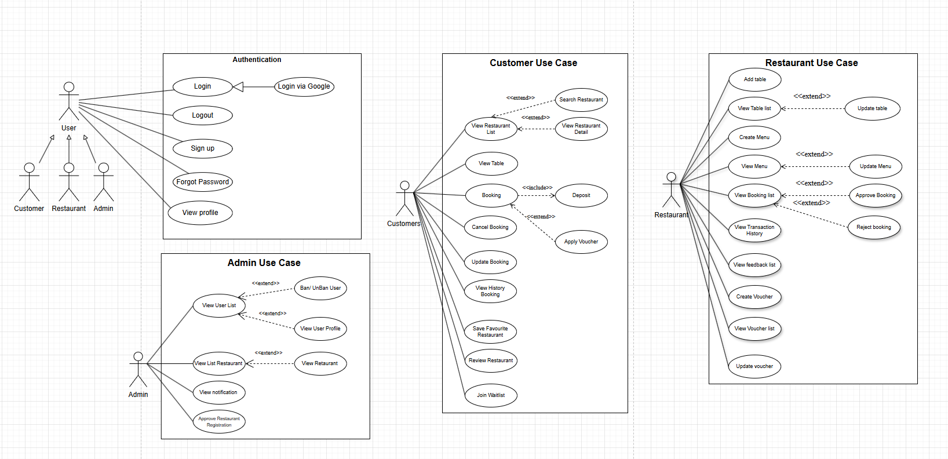

**Figure** 1: Use Case Diagram for the Restaurant Reservation System

#### b. Descriptions

| **ID** | **Feature** | **Use Case** | **Use Case Description** |
| --- | --- | --- | --- |
| 1 | Authentication | Sign up | Register a customer or restaurant account with required information. |
| 2 | Authentication | Login | Sign in with credentials to access authorized features. |
| 3 | Authentication | Login via Google | Authenticate using Google OAuth for faster sign-in. |
| 4 | Authentication | Logout | End the current authenticated session safely. |
| 5 | Authentication | Forgot Password | Request a password reset via email/OTP verification. |
| 6 | Authentication | View Profile | View personal profile details and account status. |
| 7 | Restaurant Discovery | Search Restaurant | Search restaurants by name, location, cuisine, and filters. |
| 8 | Restaurant Discovery | View Restaurant List | Browse the list of restaurants that match search criteria. |
| 9 | Restaurant Discovery | View Restaurant Detail | View full restaurant details (description, photos, rating, hours, address). |
| 10 | Table Browsing & Management | View Table (Availability) | See table layout and availability for a selected date/time. |
| **ID** | **Feature** | **Use Case** | **Use Case Description** |
| 11 | Table Browsing & Management | Add Table | Add a new table to the restaurant’s inventory. |
| 12 | Table Browsing & Management | Update Table | Modify table size, status, or attributes. |
| 13 | Table Browsing & Management | View Table List | View the complete list/layout of tables in the restaurant. |
| 14 | Menu Management | Create Menu | Create the initial menu with items, prices, and categories. |
| 15 | Menu Management | View Menu | View the current menu items available to customers. |
| 16 | Menu Management | Update Menu | Add, edit, or disable menu items and prices. |
| 17 | Booking Management | Booking (Create) | Create a table booking with date/time, party size, and notes. |
| 18 | Booking Management | Update Booking | Change booking details such as time, party size, or notes. |
| 19 | Booking Management | Cancel Booking | Cancel an existing booking according to policy. |
| 20 | Booking Management | View Booking List | View all incoming bookings awaiting action. |
| 21 | Booking Management | Approve Booking | Accept a booking and send confirmation to the customer. |
| 22 | Booking Management | Reject Booking | Decline a booking and notify the customer with a reason. |
| 23 | Waitlist | Join Waitlist | Join the waitlist when no suitable table is available. |
| 24 | Payment & Deposits | Deposit | Pay a deposit required to secure the booking. |
| 25 | Voucher & Promotions | Create Voucher | Create a discount voucher or promotional campaign. |
| 26 | Voucher & Promotions | View Voucher List | View all existing vouchers and their status. |
| 27 | Voucher & Promotions | Update Voucher | Edit voucher rules, discount amount, and validity period. |
| **ID** | **Feature** | **Use Case** | **Use Case Description** |
| 28 | Voucher & Promotions | Apply Voucher | Apply a voucher code to the booking or bill. |
| 29 | Reviews & Feedback | Review Restaurant | Submit a rating and written review after the visit. |
| 30 | Reviews & Feedback | View Feedback List | View and manage customer reviews/feedback. |
| 31 | Favorites | Save Favourite Restaurant | Save or remove a restaurant from personal favorites. |
| 32 | History & Reports | View History Booking | View personal history of past bookings. |
| 33 | History & Reports | View Transaction History | View deposits and payment transactions over time. |
| 34 | User & Restaurant Governance | View User List | View the system’s list of registered users. |
| 35 | User & Restaurant Governance | View User Profile | View detailed profile information of a selected user. |
| 36 | User & Restaurant Governance | Ban/UnBan User | Suspend or reinstate a user account. |
| 37 | User & Restaurant Governance | View List Restaurant | View the list of restaurants registered in the system. |
| 38 | User & Restaurant Governance | View Restaurant (Detail) | View detailed information of a selected restaurant. |
| 39 | User & Restaurant Governance | Approve Restaurant Registration | Approve onboarding requests from new restaurants. |

## 

## 2. Overall Functionalities

### 2.1 Screens Flow

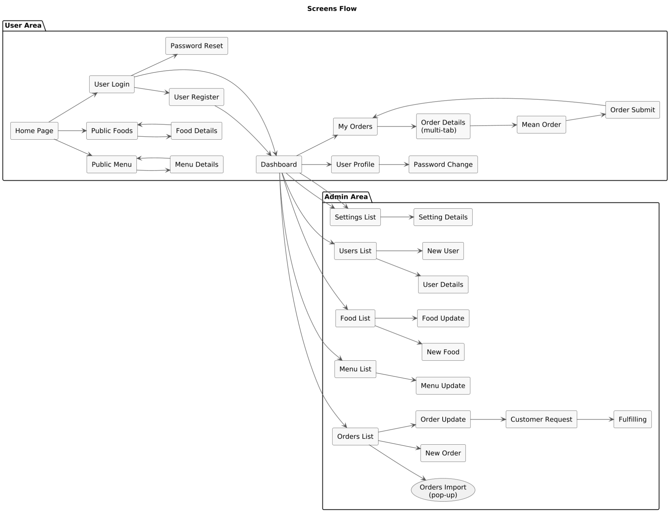

### 2.2 Screen Descriptions

*[Provide the descriptions for the screens in the Screens Flow above]*

| **#** | **Feature** | **Screen** | **Description** |
| --- | --- | --- | --- |
| 1 | Authentication | Login Screen | Screen allows users to log into the system using username/password or Google OAuth. Displays login form with validation and link to register new account. |
| 2 | Authentication | Register Screen | Screen allows guests to create new accounts with information including username, email, password, full name, phone number. Has real-time validation and email verification after registration. |
| 3 | Authentication | Profile Screen | Screen displays personal information of logged-in users, including avatar, contact information, and profile editing options. |
| 4 | Restaurant Search | Restaurant List Screen | Screen displays list of restaurants with filters by location, cuisine type, price range, rating. Has pagination and search box for quick search. |
| 5 | Restaurant Search | Restaurant Detail Screen | Screen displays restaurant details including basic information, menu, reviews, images, and booking button. Customers can view reviews and ratings. |
| 6 | Restaurant Search | Menu Screen | Screen displays restaurant menu items with prices, descriptions, images. Has filter by category (appetizer, main course, beverage, dessert). |
| 7 | Booking | Booking Form Screen | Screen allows customers to create new restaurant bookings by selecting date, time, number of guests, tables, and entering notes. Displays deposit price and available tables. |
| 8 | Booking | Booking List Screen | Screen displays list of all customer bookings with status (PENDING, CONFIRMED, COMPLETED, CANCELLED). Has filter by status and time. |
| 9 | Booking | Booking Detail Screen | Screen displays details of a specific booking including restaurant information, table, time, number of guests, payment status, and action buttons. |
| 10 | Payment | Payment Screen | Screen for deposit payment through PayOS gateway. Displays booking information, amount to pay, and available payment methods. |
| 11 | Payment | Payment History Screen | Screen displays user transaction history with filters by time, transaction type, and status. Can view details of each transaction. |
| 12 | Restaurant Management | Restaurant Dashboard | Overview screen for Restaurant Owners displaying booking statistics, revenue, reviews, and new notifications. Has quick access to main functions. |
| 13 | Restaurant Management | Restaurant Profile Screen | Screen allows Restaurant Owners to manage restaurant information such as name, address, opening hours, description, and images. Has validation and preview. |
| 14 | Restaurant Management | Table Management Screen | Screen allows Restaurant Owners to manage dining tables including adding, editing, deleting tables with information like table name, capacity, deposit price, and status. |
| 15 | Restaurant Management | Menu Management Screen | Screen allows Restaurant Owners to manage menu including adding, editing, deleting dishes with information like name, description, price, category, and images. |
| 16 | Booking Management | Booking Approval Screen | Screen allows Restaurant Owners to approve bookings from customers. Displays list of PENDING bookings with detailed information and Approve/Reject buttons. |
| 17 | Review System | Review List Screen | Screen displays all reviews of a restaurant with ratings, comments, and reviewer information. Has filter by rating and time. |
| 18 | Review System | Write Review Screen | Screen allows customers to write reviews and ratings for restaurants after completing their bookings. Has 1-5 star rating form and comment box. |
| 19 | Chat System | Chat List Screen | Screen displays list of user conversations with customers or restaurant owners. Shows last message and time. |
| 20 | Chat System | Chat Window Screen | Real-time chat screen between customers and restaurant owners. Has input box to send messages, displays chat history, and notifications for new messages. |
| 21 | Voucher System | Voucher List Screen | Screen displays list of available vouchers for customers with discount information, usage conditions, and expiry date. |
| 22 | Voucher System | Voucher Management Screen | Screen allows Restaurant Owners to create and manage vouchers with discount type, value, usage limit, and validity period information. |
| 23 | Waitlist System | Waitlist Screen | Screen allows customers to join restaurant waitlist when no tables are available. Displays position in queue and estimated wait time. |
| 24 | Revenue Management | Revenue Report Screen | Screen displays revenue reports for Restaurant Owners by day, month, year with charts and detailed breakdown. |
| 25 | Revenue Management | Withdrawal Request Screen | Screen allows Restaurant Owners to request withdrawals with amount, bank account information, and reason. Displays available balance. |
| 26 | Admin Management | Admin Dashboard | Overview screen for Admin displaying system-wide statistics including users, restaurants, bookings, revenue, and pending notifications. |
| 27 | Admin Management | User Management Screen | Screen allows Admin to manage users including viewing list, ban/unban accounts, and viewing profile details. |
| 28 | Admin Management | Restaurant Approval Screen | Screen allows Admin to approve new restaurant registrations with detailed information, business license, and Approve/Reject buttons. |
| 29 | Admin Management | Withdrawal Approval Screen | Screen allows Admin to approve withdrawal requests from Restaurant Owners with detailed transaction information and bank account details. |

### 2.3 Screen Authorization

### 

| **Screen** | **Guest** | **Customer** | **Restaurant Owner** | **Admin** |
| --- | --- | --- | --- | --- |
| Login Page | X | X | X | X |
| ▫ Fill in information | X | X | X | X |
| ▫ Login with Google | X | X | X | X |
| Register Page | X | X | X | X |
| ▫ Fill in information | X | X | X | X |
| ▫ Submit registration | X | X | X | X |
| Forgot Password Page | X | X | X | X |
| ▫ Request password reset | X | X | X | X |
| ▫ Reset password | X | X | X | X |
| Profile Page |  | X | X | X |
| ▫ View profile |  | X | X | X |
| ▫ Edit profile |  | X | X | X |
| ▫ Change password |  | X | X | X |
| Restaurant Search Page | X | X |  |  |
| ▫ Search by criteria | X | X |  |  |
| ▫ View restaurant list | X | X |  |  |
| Restaurant Detail Page | X | X |  |  |
| ▫ View restaurant info | X | X |  |  |
| ▫ View menu | X | X |  |  |
| ▫ View services | X | X |  |  |
| ▫ View reviews | X | X |  |  |
| ▫ Add to favorites |  | X |  |  |
| Booking Form Page |  | X |  |  |
| ▫ Select date/time/guests |  | X |  |  |
| ▫ Select table |  | X |  |  |
| ▫ Confirm booking |  | X |  |  |
| ▫ Make deposit |  | X |  |  |
| My Bookings Page |  | X |  |  |
| ▫ View booking history |  | X |  |  |
| ▫ Edit booking |  | X |  |  |
| ▫ Cancel booking |  | X |  |  |
| Review/Rating Page |  | X |  |  |
| ▫ Submit review |  | X |  |  |
| Payment History Page |  | X |  |  |
| ▫ View payment details |  | X |  |  |
| Restaurant Dashboard |  |  | X |  |
| ▫ View overview |  |  | X |  |
| ▫ Manage bookings |  |  | X |  |
| Restaurant Profile Management |  |  | X |  |
| ▫ Edit restaurant info |  |  | X |  |
| ▫ Upload images |  |  | X |  |
| ▫ Manage business license |  |  | X |  |
| Table Management Page |  |  | X |  |
| ▫ Add new table |  |  | X |  |
| ▫ Edit table |  |  | X |  |
| ▫ Delete table |  |  | X |  |
| Dish Management Page |  |  | X |  |
| ▫ Add new dish |  |  | X |  |
| ▫ Edit dish |  |  | X |  |
| ▫ Delete dish |  |  | X |  |
| Service Management Page |  |  | X |  |
| ▫ Add new service |  |  | X |  |
| ▫ Edit service |  |  | X |  |
| ▫ Delete service |  |  | X |  |
| Booking Approval Page |  |  | X |  |
| ▫ View pending bookings |  |  | X |  |
| ▫ Approve booking |  |  | X |  |
| ▫ Reject booking |  |  | X |  |
| Voucher Management Page |  |  | X |  |
| ▫ Create voucher |  |  | X |  |
| ▫ Manage existing vouchers |  |  | X |  |
| Balance & Withdrawal Page |  |  | X |  |
| ▫ View balance |  |  | X |  |
| ▫ Request withdrawal |  |  | X |  |
| Admin Dashboard |  |  |  | X |
| ▫ View system statistics |  |  |  | X |
| User Management Page |  |  |  | X |
| ▫ View user list |  |  |  | X |
| ▫ Edit user roles |  |  |  | X |
| ▫ Activate/Deactivate user |  |  |  | X |
| Restaurant Approval Page |  |  |  | X |
| ▫ View pending restaurants |  |  |  | X |
| ▫ Approve restaurant |  |  |  | X |
| ▫ Reject restaurant |  |  |  | X |
| Transaction Management Page |  |  |  | X |
| ▫ View all transactions |  |  |  | X |
| ▫ Refund transactions |  |  |  | X |
| Payout Management Page |  |  |  | X |
| ▫ View withdrawal requests |  |  |  | X |
| ▫ Process payouts |  |  |  | X |

### 

### 2.4 Non-UI Functions

| **No.** | **Feature** | **System Function** | **Description** |
| --- | --- | --- | --- |
| 1 | Booking Reliability | Auto-cancel Pending Bookings | Automatically cancels pending holds/orders after the configured hold time to free tables/capacity. |
| 2 | Customer Engagement | Booking Reminder Notifications | Sends email/SMS reminders before the reservation time and on status updates. |
| 3 | Capacity Control | Table/Capacity Hold & Release | Reserves capacity during order creation and releases it on cancel/expiry. |
| 4 | Pricing | Promotions & Dynamic Pricing | Applies vouchers/discount rules and calculates final prices based on validity conditions. |
| 5 | Payments | Payment Processing & Webhooks | Creates payment intents and handles provider webhooks (success/failure/refund) to update order status. |
| 6 | Performance | Menu/Food Cache Rebuild | Periodically refreshes cached menu/food data (e.g., Redis) to speed up reads. |
| 7 | Maintenance | Data Cleanup & Token Rotation | Removes stale logs/drafts/expired tokens and rotates secrets/keys on schedule. |
| 8 | Reporting | Daily Close & Report Export | Generates end-of-day revenue/order reports and exports PDF/CSV to admins. |
| 9 | Observability | Structured Logging & Audit Trail | Captures structured logs and admin action trails for monitoring and compliance. |
| 10 | Security | Rate Limiting & Throttling | Enforces request quotas on sensitive APIs to prevent abuse and reduce load. |

## 3. System High Level Design

### 3.1 Database Design

*[Provide the tables relationship like example below]*

#### a. Database Schema

[*https://drive.google.com/file/d/1BvmGmF2s2Ocbej6L9G4vmi_ywXFLQ-KR/view?usp=sharing*](https://drive.google.com/file/d/1BvmGmF2s2Ocbej6L9G4vmi_ywXFLQ-KR/view?usp=sharing)

#### b. Table Descriptions

| **No** | **Table** | **Description** |
| --- | --- | --- |
| 1 | users | Stores user information for the system, including customers, restaurant owners, and administrators. Contains login credentials, authentication data, and personal profiles.  Primary keys: id |
| 2 | customer | Extended customer information table linked to users table. Stores additional customer-specific data and profile information.  Primary keys: customer_id  Foreign keys: user_id → users(id) |
| 3 | restaurant_owner | Extended restaurant owner information table linked to users table. Stores additional owner-specific data and business information.  Primary keys: owner_id  Foreign keys: user_id → users(id) |
| 4 | restaurant_profile | Contains detailed information about registered restaurants on the platform, including basic information, approval status, and contract details.  Primary keys: restaurant_id  Foreign keys: owner_id → restaurant_owner(owner_id) |
| 5 | restaurant_table | Stores information about available dining tables within each restaurant, including table name, capacity, status, and deposit amount.  Primary keys: table_id  Foreign keys: restaurant_id → restaurant_profile(restaurant_id) |
| 6 | restaurant_media | Stores information about restaurant images and media files, including main images, menu photos, and attachments.  Primary keys: id  Foreign keys: restaurant_id → restaurant_profile(restaurant_id) |
| 7 | restaurant_service | Contains information about additional services provided by restaurants (e.g., live music, private rooms, special services).  Primary keys: service_id  Foreign keys: restaurant_id → restaurant_profile(restaurant_id) |
| 8 | booking | Records detailed information about customer reservations at restaurants, including booking time, guest count, status, and deposit amount.  Primary keys: booking_id  Foreign keys: customer_id → customer(customer_id), restaurant_id → restaurant_profile(restaurant_id) |
| 9 | booking_table | Junction table linking bookings and restaurant tables, recording which tables are assigned to which bookings.  Primary keys: booking_table_id  Foreign keys: booking_id → booking(booking_id), table_id → restaurant_table(table_id) |
| 10 | booking_dish | Junction table linking bookings and dishes, recording which menu items are ordered in which bookings with quantity and pricing.  Primary keys: booking_dish_id  Foreign keys: booking_id → booking(booking_id), dish_id → dish(dish_id) |
| 11 | booking_service | Junction table linking bookings and restaurant services, recording which services are selected for bookings.  Primary keys: booking_service_id  Foreign keys: booking_id → booking(booking_id), service_id → restaurant_service(service_id) |
| 12 | dish | Contains information about menu items offered by each restaurant, including name, description, price, and category.  Primary keys: dish_id  Foreign keys: restaurant_id → restaurant_profile(restaurant_id) |
| 13 | payment | Stores information about payment transactions related to bookings, including PayOS integration and voucher details.  Primary keys: payment_id  Foreign keys: customer_id → customer(customer_id), booking_id → booking(booking_id), voucher_id → voucher(voucher_id) |
| 14 | voucher | Contains information about discount codes or promotions, including discount type, value, usage limits, and validity period.  Primary keys: voucher_id  Foreign keys: restaurant_id → restaurant_profile(restaurant_id), created_by_user → users(id) |
| 15 | customer_voucher | Junction table linking customers and vouchers, recording which vouchers are assigned to which customers and their usage status.  Primary keys: customer_voucher_id  Foreign keys: customer_id → customer(customer_id), voucher_id → voucher(voucher_id) |
| 16 | voucher_redemption | Audit log table recording each voucher usage with detailed transaction information for accurate counting and reporting.  Primary keys: redemption_id  Foreign keys: voucher_id → voucher(voucher_id), customer_id → customer(customer_id), booking_id → booking(booking_id), payment_id → payment(payment_id) |
| 17 | review | Records customer reviews and ratings for restaurants, including rating score (1-5) and comments.  Primary keys: review_id  Foreign keys: customer_id → customer(customer_id), restaurant_id → restaurant_profile(restaurant_id) |
| 18 | review_report | Stores reports about inappropriate reviews from restaurant owners, including report reasons and resolution status.  Primary keys: report_id  Foreign keys: review_id → review(review_id), restaurant_id → restaurant_profile(restaurant_id), owner_id → restaurant_owner(owner_id) |
| 19 | review_report_evidence | Stores evidence files and attachments for review reports, including file URLs and metadata.  Primary keys: evidence_id  Foreign keys: report_id → review_report(report_id) |
| 20 | chat_room | Manages chat rooms between customers, restaurant owners, and administrators, including participant information and status.  Primary keys: room_id  Foreign keys: customer_id → customer(customer_id), restaurant_id → restaurant_profile(restaurant_id), admin_id → users(id) |
| 21 | message | Stores messages within chat rooms, including content, message type, and read status.  Primary keys: message_id  Foreign keys: room_id → chat_room(room_id), sender_id → users(id) |
| 22 | waitlist | Manages customer waitlists when no tables are available, including party size and preferred booking time.  Primary keys: waitlist_id  Foreign keys: customer_id → customer(customer_id), restaurant_id → restaurant_profile(restaurant_id) |
| 23 | waitlist_dish | Junction table linking waitlist entries and dishes, recording which menu items are selected for waitlist.  Primary keys: waitlist_dish_id  Foreign keys: waitlist_id → waitlist(waitlist_id), dish_id → dish(dish_id) |
| 24 | waitlist_service | Junction table linking waitlist entries and restaurant services, recording which services are selected for waitlist.  Primary keys: waitlist_service_id  Foreign keys: waitlist_id → waitlist(waitlist_id), service_id → restaurant_service(service_id) |
| 25 | waitlist_table | Junction table linking waitlist entries and restaurant tables, recording which tables are assigned to waitlist.  Primary keys: waitlist_table_id  Foreign keys: waitlist_id → waitlist(waitlist_id), table_id → restaurant_table(table_id) |
| 26 | restaurant_balance | Tracks account balance for each restaurant in the system, including total revenue and available balance.  Primary keys: balance_id  Foreign keys: restaurant_id → restaurant_profile(restaurant_id) |
| 27 | restaurant_bank_account | Stores restaurant bank account information for withdrawal transactions and payout processing.  Primary keys: account_id  Foreign keys: restaurant_id → restaurant_profile(restaurant_id) |
| 28 | withdrawal_request | Records withdrawal requests from restaurant balances, including amount, reason, and processing status.  Primary keys: request_id  Foreign keys: restaurant_id → restaurant_profile(restaurant_id), bank_account_id → restaurant_bank_account(account_id) |
| 29 | withdrawal_audit_log | Records audit history of withdrawal transactions for tracking and transparency verification purposes.  Primary keys: log_id  Foreign keys: withdrawal_request_id → withdrawal_request(request_id) |
| 30 | user_preferences | Stores user preferences for AI recommendations, including cuisine preferences, price range, and location preferences.  Primary keys: id  Foreign keys: user_id → users(id) |
| 31 | ai_recommendations | Stores AI recommendation results and metadata, including query analysis and confidence scores.  Primary keys: id Foreign keys: user_id → users(id) |
| 32 | ai_interactions | Tracks user interactions with AI for learning and improvement, including query types and user actions.  Primary keys: id  Foreign keys: user_id → users(id), restaurant_id → restaurant_profile(restaurant_id) |
| 33 | ai_analytics | Daily/hourly analytics for AI performance, including query metrics and conversion rates.  Primary keys: id |
| 34 | ai_configuration | Configuration settings for AI features, including model settings and rate limits.  Primary keys: id |
| 35 | bank_directory | Stores list of supported banks in the system, including bank codes and bank names for payment processing.  Primary keys: id |
| 36 | notification | Stores system notifications for users, including booking confirmations, payment updates, and system announcements.  Primary keys: notification_id  Foreign keys: recipient_user_id → users(id) |
| 37 | customer_favorite | Junction table linking customers and restaurants, recording which restaurants customers have favorited.  Primary keys: favorite_id  Foreign keys: customer_id → customer(customer_id), restaurant_id → restaurant_profile(restaurant_id) |
| 38 | persistent_logins | Spring Security remember-me persistent login tokens for user authentication.  Primary keys: series |
| 39 | restaurant_contract | Stores restaurant partnership contracts with commission rates, terms, and signature tracking.  Primary keys: contract_id  Foreign keys: restaurant_id → restaurant_profile(restaurant_id), owner_id → restaurant_owner(owner_id) |
| 40 | contract_terms_template | Stores template contract terms for different contract types (standard, premium, enterprise).  Primary keys: template_id |

### 

### 3.2 Code Packages

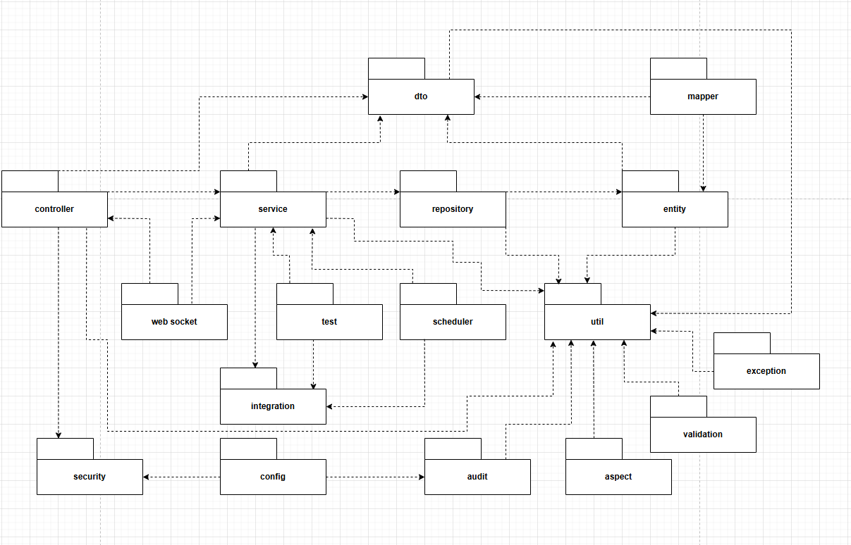

***Package descriptions***

| **No** | **Package** | **Description** |
| --- | --- | --- |
| *1* | *controller* | *Lớp biên nhận request (REST/Web), validate cơ bản, gọi service và chuyển đổi dữ liệu vào/ra DTO.* |
| *2* | *service* | *Xử lý nghiệp vụ ứng dụng, điều phối luồng, quản lý giao dịch; gọi repository và integration.* |
| *3* | *repository* | *Truy cập dữ liệu (JPA/Jdbc/Mongo…). Chỉ chứa logic truy vấn và ánh xạ persistence.* |
| *4* | *entity* | *Mô hình domain/persistence (Entity/Aggregate/ValueObject) dùng trong nghiệp vụ và lưu trữ.* |
| *5* | *dto* | *Đối tượng truyền dữ liệu cho request/response/sự kiện; không chứa nghiệp vụ.* |
| *6* | *util* | *Tiện ích/dùng chung (helper, constants, time, id, common functions).* |
| *7* | *integration* | *Client/adapter kết nối hệ thống bên ngoài (REST/RPC/message), anti-corruption layer.* |
| *8* | *security* | *Xác thực/Phân quyền (filters, interceptors, policies, permission evaluators, security config).* |
| *9* | *mapper* | *Chuyển đổi giữa DTO ↔ Entity (MapStruct/hand-written mappers).* |
| *10* | *scheduler* | *Tác vụ định kỳ (Quartz/Spring Scheduling) kích hoạt service/integration theo lịch.* |
| *11* | *websocket* | *Kênh realtime (STOMP/Socket), đẩy/nhận sự kiện, giao tiếp với controller/service.* |
| *12* | *test* | *Mã kiểm thử (unit/integration), gọi service và integration; dựng mock/stub khi cần.* |
| *13* | *aspect* | *Cross-cutting bằng AOP (logging, tracing, transaction advice…).* |
| *14* | *audit* | *Ghi vết/audit trail (ai làm gì, khi nào), lưu trữ & tra cứu bản ghi audit.* |
| *15* | *exception* | *Chuẩn hoá ngoại lệ, handler toàn cục, mã lỗi/thông điệp.* |
| *16* | *validation* | *Ràng buộc/validator tuỳ chỉnh, annotation kiểm tra dữ liệu vào.* |
| *17* | *config* | *Cấu hình ứng dụng (bean/config properties, profile), khởi tạo hạ tầng.* |

# II. Requirement Specifications

## 1.Authentication

## 1.1 UC-01: User Registration

#### a. Functional Description

#### 

| UC ID and Name: | **UC-01: User Registration** | | |
| --- | --- | --- | --- |
| Created By: | ThangTK | Date Created: | 15/10/2025 |
| Primary Actor: | Customer | Secondary Actors: | None |
| Trigger: | User clicks "Đăng ký" button on registration page | | |
| Description: | *As a user, I want to register a new account so that I can access the restaurant booking system with my credentials.* | | |
| Preconditions: | PRE-1: User has valid email address from allowed domains  PRE-2: Email service is operational  PRE-3: Username and email are not already registered | | |
| Postconditions: | * POST-1: User session is established with appropriate role-based access * POST-2: User is redirected to dashboard corresponding to their role * POST-3: Last login timestamp is updated in database | | |
| Normal Flow | • User accesses registration page  • System displays registration form with validation rules  • User selects account type (Customer or Restaurant Owner)  • User enters required information: username, email, password, confirm password, full name  • User enters optional information: phone number, address  • User submits registration form  • System validates form data against business rules  • System checks username uniqueness (case-insensitive)  • System checks email uniqueness (case-insensitive)  • System validates password confirmation match  • System creates new User entity with provided information  • System encodes password using BCrypt  • System generates email verification token (UUID)  • System sets email verification status to false  • System sets active status based on role (CUSTOMER: true, RESTAURANT_OWNER: false)  • System saves user to database  • If role is RESTAURANT_OWNER: System creates RestaurantOwner entity  • System sends verification email to user  • System resets rate limit for successful registration  • System redirects to success page with confirmation message | | |
| Alternative Flows: | • 7.1: Restaurant Owner registration → System creates RestaurantOwner entity and sets active=false  • 7.2: Customer registration → System sets active=true immediately | | |
| Exceptions: | • 6.0.E1: Username already exists → System displays "Username đã tồn tại"  • 6.0.E2: Email already exists → System displays "Email đã được sử dụng"  • 6.0.E3: Password confirmation mismatch → System displays "Mật khẩu xác nhận không khớp"  • 6.0.E4: Validation errors → System displays specific field validation messages  • 8.0.E1: Rate limit exceeded → System displays "Quá nhiều yêu cầu đăng ký. Vui lòng thử lại sau."  • 12.0.E1: Database save fails → System displays generic error message  • 15.0.E1: Email sending fails → System logs error and continues registration process  4.0.E2: Email not verified → Display "Please verify your email before logging in" | | |
| Priority: | Must Have | | |
| Frequency of Use: | High (new user onboarding) | | |
| Business Rules: | BR-46, BR-47, BR-48, BR-49, BR-50, BR-51, BR-52, BR-53, BR-54, BR-55, BR-56 | | |
| Other Information: | Rate limiting applied to prevent spam registrations. Email verification required before login. Different activation rules for different user roles. | | |
| Assumptions: | User has valid email access, user understands account type selection, email service is reliable | | |

#### b. Business Rules

| ID | Business Rule | Business Rule Description |
| --- | --- | --- |
| BR-46 | Username Validation | Username must be between 3 and 50 characters long and contain only alphanumeric characters and underscores (^[a-zA-Z0-9_]+$) |
| BR-47 | Email Domain Restriction | Email addresses must belong to one of the allowed domains: @gmail.com, @outlook.com.vn, @yahoo.com, @hotmail.com, @student.ctu.edu.vn, @ctu.edu.vn |
| BR-48 | Password Strength Requirements | Password must be at least 8 characters long and contain at least one uppercase letter, one lowercase letter, one digit, and one special character (@$!%?&) |
| BR-49 | Password Confirmation Match | Password and confirm password fields must match exactly for registration to proceed |
| BR-50 | Username Uniqueness | Username must be unique across the system (case-insensitive comparison) |
| BR-51 | Email Uniqueness | Email address must be unique across the system (case-insensitive comparison) |
| BR-52 | Phone Number Format | Phone number must be 10 digits starting with 03, 05, 07, 08, or 09, or be left empty |
| BR-53 | Full Name Length Limit | Full name must not exceed 100 characters and cannot be empty |
| BR-54 | Address Length Limit | Address field is optional and must not exceed 500 characters if provided |
| BR-55 | Account Type Selection | User must select account type (Customer or Restaurant Owner) during registration |
| BR-56 | Role-Based Activation | Customer accounts are activated immediately (active=true), Restaurant Owner accounts require admin approval (active=false) |
| BR-57 | Email Verification Requirement | All new accounts require email verification before login is allowed |
| BR-58 | RestaurantOwner Entity Creation | When user selects Restaurant Owner role, system automatically creates RestaurantOwner |
| BR-59 | Password Encoding | All passwords are encoded using BCrypt before storage in database |
| BR-60 | Registration Rate Limiting | Maximum 5 registration attempts allowed per minute per IP address to prevent spam |
| BR-61 | Verification Token Generation | Email verification token is generated using UUID.randomUUID() for security and uniqueness |

### 1.2 UC-2_Login System

#### a. Functional Description

| UC ID and Name: | **UC-2_Login System** | | |
| --- | --- | --- | --- |
| Created By: | ThangTK | Date Created: | 15/10/2025 |
| Primary Actor: | Customer | Secondary Actors: | None |
| Trigger: | User clicks "Login" button after entering credentials | | |
| Description: | As a user, I want to log into the system so that I can access my account and use the restaurant booking platform features. | | |
| Preconditions: | PRE-1: User has registered account with verified email  PRE-2: User account is not locked or deactivated | | |
| Postconditions: | * POST-1: User session is established with appropriate role-based access * POST-2: User is redirected to dashboard corresponding to their role * POST-3: Last login timestamp is updated in database | | |
| Normal Flow | **User opens login page**  **User enters username/email and password**  **System validates credentials against database**  **System checks account status and email verification**  **System creates authenticated session with JWT token**  **System logs successful login event User is redirected to appropriate dashboard (Customer/Restaurant Owner/Admin)** | | |
| Alternative Flows: | 2.1: User selects "Login with Google" → System initiates OAuth flow → Google authentication → Account linking → Redirect to dashboard | | |
| Exceptions: | 3.0.E1: System can't authenticate user → Display error message → User can choose: Cancel, Forgot Password, or Register  4.0.E1: Account locked → Display "Account locked due to multiple failed attempts"  4.0.E2: Email not verified → Display "Please verify your email before logging in" | | |
| Priority: | Must Have | | |
| Frequency of Use: | High (multiple times per day per user) | | |
| Business Rules: | BR-01, BR-02, BR-05, BR-06, BR-07, BR-08, BR-09, BR-10 | | |
| Other Information: | Password hashed using BCrypt, session expires after 24 hours, failed attempts tracked | | |
| Assumptions: | User has stable internet connection and browser supports cookies | | |

#### b. Business Rules(Done)

| **ID** | **Business Rule** | **Business Rule Description** |
| --- | --- | --- |
| BR-01 | Username Validation | Username must be between 3 and 50 characters long and contain only alphanumeric characters and underscores. |
| BR-02 | Password Encoding | User's password must be encoded with BCrypt hashing before storage and comparison during login authentication. |
| BR-05 | Account Lock Policy | After 6 consecutive failed login attempts, the user account will be temporarily locked for 30 minutes to prevent brute-force attacks. |
| BR-06 | Rate Limiting Policy | Maximum 5 login attempts allowed per minute per IP address to prevent abuse and DDoS attacks. |
| BR-07 | Email Verification Requirement | Users must verify their email address before they can successfully log into the system. |
| BR-08 | Active Account Requirement | Only active accounts can log into the system. Disabled or soft-deleted accounts will not be allowed to log in. |
| BR-09 | Google OAuth Integration | Users can log in using their linked Google account through Google OAuth 2.0 service with proper token validation. |
| BR-10 | Role-Based Access Control | Upon successful login, system determines user role (CUSTOMER, RESTAURANT_OWNER, ADMIN) and applies corresponding access permissions. |
| BR-11 | Session Management | User session expires after 24 hours of inactivity and requires re-authentication for security. |
| BR-12 | Login Attempt Tracking | System tracks and logs all login attempts (successful and failed) for security monitoring and audit purposes. |
| BR-13 | Password Reset Integration | Failed login attempts provide option to reset password through secure email-based password reset flow. |
| BR-14 | Multi-Device Session | Users can maintain active sessions on multiple devices simultaneously with session synchronization. |
| BR-15 | Last Login Tracking | System updates and stores last successful login timestamp for user activity monitoring. |

### 1.3 UC-05_Reset Password

### 

### a. Functional Description

| UC ID and Name: | **UC-05_Reset Password** | | |
| --- | --- | --- | --- |
| Created By: | ThangTK | Date Created: | 15/10/2025 |
| Primary Actor: | Customer | Secondary Actors: | None |
| Trigger: | User clicks "Forgot Password" link on login page | | |
| Description: | As a user, I want to reset my password so that I can regain access to my account when I forget my current password. | | |
| Preconditions: | • PRE-1: User has registered account with valid email  • PRE-2: Email service is operational  • PRE-3: User account is not locked or deactivated | | |
| Postconditions: | * POST-1: Password reset token is generated and sent to user's email * • POST-2: User can access password reset form with valid token * • POST-3: New password is set and old password is invalidated * • POST-4: Reset token is invalidated after successful password change | | |
| Normal Flow | **User clicks "Forgot Password" link**  **• User enters registered email address**  **• System validates email exists in database**  **• System generates secure password reset token (UUID)**  **• System sets token expiry to 1 hour from current time**  **• System sends reset link to user's email via EmailService**  **• User receives email and clicks reset link**  **• User enters new password twice for confirmation**  **• System validates new password meets requirements (min 8 chars, uppercase, lowercase, digit, special char)**  **• System updates password with BCrypt hash**  **• System invalidates reset token**  **• System displays "Password reset successful" message**  **• User is redirected to login page** | | |
| Alternative Flows: | • 7.1: Reset token expired → System displays "Reset link expired, please request new one"  • 7.2: Reset token already used → System displays "Reset link has been used, please request new one" | | |
| Exceptions: | 3.0.E1: Email not found → System displays generic message "If email exists, reset link has been sent" (security)  • 5.0.E1: Email service fails → System logs error and displays "Unable to send email"  • 8.0.E1: Password validation fails → System displays specific password requirements  • 8.0.E2: Password confirmation mismatch → System displays "Password confirmation does not match"  • 9.0.E1: Token invalid or expired → System displays "Reset link invalid or expired"  • 10.0.E1: Database update fails → System displays "Error occurred, please try again" | | |
| Priority: | Must Have | | |
| Frequency of Use: | Medium (occasional password resets) | | |
| Business Rules: | BR-02, BR-06, BR-07, BR-08, BR-09 | | |
| Other Information: | Reset token expires after 1 hour, one-time use only, rate limited to prevent abuse, password hashed using BCrypt, generic response for security | | |
| Assumptions: | User has access to registered email account, email service is reliable, user can access email within 1 hour | | |

#### b. Business Rules(Done)

| ID | Business Rule | Business Rule Description |
| --- | --- | --- |
| BR-16 | Email Validation for Reset | System validates that the provided email exists in the database before generating reset token. If email doesn't exist, system returns generic success message for security |
| BR-17 | Reset Token Generation | Password reset tokens are generated using UUID.randomUUID() to ensure cryptographic security and uniqueness |
| BR-18 | Reset Token Expiry | Password reset tokens expire exactly 1 hour after generation (LocalDateTime.now().plusHours(1)) and cannot be used after expiration |
| BR-19 | One-Time Token Usage | Each password reset token can only be used once. After successful password reset, the token is immediately invalidated and removed from database |
| BR-20 | Password Strength Validation | New passwords must meet minimum requirements: at least 8 characters, including uppercase letter, lowercase letter, digit, and special character (@$!%?&) |
| BR-21 | Password Confirmation Match | User must enter new password twice and both entries must match exactly before password can be updated |
| BR-22 | BCrypt Password Hashing | All new passwords are hashed using BCrypt encoder before storage in database for security |
| BR-23 | Reset Request Rate Limiting | Maximum 5 password reset requests allowed per minute per IP address to prevent abuse and email spam |
| BR-24 | Email Service Integration | Password reset emails are sent through EmailService with proper formatting, including reset URL and expiry information |
| BR-25 | Account Status Validation | Password reset can only be initiated for active, non-locked user accounts. Inactive or locked accounts cannot reset passwords |
| BR-26 | Reset Token Database Storage | Reset tokens are stored in User entity with corresponding expiry timestamp for validation during reset process |
| BR-27 | Security Response Policy | System provides generic success message regardless of email existence to prevent email enumeration attacks |
| BR-28 | Reset Completion Notification | After successful password reset, system displays confirmation message and redirects user to login page |
| BR-29 | Token Cleanup Process | Expired or used reset tokens are automatically removed from database to maintain data hygiene and security |
| BR-30 | Email Template Compliance | Password reset emails include proper branding, clear instructions, security warnings, and 1-hour expiry notice |

### 1.4 UC-03: Google OAuth Integration

#### a. Functional Description

#### 

| UC ID and Name: | **UC-03: Google OAuth Integration** | | |
| --- | --- | --- | --- |
| Created By: | ThangTK | Date Created: | 15/10/2025 |
| Primary Actor: | Customer | Secondary Actors: | None |
| Trigger: | User clicks "Đăng nhập với Google" or "Tiếp tục với Google" button | | |
| Description: | *As a user, I want to authenticate using my Google account so that I can quickly access the system without creating a separate account.* | | |
| Preconditions: | • PRE-1: User has a valid Google account  • PRE-2: Google OAuth service is operational  • PRE-3: System has valid Google OAuth credentials configured | | |
| Postconditions: | * POST-1: User is authenticated and logged into the system * POST-2: User account is created or linked with Google ID * POST-3: User is redirected to appropriate dashboard based on role | | |
| Normal Flow | • User clicks Google OAuth button on login/register page  • System redirects user to Google OAuth authorization endpoint  • User grants permission to the application  • Google redirects back with authorization code  • System exchanges authorization code for access token  • System retrieves user profile information from Google  • System extracts email, name, and Google ID (sub) from profile  • System checks if user exists by Google ID  • If user exists: System updates last login timestamp  • If user doesn't exist: System checks for existing email  • If email exists: System links Google account to existing user  • If no existing user: System creates new user with Google data  • System sets email as verified (Google accounts are pre-verified)  • System assigns default role (CUSTOMER) for new users  • System creates RestaurantOwner record if role is RESTAURANT_OWNER  • System establishes authenticated session  • User is redirected to homepage or role-specific dashboard | | |
| Alternative Flows: | • 9.1: Existing user by email found → System links Google ID to existing account  • 9.2: User selects account type after OAuth → System updates role accordingly  • 13.1: Restaurant Owner role selected → System creates RestaurantOwner entity | | |
| Exceptions: | 6.0.E1: Google OAuth service unavailable → System displays "Google authentication temporarily unavailable"  • 7.0.E1: Email not provided by Google → System throws OAuth2AuthenticationException  • 7.0.E2: Invalid Google OAuth response → System logs error and redirects to login  • 10.0.E1: Database connection fails → System displays "Authentication failed, please try again"  • 11.0.E1: User creation fails → System logs error and redirects to login with error message | | |
| Priority: | High | | |
| Frequency of Use: | High (primary authentication method for many users) | | |
| Business Rules: | BR-62, BR-63, BR-64, BR-65, BR-66, BR-67, BR-68, BR-69, BR-70, BR-71 | | |
| Other Information: | OAuth2 scopes: openid, email, profile. Supports both OAuth2 and OIDC flows. Automatic email verification for Google accounts. | | |
| Assumptions: | User has stable internet connection, Google account is active, user grants necessary permissions | | |

#### b. Business Rules

| **ID** | **Business Rule** | **Business Rule Description** |
| --- | --- | --- |
| BR-62 | Google OAuth Configuration | System must be configured with valid Google OAuth2 client credentials (client-id, client-secret) and proper redirect URIs for development and production environments. |
| BR-63 | OAuth Scope Requirements | Google OAuth requests must include required scopes: openid, email, and profile to access user's basic information and email address. |
| BR-64 | Google ID Uniqueness | Each Google account (identified by 'sub' attribute) can only be linked to one system user account. System prevents duplicate Google ID associations. |
| BR-65 | Email-Based Account Linking | If Google OAuth returns an email that already exists in the system, the Google account is automatically linked to the existing user account without creating duplicates. |
| BR-66 | Automatic Email Verification | All Google OAuth authenticated users have their email automatically marked as verified since Google handles email verification. |
| BR-67 | Default Role Assignment | New users created via Google OAuth are assigned CUSTOMER role by default. Role can be changed through account type selection flow. |
| BR-68 | Username Generation | For Google OAuth users, username is automatically generated using the email address (normalized to lowercase) or Google ID if email is unavailable. |
| BR-69 | Password Generation | Google OAuth users receive a randomly generated secure password (UUID-based) since they don't set a password during registration. |
| BR-70 | RestaurantOwner Entity Creation | When a Google OAuth user selects or is assigned RESTAURANT_OWNER role, system automatically creates corresponding RestaurantOwner entity in database. |
| BR-71 | OAuth Error Handling | System provides user-friendly error messages for OAuth failures and logs detailed technical information for debugging purposes. |
| BR-72 | Session Management Integration | Google OAuth authenticated users follow the same session management rules as regular users, including 24-hour session expiry and remember-me functionality. |
| BR-73 | Profile Information Sync | System automatically updates user's full name from Google profile information during OAuth authentication process. |
| BR-74 | OAuth Redirect URI Security | OAuth redirect URIs must match exactly between Google OAuth configuration and system configuration to prevent security vulnerabilities. |
| BR-75 | Account Type Selection Flow | New Google OAuth users can select between CUSTOMER and RESTAURANT_OWNER account types through dedicated selection interface after initial authentication. |
| BR-76 | OAuth Token Validation | System validates Google OAuth tokens and handles token refresh automatically through Spring Security OAuth2 client integration. |

### 1.5 UC-04: Logout

#### a. Functional Description

#### 

| UC ID and Name: | **UC-04: Logout** | | |
| --- | --- | --- | --- |
| Created By: | ThangTK |  |  |
| Primary Actor: | Customer |  |  |
| Trigger: | User clicks "Sign Out" button in user dropdown menu | | |
| Description: | *As a user, I want to log out of the system so that I can safely end my session and protect my account from unauthorized access.* | | |
| Preconditions: | • PRE-1: User is currently authenticated and logged in  • PRE-2: User has active session in the system | | |
| Postconditions: | • POST-1: User session is terminated and invalidated  • POST-2: All session cookies are deleted  • POST-3: User is redirected to homepage as guest  • POST-4: User must re-authenticate to access protected resources | | |
| Normal Flow | • User clicks on user avatar/name in header navigation  • System displays user dropdown menu with profile options  • User clicks "Sign Out" button in dropdown menu  • System submits logout form with POST request to /logout endpoint  • System invalidates user's authentication session  • System deletes session cookies (JSESSIONID)  • System deletes remember-me cookies (BOOKEAT_REMEMBER_ME)  • System clears all user authentication data  • System redirects user to homepage (/)  • User sees homepage as unauthenticated guest | | |
| Alternative Flows: | None | | |
| Exceptions: | • 4.0.E1: User not authenticated → System ignores logout request  • 5.0.E1: Session invalidation fails → System logs error but continues logout process  • 6.0.E1: Cookie deletion fails → System logs error but continues logout process  • 7.0.E1: Redirect fails → System displays logout confirmation message | | |
| Priority: | Must Have | | |
| Frequency of Use: | High (every user session ends with logout) | | |
| Business Rules: | BR-77, BR-78, BR-79, BR-80, BR-81 | | |
| Other Information: | Logout is handled by Spring Security. No additional business logic required. Works for all user roles. | | |
| Assumptions: | User understands logout action terminates session completely | | |

#### b. Business Rules

| **ID** | **Business Rule** | **Business Rule Description** |
| --- | --- | --- |
| BR-77 | Logout URL Configuration | Logout endpoint is configured as /logout and accepts POST requests only for security. |
| BR-78 | Session Invalidation | Upon logout, system must completely invalidate the user's authentication session and remove all session data. |
| BR-79 | Cookie Cleanup | System must delete all authentication-related cookies including JSESSIONID and BOOKEAT_REMEMBER_ME upon logout. |
| BR-80 | Logout Success Redirect | After successful logout, user is automatically redirected to homepage (/) as an unauthenticated guest. |
| BR-81 | Logout Permission | Logout functionality is accessible to all authenticated users regardless of their role (CUSTOMER, RESTAURANT_OWNER, ADMIN). |
| BR-82 | Security Logout | Logout must be performed via POST request to prevent CSRF attacks and ensure secure session termination. |
| BR-83 | Session Cleanup | All user-specific session data, including shopping cart, preferences, and temporary data, must be cleared upon logout. |
| BR-84 | Remember-Me Token Cleanup | If user used remember-me functionality, the remember-me token must be invalidated and cookie deleted during logout. |
| BR-85 | Logout Confirmation | No confirmation dialog required for logout - action is immediate and irreversible. |
| BR-86 | Multi-Device Session Handling | Logout only affects current browser session; other active sessions on different devices remain unaffected. |
| BR-87 | Logout Error Handling | If logout process encounters errors, system logs the error but continues with session termination to ensure security. |
| BR-88 | Post-Logout Access | After logout, user loses access to all protected resources and must re-authenticate to access system features. |

### 1.6 UC-06: View Profile

#### a. Functional Description

#### 

| UC ID and Name: | **UC-06: View Profile** | | |
| --- | --- | --- | --- |
| Created By: | ThangTK |  |  |
| Primary Actor: | Customer |  |  |
| Trigger: | User clicks "Profile" option in user dropdown menu | | |
| Description: | *As a user, I want to view my personal profile information so that I can see my account details and verify my information.* | | |
| Preconditions: | PRE-1: User is currently authenticated and logged in  PRE-2: User account exists in the database | | |
| Postconditions: | • POST-1: User profile information is displayed  • POST-2: User can see all their personal account details  • POST-3: User can access profile editing options | | |
| Normal Flow | • User clicks on user avatar/name in header navigation  • System displays user dropdown menu with profile options  • User clicks "Profile" option in dropdown menu  • System retrieves current user from authentication context  • System checks if user is authenticated  • System calls getCurrentUser() helper method  • System handles both regular and OAuth2 user authentication  • System fetches complete user profile from database  • System loads user information: username, email, full name, phone, address, role, status  • System checks if user is OAuth2 user (Google login)  • System displays profile page with user information  • System shows profile avatar, account details, and status  • System provides edit profile and change password options | | |
| Alternative Flows: | • 5.1: Regular user authentication → System uses User principal  • 5.2: OAuth2 user authentication → System uses email or Google ID to find user | | |
| Exceptions: | • 4.0.E1: User not authenticated → System redirects to login page  • 6.0.E1: User not found in database → System redirects to login page  • 7.0.E1: Database connection fails → System displays error message | | |
| Priority: | High | | |
| Frequency of Use: | Medium (users check profile occasionally) | | |
| Business Rules: | BR-89, BR-90, BR-91, BR-92, BR-93, BR-94 | | |
| Other Information: | Profile view is read-only. Users can access edit functionality from profile page. Supports both regular and OAuth2 users. | | |
| Assumptions: | User understands profile information displayed, user has stable internet connection | | |

#### b. Business Rules

| ID | Business Rule | Business Rule Description |
| --- | --- | --- |
| BR-89 | Authentication Requirement | Only authenticated users can access profile page. Unauthenticated users are redirected to login. |
| BR-90 | Profile Access Permission | Users can only view their own profile information. No access to other users' profiles. |
| BR-91 | User Data Retrieval | System must retrieve complete user profile information including username, email, full name, phone number, address, role, and account status |

## 2. Restaurant Discovery

### 2.1 UC-07: Search Restaurant

#### a. Functional Description

#### 

| UC ID and Name: | **UC-07: Search Restaurant** | | |
| --- | --- | --- | --- |
| Created By: | ThangTK |  |  |
| Primary Actor: | Customer |  |  |
| Trigger: | User enters search criteria in restaurant search interface | | |
| Description: | *As a user, I want to search for restaurants by various criteria so that I can find restaurants that match my preferences and requirements.* | | |
| Preconditions: | • PRE-1: System has approved restaurants in database  • PRE-2: Restaurant search interface is available | | |
| Postconditions: | • POST-1: Search results are displayed to user  • POST-2: User can view filtered restaurant list  • POST-3: User can access detailed restaurant information | | |
| Normal Flow | User accesses restaurant listing page (/restaurants)  • System displays search and filter interface  • User enters search criteria (name, location, cuisine)  • User selects optional filters (cuisine type, price range, rating)  • User selects sorting options (name, rating, price)  • User submits search request  • System retrieves all APPROVED restaurants from database  • System applies search filter to restaurant name, address, and cuisine type  • System applies cuisine type filter if specified  • System applies price range filter (under-50k, 50k-100k, 100k-200k, over-200k)  • System applies rating filter (5-star, 4-star, 3-star, 2-star, 1-star)  • System sorts filtered results by selected criteria  • System applies pagination to sorted results  • System loads cover images for each restaurant  • System displays search results with restaurant information  • User can view restaurant details or apply additional filters | | |
| Alternative Flows: | 7.1: No search criteria → System displays all approved restaurants  • 7.2: No results found → System displays "No restaurants found" message  • 7.3: User changes filters → System re-applies all filters and re-sorts | | |
| Exceptions: | • 6.0.E1: Database connection fails → System displays error message  • 7.0.E1: Invalid filter parameters → System ignores invalid filters  • 8.0.E1: Image loading fails → System displays restaurant without cover image | | |
| Priority: | High | | |
| Frequency of Use: | High (primary discovery method for users) | | |
| Business Rules: | BR-95, BR-96, BR-97, BR-98, BR-99, BR-100, BR-101, BR-102 | | |
| Other Information: | Search is case-insensitive. Only approved restaurants are shown to customers. Supports pagination and sorting. | | |
| Assumptions: | User understands search interface, user has stable internet connection | | |

#### b. Business Rules

| ID | Business Rule | Business Rule Description |
| --- | --- | --- |
| BR-95 | Approved Restaurant Filter | Only restaurants with APPROVED status are displayed in search results to customers. Pending or rejected restaurants are excluded. |
| BR-96 | Search Criteria Matching | Search functionality matches restaurant name, address, and cuisine type using case-insensitive partial matching. |
| BR-97 | Cuisine Type Filter | Users can filter restaurants by specific cuisine types. Filter matches exact cuisine type values. |
| BR-98 | Price Range Filter | Price range filters are defined as: under-50k (<50,000 VND), 50k-100k (50,000-100,000 VND), 100k-200k (100,000-200,000 VND), over-200k (>200,000 VND). |
| BR-99 | Rating Filter | Rating filters are defined as: 5-star (≥5.0), 4-star (≥4.0), 3-star (≥3.0), 2-star (≥2.0), 1-star (≥1.0). |
| BR-100 | Search Result Sorting | Users can sort search results by restaurant name (ascending/descending), rating, or price. Default sorting is by restaurant name ascending. |
| BR-101 | Search Result Pagination | Search results are paginated with default page size of 12 restaurants per page. Users can navigate through multiple pages. |
| BR-102 | Empty Search Handling | If no search criteria are provided, system displays all approved restaurants with default sorting and pagination. |
| BR-103 | Multiple Filter Combination | Users can apply multiple filters simultaneously (search text + cuisine + price + rating). All filters must match for restaurant to appear in results. |
| BR-104 | Search Performance | Search operations are optimized for performance with database indexing on restaurant name, cuisine type, and approval status. |
| BR-105 | Cover Image Display | System loads and displays cover images for restaurants in search results. If no cover image exists, restaurant is shown without image. |
| BR-106 | Search Result Validation | All search results are validated to ensure restaurants are active, approved, and have valid profile information. |
| BR-107 | Filter State Persistence | Applied filters and search criteria are maintained in the URL parameters for bookmarking and sharing search results. |

### 2.2 UC-08: View Restaurant List

#### a. Functional Description

#### 

| UC ID and Name: | **UC-08: View Restaurant List** | | |
| --- | --- | --- | --- |
| Created By: | ThangTK |  |  |
| Primary Actor: | Customer |  |  |
| Trigger: | User navigates to restaurant listing page or applies search/filter criteria | | |
| Description: | *As a user, I want to view a list of restaurants so that I can browse available dining options and find restaurants that match my preferences.* | | |
| Preconditions: | • PRE-1: System has approved restaurants in database  • PRE-2: User has access to restaurant listing page | | |
| Postconditions: | • POST-1: Restaurant list is displayed to user  • POST-2: User can see restaurant information and images  • POST-3: User can access restaurant details or apply filters | | |
| Normal Flow | • User navigates to restaurant listing page (/restaurants)  • System loads page with default parameters (page=0, size=12, sort=restaurantName asc)  • System retrieves all APPROVED restaurants from database  • System applies any provided search and filter criteria  • System sorts restaurants by specified criteria (name, rating, price)  • System applies pagination to results (12 restaurants per page by default)  • System loads cover images for each restaurant  • System displays restaurant list with key information  • System shows restaurant name, cuisine type, average rating, price range  • System displays pagination controls for navigation  • System shows filter and search options  • User can browse restaurants, apply filters, or view details | | |
| Alternative Flows: | • 7.1: No restaurants found → System displays "No restaurants available" message  • 7.2: User applies filters → System re-applies filters and updates list  • 7.3: User changes sorting → System re-sorts and displays updated list  • 7.4: User navigates to different page → System loads restaurants for that page | | |
| Exceptions: | • 5.0.E1: Database connection fails → System displays error message  • 7.0.E1: Image loading fails → System displays restaurant without cover image  • 8.0.E1: Invalid pagination parameters → System uses default values | | |
| Priority: | High | | |
| Frequency of Use: | High (primary discovery method for users) | | |
| Business Rules: | BR-108, BR-109, BR-110, BR-111, BR-112, BR-113, BR-114, BR-115 | | |
| Other Information: | List view supports search, filtering, sorting, and pagination. Only approved restaurants are shown. | | |
| Assumptions: | User understands list interface, user has stable internet connection | | |

#### b. Business Rules

| ID | Business Rule | Business Rule Description |
| --- | --- | --- |
| BR-108 | Approved Restaurant Display | Only restaurants with APPROVED status are displayed in the restaurant list. Pending, rejected, or suspended restaurants are excluded from customer view. |
| BR-109 | Default Pagination | Restaurant list displays 12 restaurants per page by default. Users can navigate through multiple pages using pagination controls. |
| BR-110 | Default Sorting | Restaurant list is sorted by restaurant name in ascending order by default. Users can change sorting criteria. |
| BR-111 | Restaurant Information Display | Each restaurant in the list displays: restaurant name, cuisine type, average rating, price range, and cover image. |
| BR-112 | Cover Image Loading | System loads and displays cover images for restaurants. If no cover image exists, restaurant is shown with placeholder or no image. |
| BR-113 | List Performance Optimization | Restaurant list loading is optimized with pagination to ensure fast page load times and good user experience. |
| BR-114 | Filter State Management | Applied filters, search terms, and sorting options are maintained in URL parameters for bookmarking and sharing. |
| BR-115 | List Accessibility | Restaurant list is accessible to all users (authenticated and unauthenticated) for browsing purposes. |
| BR-116 | Restaurant Count Display | System displays total number of restaurants found and current page information for user reference. |
| BR-117 | List Responsive Design | Restaurant list adapts to different screen sizes and devices for optimal viewing experience. |
| BR-118 | Restaurant Card Interaction | Each restaurant card in the list is clickable and leads to detailed restaurant information page. |
| BR-119 | Empty State Handling | When no restaurants match criteria, system displays appropriate message with suggestions to modify filters. |
| BR-120 | List Data Validation | All restaurant data displayed in the list is validated to ensure completeness and accuracy. |
| BR-121 | Favorites Integration | Authenticated users can add/remove restaurants from favorites directly from the restaurant list view. |

### 2.3 UC-09: Restaurant Details View

#### a. Functional Description

| ID and Name: | **UC-09: Restaurant Details View** | | |
| --- | --- | --- | --- |
| Created By: | ThangTK | Date Created: | 15/10/2025 |
| Primary Actor: | Customer | Secondary Actors: | Database, Restaurant Management Service, Review Service |
| Description: | As a user, I want to view detailed information about a restaurant so that I can make an informed decision about dining there. | | |
| Trigger: | User clicks on restaurant card from restaurant list or navigates to restaurant detail page | | |
| Preconditions: | • PRE-1: Restaurant exists in database  • PRE-2: Restaurant is approved and active  • PRE-3: User has access to restaurant detail page | | |
| Postconditions: | • POST-1: Complete restaurant information is displayed  • POST-2: User can see all restaurant details, media, and reviews  • POST-3: User can proceed to book table or view additional information | | |
| Normal Flow: | 1. • User clicks on restaurant from list or navigates to /restaurants/{id} 2. • System retrieves restaurant by ID from database 3. • System validates restaurant exists and is approved 4. • System loads restaurant profile information 5. • System retrieves restaurant media (logos, covers, gallery, menus) 6. • System organizes media by type (logo, cover, gallery, menu) 7. • System loads restaurant dishes/menu items 8. • System loads restaurant tables and availability 9. • System retrieves review statistics and recent reviews 10. • System checks if authenticated user has reviewed this restaurant 11. • System loads customer's review if exists 12. • System displays complete restaurant detail page 13. • System shows restaurant name, description, address, contact info 14. • System displays restaurant media gallery 15. • System shows menu items and prices 16. • System displays table information and capacity 17. • System shows review statistics and customer reviews 18. • System provides booking button and review form | | |
| Alternative Flows: | • 4.1: Restaurant not found → System redirects to restaurant list with error  • 4.2: Restaurant not approved → System redirects to restaurant list with error  • 8.1: No media available → System displays restaurant without images  • 9.1: No reviews available → System displays "No reviews yet" message  • 10.1: User not authenticated → System hides review form and booking button | | |
| Exceptions: | • 3.0.E1: Invalid restaurant ID → System redirects to restaurant list  • 5.0.E1: Database connection fails → System displays error message  • 7.0.E1: Media loading fails → System continues without media  • 9.0.E1: Review service unavailable → System continues without reviews | | |
| Priority: | High | | |
| Business Rules: | BR-122, BR-123, BR-124, BR-125, BR-126, BR-127, BR-128, BR-129 | | |
| Other Information: | Detail view is accessible to all users. Authenticated users can book tables and leave reviews. | | |

#### b. Business Rules

#### 

| ID | Business Rule | Business Rule Description |
| --- | --- | --- |
| BR-122 | Restaurant Access Control | Only approved and active restaurants are accessible through detail view. Pending, rejected, or suspended restaurants redirect users to restaurant list. |
| BR-123 | Complete Information Display | Restaurant detail page must display all available information including name, description, address, contact details, cuisine type, price range, and operating hours. |
| BR-124 | Media Organization | Restaurant media is organized by type: logo, cover image, gallery images, and menu images. Each type is displayed in appropriate sections. |
| BR-125 | Menu Information Display | Restaurant detail page displays all available dishes/menu items with names, descriptions, and prices for customer reference. |
| BR-126 | Table Information Display | Restaurant detail page shows available tables with capacity information to help customers understand seating options. |
| BR-127 | Review Integration | Restaurant detail page displays review statistics, recent customer reviews, and allows authenticated users to leave reviews. |
| BR-128 | Booking Access | Authenticated users can access booking functionality directly from restaurant detail page. Unauthenticated users are prompted to login. |
| BR-129 | Error Handling | If restaurant is not found or not accessible, system redirects to restaurant list with appropriate error message. |
| BR-130 | Media Fallback | If restaurant has no media images, system displays restaurant information without images rather than showing broken image placeholders. |
| BR-131 | Review Status Check | System checks if authenticated user has already reviewed the restaurant and displays appropriate review form or existing review. |
| BR-132 | Page Title Generation | Restaurant detail page title includes restaurant name for SEO and user reference. |
| BR-133 | Responsive Design | Restaurant detail page is responsive and displays properly on all device sizes for optimal user experience. |
| BR-134 | Data Validation | All restaurant data displayed on detail page is validated to ensure accuracy and completeness. |
| BR-135 | Performance Optimization | Restaurant detail page loads efficiently with optimized queries for media, reviews, and related data. |
| Related Existing Business Rules: |  |  |

#### 

## 3. Table Browsing & Management

### 3.1 UC-10: View Table (Availability)

#### a. Functional Description

#### 

| UC ID and Name: | **UC-10_View Table Availability** | | |
| --- | --- | --- | --- |
| Created By: | PhucNH | Date Created: | 15/10/2025 |
| Primary Actor: | Customer | Secondary Actors: | Restaurant Owner |
| Trigger: | Customer selects a restaurant and date/time for booking | | |
| Description: | *As a customer, I want to view available tables at a restaurant for a specific date and time so that I can make an informed booking decision.*  *Preconditions:* | | |
| Preconditions: | PRE-1: Customer has selected a restaurant  PRE-2: Restaurant has tables configured in the system  PRE-3: Date and time are within restaurant operating hours | | |
| Postconditions: | POST-1: Available tables are displayed with details  POST-2: Table capacity and features are shown  POST-3: Real-time availability status is updated | | |
| Normal Flow | **Customer navigates to restaurant detail page**  **Customer selects desired date and time**  **Customer specifies party size**  **System queries table availability for selected criteria**  **System displays available tables with capacity and features**  **Customer can view table layout and details** | | |
| Alternative Flows: | 2.1: No tables available → Display "No tables available" message → Suggest waitlist option  2.2: Partial availability → Show available tables → Display waitlist for preferred times | | |
| Exceptions: | 4.0.E1: System error retrieving table data → Display error message → Allow retry  4.0.E2: Restaurant closed for selected date → Display closure message → Suggest alternative dates | | |
| Priority: | Must Have | | |
| Frequency of Use: | High (multiple times per day per user) | | |
| Business Rules: | BR1, BR2, BR3 | | |
| Other Information: | Real-time synchronization required | | |
| Assumptions: | Restaurant maintains accurate table inventory | | |

#### b. Business Rules

#### 

| **ID** | **Business Rule** | **Business Rule Description** |
| --- | --- | --- |
| BR1 | Table Capacity | Tables must accommodate specified party size with minimum 1.5m² per person |
| BR2 | Operating Hours | Tables only available during restaurant operating hours |
| BR3 | Advance Booking | Tables can be booked maximum 30 days in advance |

### 3.2 UC-11: Add Table (Availability)

#### a. Functional Description

| ID and Name: | **UC-11 Add Table System** | | |
| --- | --- | --- | --- |
| Created By: | DanhDVC | Date Created: | 15/01/2025 |
| Primary Actor: | Restaurant Owner | Secondary Actors: | System Administrator (for validation) |
| Description: | As a restaurant owner, I want to add new tables to my restaurant so that I can manage seating capacity and accommodate customer bookings effectively. | | |
| Trigger: | Restaurant Owner clicks "Add Table" button in table management interface | | |
| Preconditions: | PRE-1: Restaurant Owner is authenticated and logged in.  PRE-2: Restaurant profile exists and is active.  PRE-3: Restaurant Owner has permission to manage tables.  PRE-4: System has sufficient storage for table images. | | |
| Postconditions: | POST-1: New table is created with a unique ID in the database.  POST-2: Table is assigned to a specific restaurant.  POST-3: Table status is set to AVAILABLE by default.  POST-4: Table images are uploaded and linked to table.  POST-5: Restaurant capacity statistics are updated.  POST-6: Table management interface is refreshed. | | |
| Normal Flow: | **11.0 Add a Single Table**   1. The Restaurant Owner navigates to the table management page for their restaurant. 2. The Restaurant Owner clicks the "Add Table" button. 3. RMS displays table creation form with required fields. 4. Restaurant Owner enters table information:    1. Table name (required, max 100 characters).    2. Capacity (required, 1-20 people).    3. Deposit amount (required, minimum 0 VNĐ).    4. Table images (optional, multiple files). 5. The Restaurant Owner submits the form. 6. RMS validates all input data and checks table name uniqueness. 7. RMS creates table records in a database with AVAILABLE status. 8. RMS uploads table images to Cloudinary if provided. 9. RMS links uploaded images to table record. 10. RMS updates restaurant capacity statistics. 11. RMS displays a success message and redirects to table management page. | | |
| Alternative Flows: | **11.1 Add multiple tables via Excel import**   1. Restaurant Owner selects "Import from Excel" option 2. RMS displays Excel import dialog 3. Restaurant Owner uploads Excel file with table data 4. RMS validates Excel data format and content 5. RMS creates multiple tables in batch 6. Return to step 11 of normal flow   **11.2 Add table with multiple images**   1. Restaurant Owner selects multiple image files for upload 2. RMS processes each image file individually 3. RMS links all successfully uploaded images to table 4. Return to step 10 of normal flow | | |
| Exceptions: | **11.0.E1 Table name already exists in restaurant**  1. RMS informs Restaurant Owner that table name already exists  2a. If the Restaurant Owner cancels the process, then RMS terminates the use case.  2b. Else if Restaurant Owner modifies table name, then RMS continues from step 6  **11.0.E2 Validation fails for input data**  1. RMS displays specific validation error messages.  2. The Restaurant Owner corrects the invalid input.  3. RMS continues from step 5.  **11.1.E3 Image upload fails**  1. RMS displays warning about failed image upload.  2. RMS continues table creation without images.  3. RMS logs upload failure for system administrator.  **11.1.E4 Database connection fails**  1. RMS displays "Lỗi hệ thống, vui lòng thử lại" message.  2. RMS logs database error.  3. RMS returns Restaurant Owner to table creation form.  **11.1.E5 Image file exceeds size limit**  1. RMS informs the Restaurant Owner that the file is too large (>20MB).  2. The Restaurant Owner selects a smaller image file.  3. RMS continues from step 8.  **11.1.E6 Unsupported image format**  1. RMS informs the Restaurant Owner about the unsupported format.  2. The Restaurant Owner selects PNG, JPG, or WebP format.  3. RMS continues from step 8. | | |
| Priority: | Must Have | | |
| Frequency of Use: | Medium (when restaurant expands or reconfigures seating) | | |
| Business Rules: | BR-11.1, BR-11.2, BR-11.3, BR-11.4, BR-11.5, BR-11.6, BR-11.7 | | |
| Other Information: | 1. Table images stored in Cloudinary with restaurant-specific folders 2. Form uses multipart/form-data for file uploads 3. Real-time validation with JavaScript 4. CSRF protection enabled 5. Transaction rollback on any failure 6. Audit trail maintained for compliance | | |
| Assumptions: | The user has a stable internet connection. The restaurant already has an active subscription plan (if required). Browser supports JavaScript for form validation and live update. | | |

#### b. Business Rules

| **ID** | **Business Rule** | **Business Rule Description** |
| --- | --- | --- |
| BR-11.1 | Table Uniqueness | Each table must have a unique name or number within the same restaurant. Duplicate table identifiers are not allowed. |
| BR-11.2 | Table Capacity | Table capacity must be an integer value between 1 and 20 seats. |
| BR-11.3 | Default Status | Newly added tables are set to “Available” by default unless manually changed. |
| BR-11.4 | Validation Rule | All required fields (Table Name, Capacity, Location) must be filled and pass validation before saving. |
| BR-11.5 | Maximum Limit | Each restaurant can have a maximum of 100 tables registered in the system. |
| BR-11.6 | Audit Logging | Every “Add Table” operation must be logged with timestamp, restaurant ID, and user ID for auditing purposes. |
| BR-11.7 | Transaction Safety | Table creation must be transactional — if an error occurs during saving, no partial data should be stored in the database. |

### 3.3 UC-12: Update Table

#### a. Functional Description

#### 

| ID and Name: | **UC-12 Update Table System** | | |
| --- | --- | --- | --- |
| Created By: | DanhDVC | Date Created: | 15/01/2025 |
| Primary Actor: | Restaurant Owner | Secondary Actors: | System Administrator (for validation) |
| Description: | As a restaurant owner, I want to update existing table information so that I can maintain accurate table details and accommodate changing business needs effectively. | | |
| Trigger: | Restaurant Owner clicks 'Edit Table' button in table management interface | | |
| Preconditions: | PRE-1: Restaurant Owner is authenticated and logged in.  PRE-2: Restaurant profile exists and is active.  PRE-3: Restaurant Owner has permission to manage tables.  PRE-4: Target table exists and belongs to the restaurant.  PRE-5: Table is not currently assigned to an active booking (for certain field updates). | | |
| Postconditions: | POST-1: Table information is updated with new values in the database.  POST-2: Table images are updated if new images are provided.  POST-3: Restaurant capacity statistics are recalculated and updated.  POST-4: Table management interface is refreshed with updated information.  POST-5: Audit log entry is created for the update operation..  POST-6: System validates all changes comply with business rules. | | |
| Normal Flow: | **12.0 Update Table Information**  1. The Restaurant Owner navigates to the table management page for their restaurant.  2. The Restaurant Owner clicks the "Edit Table" button for a specific table.  3. RMS displays the table edit form with current table information pre-populated.  4. Restaurant Owner modifies table information:  - a. Table name (required, max 100 characters, must be unique within restaurant).  - b. Capacity (required, 1-20 people).  - c. Deposit amount (required, minimum 0 VNĐ).  - d. Table status (AVAILABLE, OCCUPIED, RESERVED, CLEANING, MAINTENANCE).  - e. Table images (optional, multiple files, replace existing images).  5. The Restaurant Owner submits the form.  6. RMS validates all input data and checks table name uniqueness (excluding current table).  7. RMS checks if table can be updated based on current booking status.  8. RMS updates table records in database with new information.  9. RMS uploads new table images to Cloudinary if provided, replacing old images.  10. RMS links uploaded images to table record.  11. RMS updates restaurant capacity statistics.  12. RMS creates audit log entry for the update operation.  13. RMS displays success message and redirects to table management page. | | |
| Alternative Flows: | **12.1 Update table with image replacement**  1. Restaurant Owner selects "Replace Images" option.  2. Restaurant Owner uploads new image files.  3. RMS deletes old table images from Cloudinary.  4. RMS uploads new images to Cloudinary.  5. RMS updates image references in database.  6. System returns to step 10 of normal flow.  **12.2 Update table status only**  1. Restaurant Owner selects "Quick Status Update" option.  2. RMS displays status dropdown with available options.  3. Restaurant Owner selects new status.  4. RMS validates status change is allowed based on current bookings.  5. RMS updates only the status field.  6. RMS creates audit log entry.  7. System returns to step 13 of normal flow. | | |
| Exceptions: | **12.0.E1 Table name already exists in restaurant (excluding current table)**  1. RMS displays error message: "Tên bàn đã tồn tại trong nhà hàng này. Vui lòng chọn tên khác."  2. RMS highlights the table name field in red.  3. Restaurant Owner modifies the table name.  4. RMS continues from step 6.  **12.0.E2 Validation fails for input data**  1. RMS displays specific validation error messages for each invalid field.  2. RMS highlights invalid fields in red.  3. Restaurant Owner corrects the invalid input.  4. RMS continues from step 5.  **12.0.E3 Table is currently assigned to active booking**  1. RMS displays warning: "Bàn này đang được sử dụng trong booking. Một số thay đổi có thể bị hạn chế."  2. RMS disables fields that cannot be changed (capacity, deposit amount).  3. Restaurant Owner can only update allowed fields (name, images, status).  4. RMS continues from step 6 with restricted validation.  **12.0.E4 Image upload fails**  1. RMS displays warning: "Không thể tải lên một số hình ảnh. Bàn sẽ được cập nhật mà không có hình ảnh mới."  2. RMS continues table update without new images.  3. RMS logs the upload failure for system administrator.  4. System continues to step 13.  **12.0.E5 Database connection fails**  1. RMS displays error message: "Lỗi hệ thống, vui lòng thử lại sau."  2. RMS logs database error with timestamp and user information.  3. RMS returns Restaurant Owner to table edit form with data preserved.  4. Restaurant Owner can retry the operation.  **12.0.E6 Image file exceeds size limit**  1. RMS displays error: "File hình ảnh quá lớn (>20MB). Vui lòng chọn file nhỏ hơn."  2. RMS highlights the problematic image file.  3. Restaurant Owner selects smaller image files.  4. RMS continues from step 8.  **12.0.E7 Unsupported image format**  1. RMS displays error: "Định dạng hình ảnh không được hỗ trợ. Chỉ chấp nhận PNG, JPG, WebP."  2. RMS highlights the problematic image file.  3. Restaurant Owner selects supported format files.  4. RMS continues from step 8.  **12.0.E8 Concurrent modification detected**  1. RMS displays warning: "Bàn đã được chỉnh sửa bởi người khác. Vui lòng làm mới và thử lại."  2. RMS reloads current table data.  3. Restaurant Owner reviews changes and makes updates again.  4. RMS continues from step 3. | | |
| Priority: | Must Have | | |
| Frequency of Use: | High (frequent updates for table capacity, pricing, and status changes) | | |
| Business Rules: | BR-12.1, BR-12.2, BR-12.3, BR-12.4, BR-12.5, BR-12.6, BR-12.7, BR-12.8, BR-12.9, BR-12.10 | | |
| Other Information: | 1. Image Management: Table images are stored in Cloudinary with restaurant-specific folders and table-specific subfolders.  2. Form Handling: The update form uses `multipart/form-data` for file uploads and supports multiple image files.  3. Real-time Validation: Client-side validation is implemented using JavaScript for immediate feedback.  4. Security: CSRF (Cross-Site Request Forgery) protection is enabled for all update operations.  5. Transaction Management: Database operations use @Transactional annotation for automatic rollback on failures.  6. Audit Trail: All table updates are logged in the audit_log table with detailed change information.  7. Caching: Table information is cached for performance, with cache invalidation on updates.  8. API Integration: The system provides REST API endpoints for table updates with proper authentication and authorization.  9. Notification System: Restaurant owners receive notifications for significant table changes (status changes, capacity | | |
| Assumptions: | - The user has a stable internet connection for image uploads.  - The restaurant has an active subscription plan (if required).  - Browser supports JavaScript for form validation and real-time updates.  - Cloudinary service is available for image storage and management.  - Database transactions are properly configured for rollback on failures. | | |

#### b. Business Rules

| **ID** | **Business Rule** | **Business Rule Description** |
| --- | --- | --- |
| BR-12.1 | Table Name Uniqueness | Each table must have a unique name within the same restaurant profile. Duplicate table names are not allowed except for the table being updated. |
| BR-12.2 | Table Capacity Range | Table capacity must be an integer between 1 and 20 seats. |
| BR-12.3 | Deposit Amount Validation | Deposit amount must be a non-negative decimal value with maximum two decimal places. |
| BR-12.4 | Status Change Validation | Table status can only be changed according to current booking assignments and availability rules. |
| BR-12.5 | Image File Constraints | Table images must be PNG, JPG, or WebP format with a maximum size of 20 MB per file. |
| BR-12.6 | Audit Logging | Every table update operation must be logged with timestamp, restaurant ID, user ID, and changed fields for auditing purposes. |
| BR-12.7 | Transaction Safety | Table update must be transactional — if any error occurs during saving, no partial data should be committed to the database. |
| BR-12.8 | Booking Conflict Check | Table capacity and deposit amount cannot be changed if the table is currently assigned to an active booking. |
| BR-12.9 | Image Replacement Policy | When updating table images, old images are completely replaced with new ones, and previous files are deleted from Cloudinary. |
| BR-12.10 | Concurrent Access Control | The system must implement optimistic locking or versioning to prevent data inconsistency from concurrent modifications. |

### 3.4 UC-13: View Table List

#### a. Functional Description

#### 

| ID and Name: | **UC-13 View Table List System** | | |
| --- | --- | --- | --- |
| Created By: | DanhDVC | Date Created: | 15/01/2025 |
| Primary Actor: | Restaurant Owner | Secondary Actors: | System Administrator (for monitoring) |
| Description: | As a restaurant owner, I want to view a comprehensive list of all tables in my restaurant so that I can monitor table status, capacity, and manage table operations effectively. | | |
| Trigger: | Restaurant Owner navigates to table management page or clicks 'View Tables' button | | |
| Preconditions: | PRE-1: Restaurant Owner is authenticated and logged in.  PRE-2: Restaurant profile exists and is active.  PRE-3: Restaurant Owner has permission to view tables.  PRE-4: At least one table exists in the restaurant (for detailed view).  PRE-5: System has sufficient resources to load table data and images. | | |
| Postconditions: | POST-1: Table list is displayed with current status and information.  POST-2: Table statistics are calculated and shown (total capacity, available tables, occupied tables).  POST-3: Table images are loaded and displayed in carousel format.  POST-4: Filtering and sorting options are available for table management.  POST-5: Quick action buttons are accessible for each table (Edit, Delete, Status Change).  POST-6: System performance is maintained with efficient data loading. | | |
| Normal Flow: | **13.0 View Table List**  1. The Restaurant Owner navigates to the restaurant management dashboard.  2. The Restaurant Owner clicks on "Table Management" or "Quản lý Bàn" option.  3. RMS displays the table management page with restaurant information.  4. RMS loads all tables belonging to the restaurant from database.  5. RMS calculates table statistics:  - a. Total number of tables.  - b. Total seating capacity.  - c. Number of available tables.  - d. Number of occupied tables.  - e. Number of reserved tables.  6. RMS loads table images from Cloudinary for each table.  7. RMS displays tables in a responsive grid layout with:  - a. Table name and status badge.  - b. Capacity information.  - c. Deposit amount.  - d. Image carousel (if available).  - e. Quick action buttons.  8. RMS provides filtering options:  - a. Filter by status (All, Available, Occupied, Reserved, Cleaning, Maintenance).  - b. Filter by capacity range (1-5, 6-10, 11-15, 16-20).  - c. Search by table name.  9. RMS provides sorting options:  - a. Sort by table name (A-Z, Z-A).  - b. Sort by capacity (Low to High, High to Low).  - c. Sort by status.  - d. Sort by deposit amount.  10. RMS displays pagination controls if tables exceed page limit.  11. RMS shows real-time table status updates.  12. RMS provides quick statistics summary at the top of the page. | | |
| Alternative Flows: | **13.1 View table list with advanced filtering**  1. Restaurant Owner clicks "Advanced Filters" button.  2. RMS displays expanded filter panel with additional options:  - a. Date range for table creation.  - b. Deposit amount range.  - c. Table name pattern matching.  3. Restaurant Owner applies multiple filters simultaneously.  4. RMS updates table list based on combined filter criteria.  5. System returns to step 7 of normal flow.  **13.2 View table list in different view modes**  1. Restaurant Owner selects view mode (Grid, List, Card).  2. RMS adjusts table display layout accordingly.  3. RMS maintains all functionality in different view modes.  4. System returns to step 7 of normal flow.  **13.3 Export table list data**  1. Restaurant Owner clicks "Export" button.  2. RMS displays export format options (Excel, PDF, CSV).  3. Restaurant Owner selects desired format.  4. RMS generates export file with current filtered data.  5. RMS downloads file to user's device. | | |
| Exceptions: | **13.0.E1 No tables found in restaurant**  1. RMS displays message: "Chưa có bàn nào trong nhà hàng. Hãy tạo bàn đầu tiên!"  2. RMS shows "Add Table" button prominently.  3. Restaurant Owner can create first table.  4. System redirects to table creation form.  **13.0.E2 Database connection fails**  1. RMS displays error message: "Lỗi kết nối cơ sở dữ liệu. Vui lòng thử lại sau."  2. RMS shows retry button.  3. RMS logs database error for system administrator.  4. Restaurant Owner can retry loading table list.  **13.0.E3 Image loading fails**  1. RMS displays table list without images.  2. RMS shows placeholder icons for failed images.  3. RMS logs image loading errors.  4. System continues with other table information.  **13.0.E4 Insufficient permissions**  1. RMS displays error: "Bạn không có quyền xem danh sách bàn."  2. RMS redirects to restaurant owner dashboard.  3. RMS logs unauthorized access attempt.  **13.0.E5 Restaurant not found**  1. RMS displays error: "Không tìm thấy nhà hàng."  2. RMS redirects to restaurant owner profile page.  3. RMS suggests creating restaurant profile first.  **13.0.E6 Large dataset performance issue**  1. RMS displays loading indicator for tables with many records.  2. RMS implements pagination automatically.  3. RMS shows "Loading more tables..." message.  4. System loads tables in batches for better performance.  **13.0.E7 Filter results in empty list**  1. RMS displays message: "Không tìm thấy bàn nào phù hợp với bộ lọc."  2. RMS shows "Clear Filters" button.  3. RMS suggests alternative filter criteria.  4. Restaurant Owner can adjust or clear filters.  **13.0.E8 Concurrent table status changes**  1. RMS detects table status changes from other sessions.  2. RMS shows notification: "Một số bàn đã được cập nhật. Đang làm mới danh sách..."  3. RMS automatically refreshes affected table data.  4. System continues with updated information. | | |
| Priority: | Must Have | | |
| Frequency of Use: | Very High (primary interface for table management, accessed multiple times daily) | | |
| Business Rules: | BR-13.1, BR-13.2, BR-13.3, BR-13.4, BR-13.5, BR-13.6, BR-13.7, BR-13.8, BR-13.9, BR-13.10 | | |
| Other Information: | 1. Grid Layout: Tables are displayed in a responsive grid with 3-4 columns on desktop, 2 on tablet, 1 on mobile. 2. Image Carousel: Each table can display multiple images in a carousel format with navigation controls. 3. Status Badges: Table status is displayed with color-coded badges (Green: Available, Red: Occupied, Yellow: Reserved, etc.). 4. Quick Actions: Each table card includes quick action buttons for Edit, Delete, and Status Change. 5. Search Functionality: Real-time search filters tables by name as user types. 6. Sorting Options: Multiple sorting criteria with visual indicators for current sort direction. 7. Pagination: Smart pagination with page size options (10, 20, 50, 100 tables per page). 8. Export Features: Export functionality supports Excel, PDF, and CSV formats with current filter settings. 9. Real-time Updates: WebSocket or polling mechanism for real-time status updates. 10. Performance Optimization: Lazy loading, image compression, and efficient database queries. | | |
| Assumptions: | - The user has a stable internet connection for loading table images.  - The restaurant has an active subscription plan (if required).  - Browser supports JavaScript for interactive features and real-time updates.  - Cloudinary service is available for image loading and management.  - Database performance is adequate for handling table queries efficiently. | | |

#### b. Business Rules

| ID | Business Rule | Business Rule Description |
| --- | --- | --- |
| BR-13.1 | Table Ownership | Restaurant owners can only view tables belonging to their own restaurants. |
| BR-13.2 | Real-time Status Updates | Table status must be displayed in real-time and updated automatically. |
| BR-13.3 | Image Loading Performance | Table images must be loaded efficiently with lazy loading for better performance. |
| BR-13.4 | Pagination Requirement | Table list must support pagination when more than 20 tables exist. |
| BR-13.5 | Filter Persistence | Applied filters must persist during the session until manually changed. |
| BR-13.6 | Responsive Design | Table list must be fully responsive and work on all device sizes. |
| BR-13.7 | Data Refresh Policy | Table data must be refreshed every 30 seconds to show current status. |
| BR-13.8 | Export Data Integrity | Exported data must match exactly what is displayed on screen. |
| BR-13.9 | Access Control | Only authenticated restaurant owners can access their table lists. |
| BR-13.10 | Performance Standards | Page load time must not exceed 3 seconds for up to 100 tables. |

## 4. Menu Management

### 4.1 UC-14: Create Menu

#### a. Functional Description

#### 

| ID and Name: | **UC-14 Create Menu System** | | |
| --- | --- | --- | --- |
| Created By: | DanhDVC | Date Created: | 15/01/2025 |
| Primary Actor: | Restaurant Owner | Secondary Actors: | System Administrator (for validation) |
| Description: | As a restaurant owner, I want to create and add new dishes to my restaurant menu so that I can offer diverse food options to customers and manage my menu effectively. | | |
| Trigger: | Restaurant Owner clicks 'Add Dish' button in dish management interface | | |
| Preconditions: | PRE-1: Restaurant Owner is authenticated and logged in.  PRE-2: Restaurant profile exists and is active.  PRE-3: Restaurant Owner has permission to manage dishes.  PRE-4: System has sufficient storage for dish images.  PRE-5: Cloudinary service is available for image uploads. | | |
| Postconditions: | POST-1: New dish is created with a unique ID in the database.  POST-2: Dish is assigned to the specific restaurant.  POST-3: Dish status is set to AVAILABLE by default.  POST-4: Dish image is uploaded and linked to dish record.  POST-5: Restaurant menu statistics are updated.  POST-6: Dish management interface is refreshed with new dish. | | |
| Normal Flow: | **14.0 Create a Single Dish**  1. The Restaurant Owner navigates to the dish management page for their restaurant.  2. The Restaurant Owner clicks the "Add Dish" button.  3. RMS displays dish creation form with required fields.  4. Restaurant Owner enters dish information:  - a. Dish name (required, max 255 characters).  - b. Description (optional, text field).  - c. Price (required, minimum 0 VNĐ).  - d. Category (required, select from: Starter, Main, Dessert, Drink).  - e. Dish image (optional, single file).  5. The Restaurant Owner submits the form.  6. RMS validates all input data and checks dish name uniqueness within restaurant.  7. RMS creates dish record in database with AVAILABLE status.  8. RMS uploads dish image to Cloudinary if provided.  9. RMS links uploaded image to dish record.  10. RMS updates restaurant menu statistics.  11. RMS displays success message and redirects to dish management page. | | |
| Alternative Flows: | **14.1 Create multiple dishes via Excel import**  1. Restaurant Owner selects "Import from Excel" option.  2. RMS displays Excel import dialog.  3. Restaurant Owner uploads Excel file containing dish data.  4. RMS validates Excel data format and content.  5. RMS creates multiple dishes in batch.  6. System returns to step 10 of normal flow.  **14.2 Create dish with multiple images**  1. Restaurant Owner selects "Add Multiple Images" option.  2. Restaurant Owner uploads multiple image files.  3. RMS processes each image file individually.  4. RMS links all successfully uploaded images to the dish.  5. System returns to step 9 of normal flow.  **14.3 Create dish from template**  1. Restaurant Owner selects "Use Template" option.  2. RMS displays predefined dish templates.  3. Restaurant Owner selects a template and customizes it.  4. RMS pre-fills form with template data.  5. Restaurant Owner modifies details as needed.  6. System continues from step 5 of normal flow. | | |
| Exceptions: | **14.0.E1 Dish name already exists in restaurant**  1. RMS displays error message: "Tên món ăn đã tồn tại trong nhà hàng này. Vui lòng chọn tên khác."  2. RMS highlights the dish name field in red.  3. Restaurant Owner modifies the dish name.  4. RMS continues from step 6**.**  **14.0.E2 Validation fails for input data**  1. RMS displays specific validation error messages for each invalid field.  2. RMS highlights invalid fields in red.  3. Restaurant Owner corrects the invalid input.  4. RMS continues from step 5.  **14.0.E3 Image upload fails**  1. RMS displays warning: "Không thể tải lên hình ảnh. Món ăn sẽ được tạo mà không có hình ảnh."  2. RMS continues dish creation without image.  3. RMS logs the upload failure for system administrator.  4. System continues to step 11.  **14.0.E4 Database connection fails**  1. RMS displays error message: "Lỗi hệ thống, vui lòng thử lại sau."  2. RMS logs database error with timestamp and user information.  3. RMS returns Restaurant Owner to dish creation form with data preserved.  4. Restaurant Owner can retry the operation.  **14.0.E5 Image file exceeds size limit**  1. RMS displays error: "File hình ảnh quá lớn (>5MB). Vui lòng chọn file nhỏ hơn."  2. RMS highlights the problematic image file.  3. Restaurant Owner selects smaller image file.  4. RMS continues from step 8.  **14.0.E6 Unsupported image format**  1. RMS displays error: "Định dạng hình ảnh không được hỗ trợ. Chỉ chấp nhận PNG, JPG, WebP."  2. RMS highlights the problematic image file.  3. Restaurant Owner selects supported format file.  4. RMS continues from step 8.  **14.0.E7 Invalid price format**  1. RMS displays error: "Giá không hợp lệ. Vui lòng nhập số dương."  2. RMS highlights the price field in red.  3. Restaurant Owner corrects the price format.  4. RMS continues from step 6.  **14.0.E8 Category not selected**  1. RMS displays error: "Vui lòng chọn danh mục cho món ăn."  2. RMS highlights the category dropdown in red.  3. Restaurant Owner selects a category.  4. RMS continues from step 6. | | |
| Priority: | Must Have | | |
| Frequency of Use: | High (frequent menu updates, seasonal changes, new dish additions) | | |
| Business Rules: | BR-14.1, BR-14.2, BR-14.3, BR-14.4, BR-14.5, BR-14.6, BR-14.7, BR-14.8, BR-14.9, BR-14.10 | | |
| Other Information: | 1. Image Management: Dish images are stored in Cloudinary with restaurant-specific folders and dish-specific subfolders. 2. Form Handling: The creation form uses multipart/form-data for file uploads and supports single image file. 3. Real-time Validation: Client-side validation is implemented using JavaScript for immediate feedback. 4. Security: CSRF (Cross-Site Request Forgery) protection is enabled for all creation operations. 5. Transaction Management: Database operations use @Transactional annotation for automatic rollback on failures. 6. Audit Trail: All dish creations are logged in the audit_log table with detailed change information. 7. Image Optimization: Images are automatically optimized and resized for web display. 8. Category Management: Dish categories are predefined and can be extended by system administrators. 9. Price Formatting: Prices are displayed in Vietnamese Dong (VNĐ) format with proper currency symbols. 10. Template System: Predefined dish templates can be used for quick creation of common dishes. | | |
| Assumptions: | The user has a stable internet connection for image uploads.  The restaurant has an active subscription plan (if required).  Browser supports JavaScript for form validation and image preview.  Cloudinary service is available for image storage and management.  Database transactions are properly configured for rollback on failures. | | |

#### b. Business Rules

| **ID** | **Business Rule** | **Business Rule Description** |
| --- | --- | --- |
| BR-14.1 | Dish Name Uniqueness | Each dish must have a unique name within the same restaurant. Duplicate dish names are not allowed. |
| BR-14.2 | Price Validation | Dish price must be a positive decimal value with maximum 2 decimal places. |
| BR-14.3 | Default Status | Newly created dishes are set to "Available" by default unless manually changed. |
| BR-14.4 | Required Fields | All required fields (Dish Name, Price, Category) must be filled and pass validation before saving. |
| BR-14.5 | Image File Constraints | Dish images must be in PNG, JPG, or WebP format with maximum size of 5MB per file. |
| BR-14.6 | Category Validation | Dish category must be selected from predefined list: Starter, Main, Dessert, Drink. |
| BR-14.7 | Audit Logging | Every dish creation operation must be logged with timestamp, restaurant ID, and user ID for auditing purposes. |
| BR-14.8 | Transaction Safety | Dish creation must be transactional — if any error occurs during saving, no partial data should be stored in the database. |
| BR-14.9 | Image Aspect Ratio | Recommended image aspect ratio is 16:9 for optimal display. |
| BR-14.10 | Description Length | Dish description can be up to 1000 characters for detailed information. |

### 4.2 UC-15: View Menu

#### a. Functional Description

| ID and Name: | **UC-15 View Menu System** | | |
| --- | --- | --- | --- |
| Created By: | DanhDVC | Date Created: | 15/01/2025 |
| Primary Actor: | Customer / Restaurant Owner / System Administrator | Secondary Actors: | Restaurant System, Image Management System |
| Description: | As a customer, restaurant owner, or system administrator, I want to view restaurant menus and dishes so that I can browse available food items, check prices, and make informed dining decisions. | | |
| Trigger: | User navigates to restaurant detail page or clicks 'View Menu' button | | |
| Preconditions: | PRE-1: User is authenticated and logged in (for restaurant owner/admin views).  PRE-2: Target restaurant exists and is approved (for customer views).  PRE-3: Restaurant has dishes available in the menu.  PRE-4: System has sufficient resources to load and display menu data.  PRE-5: Database contains dish and menu information. | | |
| Postconditions: | POST-1: Restaurant menu is displayed with comprehensive dish information.  POST-2: User can browse dishes by category and status.  POST-3: User can view dish details including images, prices, and descriptions.  POST-4: User can filter and search menu items.  POST-5: User can access additional menu information (if available).  POST-6: System tracks user interaction with menu data. | | |
| Normal Flow: | **15.0 View Restaurant Menu**  1. The User navigates to a restaurant detail page or menu section.  2. RMS loads restaurant information and validates access permissions.  3. RMS retrieves all dishes for the restaurant from the database.  4. RMS filters dishes based on user role and restaurant status:  - a. Customer: Only AVAILABLE dishes from approved restaurants.  - b. Restaurant Owner: All dishes for their own restaurants.  - c. Admin: All dishes from all restaurants.  5. RMS organizes dishes by category (Starter, Main, Dessert, Drink).  6. RMS loads dish images and additional media if available.  7. RMS displays menu with:  - a. Restaurant name and basic information.  - b. Dish cards organized by category.  - c. Each dish showing:  - i. Dish name and description.  - ii. Price in Vietnamese Dong (VNĐ).  - iii. Category badge.  - iv. Status indicator (Available/Out of Stock/Discontinued).  - v. Dish image (if available).  - vi. Additional details (allergens, preparation time, etc.).  8. RMS provides menu navigation:  - a. Category tabs or sections.  - b. Search functionality within menu.  - c. Filter options (price range, availability).  9. RMS displays menu statistics:  - a. Total number of dishes.  - b. Number of dishes per category.  - c. Price range information.  10. RMS provides additional menu features:  - a. Menu PDF download (if available).  - b. Print menu option.  - c. Share menu functionality.  11. RMS logs user interaction with menu data.  12. RMS displays success/error messages for any operations. | | |
| Alternative Flows: | **15.1 View menu with filtering**  1. User applies filters to menu display.  2. RMS filters dishes based on selected criteria:  - a. Filter by category (Starter, Main, Dessert, Drink).  - b. Filter by price range.  - c. Filter by availability status.  - d. Filter by dietary restrictions.  3. RMS updates menu display with filtered results.  4. RMS maintains filter state during session.  5. System returns to step 8 of normal flow.  **15.2 Search within menu**  1. User enters search term in menu search box.  2. RMS searches dish names and descriptions.  3. RMS highlights matching dishes.  4. RMS displays search results with context.  5. RMS provides search suggestions and autocomplete.  6. System returns to step 8 of normal flow.  **15.3 View dish details**  1. User clicks on a specific dish card.  2. RMS displays detailed dish information:  - a. Full dish description.  - b. High-resolution images.  - c. Nutritional information (if available).  - d. Allergen warnings.  - e. Preparation time.  - f. Chef's recommendations.  3. RMS provides action buttons:  - a. Add to booking (if customer).  - b. Edit dish (if restaurant owner).  - c. Share dish.  4. System returns to step 12 of normal flow.  **15.4 View menu by category**  1. User clicks on specific category tab.  2. RMS displays only dishes from selected category.  3. RMS updates category navigation to show active state.  4. RMS provides category statistics.  5. System continues from step 7 of normal flow.  **15.5 Download menu PDF**  1. User clicks "Download Menu" button.  2. RMS generates PDF version of menu.  3. RMS includes restaurant branding and contact information.  4. RMS provides download link for PDF file.  5. System returns to step 12 of normal flow.  **15.6 View menu for restaurant owner**  1. Restaurant owner accesses their restaurant's menu.  2. RMS displays all dishes regardless of status.  3. RMS shows management options:  - a. Add new dish.  - b. Edit existing dishes.  - c. Change dish status.  - d. Reorder dishes.  4. RMS provides menu analytics and statistics.  5. System continues from step 7 of normal flow. | | |
| Exceptions: | **15.0.E1 Restaurant not found**  1. RMS displays error: "Nhà hàng không tồn tại."  2. RMS redirects to restaurant listing page.  3. RMS logs the error for system administrator.  4. User can search for other restaurants.  **15.0.E2 Restaurant not approved**  1. RMS displays message: "Nhà hàng chưa được duyệt."  2. RMS shows limited information or redirects.  3. RMS logs the access attempt.  4. Customer cannot view menu of unapproved restaurants.  **15.0.E3 No dishes available**  1. RMS displays message: "Nhà hàng chưa có thực đơn."  2. RMS shows restaurant information without menu.  3. RMS provides contact information for inquiries.  4. User can check back later or contact restaurant.  **15.0.E4 Database connection fails**  1. RMS displays error: "Lỗi hệ thống, vui lòng thử lại sau."  2. RMS logs database error with timestamp.  3. RMS shows retry button.  4. User can retry the operation.  **15.0.E5 Insufficient permissions**  1. RMS displays error: "Bạn không có quyền xem thực đơn này."  2. RMS redirects to appropriate dashboard.  3. RMS logs unauthorized access attempt.  4. User can contact administrator for access.  **15.0.E6 Image loading fails**  1. RMS displays placeholder image for failed dish images.  2. RMS logs image loading errors.  3. RMS continues displaying menu with placeholders.  4. User can still view menu information.  **15.0.E7 Invalid dish data**  1. RMS skips invalid dishes and continues loading.  2. RMS logs data validation errors.  3. RMS displays available dishes only.  4. System continues normal operation.  **15.0.E8 Menu generation timeout**  1. RMS displays loading indicator for large menus.  2. RMS implements progressive loading.  3. RMS shows partial menu while loading continues.  4. System continues from step 7 of normal flow.  **15.0.E9 PDF generation fails**  1. RMS displays error: "Không thể tạo file PDF. Vui lòng thử lại."  2. RMS logs PDF generation failure.  3. RMS provides alternative menu viewing options.  4. User can try again or use web view.  **15.0.E10 Search query too broad**  1. RMS displays warning: "Kết quả tìm kiếm quá rộng. Vui lòng thu hẹp từ khóa."  2. RMS suggests more specific search terms.  3. RMS limits search results to prevent performance issues.  4. User can refine search query. | | |
| Priority: | Must Have | | |
| Frequency of Use: | High (frequent customer interaction, essential restaurant feature) | | |
| Business Rules: | BR-15.1, BR-15.2, BR-15.3, BR-15.4, BR-15.5, BR-15.6, BR-15.7, BR-15.8, BR-15.9, BR-15.10, BR-15.11, BR-15.12, BR-15.13, BR-15.14 | | |
| Other Information: | 1. Performance Optimization: Lazy loading for dish images and large menus.  2. Mobile Responsive: Menu adapts to different screen sizes.  3. Accessibility: Screen reader support and keyboard navigation.  4. Search Functionality: Full-text search across dish names and descriptions.  5. Filtering Options: Multiple filter criteria for better user experience.  6. Image Management: Automatic image optimization and fallback handling.  7. Caching: Redis caching for frequently accessed menu data.  8. Analytics: Menu viewing statistics for restaurant owners.  9. Print Support: Print-friendly menu layouts.  10. Social Sharing: Share menu items on social media. | | |
| Assumptions: | - The user has a stable internet connection for viewing menus.  - The system has adequate database resources for menu queries.  - Browser supports JavaScript for interactive menu features.  - The restaurant system is properly configured and operational.  - Dish images are properly stored and accessible. | | |

#### b. Business Rules

| **ID** | **Business Rule** | **Business Rule Description** |
| --- | --- | --- |
| BR-15.1 | Restaurant Approval | Only approved restaurants can display menus to customers. |
| BR-15.2 | Dish Status Filtering | Customers only see AVAILABLE dishes by default. |
| BR-15.3 | Owner Access | Restaurant owners can view all dishes for their restaurants. |
| BR-15.4 | Admin Access | System administrators can view all restaurant menus. |
| BR-15.5 | Category Organization | Dishes must be organized by predefined categories. |
| BR-15.6 | Price Display | All prices must be displayed in Vietnamese Dong (VNĐ). |
| BR-15.7 | Image Optimization | Dish images must be optimized for web display. |
| BR-15.8 | Search Performance | Menu search must be fast and responsive. |
| BR-15.9 | Mobile Responsive | Menu must be viewable on all device sizes. |
| BR-15.10 | Data Validation | All dish data must be validated before display. |
| BR-15.11 | Caching Strategy | Menu data should be cached for performance. |
| BR-15.12 | Rate Limiting | Menu viewing operations must respect rate limits. |
| BR-15.13 | Audit Logging | Menu access operations must be logged. |
| BR-15.14 | Content Security | Menu content must be sanitized for XSS prevention. |

### 4.3 UC-16: Update Menu

#### a. Functional Description

#### 

| ID and Name: | **UC-16 Update Menu System** | | |
| --- | --- | --- | --- |
| Created By: | DanhDVC | Date Created: | 15/01/2025 |
| Primary Actor: | Restaurant Owner | Secondary Actors: | System Administrator (for validation) |
| Description: | As a restaurant owner, I want to update existing dish information in my menu so that I can maintain accurate menu details, adjust pricing, and accommodate changing business needs effectively. | | |
| Trigger: | Restaurant Owner clicks 'Edit Dish' button in dish management interface | | |
| Preconditions: | PRE-1: Restaurant Owner is authenticated and logged in.  PRE-2: Restaurant profile exists and is active.  PRE-3: Restaurant Owner has permission to manage dishes.  PRE-4: Target dish exists and belongs to the restaurant.  PRE-5: System has sufficient storage for dish images. | | |
| Postconditions: | POST-1: Dish information is updated with new values in the database.  POST-2: Dish image is updated if new image is provided.  POST-3: Restaurant menu statistics are recalculated and updated.  POST-4: Dish management interface is refreshed with updated information.  POST-5: Audit log entry is created for the update operation.  POST-6: System validates all changes comply with business rules. | | |
| Normal Flow: | **16.0 Update Dish Information**  1. The Restaurant Owner navigates to the dish management page for their restaurant.  2. The Restaurant Owner clicks the "Edit Dish" button for a specific dish.  3. RMS displays the dish edit form with current dish information pre-populated.  4. Restaurant Owner modifies dish information:  - a. Dish name (required, max 255 characters, must be unique within restaurant).  - b. Description (optional, text field).  - c. Price (required, minimum 0 VNĐ).  - d. Category (required, select from: Starter, Main, Dessert, Drink).  - e. Status (AVAILABLE, OUT_OF_STOCK, DISCONTINUED).  - f. Dish image (optional, single file, replace existing image).  5. The Restaurant Owner submits the form.  6. RMS validates all input data and checks dish name uniqueness (excluding current dish).  7. RMS checks if dish can be updated based on current booking status.  8. RMS updates dish records in database with new information.  9. RMS uploads new dish image to Cloudinary if provided, replacing old image.  10. RMS links uploaded image to dish record.  11. RMS updates restaurant menu statistics.  12. RMS creates audit log entry for the update operation.  13. RMS displays success message and redirects to dish management page. | | |
| Alternative Flows: | **16.1 Update dish with image replacement**  1. Restaurant Owner selects "Replace Image" option.  2. Restaurant Owner uploads new image file.  3. RMS deletes old dish image from Cloudinary.  4. RMS uploads new image to Cloudinary.  5. RMS updates image reference in database.  6. System returns to step 10 of normal flow.  **16.2 Update dish status only**  1. Restaurant Owner selects "Quick Status Update" option.  2. RMS displays status dropdown with available options.  3. Restaurant Owner selects new status.  4. RMS validates status change is allowed based on current bookings.  5. RMS updates only the status field.  6. RMS creates audit log entry.  7. System returns to step 13 of normal flow.  **16.3 Update dish from template**  1. Restaurant Owner selects "Use Template" option.  2. RMS displays predefined dish templates.  3. Restaurant Owner selects a template and customizes it.  4. RMS pre-fills form with template data.  5. Restaurant Owner modifies details as needed.  6. System continues from step 5 of normal flow. | | |
| Exceptions: | **16.0.E1 Dish name already exists in restaurant (excluding current dish)**  1. RMS displays error message: "Tên món ăn đã tồn tại trong nhà hàng này. Vui lòng chọn tên khác."  2. RMS highlights the dish name field in red.  3. Restaurant Owner modifies the dish name.  4. RMS continues from step 6.  **16.0.E2 Validation fails for input data**  1. RMS displays specific validation error messages for each invalid field.  2. RMS highlights invalid fields in red.  3. Restaurant Owner corrects the invalid input.  4. RMS continues from step 5.  **16.0.E3 Dish is currently ordered in active booking**  1. RMS displays warning: "Món ăn này đang được đặt trong booking. Một số thay đổi có thể bị hạn chế."  2. RMS disables fields that cannot be changed (price, category).  3. Restaurant Owner can only update allowed fields (name, description, image, status).  4. RMS continues from step 6 with restricted validation.  **16.0.E4 Image upload fails**  1. RMS displays warning: "Không thể tải lên hình ảnh. Món ăn sẽ được cập nhật mà không có hình ảnh mới."  2. RMS continues dish update without new image.  3. RMS logs the upload failure for system administrator.  4. System continues to step 13.  **16.0.E5 Database connection fails**  1. RMS displays error message: "Lỗi hệ thống, vui lòng thử lại sau."  2. RMS logs database error with timestamp and user information.  3. RMS returns Restaurant Owner to dish edit form with data preserved.  4. Restaurant Owner can retry the operation.  **16.0.E6 Image file exceeds size limit**  1. RMS displays error: "File hình ảnh quá lớn (>5MB). Vui lòng chọn file nhỏ hơn."  2. RMS highlights the problematic image file.  3. Restaurant Owner selects smaller image file.  4. RMS continues from step 8.  **16.0.E7 Unsupported image format**  1. RMS displays error: "Định dạng hình ảnh không được hỗ trợ. Chỉ chấp nhận PNG, JPG, WebP."  2. RMS highlights the problematic image file.  3. Restaurant Owner selects supported format file.  4. RMS continues from step 8.  **16.0.E8 Concurrent modification detected**  1. RMS displays warning: "Món ăn đã được chỉnh sửa bởi người khác. Vui lòng làm mới và thử lại."  2. RMS reloads current dish data.  3. Restaurant Owner reviews changes and makes updates again.  4. RMS continues from step 3.  **16.0.E9 Invalid price format**  1. RMS displays error: "Giá không hợp lệ. Vui lòng nhập số dương."  2. RMS highlights the price field in red.  3. Restaurant Owner corrects the price format.  4. RMS continues from step 6.  **16.0.E10 Category not selected**  1. RMS displays error: "Vui lòng chọn danh mục cho món ăn."  2. RMS highlights the category dropdown in red.  3. Restaurant Owner selects a category.  4. RMS continues from step 6**.** | | |
| Priority: | Must Have | | |
| Frequency of Use: | High (frequent menu updates, price adjustments, seasonal changes) | | |
| Business Rules: | BR-16.1, BR-16.2, BR-16.3, BR-16.4, BR-16.5, BR-16.6, BR-16.7, BR-16.8, BR-16.9, BR-16.10, BR-16.11, BR-16.12 | | |
| Other Information: | 1. Image Management: Dish images are stored in Cloudinary with restaurant-specific folders and dish-specific subfolders. 2. Form Handling: The update form uses multipart/form-data for file uploads and supports single image file. 3. Real-time Validation: Client-side validation is implemented using JavaScript for immediate feedback. 4. Security: CSRF (Cross-Site Request Forgery) protection is enabled for all update operations. 5. Transaction Management: Database operations use @Transactional annotation for automatic rollback on failures. 6. Audit Trail: All dish updates are logged in the audit_log table with detailed change information. 7. Image Optimization: Images are automatically optimized and resized for web display. 8. Category Management: Dish categories are predefined and can be extended by system administrators. 9. Price Formatting: Prices are displayed in Vietnamese Dong (VNĐ) format with proper currency symbols. 10. Template System: Predefined dish templates can be used for quick updates of common dishes. | | |
| Assumptions: | - The user has a stable internet connection for image uploads.  - The restaurant has an active subscription plan (if required).  - Browser supports JavaScript for form validation and real-time updates.  - Cloudinary service is available for image storage and management.  - Database transactions are properly configured for rollback on failures. | | |

#### b. Business Rules

#### 

| **ID** | **Business Rule** | **Business Rule Description** |
| --- | --- | --- |
| BR-16.1 | Dish Name Uniqueness | Each dish must have a unique name within the same restaurant. Duplicate dish names are not allowed except for the dish being updated. |
| BR-16.2 | Price Validation | Dish price must be a positive decimal value with maximum 2 decimal places. |
| BR-16.3 | Status Change Validation | Dish status can only be changed to certain values based on current booking status and business rules. |
| BR-16.4 | Required Fields | All required fields (Dish Name, Price, Category) must be filled and pass validation before saving. |
| BR-16.5 | Image File Constraints | Dish images must be in PNG, JPG, or WebP format with maximum size of 5MB per file. |
| BR-16.6 | Category Validation | Dish category must be selected from predefined list: Starter, Main, Dessert, Drink. |
| BR-16.7 | Audit Logging | Every dish update operation must be logged with timestamp, restaurant ID, user ID, and changed fields for auditing purposes. |
| BR-16.8 | Transaction Safety | Dish update must be transactional — if any error occurs during saving, no partial data should be stored in the database. |
| BR-16.9 | Booking Conflict Check | Dish price and category cannot be changed if the dish is ordered in an active booking. |
| BR-16.10 | Image Replacement Policy | When updating dish images, old images are completely replaced with new ones. Previous images are deleted from Cloudinary. |
| BR-16.11 | Concurrent Access Control | System must handle concurrent modifications to prevent data inconsistency. |
| BR-16.12 | Description Length | Dish description can be up to 1000 characters for detailed information. |

#### 

#### 

## 5. Booking Management

### 5.1 UC-17: Booking (Create)

#### a. Functional Description

#### 

| UC ID and Name: | **UC-17_Create Booking** | | |
| --- | --- | --- | --- |
| Created By: | PhucNH | Date Created: | 15/10/2025 |
| Primary Actor: | Customer | Secondary Actors: | Restaurant Owner |
| Trigger: | Customer confirms table selection and booking details | | |
| Description: | *As a customer, I want to create a table booking so that I can reserve a table for my dining experience.* | | |
| Preconditions: | • PRE-1: Customer is authenticated  • PRE-2: Table is available for selected date/time  • PRE-3: Customer has valid payment method | | |
| Postconditions: | • POST-1: Booking is created with pending status  • POST-2: Restaurant owner receives booking notification  • POST-3: Customer receives booking confirmation | | |
| Normal Flow | **• Customer selects available table**  **• Customer enters booking details (party size, special requests**  **• Customer reviews booking summary**  **• Customer provides contact information**  **• System creates booking with unique ID**  **• System sends confirmation to customer**  **• System notifies restaurant owner** | | |
| Alternative Flows: | • 2.1: Customer applies voucher → System validates voucher → Applies discount → Updates booking total  • 2.2: Deposit required → Customer pays deposit → Booking confirmed upon payment | | |
| Exceptions: | • 4.0.E1: Table no longer available → Display error → Suggest alternatives  • 4.0.E2: Payment failed → Display error → Allow retry or alternative payment  • 4.0.E3: Invalid voucher code → Display error → Allow booking without voucher | | |
| Priority: | Must Have | | |
| Frequency of Use: | High (multiple times per day per user) | | |
| Business Rules: | BR1, BR2, BR3, BR4 | | |
| Other Information: | Booking confirmation includes cancellation policy | | |
| Assumptions: | Customer provides accurate contact information | | |

#### b. Business Rules

#### 

| **ID** | **Business Rule** | **Business Rule Description** |
| --- | --- | --- |
| BR1 | Booking Window | Bookings can be made minimum 2 hours in advance |
| BR2 | Party Size | Maximum party size per table is 8 people |
| BR3 | Special Requests | Special requests must be under 200 characters |
| BR4 | Deposit Policy | Deposits required for parties of 6+ people or special occasions |

### 5.2 UC-18: Update Booking (done)

#### a. Functional Description

#### 

| UC ID and Name: | **UC-18_Update Booking** | | |
| --- | --- | --- | --- |
| Created By: | PhucNH | Date Created: | 15/10/2025 |
| Primary Actor: | Customer | Secondary Actors: | Restaurant Owner |
| Trigger: | Customer requests to modify existing booking | | |
| Description: | *As a customer, I want to update my existing booking details so that I can accommodate changes in my dining plans.* | | |
| Preconditions: | • PRE-1: Customer has active booking  • PRE-2: Booking is not confirmed by restaurant  • PRE-3: New date/time is available | | |
| Postconditions: | • POST-1: Booking details are updated  • POST-2: Restaurant owner is notified of changes  • POST-3: Customer receives updated confirmation | | |
| Normal Flow | **• Customer accesses booking management**  **• Customer selects booking to modify**  **• Customer updates desired details**  **• System validates new availability**  **• System updates booking record**  **• System notifies restaurant owner**  **• Customer receives confirmation** | | |
| Alternative Flows: | • 2.1: New time requires different table → System suggests alternatives → Customer selects new table  • 2.2: Party size increased → System checks larger table availability → Updates booking | | |
| Exceptions: | • 4.0.E1: New time not available → Display alternatives → Allow selection  • 4.0.E2: Booking already confirmed → Display restriction → Allow cancellation only | | |
| Priority: | Must Have | | |
| Frequency of Use: | Medium (occasional per user) | | |
| Business Rules: | BR1, BR2, BR3 | | |
| Other Information: | Update restrictions apply based on booking status | | |
| Assumptions: | Customer makes reasonable changes within policy | | |

#### b. Business Rules

#### 

| **ID** | **Business Rule** | **Business Rule Description** |
| --- | --- | --- |
| BR1 | Update Window | Bookings can be updated up to 24 hours before reserved time |
| BR2 | Confirmation Lock | Confirmed bookings cannot be modified by customers |
| BR3 | Change Limit | Maximum 3 modifications allowed per booking |

### 5.3 UC-19: Cancel Booking (done)

#### a. Functional Description

#### 

| UC ID and Name: | **UC-19_Cancel Booking** | | |
| --- | --- | --- | --- |
| Created By: | PhucNH | Date Created: | 15/10/2025 |
| Primary Actor: | Customer | Secondary Actors: | Restaurant Owner |
| Trigger: | Customer requests to cancel existing booking | | |
| Description: | *As a customer, I want to cancel my booking so that I can free up the table for others and handle my schedule changes.* | | |
| Preconditions: | • PRE-1: Customer has active booking  • PRE-2: Booking cancellation is allowed per policy | | |
| Postconditions: | • POST-1: Booking is cancelled  • POST-2: Table becomes available for others  • POST-3: Refund processed if applicable | | |
| Normal Flow | **• Customer accesses booking management**  **• Customer selects booking to cancel**  **• Customer confirms cancellation**  **• System processes cancellation**  **• System updates table availability**  **• System processes refund if applicable**  **• Customer receives cancellation confirmation** | | |
| Alternative Flows: | • 2.1: Partial refund applies → System calculates refund amount → Processes refund → Confirms cancellation | | |
| Exceptions: | • 4.0.E1: Cancellation not allowed → Display policy → Suggest reschedule<br>  • 4.0.E2: Refund processing failed → Display error → Manual processing required | | |
| Priority: | Must Have | | |
| Frequency of Use: | Medium (occasional per user) | | |
| Business Rules: | BR1, BR2, BR3 | | |
| Other Information: | Cancellation policy varies by restaurant | | |
| Assumptions: | Customer understands cancellation terms | | |

#### b. Business Rules

#### 

| **ID** | **Business Rule** | **Business Rule Description** |
| --- | --- | --- |
| BR1 | Cancellation Window | Free cancellation up to 2 hours before booking time |
| BR2 | Refund Policy | 50% refund for cancellations within 2-24 hours, no refund within 2 hours |
| BR3 | No-Show Policy | No-show bookings are automatically cancelled after 30 minutes |

### 5.4 UC-20: View Booking List

#### a. Functional Description

#### 

| UC ID and Name: | **UC-20_View Booking List** | | |
| --- | --- | --- | --- |
| Created By: | PhucNH | Date Created: | 15/10/2025 |
| Primary Actor: | Restaurant Owner | Secondary Actors: | None |
| Trigger: | Restaurant owner accesses booking management | | |
| Description: | *As a restaurant owner, I want to view all incoming bookings so that I can manage my restaurant's reservations effectively.* | | |
| Preconditions: | • PRE-1: Restaurant owner is authenticated  • PRE-2: Restaurant has active bookings | | |
| Postconditions: | • POST-1: Booking list is displayed  • POST-2: Owner can take actions on bookings | | |
| Normal Flow | **• Restaurant owner logs into dashboard**  **• Owner navigates to booking management**  **• System displays booking list with filters**  **• Owner can filter by date, status, table**  **• Owner can view booking details**  **• Owner can approve/reject bookings** | | |
| Alternative Flows: | • 2.1: Filter by pending status → Display only pending bookings → Focus on actions needed | | |
| Exceptions: | • 4.0.E1: No bookings found → Display empty state → Show booking statistics | | |
| Priority: | Must Have | | |
| Frequency of Use: | High (multiple times per day) | | |
| Business Rules: | BR1, BR2 | | |
| Other Information: | Real-time updates for new bookings | | |
| Assumptions: | Owner checks bookings regularly | | |

#### b. Business Rules

#### 

| **ID** | **Business Rule** | **Business Rule Description** |
| --- | --- | --- |
| BR1 | Response Time | Restaurant owners must respond to bookings within 2 hours |
| BR2 | Booking Display | Bookings sorted by date and time, newest first |

### 5.5 UC-21: Approve Booking

#### a. Functional Description

#### 

| UC ID and Name: | **UC-21_Approve Booking** | | |
| --- | --- | --- | --- |
| Created By: | PhucNH | Date Created: | 15/10/2025 |
| Primary Actor: | Restaurant Owner | Secondary Actors: | Customer |
| Trigger: | Restaurant owner approves a pending booking | | |
| Description: | *As a restaurant owner, I want to approve customer bookings so that I can confirm reservations and prepare for service.* | | |
| Preconditions: | • PRE-1: Booking is in pending status  • PRE-2: Table is still available  • PRE-3: Restaurant owner is authenticated | | |
| Postconditions: | • POST-1: Booking status changes to confirmed  • POST-2: Customer receives approval notification  • POST-3: Table is reserved for customer | | |
| Normal Flow | **• Restaurant owner views booking list**  **• Owner selects booking to review**  **• Owner reviews booking details**  **• Owner clicks approve**  **• System updates booking status**  **• System sends confirmation to customer**  **• Table is marked as reserved** | | |
| Alternative Flows: | • 2.1: Add special notes → Owner adds preparation notes → System includes in confirmation | | |
| Exceptions: | • 4.0.E1: Table no longer available → Display error → Suggest alternatives  • 4.0.E2: Notification failed → Log error → Manual follow-up required | | |
| Priority: | Must Have | | |
| Frequency of Use: | High (multiple times per day) | | |
| Business Rules: | BR1, BR2 | | |
| Other Information: | Confirmation includes arrival instructions | | |
| Assumptions: | Owner reviews bookings promptly | | |

#### b. Business Rules

#### 

| **ID** | **Business Rule** | **Business Rule Description** |
| --- | --- | --- |
| BR1 | Approval Window | Bookings must be approved within 2 hours of submission |
| BR2 | Confirmation Details | Approval confirmation must include table number and arrival time |

### 5.6 UC-22: Reject Booking

#### a. Functional Description

#### 

| UC ID and Name: | **UC-22_Reject Booking** | | |
| --- | --- | --- | --- |
| Created By: | PhucNH | Date Created: | 15/10/2025 |
| Primary Actor: | Restaurant Owner | Secondary Actors: | Customer |
| Trigger: | Restaurant owner rejects a pending booking | | |
| Description: | *As a restaurant owner, I want to reject customer bookings when they cannot be accommodated so that I can manage my capacity effectively.* | | |
| Preconditions: | • PRE-1: Booking is in pending status  • PRE-2: Restaurant owner is authenticated | | |
| Postconditions: | • POST-1: Booking status changes to rejected  • POST-2: Customer receives rejection notification  • POST-3: Table remains available for others | | |
| Normal Flow | **• Restaurant owner views booking list**  **• Owner selects booking to review**  **• Owner determines booking cannot be accommodated**  **• Owner selects rejection reason**  **• Owner adds optional explanation**  **• Owner clicks reject**  **• System updates booking status**  **• System sends rejection notification to customer** | | |
| Alternative Flows: | • 2.1: Suggest alternative time → Owner suggests different time → System includes in rejection message | | |
| Exceptions: | • 4.0.E1: No reason selected → Display error → Require reason selection | | |
| Priority: | Must Have | | |
| Frequency of Use: | Medium (occasional) | | |
| Business Rules: | BR1, BR2 | | |
| Other Information: | Rejection reasons are predefined | | |
| Assumptions: | Owner provides constructive feedback | | |

#### b. Business Rules

| **ID** | **Business Rule** | **Business Rule Description** |
| --- | --- | --- |
| BR1 | Rejection | Must select from predefined rejection reasons |
| BR2 | Customer Communication | Rejection notification must be polite and professional |

## 6. Waitlist

### 6.1 UC-23: Join Waitlist

#### a. Functional Description

#### 

| UC ID and Name: | **UC-23_Join Waitlist** | | |
| --- | --- | --- | --- |
| Created By: | PhucNH | Date Created: | 15/10/2025 |
| Primary Actor: | Customer | Secondary Actors: | Restaurant Owner |
| Trigger: | No tables available for desired date/time | | |
| Description: | *As a customer, I want to join a waitlist when no tables are available so that I can be notified when a table becomes available.* | | |
| Preconditions: | • PRE-1: Customer has selected restaurant and date/time  • PRE-2: No tables available for specified criteria  • PRE-3: Waitlist is open for the restaurant | | |
| Postconditions: | • POST-1: Customer is added to waitlist  • POST-2: Customer receives waitlist confirmation  • POST-3: Customer can be notified when table becomes available | | |
| Normal Flow | **• System displays "No tables available" message**  **• System offers waitlist option**  **• Customer provides contact details and party size**  **• Customer enters preferred time range**  **• System adds customer to waitlist**  **• System sends waitlist confirmation**  **• System monitors for table availability** | | |
| Alternative Flows: | • 2.1: Customer has existing booking → Display current booking → Allow modification instead | | |
| Exceptions: | • 4.0.E1: Waitlist full → Display waitlist full message → Suggest alternative restaurants  • 4.0.E2: Invalid contact information → Display error → Allow correction | | |
| Priority: | Should Have | | |
| Frequency of Use: | Medium (occasional per user) | | |
| Business Rules: | BR1, BR2, BR3 | | |
| Other Information: | Waitlist positions are first-come-first-served | | |
| Assumptions: | Customers will respond promptly to availability notifications | | |

#### b. Business Rules

#### 

| **ID** | **Business Rule** | **Business Rule Description** |
| --- | --- | --- |
| BR1 | Waitlist Capacity | Maximum 20 customers per time slot on waitlist |
| BR2 | Notification Window | Customers have 15 minutes to respond to availability notification |
| BR3 | Waitlist Duration | Waitlist entries expire after 4 hours |

#### 

#### 

## 7. Payment & Deposits

### 7.1 UC-24: Deposit

#### a. Functional Description

#### 

| UC ID and Name: | **UC-24_Deposit** | | |
| --- | --- | --- | --- |
| Created By: | PhucNH | Date Created: | 15/10/2025 |
| Primary Actor: | Customer | Secondary Actors: | Payment System |
| Trigger: | Booking requires deposit payment | | |
| Description: | *As a customer, I want to pay a deposit for my booking so that I can secure my reservation and comply with restaurant policy.* | | |
| Preconditions: | • PRE-1: Booking is created  • PRE-2: Deposit is required per policy  • PRE-3: Customer has valid payment method | | |
| Postconditions: | • POST-1: Deposit payment is processed  • POST-2: Booking is confirmed  • POST-3: Payment receipt is generated | | |
| Normal Flow | **• System calculates required deposit amount**  **• Customer reviews deposit details**  **• Customer selects payment method**  **• Customer enters payment information**  **• System processes payment**  **• Payment gateway confirms transaction**  **• System confirms booking**  **• Customer receives payment confirmation** | | |
| Alternative Flows: | • 2.1: Payment failed → Display error → Allow retry with different method | | |
| Exceptions: | • 4.0.E1: Payment gateway unavailable → Display error → Allow manual payment  • 4.0.E2: Insufficient funds → Display error → Suggest alternative payment | | |
| Priority: | Must Have | | |
| Frequency of Use: | Medium (when deposit required) | | |
| Business Rules: | BR1, BR2, BR3 | | |
| Other Information: | Deposit amount varies by restaurant and party size | | |
| Assumptions: | Customer has valid payment method | | |

#### b. Business Rules

#### 

| **ID** | **Business Rule** | **Business Rule Description** |
| --- | --- | --- |
| BR1 | Deposit Amount | Deposit is 20% of estimated bill or minimum 50,000 VND |
| BR2 | Payment Methods | Accepts credit card, debit card, and digital wallet |
| BR3 | Refund Policy | Deposit refundable if cancelled within policy window |

#### 

## 8. Voucher & Promotions

### 8.1 UC-25: Create Voucher

#### a. Functional Description

#### 

| ID and Name: | **UC-25 Create Voucher System** | | |
| --- | --- | --- | --- |
| Created By: | DanhDVC | Date Created: | 15/01/2025 |
| Primary Actor: | Restaurant Owner / System Administrator | Secondary Actors: | Customer (for voucher usage) |
| Description: | As a restaurant owner or system administrator, I want to create discount vouchers for my restaurant or system-wide so that I can attract customers, increase bookings, and manage promotional campaigns effectively. | | |
| Trigger: | Restaurant Owner clicks 'Create Voucher' button in voucher management interface | | |
| Preconditions: | PRE-1: User is authenticated and logged in.  PRE-2: User has permission to create vouchers (Restaurant Owner or Admin).  PRE-3: Restaurant profile exists and is active (for restaurant-specific vouchers).  PRE-4: System has sufficient resources to process voucher creation.  PRE-5: Voucher code is unique within the system. | | |
| Postconditions: | POST-1: New voucher is created with a unique ID in the database.  POST-2: Voucher is assigned to specific restaurant or marked as global.  POST-3: Voucher status is set to ACTIVE or SCHEDULED based on start date.  POST-4: Voucher validation rules are applied and stored.  POST-5: Voucher management interface is refreshed with new voucher.  POST-6: Audit log entry is created for the voucher creation. | | |
| Normal Flow: | **25.0 Create a Single Voucher**  1. The User navigates to the voucher management page.  2. The User clicks the "Create Voucher" button.  3. RMS displays voucher creation form with required fields.  4. User enters voucher information:  - a. Voucher code (required, max 50 characters, unique).  - b. Description (optional, max 255 characters).  - c. Discount type (required, select from: PERCENT, FIXED).  - d. Discount value (required, minimum 0 VNĐ).  - e. Start date (optional, future date).  - f. End date (optional, after start date).  - g. Global usage limit (optional, maximum uses).  - h. Per customer limit (optional, minimum 1).  - i. Minimum order amount (optional, minimum 0 VNĐ).  - j. Maximum discount amount (optional, caps the discount).  - k. Restaurant scope (required for Restaurant Owner, optional for Admin).  5. The User submits the form.  6. RMS validates all input data and checks voucher code uniqueness.  7. RMS validates date ranges and business rules.  8. RMS creates voucher record in database with appropriate status.  9. RMS sets voucher status based on start date (ACTIVE if no start date, SCHEDULED if future start date).  10. RMS creates audit log entry for the voucher creation.  11. RMS displays success message and redirects to voucher management page. | | |
| Alternative Flows: | **25.1 Create global voucher (Admin only)**  1. System Administrator selects "Create Global Voucher" option.  2. RMS displays form with global voucher settings.  3. System Administrator enters voucher details without restaurant scope.  4. RMS creates voucher with null restaurant ID (global scope).  5. System returns to step 10 of normal flow.  **25.2 Create scheduled voucher**  1. User sets start date to future date.  2. RMS automatically sets voucher status to SCHEDULED.  3. RMS schedules voucher activation for start date.  4. System returns to step 10 of normal flow.  **25.3 Create voucher with customer assignment**  1. User selects "Assign to Specific Customers" option.  2. RMS displays customer selection interface.  3. User selects target customers from list.  4. RMS creates voucher and assigns to selected customers.  5. System returns to step 10 of normal flow.  **25.4 Create voucher from template**  1. User selects "Use Template" option.  2. RMS displays predefined voucher templates.  3. User selects a template and customizes it.  4. RMS pre-fills form with template data.  5. User modifies details as needed.  6. System continues from step 5 of normal flow. | | |
| Exceptions: | **25.0.E1 Voucher code already exists**  1. RMS displays error message: "Mã voucher đã tồn tại. Vui lòng chọn mã khác."  2. RMS highlights the voucher code field in red.  3. User modifies the voucher code.  4. RMS continues from step 6.  **25.0.E2 Validation fails for input data**  1. RMS displays specific validation error messages for each invalid field.  2. RMS highlights invalid fields in red.  3. User corrects the invalid input.  4. RMS continues from step 5.  **25.0.E3 Invalid date range**  1. RMS displays error: "Ngày kết thúc phải sau ngày bắt đầu."  2. RMS highlights the date fields in red.  3. User corrects the date range.  4. RMS continues from step 6.  **25.0.E4 Invalid discount value**  1. RMS displays error: "Giá trị giảm giá không hợp lệ. Vui lòng nhập số dương."  2. RMS highlights the discount value field in red.  3. User corrects the discount value.  4. RMS continues from step 6.  **25.0.E5 Invalid percentage discount**  1. RMS displays error: "Phần trăm giảm giá không được vượt quá 100%."  2. RMS highlights the discount value field in red.  3. User corrects the percentage value.  4. RMS continues from step 6.  **25.0.E6 Database connection fails**  1. RMS displays error message: "Lỗi hệ thống, vui lòng thử lại sau."  2. RMS logs database error with timestamp and user information.  3. RMS returns User to voucher creation form with data preserved.  4. User can retry the operation.  25.0.E7 Insufficient permissions  1. RMS displays error: "Bạn không có quyền tạo voucher cho nhà hàng này."  2. RMS redirects to appropriate dashboard.  3. RMS logs unauthorized access attempt.  **25.0.E8 Restaurant not found**  1. RMS displays error: "Không tìm thấy nhà hàng."  2. RMS redirects to restaurant selection page.  3. RMS suggests creating restaurant profile first.  **25.0.E9 Invalid usage limits**  1. RMS displays error: "Giới hạn sử dụng mỗi khách phải nhỏ hơn hoặc bằng giới hạn tổng."  2. RMS highlights the limit fields in red.  3. User corrects the usage limits.  4. RMS continues from step 6.  **25.0.E10 Invalid minimum order amount**  1. RMS displays error: "Số tiền đơn hàng tối thiểu phải nhỏ hơn giá trị giảm giá cố định."  2. RMS highlights the minimum order amount field in red.  3. User corrects the minimum order amount.  4. RMS continues from step 6. | | |
| Priority: | Must Have | | |
| Frequency of Use: | Medium (periodic promotional campaigns, seasonal offers) | | |
| Business Rules: | BR-25.1, BR-25.2, BR-25.3, BR-25.4, BR-25.5, BR-25.6, BR-25.7, BR-25.8, BR-25.9, BR-25.10, BR-25.11, BR-25.12 | | |
| Other Information: | 1. Voucher Types: System supports both percentage-based and fixed-amount discounts. 2. Scope Management: Vouchers can be restaurant-specific or global (system-wide). 3. Status Management: Vouchers have multiple statuses (SCHEDULED, ACTIVE, INACTIVE, EXPIRED). 4. Usage Tracking: System tracks both global and per-customer usage limits. 5. Date Management: Vouchers can be scheduled for future activation or immediate use. 6. Customer Assignment: Vouchers can be assigned to specific customers or made available to all. 7. Validation Engine: Real-time validation ensures data integrity and business rule compliance. 8. Audit Trail: All voucher operations are logged for compliance and tracking. 9. Template System: Predefined voucher templates can be used for quick creation. 10. Integration: Vouchers integrate with booking and payment systems for automatic application. | | |
| Assumptions: | - The user has a stable internet connection for voucher creation.  - The system has adequate database resources for voucher storage.  - Browser supports JavaScript for form validation and real-time updates.  - The voucher system is properly configured and operational.  - Database transactions are properly configured for rollback on failures. | | |

#### b. Business Rules

| **ID** | **Business Rule** | **Business Rule Description** |
| --- | --- | --- |
| BR-25.1 | Voucher Code Uniqueness | Each voucher must have a unique code within the entire system. Duplicate codes are not allowed. |
| BR-25.2 | Discount Value Validation | Discount value must be a positive decimal value with maximum 2 decimal places. |
| BR-25.3 | Percentage Discount Limit | Percentage discount cannot exceed 100% of the order amount. |
| BR-25.4 | Date Range Validation | End date must be after start date if both are provided. |
| BR-25.5 | Usage Limit Logic | Per customer limit must be less than or equal to global usage limit. |
| BR-25.6 | Minimum Order Amount | Minimum order amount must be less than fixed discount value. |
| BR-25.7 | Voucher Status Rules | Vouchers with future start dates are set to SCHEDULED, others to ACTIVE. |
| BR-25.8 | Restaurant Scope | Restaurant owners can only create vouchers for their own restaurants. |
| BR-25.9 | Admin Global Vouchers | System administrators can create global vouchers applicable to all restaurants. |
| BR-25.10 | Audit Logging | Every voucher creation operation must be logged with timestamp, user ID, and voucher details. |
| BR-25.11 | Transaction Safety | Voucher creation must be transactional — if any error occurs during saving, no partial data should be stored. |
| BR-25.12 | Code Format Validation | Voucher codes must be alphanumeric and case-insensitive. |

#### 

### 8.2 UC-26: View Voucher List

#### a. Functional Description

| ID and Name: | **UC-26 View Voucher List System** | | |
| --- | --- | --- | --- |
| Created By: | DanhDVC | Date Created: | 15/01/2025 |
| Primary Actor: | Restaurant Owner / System Administrator | Secondary Actors: | Customer (for viewing available vouchers) |
| Description: | As a restaurant owner, system administrator, or customer, I want to view a comprehensive list of vouchers so that I can monitor voucher status, track usage, and manage promotional campaigns effectively. | | |
| Trigger: | User navigates to voucher management page or clicks 'View Vouchers' button | | |
| Preconditions: | PRE-1: User is authenticated and logged in.  PRE-2: User has permission to view vouchers based on their role.  PRE-3: At least one voucher exists in the system (for detailed view).  PRE-4: System has sufficient resources to load voucher data.  PRE-5: Database connection is available for voucher queries. | | |
| Postconditions: | POST-1: Voucher list is displayed with current status and information.  POST-2: Voucher statistics are calculated and shown (total, active, expired, usage counts).  POST-3: Filtering and sorting options are available for voucher management.  POST-4: Quick action buttons are accessible for each voucher (Edit, Delete, Status Change).  POST-5: System performance is maintained with efficient data loading.  POST-6: Real-time voucher status updates are displayed. | | |
| Normal Flow: | **26.0 View Voucher List**  1. The User navigates to the voucher management page.  2. RMS determines user role and loads appropriate vouchers:  - a. Restaurant Owner: Loads vouchers for their restaurants only.  - b. System Administrator: Loads all vouchers (global and restaurant-specific).  - c. Customer: Loads available vouchers (global and assigned).  3. RMS calculates voucher statistics:  - a. Total number of vouchers.  - b. Number of active vouchers.  - c. Number of scheduled vouchers.  - d. Number of expired vouchers.  - e. Number of inactive vouchers.  - f. Total usage count across all vouchers.  4. RMS displays vouchers in a responsive list/grid layout with:  - a. Voucher code and description.  - b. Discount type and value.  - c. Status badge with color coding.  - d. Validity period (start and end dates).  - e. Usage limits and current usage count.  - f. Restaurant scope (if applicable).  - g. Quick action buttons.  5. RMS provides filtering options:  - a. Filter by status (All, Active, Scheduled, Inactive, Expired).  - b. Filter by discount type (All, Percentage, Fixed).  - c. Filter by restaurant (for Admin) or show only assigned (for Customer).  - d. Search by voucher code or description.  6. RMS provides sorting options:  - a. Sort by creation date (Newest, Oldest).  - b. Sort by voucher code (A-Z, Z-A).  - c. Sort by discount value (High to Low, Low to High).  - d. Sort by status.  - e. Sort by usage count.  7. RMS displays pagination controls if vouchers exceed page limit.  8. RMS shows real-time voucher status updates.  9. RMS provides quick statistics summary at the top of the page. | | |
| Alternative Flows: | **26.1 View voucher list with advanced filtering**  1. User clicks "Advanced Filters" button.  2. RMS displays expanded filter panel with additional options:  - a. Date range for voucher creation.  - b. Discount value range.  - c. Usage count range.  - d. Restaurant-specific filters (for Admin).  3. User applies multiple filters simultaneously.  4. RMS updates voucher list based on combined filter criteria.  5. System returns to step 4 of normal flow.  **26.2 View voucher list in different view modes**  1. User selects view mode (List, Grid, Card).  2. RMS adjusts voucher display layout accordingly.  3. RMS maintains all functionality in different view modes.  4. System returns to step 4 of normal flow.  **26.3 Export voucher list data**  1. User clicks "Export" button.  2. RMS displays export format options (Excel, PDF, CSV).  3. User selects desired format.  4. RMS generates export file with current filtered data.  5. RMS downloads file to user's device.  **26.4 View voucher usage statistics**  1. User clicks "View Statistics" button.  2. RMS displays detailed usage analytics:  - a. Usage trends over time.  - b. Most popular vouchers.  - c. Customer redemption patterns.  - d. Revenue impact analysis.  3. System returns to step 4 of normal flow. | | |
| Exceptions: | **26.0.E1 No vouchers found**  1. RMS displays message: "Chưa có voucher nào. Hãy tạo voucher đầu tiên!"  2. RMS shows "Create Voucher" button prominently.  3. User can create first voucher.  4. System redirects to voucher creation form.  **26.0.E2 Database connection fails**  1. RMS displays error message: "Lỗi kết nối cơ sở dữ liệu. Vui lòng thử lại sau."  2. RMS shows retry button.  3. RMS logs database error for system administrator.  4. User can retry loading voucher list.  **26.0.E3 Insufficient permissions**  1. RMS displays error: "Bạn không có quyền xem danh sách voucher."  2. RMS redirects to appropriate dashboard.  3. RMS logs unauthorized access attempt.  **26.0.E4 Large dataset performance issue**  1. RMS displays loading indicator for vouchers with many records.  2. RMS implements pagination automatically.  3. RMS shows "Loading more vouchers..." message.  4. System loads vouchers in batches for better performance.  **26.0.E5 Filter results in empty list**  1. RMS displays message: "Không tìm thấy voucher nào phù hợp với bộ lọc."  2. RMS shows "Clear Filters" button.  3. RMS suggests alternative filter criteria.  4. User can adjust or clear filters.  **26.0.E6 Concurrent voucher status changes**  1. RMS detects voucher status changes from other sessions.  2. RMS shows notification: "Một số voucher đã được cập nhật. Đang làm mới danh sách..."  3. RMS automatically refreshes affected voucher data.  4. System continues with updated information.  **26.0.E7 Restaurant not found (for Restaurant Owner)**  1. RMS displays error: "Không tìm thấy nhà hàng."  2. RMS redirects to restaurant management page.  3. RMS suggests creating restaurant profile first.  **26.0.E8 Voucher data corruption**  1. RMS displays warning: "Một số voucher có dữ liệu không hợp lệ."  2. RMS shows corrupted vouchers with error indicators.  3. RMS logs data corruption issues.  4. System continues with valid vouchers. | | |
| Priority: | Must Have | | |
| Frequency of Use: | High (frequent menu updates, seasonal changes, new dish additions) | | |
| Business Rules: | BR-26.1, BR-26.2, BR-26.3, BR-26.4, BR-26.5, BR-26.6, BR-26.7, BR-26.8, BR-26.9, BR-26.10, BR-26.11, BR-26.12 | | |
| Other Information: |  | | |
| Assumptions: | The user has a stable internet connection for loading voucher data.  The system has adequate database resources for voucher queries.  Browser supports JavaScript for interactive features and real-time updates.  The voucher system is properly configured and operational.  Database performance is adequate for handling voucher queries efficiently. | | |

#### 

#### b. Business Rules

#### 

| **ID** | **Business Rule** | **Business Rule Description** |
| --- | --- | --- |
| BR-26.1 | Voucher Visibility | Restaurant owners can only view vouchers belonging to their restaurants. |
| BR-26.2 | Admin Global Access | System administrators can view all vouchers (global and restaurant-specific). |
| BR-26.3 | Customer Voucher Access | Customers can only view vouchers assigned to them or global vouchers. |
| BR-26.4 | Real-time Status Updates | Voucher status must be displayed in real-time and updated automatically. |
| BR-26.5 | Pagination Requirement | Voucher list must support pagination when more than 20 vouchers exist. |
| BR-26.6 | Filter Persistence | Applied filters must persist during the session until manually changed. |
| BR-26.7 | Responsive Design | Voucher list must be fully responsive and work on all device sizes. |
| BR-26.8 | Data Refresh Policy | Voucher data must be refreshed every 30 seconds to show current status. |
| BR-26.9 | Export Data Integrity | Exported data must match exactly what is displayed on screen. |
| BR-26.10 | Performance Standards | Page load time must not exceed 3 seconds for up to 100 vouchers. |
| BR-26.11 | Usage Statistics | Usage counts must be calculated in real-time and displayed accurately. |
| BR-26.12 | Security Access Control | Only authenticated users with proper roles can access voucher lists. |

#### 

### 8.3 UC-27: Update Voucher

#### a. Functional Description

| ID and Name: | **UC-27 Update Voucher System** | | |
| --- | --- | --- | --- |
| Created By: | DanhDVC | Date Created: | 15/01/2025 |
| Primary Actor: | Restaurant Owner / System Administrator | Secondary Actors: | Customer (for voucher usage impact) |
| Description: | As a restaurant owner or system administrator, I want to update existing voucher information so that I can maintain accurate voucher details, adjust promotional campaigns, and manage voucher effectiveness. | | |
| Trigger: | User clicks 'Edit Voucher' button in voucher management interface | | |
| Preconditions: | PRE-1: User is authenticated and logged in.  PRE-2: User has permission to update vouchers (Restaurant Owner or Admin).  PRE-3: Target voucher exists and belongs to user's restaurant (for Restaurant Owner).  PRE-4: System has sufficient resources to process voucher updates.  PRE-5: Voucher is not currently being used in active bookings (for certain field updates). | | |
| Postconditions: | POST-1: Voucher information is updated with new values in the database.  POST-2: Voucher validation rules are updated and applied.  POST-3: Voucher status is updated based on new date ranges.  POST-4: Voucher management interface is refreshed with updated information.  POST-5: Audit log entry is created for the update operation.  POST-6: System validates all changes comply with business rules. | | |
| Normal Flow: | **27.0 Update Voucher Information**  1. The User navigates to the voucher management page.  2. The User clicks the "Edit Voucher" button for a specific voucher.  3. RMS displays the voucher edit form with current voucher information pre-populated.  4. User modifies voucher information:  - a. Description (optional, max 255 characters).  - b. Discount value (required, minimum 0 VNĐ).  - c. Start date (optional, future date).  - d. End date (optional, after start date).  - e. Global usage limit (optional, maximum uses).  - f. Per customer limit (optional, minimum 1).  - g. Minimum order amount (optional, minimum 0 VNĐ).  - h. Maximum discount amount (optional, caps the discount).  - i. Status (ACTIVE, INACTIVE, EXPIRED).  5. The User submits the form.  6. RMS validates all input data and checks business rules.  7. RMS validates date ranges and usage limits.  8. RMS checks if voucher can be updated based on current usage status.  9. RMS updates voucher record in database with new information.  10. RMS updates voucher status based on new date ranges.  11. RMS creates audit log entry for the update operation.  12. RMS displays success message and redirects to voucher management page. | | |
| Alternative Flows: | **27.1 Update voucher status only**  1. User selects "Quick Status Update" option.  2. RMS displays status dropdown with available options.  3. User selects new status.  4. RMS validates status change is allowed based on current usage.  5. RMS updates only the status field.  6. RMS creates audit log entry.  7. System returns to step 12 of normal flow.  **27.2 Update voucher with date changes**  1. User modifies start or end dates.  2. RMS validates new date ranges.  3. RMS automatically updates voucher status based on new dates.  4. RMS schedules status changes if needed.  5. System returns to step 10 of normal flow.  **27.3 Update voucher usage limits**  1. User modifies usage limits.  2. RMS validates new limits against current usage.  3. RMS warns if new limits are lower than current usage.  4. RMS updates limits with appropriate warnings.  5. System returns to step 10 of normal flow.  **27.4 Update voucher from template**  1. User selects "Use Template" option.  2. RMS displays predefined voucher templates.  3. User selects a template and customizes it.  4. RMS pre-fills form with template data.  5. User modifies details as needed.  6. System continues from step 5 of normal flow. | | |
| Exceptions: | **27.0.E1 Voucher not found**  1. RMS displays error message: "Không tìm thấy voucher."  2. RMS redirects to voucher management page.  3. RMS logs the error for system administrator.  **27.0.E2 Validation fails for input data**  1. RMS displays specific validation error messages for each invalid field.  2. RMS highlights invalid fields in red.  3. User corrects the invalid input.  4. RMS continues from step 5.  **27.0.E3 Invalid date range**  1. RMS displays error: "Ngày kết thúc phải sau ngày bắt đầu."  2. RMS highlights the date fields in red.  3. User corrects the date range.  4. RMS continues from step 6.  **27.0.E4 Invalid discount value**  1. RMS displays error: "Giá trị giảm giá không hợp lệ. Vui lòng nhập số dương."  2. RMS highlights the discount value field in red.  3. User corrects the discount value.  4. RMS continues from step 6.  **27.0.E5 Invalid percentage discount**  1. RMS displays error: "Phần trăm giảm giá không được vượt quá 100%."  2. RMS highlights the discount value field in red.  3. User corrects the percentage value.  4. RMS continues from step 6.  **27.0.E6 Voucher currently in use**  1. RMS displays warning: "Voucher này đang được sử dụng. Một số thay đổi có thể bị hạn chế."  2. RMS disables fields that cannot be changed (discount type, code).  3. User can only update allowed fields (description, dates, limits, status).  4. RMS continues from step 6 with restricted validation.  **27.0.E7 Database connection fails**  1. RMS displays error message: "Lỗi hệ thống, vui lòng thử lại sau."  2. RMS logs database error with timestamp and user information.  3. RMS returns User to voucher edit form with data preserved.  4. User can retry the operation.  **27.0.E8 Insufficient permissions**  1. RMS displays error: "Bạn không có quyền chỉnh sửa voucher này."  2. RMS redirects to appropriate dashboard.  3. RMS logs unauthorized access attempt.  **27.0.E9 Invalid usage limits**  1. RMS displays error: "Giới hạn sử dụng mỗi khách phải nhỏ hơn hoặc bằng giới hạn tổng."  2. RMS highlights the limit fields in red.  3. User corrects the usage limits.  4. RMS continues from step 6.  **27.0.E10 Invalid minimum order amount**  1. RMS displays error: "Số tiền đơn hàng tối thiểu phải nhỏ hơn giá trị giảm giá cố định."  2. RMS highlights the minimum order amount field in red.  3. User corrects the minimum order amount.  4. RMS continues from step 6.  **27.0.E11 Concurrent modification detected**  1. RMS displays warning: "Voucher đã được chỉnh sửa bởi người khác. Vui lòng làm mới và thử lại."  2. RMS reloads current voucher data.  3. User reviews changes and makes updates again.  4. RMS continues from step 3. | | |
| Priority: | Must Have | | |
| Frequency of Use: | Medium (periodic voucher adjustments, campaign updates) | | |
| Business Rules: | BR-26.1, BR-26.2, BR-26.3, BR-26.4, BR-26.5, BR-26.6, BR-26.7, BR-26.8, BR-26.9, BR-26.10, BR-26.11, BR-26.12 | | |
| Other Information: | 1. Field Restrictions: Some fields (code, discount type) cannot be changed after creation. 2. Status Management: Voucher status is automatically updated based on date ranges. 3. Usage Tracking: System tracks current usage against limits to prevent invalid updates. 4. Validation Engine: Real-time validation ensures data integrity and business rule compliance. 5. Audit Trail: All voucher updates are logged for compliance and tracking. 6. Template System: Predefined voucher templates can be used for quick updates. 7. Concurrent Access: System handles multiple users editing the same voucher. 8. Permission Control: Different user roles have different update capabilities. 9. Data Integrity: Updates maintain referential integrity with related entities. 10. Performance: Updates are optimized for minimal database impact. | | |
| Assumptions: | - The user has a stable internet connection for voucher updates.  - The system has adequate database resources for voucher operations.  - Browser supports JavaScript for form validation and real-time updates.  - The voucher system is properly configured and operational.  - Database transactions are properly configured for rollback on failures. | | |

#### 

#### b. Business Rules

| **ID** | **Business Rule** | **Business Rule Description** |
| --- | --- | --- |
| BR-27.1 | Voucher Ownership | Restaurant owners can only update vouchers belonging to their restaurants. |
| BR-27.2 | Admin Global Access | System administrators can update any voucher (global or restaurant-specific). |
| BR-27.3 | Code Immutability | Voucher codes cannot be changed after creation to maintain consistency. |
| BR-27.4 | Discount Type Immutability | Discount type (PERCENT/FIXED) cannot be changed after creation. |
| BR-27.5 | Usage Limit Validation | Per customer limit must be less than or equal to global usage limit. |
| BR-27.6 | Date Range Validation | End date must be after start date if both are provided. |
| BR-27.7 | Status Update Rules | Voucher status can only be changed to certain values based on current usage. |
| BR-27.8 | Active Usage Protection | Vouchers with active usage cannot have certain fields changed. |
| BR-27.9 | Audit Logging | Every voucher update operation must be logged with timestamp and changed fields. |
| BR-27.10 | Transaction Safety | Voucher update must be transactional — if any error occurs, no partial data should be stored. |
| BR-27.11 | Concurrent Access Control | System must handle concurrent modifications to prevent data inconsistency. |
| BR-27.12 | Validation Consistency | All validation rules must be consistent with voucher creation rules. |

### 8.4 UC-28: Apply Voucher

#### a. Functional Description

#### 

| UC ID and Name: | **UC-28_Apply Voucher** | | |
| --- | --- | --- | --- |
| Created By: | PhucNH | Date Created: | 15/10/2025 |
| Primary Actor: | Customer | Secondary Actors: | None |
| Trigger: | Customer enters voucher code during booking | | |
| Description: | *As a customer, I want to apply a voucher code to my booking so that I can receive discounts or special offers.* | | |
| Preconditions: | • PRE-1: Customer has valid voucher code  • PRE-2: Voucher is active and not expired  • PRE-3: Booking meets voucher requirements | | |
| Postconditions: | • POST-1: Voucher is applied to booking  • POST-2: Discount is calculated and displayed  • POST-3: Updated booking total is shown | | |
| Normal Flow | **• Customer enters voucher code**  **• System validates voucher code**  **• System checks voucher eligibility**  **• System applies discount**  **• System updates booking total**  **• Customer sees discounted amount**  **• Customer confirms booking with voucher** | | |
| Alternative Flows: | • 2.1: Multiple vouchers → System allows only one voucher per booking | | |
| Exceptions: | • 4.0.E1: Invalid voucher code → Display error → Allow booking without voucher  • 4.0.E2: Voucher expired → Display error → Suggest alternative vouchers  • 4.0.E3: Voucher not applicable → Display error → Explain requirements | | |
| Priority: | Should Have | | |
| Frequency of Use: | Medium (when vouchers available) | | |
| Business Rules: | BR1, BR2, BR3 | | |
| Other Information: | Voucher terms and conditions displayed | | |
| Assumptions: | Customer has legitimate voucher codes | | |

#### b. Business Rules

#### 

| **ID** | **Business Rule** | **Business Rule Description** |
| --- | --- | --- |
| BR1 | Voucher Limit | One voucher per booking, cannot be combined |
| BR2 | Minimum Order | Voucher applies to bookings with minimum value |
| BR3 | Expiration | Vouchers expire after specified date |

#### 

## 9. Reviews & Feedback

### 9.1 UC-29: Review Restaurant

#### a. Functional Description

#### 

| UC ID and Name: | **UC-29_Review Restaurant** | | |
| --- | --- | --- | --- |
| Created By: | PhucNH | Date Created: | 15/10/2025 |
| Primary Actor: | Customer | Secondary Actors: | Restaurant Owner |
| Trigger: | Customer completes dining experience | | |
| Description: | *As a customer, I want to submit a rating and review of my dining experience so that I can share feedback with other customers.* | | |
| Preconditions: | • PRE-1: Customer has completed booking  • PRE-2: Customer is authenticated  • PRE-3: Review period is open | | |
| Postconditions: | • POST-1: Review is submitted  • POST-2: Restaurant rating is updated  • POST-3: Review is visible to other customers | | |
| Normal Flow | **• Customer receives review invitation**  **• Customer accesses review form**  **• Customer rates restaurant (1-5 stars)**  **• Customer writes review text**  **• Customer submits review**  **• System validates review content**  **• System publishes review**  **• Restaurant owner is notified** | | |
| Alternative Flows: | • 2.1: Photo upload → Customer adds photos → System validates and includes in review | | |
| Exceptions: | • 4.0.E1: Inappropriate content → Review flagged for moderation  • 4.0.E2: Duplicate review → System prevents submission | | |
| Priority: | Should Have | | |
| Frequency of Use: | Low (after each visit) | | |
| Business Rules: | BR1, BR2, BR3 | | |
| Other Information: | Reviews are moderated for quality | | |
| Assumptions: | Customers provide honest feedback | | |

#### b. Business Rules

#### 

| **ID** | **Business Rule** | **Business Rule Description** |
| --- | --- | --- |
| BR1 | Review Period | Reviews can be submitted up to 7 days after visit |
| BR2 | Content Guidelines | Reviews must be at least 10 characters, maximum 500 characters |
| BR3 | Rating Scale | Rating scale from 1 to 5 stars, half-star increments allowed |

#### 

### 9.2 UC-30: View Feedback List

#### a. Functional Description

#### 

| ID and Name: | **UC-30 View Feedback List System** | | |
| --- | --- | --- | --- |
| Created By: | DanhDVC | Date Created: | 15/01/2025 |
| Primary Actor: | Restaurant Owner / System Administrator / Customer | Secondary Actors: | Review System, Notification System |
| Description: | As a restaurant owner, system administrator, or customer, I want to view a comprehensive list of feedback and reviews so that I can monitor customer satisfaction, analyze feedback trends, and make informed decisions about restaurant improvements. | | |
| Trigger: | User navigates to feedback management page or clicks 'View Reviews' button. | | |
| Preconditions: | PRE-1: User is authenticated and logged in.  PRE-2: User has permission to view feedback (Restaurant Owner, Admin, or Customer).  PRE-3: Restaurant has existing reviews/feedback (for restaurant-specific views).  PRE-4: System has sufficient resources to load and display feedback data.  PRE-5: Database contains review and feedback information. | | |
| Postconditions: | POST-1: Feedback list is displayed with comprehensive information.  POST-2: User can filter and sort feedback based on various criteria.  POST-3: Statistics and analytics are calculated and displayed.  POST-4: User can navigate through paginated feedback results.  POST-5: User can access detailed feedback information.  POST-6: System tracks user interaction with feedback data. | | |
| Normal Flow: | **30.0 View Feedback List**  1. The User navigates to the feedback management page.  2. RMS displays the feedback list interface with default settings.  3. RMS loads feedback data based on user permissions:  - a. Restaurant Owner: Reviews for their restaurants only.  - b. Admin: All reviews across the system.  - c. Customer: Their own reviews and public reviews.  4. RMS calculates and displays feedback statistics:  - a. Total number of reviews.  - b. Average rating.  - c. Rating distribution (1-5 stars).  - d. Recent feedback trends.  5. RMS displays feedback list with:  - a. Customer information (name, avatar).  - b. Rating (1-5 stars).  - c. Comment text.  - d. Review date and time.  - e. Restaurant information (for admin view).  - f. Review status and editability.  6. RMS provides filtering options:  - a. Filter by rating (1-5 stars).  - b. Filter by date range.  - c. Filter by restaurant (admin view).  - d. Filter by customer (admin view).  7. RMS provides sorting options:  - a. Sort by date (newest first).  - b. Sort by rating (highest first).  - c. Sort by customer name.  - d. Sort by restaurant name.  8. RMS implements pagination for large feedback lists.  9. RMS displays action buttons for each feedback item:  - a. View details.  - b. Edit (if user has permission).  - c. Delete (if user has permission).  - d. Report (if inappropriate).  10. RMS provides search functionality for feedback content.  11. RMS displays success/error messages for any operations.  12. RMS logs user interaction with feedback data. | | |
| Alternative Flows: | **30.1 View feedback with specific filters**  1. User selects specific filter criteria.  2. RMS applies filters to feedback query.  3. RMS updates display with filtered results.  4. RMS maintains filter state for pagination.  5. System returns to step 8 of normal flow.  **30.2 View feedback statistics dashboard**  1. User clicks "Statistics" or "Analytics" button.  2. RMS displays comprehensive feedback analytics:  - a. Rating trends over time.  - b. Most common feedback themes.  - c. Customer satisfaction metrics.  - d. Response rate statistics.  3. RMS provides export options for statistics.  4. System returns to step 12 of normal flow.  **30.3 View feedback by restaurant**  1. User selects specific restaurant from dropdown.  2. RMS loads feedback for selected restaurant only.  3. RMS displays restaurant-specific statistics.  4. RMS shows restaurant owner actions (if applicable).  5. System continues from step 5 of normal flow.  **30.4 View customer's own feedback**  1. Customer navigates to "My Reviews" section.  2. RMS loads only customer's own reviews.  3. RMS displays edit/delete options for customer's reviews.  4. RMS shows review status and editability.  5. System continues from step 5 of normal flow.  **30.5 Export feedback data**  1. User clicks "Export" button.  2. RMS generates export file (CSV, Excel, PDF).  3. RMS provides download link for export file.  4. RMS logs export operation.  5. System returns to step 12 of normal flow. | | |
| Exceptions: | **30.0.E1 No feedback data available**  1. RMS displays message: "Chưa có đánh giá nào cho nhà hàng này."  2. RMS shows call-to-action for first review.  3. RMS provides link to restaurant detail page.  4. RMS continues normal operation.  **30.0.E2 Database connection fails**  1. RMS displays error message: "Lỗi hệ thống, vui lòng thử lại sau."  2. RMS logs database error with timestamp.  3. RMS shows retry button.  4. User can retry the operation.  **30.0.E3 Insufficient permissions**  1. RMS displays error: "Bạn không có quyền xem đánh giá này."  2. RMS redirects to appropriate dashboard.  3. RMS logs unauthorized access attempt.  **30.0.E4 Invalid filter parameters**  1. RMS displays error: "Tham số lọc không hợp lệ."  2. RMS resets filters to default values.  3. RMS reloads feedback list with default settings.  4. User can apply valid filters.  **30.0.E5 Large dataset performance issues**  1. RMS displays loading indicator for large datasets.  2. RMS implements server-side pagination.  3. RMS limits results per page for performance.  4. RMS provides pagination controls.  **30.0.E6 Search query too broad**  1. RMS displays warning: "Kết quả tìm kiếm quá rộng. Vui lòng thu hẹp từ khóa."  2. RMS suggests more specific search terms.  3. RMS limits search results to prevent performance issues.  4. User can refine search query.  **30.0.E7 Export generation fails**  1. RMS displays error: "Không thể tạo file xuất. Vui lòng thử lại."  2. RMS logs export failure with details.  3. RMS provides alternative export formats.  4. User can retry export operation.  **30.0.E8 Invalid pagination parameters**  1. RMS resets pagination to first page.  2. RMS displays valid page range.  3. RMS loads first page of results.  4. User can navigate to valid pages.  **30.0.E9 Memory limitations**  1. RMS implements lazy loading for large datasets.  2. RMS displays partial results with load more option.  3. RMS optimizes query performance.  4. System continues with limited data display.  **30.0.E10 Concurrent data modification**  1. RMS displays warning: "Dữ liệu đã được cập nhật. Đang tải lại..."  2. RMS refreshes feedback list with latest data.  3. RMS maintains user's current view state.  4. System continues from step 2. | | |
| Priority: | Must Have | | |
| Frequency of Use: | High (daily monitoring, customer service, analytics) | | |
| Business Rules: | BR-30.1, BR-30.2, BR-30.3, BR-30.4, BR-30.5, BR-30.6, BR-30.7, BR-30.8, BR-30.9, BR-30.10, BR-30.11, BR-30.12 | | |
| Other Information: | 1. Performance Optimization: Lazy loading and pagination for large datasets. 2. Real-time Updates: Statistics are calculated dynamically. 3. Mobile Responsive: Interface adapts to different screen sizes. 4. Accessibility: Screen reader support and keyboard navigation. 5. Export Options: Multiple formats (CSV, Excel, PDF) available. 6. Search Functionality: Full-text search across feedback content. 7. Filter Combinations: Multiple filters can be applied simultaneously. 8. Sorting Options: Multiple sorting criteria available. 9. Data Visualization: Charts and graphs for feedback analytics. 10. Responsive Design: Optimized for desktop and mobile devices. | | |
| Assumptions: | - The user has a stable internet connection for viewing feedback.  - The system has adequate database resources for feedback queries.  - Browser supports JavaScript for interactive features.  - The feedback system is properly configured and operational.  - Database indexes are optimized for feedback queries. | | |

#### b. Business Rules

| **ID** | **Business Rule** | **Business Rule Description** |
| --- | --- | --- |
| BR-30.1 | Permission-based Access | Restaurant owners can only view feedback for their own restaurants. |
| BR-30.2 | Admin Global Access | System administrators can view all feedback across the system. |
| BR-30.3 | Customer Privacy | Customers can only view their own reviews and public reviews. |
| BR-30.4 | Data Pagination | Large feedback lists must be paginated for performance. |
| BR-30.5 | Real-time Statistics | Feedback statistics must be calculated in real-time. |
| BR-30.6 | Filter Persistence | Applied filters must persist during pagination. |
| BR-30.7 | Search Performance | Search queries must be optimized for large datasets. |
| BR-30.8 | Export Limitations | Export operations must have reasonable size limits. |
| BR-30.9 | Review Editability | Only reviews within 30 days can be edited by customers. |
| BR-30.10 | Content Sanitization | All feedback content must be sanitized for XSS prevention. |
| BR-30.11 | Rate Limiting | Feedback viewing operations must respect rate limits. |
| BR-30.12 | Audit Logging | All feedback access operations must be logged. |

## 10. Favorites

### 10.1 UC-31: Save Favourite Restaurant

#### a. Functional Description

| ID and Name: | **UC-31 Save Favourite Restaurant System** | | |
| --- | --- | --- | --- |
| Created By: | DanhDVC | Date Created: | 15/01/2025 |
| Primary Actor: | Customer | Secondary Actors: | Restaurant System, Notification System |
| Description: | As a customer, I want to save restaurants to my favorites list so that I can easily access and book my preferred restaurants in the future. | | |
| Trigger: | Customer clicks the heart icon on a restaurant card or restaurant detail page | | |
| Preconditions: | PRE-1: Customer is authenticated and logged in.  PRE-2: Customer has a valid customer profile.  PRE-3: Target restaurant exists and is approved (APPROVED status).  PRE-4: System has sufficient resources to process the favorite operation.  PRE-5: Database is accessible for storing favorite data. | | |
| Postconditions: | POST-1: Restaurant is added to customer's favorites list.  POST-2: Heart icon is updated to show favorited state.  POST-3: Success message is displayed to the customer.  POST-4: Favorite count is updated in the system.  POST-5: Customer can view the restaurant in their favorites list.  POST-6: System logs the favorite operation. | | |
| Normal Flow: | **31.0 Save Restaurant to Favorites**  1. The Customer views a restaurant card or restaurant detail page.  2. Customer clicks the heart icon next to the restaurant.  3. RMS validates customer authentication and profile.  4. RMS checks if restaurant exists and is approved.  5. RMS checks if restaurant is already in customer's favorites.  6. If not already favorited:  - a. RMS creates new CustomerFavorite record.  - b. RMS links customer and restaurant in the favorite relationship.  - c. RMS sets creation timestamp.  7. RMS saves the favorite record to database.  8. RMS updates the heart icon to show favorited state (filled heart).  9. RMS displays success message: "Đã thêm vào danh sách yêu thích!"  10. RMS updates favorite count for the restaurant.  11. RMS logs the favorite operation.  12. RMS returns success response to the client. | | |
| Alternative Flows: | **31.1 Remove restaurant from favorites**  1. Customer clicks heart icon on already favorited restaurant.  2. RMS validates customer authentication.  3. RMS finds existing favorite record.  4. RMS deletes the favorite record from database.  5. RMS updates heart icon to show unfavorited state (empty heart).  6. RMS displays message: "Đã xóa khỏi danh sách yêu thích!"  7. RMS updates favorite count for the restaurant.  8. System returns to step 12 of normal flow.  **31.2 Toggle favorite via AJAX**  1. Customer clicks heart icon on restaurant card.  2. RMS receives AJAX request with restaurant ID.  3. RMS processes toggle operation (add or remove).  4. RMS returns JSON response with new status.  5. Client updates UI based on response.  6. System returns to step 12 of normal flow.  **31.3 Bulk add to favorites**  1. Customer selects multiple restaurants from search results.  2. Customer clicks "Add Selected to Favorites" button.  3. RMS processes each selected restaurant.  4. RMS creates multiple favorite records.  5. RMS displays summary of added restaurants.  6. System returns to step 12 of normal flow.  **31.4 Add from restaurant detail page**  1. Customer views detailed restaurant information.  2. Customer clicks "Add to Favorites" button on detail page.  3. RMS processes the favorite operation.  4. RMS redirects back to restaurant detail page.  5. RMS shows updated favorite status.  6. System returns to step 12 of normal flow. | | |
| Exceptions: | **31.0.E1 Customer not authenticated**  1. RMS displays message: "Vui lòng đăng nhập để thêm vào yêu thích."  2. RMS redirects to login page with return URL.  3. RMS logs the unauthorized access attempt.  4. Customer can login and retry the operation.  **31.0.E2 Restaurant not found**  1. RMS displays error: "Nhà hàng không tồn tại."  2. RMS logs the error for system administrator.  3. RMS returns error response to client.  4. Customer can refresh the page and retry.  **31.0.E3 Restaurant not approved**  1. RMS displays error: "Nhà hàng chưa được duyệt."  2. RMS prevents adding to favorites.  3. RMS logs the attempt to favorite unapproved restaurant.  4. Customer cannot add unapproved restaurants to favorites.  **31.0.E4 Restaurant already favorited**  1. RMS displays message: "Nhà hàng đã có trong danh sách yêu thích."  2. RMS shows current favorite status.  3. RMS provides option to remove from favorites.  4. Customer can choose to remove or keep the favorite.  **31.0.E5 Database connection fails**  1. RMS displays error: "Lỗi hệ thống, vui lòng thử lại sau."  2. RMS logs database error with timestamp.  3. RMS shows retry button.  4. Customer can retry the operation.  **31.0.E6 Customer profile not found**  1. RMS displays error: "Không tìm thấy thông tin khách hàng."  2. RMS redirects to profile setup page.  3. RMS logs the missing profile error.  4. Customer can complete profile setup and retry.  **31.0.E7 Maximum favorites limit reached**  1. RMS displays warning: "Bạn đã đạt giới hạn số lượng yêu thích tối đa."  2. RMS suggests removing some existing favorites.  3. RMS provides link to favorites management page.  4. Customer can manage existing favorites.  **31.0.E8 Concurrent modification detected**  1. RMS displays warning: "Dữ liệu đã được cập nhật. Đang tải lại..."  2. RMS refreshes the page with latest data.  3. RMS maintains user's current view state.  4. System continues from step 2.  **31.0.E9 Invalid restaurant ID**  1. RMS displays error: "ID nhà hàng không hợp lệ."  2. RMS logs the invalid ID error.  3. RMS returns error response to client.  4. Customer can refresh the page and retry.  **31.0.E10 Rate limiting exceeded**  1. RMS displays error: "Quá nhiều yêu cầu. Vui lòng thử lại sau."  2. RMS implements temporary rate limiting.  3. RMS logs the rate limit violation.  4. Customer can retry after the rate limit period. | | |
| Priority: | Must Have | | |
| Frequency of Use: | High (frequent customer interaction, personalization feature) | | |
| Business Rules: | BR-31.1, BR-31.2, BR-31.3, BR-31.4, BR-31.5, BR-31.6, BR-31.7, BR-31.8, BR-31.9, BR-31.10, BR-31.11, BR-31.12, BR-31.13, BR-31.14 | | |
| Other Information: | 1. Performance Optimization: Lazy loading and pagination for large datasets. 2. Real-time Updates: Statistics are calculated dynamically. 3. Mobile Responsive: Interface adapts to different screen sizes. 4. Accessibility: Screen reader support and keyboard navigation. 5. Export Options: Multiple formats (CSV, Excel, PDF) available. 6. Search Functionality: Full-text search across feedback content. 7. Filter Combinations: Multiple filters can be applied simultaneously. 8. Sorting Options: Multiple sorting criteria available. 9. Data Visualization: Charts and graphs for feedback analytics. 10. Responsive Design: Optimized for desktop and mobile devices. | | |
| Assumptions: | - The customer has a stable internet connection for favorite operations.  - The system has adequate database resources for favorite operations.  - Browser supports JavaScript for AJAX operations.  - The restaurant system is properly configured and operational.  - Customer profiles are properly set up and validated. | | |

#### b. Business Rules

| **ID** | **Business Rule** | **Business Rule Description** |
| --- | --- | --- |
| BR-31.1 | Authentication Required | Only authenticated customers can save favorites. |
| BR-31.2 | Restaurant Approval | Only approved restaurants can be added to favorites. |
| BR-31.3 | Unique Favorites | Each customer can only favorite a restaurant once. |
| BR-31.4 | Customer Ownership | Customers can only manage their own favorites. |
| BR-31.5 | Restaurant Existence | Restaurant must exist and be active to be favorited. |
| BR-31.6 | Toggle Behavior | Clicking heart icon toggles favorite status (add/remove). |
| BR-31.7 | Visual Feedback | Heart icon must reflect current favorite status. |
| BR-31.8 | Real-time Updates | Favorite status must be updated immediately. |
| BR-31.9 | Count Tracking | Favorite count must be tracked for each restaurant. |
| BR-31.10 | Data Persistence | Favorite data must be persisted across sessions. |
| BR-31.11 | Rate Limiting | Favorite operations must respect rate limits. |
| BR-31.12 | Audit Logging | All favorite operations must be logged. |
| BR-31.13 | Maximum Limits | System may enforce maximum favorites per customer. |
| BR-31.14 | Privacy Protection | Favorite data must be kept private to the customer. |

## 11. History & Reports

### 11.1 UC-32: View History Booking

#### a. Functional Description

| ID and Name: | **UC-32 View History Booking System** | | |
| --- | --- | --- | --- |
| Created By: | DanhDVC | Date Created: | 15/01/2025 |
| Primary Actor: | Customer / Restaurant Owner / System Administrator | Secondary Actors: | Booking System, Payment System, Notification System |
| Description: | As a customer, restaurant owner, or system administrator, I want to view a comprehensive booking history so that I can track reservation activities, monitor booking patterns, and maintain accurate booking records. | | |
| Trigger: | User navigates to booking history page or clicks 'My Reservations' button | | |
| Preconditions: | PRE-1: User is authenticated and logged in.  PRE-2: User has permission to view booking history based on role.  PRE-3: System has booking data available for the user.  PRE-4: System has sufficient resources to load and display booking data.  PRE-5: Database contains booking and reservation information. | | |
| Postconditions: | POST-1: Booking history is displayed with comprehensive information.  POST-2: User can filter and sort bookings based on various criteria.  POST-3: Booking statistics and summaries are calculated and displayed.  POST-4: User can navigate through paginated booking results.  POST-5: User can access detailed booking information.  POST-6: System tracks user interaction with booking data. | | |
| Normal Flow: | **32.0 View Booking History**  1. The User navigates to the booking history page.  2. RMS displays the booking history interface with default settings.  3. RMS loads booking data based on user permissions:  - a. Customer: Their own bookings only.  - b. Restaurant Owner: Bookings for their restaurants.  - c. Admin: All bookings across the system.  4. RMS calculates and displays booking statistics:  - a. Total number of bookings.  - b. Booking status distribution (PENDING, CONFIRMED, COMPLETED, CANCELLED, NO_SHOW).  - c. Recent booking trends.  - d. Average booking value.  - e. Success rate percentage.  5. RMS displays booking list with:  - a. Booking ID and reference number.  - b. Customer information (name, contact).  - c. Restaurant information (name, location).  - d. Table information (table name, capacity).  - e. Booking date and time.  - f. Number of guests.  - g. Booking status with appropriate badges.  - h. Total amount and payment status.  - i. Special requests or notes.  - j. Booking creation and modification dates.  6. RMS provides filtering options:  - a. Filter by booking status.  - b. Filter by date range.  - c. Filter by restaurant (admin/owner view).  - d. Filter by customer (admin view).  - e. Filter by payment status.  - f. Filter by guest count range.  7. RMS provides sorting options:  - a. Sort by booking date (newest first).  - b. Sort by booking time.  - c. Sort by status.  - d. Sort by restaurant name.  - e. Sort by customer name.  - f. Sort by total amount.  8. RMS implements pagination for large booking lists.  9. RMS displays action buttons for each booking:  - a. View booking details.  - b. Edit booking (if allowed).  - c. Cancel booking (if allowed).  - d. Confirm booking (restaurant owner).  - e. Mark as completed (restaurant owner).  - f. Mark as no-show (restaurant owner).  10. RMS provides search functionality for booking content.  11. RMS displays success/error messages for any operations.  12. RMS logs user interaction with booking data. | | |
| Alternative Flows: | **32.1 View bookings with specific filters**  1. User selects specific filter criteria.  2. RMS applies filters to booking query.  3. RMS updates display with filtered results.  4. RMS maintains filter state for pagination.  5. System returns to step 8 of normal flow.  **32.2 View booking statistics dashboard**  1. User clicks "Statistics" or "Analytics" button.  2. RMS displays comprehensive booking analytics:  - a. Booking trends over time.  - b. Popular time slots and days.  - c. Customer booking patterns.  - d. Revenue from bookings.  - e. Cancellation rates.  - f. No-show statistics.  3. RMS provides export options for statistics.  4. System returns to step 12 of normal flow.  **32.3 View bookings by restaurant**  1. User selects specific restaurant from dropdown.  2. RMS loads bookings for selected restaurant only.  3. RMS displays restaurant-specific statistics.  4. RMS shows restaurant owner actions (if applicable).  5. System continues from step 5 of normal flow.  **32.4 View customer's own bookings**  1. Customer navigates to "My Reservations" section.  2. RMS loads only customer's own bookings.  3. RMS displays booking status and details.  4. RMS shows available actions (view, cancel, modify).  5. System continues from step 5 of normal flow.  **32.5 View booking details**  1. User clicks "View Details" for specific booking.  2. RMS displays detailed booking information:  - a. Complete booking information.  - b. Table and restaurant details.  - c. Payment information.  - d. Booking timeline and status changes.  - e. Special requests and notes.  - f. Customer contact information.  3. RMS provides action buttons for the booking.  4. System returns to step 12 of normal flow.  **32.6 Export booking data**  1. User clicks "Export" button.  2. RMS generates export file (CSV, Excel, PDF).  3. RMS provides download link for export file.  4. RMS logs export operation.  5. System returns to step 12 of normal flow.  **32.7 View waitlist entries**  1. User clicks "Waitlist" tab or filter.  2. RMS displays waitlist entries instead of confirmed bookings.  3. RMS shows estimated wait times.  4. RMS provides waitlist management actions.  5. System continues from step 5 of normal flow | | |
| Exceptions: | **32.0.E1 No booking data available**  1. RMS displays message: "Chưa có đặt bàn nào."  2. RMS shows call-to-action for first booking.  3. RMS provides link to restaurant listing page.  4. RMS continues normal operation.  **32.0.E2 Database connection fails**  1. RMS displays error message: "Lỗi hệ thống, vui lòng thử lại sau."  2. RMS logs database error with timestamp.  3. RMS shows retry button.  4. User can retry the operation.  **32.0.E3 Insufficient permissions**  1. RMS displays error: "Bạn không có quyền xem lịch sử đặt bàn này."  2. RMS redirects to appropriate dashboard.  3. RMS logs unauthorized access attempt.  **32.0.E4 Invalid filter parameters**  1. RMS displays error: "Tham số lọc không hợp lệ."  2. RMS resets filters to default values.  3. RMS reloads booking list with default settings.  4. User can apply valid filters.  **32.0.E5 Large dataset performance issues**  1. RMS displays loading indicator for large datasets.  2. RMS implements server-side pagination.  3. RMS limits results per page for performance.  4. RMS provides pagination controls.  **32.0.E6 Search query too broad**  1. RMS displays warning: "Kết quả tìm kiếm quá rộng. Vui lòng thu hẹp từ khóa."  2. RMS suggests more specific search terms.  3. RMS limits search results to prevent performance issues.  4. User can refine search query.  **32.0.E7 Export generation fails**  1. RMS displays error: "Không thể tạo file xuất. Vui lòng thử lại."  2. RMS logs export failure with details.  3. RMS provides alternative export formats.  4. User can retry export operation.  **32.0.E8 Invalid pagination parameters**  1. RMS resets pagination to first page.  2. RMS displays valid page range.  3. RMS loads first page of results.  4. User can navigate to valid pages.  **32.0.E9 Memory limitations**  1. RMS implements lazy loading for large datasets.  2. RMS displays partial results with load more option.  3. RMS optimizes query performance.  4. System continues with limited data display.  **32.0.E10 Concurrent data modification**  1. RMS displays warning: "Dữ liệu đã được cập nhật. Đang tải lại..."  2. RMS refreshes booking list with latest data.  3. RMS maintains user's current view state.  4. System continues from step 2.  **32.0.E11 Booking not found**  1. RMS displays error: "Không tìm thấy đặt bàn."  2. RMS redirects to booking list.  3. RMS logs the error for system administrator.  **32.0.E12 Invalid date range**  1. RMS displays error: "Khoảng thời gian không hợp lệ."  2. RMS resets date filters to default range.  3. RMS reloads booking list.  4. User can select valid date range.  **32.0.E13 Booking status conflict**  1. RMS displays warning: "Trạng thái đặt bàn đã thay đổi. Đang tải lại..."  2. RMS refreshes booking status.  3. RMS updates available actions.  4. System continues from step 5. | | |
| Priority: | Must Have | | |
| Frequency of Use: | High (daily monitoring, customer service, business analytics) | | |
| Business Rules: | BR-32.1, BR-32.2, BR-32.3, BR-32.4, BR-32.5, BR-32.6, BR-32.7, BR-32.8, BR-32.9, BR-32.10, BR-32.11, BR-32.12, BR-32.13, BR-32.14 | | |
| Other Information: | 1. Performance Optimization: Lazy loading and pagination for large datasets. 2. Real-time Updates: Statistics are calculated dynamically. 3. Mobile Responsive: Interface adapts to different screen sizes. 4. Accessibility: Screen reader support and keyboard navigation. 5. Export Options: Multiple formats (CSV, Excel, PDF) available. 6. Search Functionality: Full-text search across booking content. 7. Filter Combinations: Multiple filters can be applied simultaneously. 8. Sorting Options: Multiple sorting criteria available. 9. Data Visualization: Charts and graphs for booking analytics. 10. Responsive Design: Optimized for desktop and mobile devices. 11. Status Management: Real-time status updates and notifications. 12. Waitlist Integration: Combined view of bookings and waitlist entries. | | |
| Assumptions: | - The user has a stable internet connection for viewing bookings.  - The system has adequate database resources for booking queries.  - Browser supports JavaScript for interactive features.  - The booking system is properly configured and operational.  - Database indexes are optimized for booking queries. | | |

#### b. Business Rules

| **ID** | **Business Rule** | **Business Rule Description** |
| --- | --- | --- |
| BR-32.1 | Permission-based Access | Customers can only view their own bookings. |
| BR-32.2 | Restaurant Owner Access | Restaurant owners can view bookings for their restaurants. |
| BR-32.3 | Admin Global Access | System administrators can view all bookings across the system. |
| BR-32.4 | Data Pagination | Large booking lists must be paginated for performance. |
| BR-32.5 | Real-time Statistics | Booking statistics must be calculated in real-time. |
| BR-32.6 | Filter Persistence | Applied filters must persist during pagination. |
| BR-32.7 | Search Performance | Search queries must be optimized for large datasets. |
| BR-32.8 | Export Limitations | Export operations must have reasonable size limits. |
| BR-32.9 | Status Management | Booking status changes must follow business rules. |
| BR-32.10 | Action Availability | Available actions must match booking status and user role. |
| BR-32.11 | Rate Limiting | Booking viewing operations must respect rate limits. |
| BR-32.12 | Audit Logging | All booking access operations must be logged. |
| BR-32.13 | Data Retention | Booking data must be retained according to legal requirements. |
| BR-32.14 | Privacy Protection | Sensitive customer information must be protected. |

### 11.2 UC-33: View Transaction History

#### a. Functional Description

#### 

| ID and Name: | **UC-33 View Transaction History System** | | |
| --- | --- | --- | --- |
| Created By: | DanhDVC | Date Created: | 15/01/2025 |
| Primary Actor: | Customer / Restaurant Owner / System Administrator | Secondary Actors: | Payment System, Booking System, Refund System |
| Description: | As a customer, restaurant owner, or system administrator, I want to view comprehensive transaction history so that I can track payment activities, monitor financial transactions, and maintain accurate financial records. | | |
| Trigger: | User navigates to transaction history page or clicks 'View Transactions' button | | |
| Preconditions: | PRE-1: User is authenticated and logged in.  PRE-2: User has permission to view transaction history based on role.  PRE-3: System has transaction data available for the user.  PRE-4: System has sufficient resources to load and display transaction data.  PRE-5: Database contains payment and transaction information. | | |
| Postconditions: | POST-1: Transaction history is displayed with comprehensive information.  POST-2: User can filter and sort transactions based on various criteria.  POST-3: Transaction statistics and summaries are calculated and displayed.  POST-4: User can navigate through paginated transaction results.  POST-5: User can access detailed transaction information.  POST-6: System tracks user interaction with transaction data. | | |
| Normal Flow: | **33.0 View Transaction History**  1. The User navigates to the transaction history page.  2. RMS displays the transaction history interface with default settings.  3. RMS loads transaction data based on user permissions:  - a. Customer: Their own payment transactions only.  - b. Restaurant Owner: Transactions for their restaurant bookings.  - c. Admin: All transactions across the system.  4. RMS calculates and displays transaction statistics:  - a. Total number of transactions.  - b. Total transaction amount.  - c. Success rate percentage.  - d. Payment method distribution.  - e. Transaction trends over time.  5. RMS displays transaction list with:  - a. Transaction ID and order code.  - b. Customer information (name, contact).  - c. Restaurant information (for admin/owner view).  - d. Payment amount and currency.  - e. Payment method (CASH, CARD, PAYOS, ZALOPAY).  - f. Payment status (PENDING, PROCESSING, COMPLETED, FAILED, REFUNDED, CANCELLED).  - g. Transaction date and time.  - h. Booking reference information.  - i. Voucher usage (if applicable).  - j. Refund information (if applicable).  6. RMS provides filtering options:  - a. Filter by payment status.  - b. Filter by payment method.  - c. Filter by date range.  - d. Filter by amount range.  - e. Filter by restaurant (admin/owner view).  - f. Filter by customer (admin view).  7. RMS provides sorting options:  - a. Sort by date (newest first).  - b. Sort by amount (highest first).  - c. Sort by status.  - d. Sort by payment method.  8. RMS implements pagination for large transaction lists.  9. RMS displays action buttons for each transaction:  - a. View transaction details.  - b. Download receipt (if completed).  - c. Process refund (if eligible).  - d. Export transaction data.  10. RMS provides search functionality for transaction content.  11. RMS displays success/error messages for any operations.  12. RMS logs user interaction with transaction data. | | |
| Alternative Flows: | **33.1 View transactions with specific filters**  1. User selects specific filter criteria.  2. RMS applies filters to transaction query.  3. RMS updates display with filtered results.  4. RMS maintains filter state for pagination.  5. System returns to step 8 of normal flow.  **33.2 View transaction statistics dashboard**  1. User clicks "Statistics" or "Analytics" button.  2. RMS displays comprehensive transaction analytics:  - a. Revenue trends over time.  - b. Payment method popularity.  - c. Success/failure rates.  - d. Average transaction amounts.  - e. Refund statistics.  3. RMS provides export options for statistics.  4. System returns to step 12 of normal flow.  **33.3 View transactions by restaurant**  1. User selects specific restaurant from dropdown.  2. RMS loads transactions for selected restaurant only.  3. RMS displays restaurant-specific statistics.  4. RMS shows restaurant owner actions (if applicable).  5. System continues from step 5 of normal flow.  **33.4 View customer's own transactions**  1. Customer navigates to "My Transactions" section.  2. RMS loads only customer's own transactions.  3. RMS displays transaction status and details.  4. RMS shows available actions (download receipt, request refund).  5. System continues from step 5 of normal flow.  **33.5 Export transaction data**  1. User clicks "Export" button.  2. RMS generates export file (CSV, Excel, PDF).  3. RMS provides download link for export file.  4. RMS logs export operation.  5. System returns to step 12 of normal flow.  **33.6 View transaction details**  1. User clicks "View Details" for specific transaction.  2. RMS displays detailed transaction information:  - a. Complete payment information.  - b. Booking details.  - c. Payment timeline.  - d. Refund history (if applicable).  - e. Receipt information.  3. RMS provides action buttons for the transaction.  4. System returns to step 12 of normal flow. | | |
| Exceptions: | **33.0.E1 No transaction data available**  1. RMS displays message: "Chưa có giao dịch nào."  2. RMS shows call-to-action for first booking.  3. RMS provides link to restaurant listing page.  4. RMS continues normal operation.  **33.0.E2 Database connection fails**  1. RMS displays error message: "Lỗi hệ thống, vui lòng thử lại sau."  2. RMS logs database error with timestamp.  3. RMS shows retry button.  4. User can retry the operation.  **33.0.E3 Insufficient permissions**  1. RMS displays error: "Bạn không có quyền xem lịch sử giao dịch này."  2. RMS redirects to appropriate dashboard.  3. RMS logs unauthorized access attempt.  **33.0.E4 Invalid filter parameters**  1. RMS displays error: "Tham số lọc không hợp lệ."  2. RMS resets filters to default values.  3. RMS reloads transaction list with default settings.  4. User can apply valid filters.  **33.0.E5 Large dataset performance issues**  1. RMS displays loading indicator for large datasets.  2. RMS implements server-side pagination.  3. RMS limits results per page for performance.  4. RMS provides pagination controls.  **33.0.E6 Search query too broad**  1. RMS displays warning: "Kết quả tìm kiếm quá rộng. Vui lòng thu hẹp từ khóa."  2. RMS suggests more specific search terms.  3. RMS limits search results to prevent performance issues.  4. User can refine search query.  **33.0.E7 Export generation fails**  1. RMS displays error: "Không thể tạo file xuất. Vui lòng thử lại."  2. RMS logs export failure with details.  3. RMS provides alternative export formats.  4. User can retry export operation.  **33.0.E8 Invalid pagination parameters**  1. RMS resets pagination to first page.  2. RMS displays valid page range.  3. RMS loads first page of results.  4. User can navigate to valid pages.  **33.0.E9 Memory limitations**  1. RMS implements lazy loading for large datasets.  2. RMS displays partial results with load more option.  3. RMS optimizes query performance.  4. System continues with limited data display.  **33.0.E10 Concurrent data modification**  1. RMS displays warning: "Dữ liệu đã được cập nhật. Đang tải lại..."  2. RMS refreshes transaction list with latest data.  3. RMS maintains user's current view state.  4. System continues from step 2.  **33.0.E11 Transaction not found**  1. RMS displays error: "Không tìm thấy giao dịch."  2. RMS redirects to transaction list.  3. RMS logs the error for system administrator.  **33.0.E12 Invalid date range**  1. RMS displays error: "Khoảng thời gian không hợp lệ."  2. RMS resets date filters to default range.  3. RMS reloads transaction list.  4. User can select valid date range. | | |
| Priority: | Must Have | | |
| Frequency of Use: | High (daily monitoring, financial tracking, customer service) | | |
| Business Rules: | BR-33.1, BR-33.2, BR-33.3, BR-33.4, BR-33.5, BR-33.6, BR-33.7, BR-33.8, BR-33.9, BR-33.10, BR-33.11, BR-33.12, BR-33.13, BR-33.14 | | |
| Other Information: | 1. Performance Optimization: Lazy loading and pagination for large datasets. 2. Real-time Updates: Statistics are calculated dynamically. 3. Mobile Responsive: Interface adapts to different screen sizes. 4. Accessibility: Screen reader support and keyboard navigation. 5. Export Options: Multiple formats (CSV, Excel, PDF) available. 6. Search Functionality: Full-text search across transaction content. 7. Filter Combinations: Multiple filters can be applied simultaneously. 8. Sorting Options: Multiple sorting criteria available. 9. Data Visualization: Charts and graphs for transaction analytics. 10. Responsive Design: Optimized for desktop and mobile devices. 11. Receipt Generation: PDF receipts for completed transactions. 12. Refund Processing: Integrated refund management capabilities. | | |
| Assumptions: | - The user has a stable internet connection for viewing transactions.  - The system has adequate database resources for transaction queries.  - Browser supports JavaScript for interactive features.  - The payment system is properly configured and operational.  - Database indexes are optimized for transaction queries. | | |

#### b. Business Rules

| **ID** | **Business Rule** | **Business Rule Description** |
| --- | --- | --- |
| BR-33.1 | Permission-based Access | Customers can only view their own transactions. |
| BR-33.2 | Restaurant Owner Access | Restaurant owners can view transactions for their restaurant bookings. |
| BR-33.3 | Admin Global Access | System administrators can view all transactions across the system. |
| BR-33.4 | Data Pagination | Large transaction lists must be paginated for performance. |
| BR-33.5 | Real-time Statistics | Transaction statistics must be calculated in real-time. |
| BR-33.6 | Filter Persistence | Applied filters must persist during pagination. |
| BR-33.7 | Search Performance | Search queries must be optimized for large datasets. |
| BR-33.8 | Export Limitations | Export operations must have reasonable size limits. |
| BR-33.9 | Receipt Generation | Only completed transactions can generate receipts. |
| BR-33.10 | Refund Eligibility | Only completed transactions can be refunded. |
| BR-33.11 | Rate Limiting | Transaction viewing operations must respect rate limits. |
| BR-33.12 | Audit Logging | All transaction access operations must be logged. |
| BR-33.13 | Data Retention | Transaction data must be retained according to legal requirements. |
| BR-33.14 | Privacy Protection | Sensitive payment information must be masked in displays. |

## 12. User & Restaurant Governance

### 12.1 UC-34: View User List

#### a. Functional Description

#### 

| UC ID and Name: | **UC-34_View User List** | | |
| --- | --- | --- | --- |
| Created By: | ThangTK |  |  |
| Primary Actor: | Admin |  |  |
| Trigger: | Admin navigates to user management page or applies search/filter criteria | | |
| Description: | *As an admin, I want to view a comprehensive list of all system users so that I can monitor user accounts and manage user activities.* | | |
| Preconditions: | • PRE-1: Admin is authenticated and authorized  • PRE-2: System has registered users in database  • PRE-3: Admin has access to user management interface | | |
| Postconditions: | • POST-1: Complete user list is displayed to admin  • POST-2: Admin can see user details and account status  • POST-3: Admin can apply filters and search functionality | | |
| Normal Flow | • Admin navigates to user management page (/admin/users)  • System loads page with default parameters (page=0, size=10, sort=createdAt desc)  • System retrieves all users from database with pagination  • System applies any provided search criteria (username, email)  • System applies role filter if specified (ADMIN, CUSTOMER, RESTAURANT_OWNER)  • System sorts users by specified criteria (createdAt, username, email)  • System applies pagination to results (10, 20, or 50 users per page)  • System displays user list with comprehensive information  • System shows user avatar, full name, username, email  • System displays user role with color-coded badges  • System shows account status (Active/Inactive based on active and emailVerified)  • System displays account creation date  • System shows pagination controls for navigation  • System provides search and filter options  • Admin can browse users, apply filters, or view user details | | |
| Alternative Flows: | • 7.1: No users found → System displays "No users available" message  • 7.2: Admin applies search filter → System re-applies search and updates list  • 7.3: Admin changes role filter → System filters by role and displays updated list  • 7.4: Admin changes page size → System adjusts pagination and displays updated list  • 7.5: Admin changes sorting → System re-sorts and displays updated list | | |
| Exceptions: | • 5.0.E1: Database connection fails → System displays error message  • 8.0.E1: Invalid pagination parameters → System uses default values  • 9.0.E1: Invalid sort parameters → System uses default sorting | | |
| Priority: | High | | |
| Frequency of Use: | High (admin monitoring and management) | | |
| Business Rules: | BR-48, BR-56, BR-57, BR-58, BR-59 | | |
| Other Information: | User list view supports search, filtering, sorting, and pagination. Only admins can access this functionality. | | |
| Assumptions: | Admin understands user management interface, admin has stable internet connection | | |

#### b. Business Rules

| ID | Business Rule | Business Rule Description |
| --- | --- | --- |
| BR-136 | Admin Access Control | Only users with ADMIN role can access the user list management functionality. Other roles are denied access. |
| BR-137 | Default Pagination | User list displays 10 users per page by default. Admin can choose 10, 20, or 50 users per page. |
| BR-138 | Default Sorting | User list is sorted by creation date in descending order by default (newest users first). Admin can change sorting criteria. |
| BR-139 | User Information Display | Each user in the list displays: avatar (first letter of name), full name, username, email, role, status, and creation date. |
| BR-140 | Role-Based Filtering | Admin can filter users by role: ADMIN, CUSTOMER, or RESTAURANT_OWNER. All roles option shows all users. |
| BR-141 | Search Functionality | Admin can search users by username or email address using case-insensitive partial matching. |
| BR-142 | Account Status Display | User account status is determined by both active flag and emailVerified flag. Active and verified = ACTIVE, otherwise = INACTIVE. |
| BR-143 | Role Badge Styling | User roles are displayed with color-coded badges: ADMIN (red), RESTAURANT_OWNER (blue), CUSTOMER (green). |
| BR-144 | Avatar Generation | User avatar displays the first letter of full name (if available) or username (if full name is empty), capitalized. |
| BR-145 | Pagination Controls | User list includes pagination controls showing current page, total pages, and total elements for navigation. |
| BR-146 | Filter State Management | Applied filters, search terms, and sorting options are maintained in URL parameters for bookmarking and sharing. |
| BR-147 | Empty State Handling | When no users match criteria, system displays appropriate message with suggestions to modify filters. |
| BR-148 | Performance Optimization | User list loading is optimized with pagination to ensure fast page load times and good user experience. |
| BR-149 | Data Validation | All user data displayed in the list is validated to ensure completeness and accuracy. |
| BR-150 | Security Compliance | User list access is protected by Spring Security with role-based authorization checks. |
| BR-151 | Responsive Design | User list adapts to different screen sizes and devices for optimal viewing experience on all devices. |
| BR-152 | User Card Interaction | Each user card in the list is interactive and can lead to detailed user management actions. |
| BR-153 | Search Reset Functionality | Admin can reset all filters and search criteria to return to default view of all users. |
| BR-154 | Sorting Options | Admin can sort users by creation date, username, email, or other available fields in ascending or descending order. |

### 12.2 UC-35: View User Profile

#### a. Functional Description

#### 

| UC ID and Name: | **UC-35_View User Profile** | | |
| --- | --- | --- | --- |
| Created By: | ThangTK |  |  |
| Primary Actor: | Admin |  |  |
| Trigger: | Admin clicks on user card or "Edit" button from user list to view detailed user information | | |
| Description: | *As an admin, I want to view detailed profile information of a specific user so that I can verify their account details and manage user accounts effectively.* | | |
| Preconditions: | • PRE-1: Admin is authenticated and authorized  • PRE-2: User exists in database  • PRE-3: Admin has access to user management interface | | |
| Postconditions: | • POST-1: Complete user profile information is displayed to admin  • POST-2: Admin can see all user account details and status  • POST-3: Admin can edit user information if needed | | |
| Normal Flow | • Admin clicks on user card or "Edit" button from user list  • System navigates to user profile/edit page (/admin/users/{id}/edit)  • System retrieves user by ID from database  • System validates user exists and admin has access  • System populates UserEditForm with user data  • System loads all available user roles  • System displays comprehensive user profile form  • System shows user avatar (first letter of name/username)  • System displays user basic information (username, email, full name)  • System shows contact information (phone number, address)  • System displays user role with selection dropdown  • System shows account status (active, email verified)  • System displays account creation date  • System shows last login information if available  • System provides password change option  • Admin can view all information and make edits if needed  • Admin can browse users, apply filters, or view user details | | |
| Alternative Flows: | • 4.1: User not found → System redirects to user list with error message  • 4.2: Admin lacks permission → System redirects to unauthorized page  • 7.1: Admin makes changes → System processes user profile updates  • 7.2: Admin cancels → System returns to user list without changes | | |
| Exceptions: | • 3.0.E1: Invalid user ID → System redirects to user list with error  • 4.0.E1: Database connection fails → System displays error message  • 5.0.E1: User data loading fails → System displays error and redirects | | |
| Priority: | High | | |
| Frequency of Use: | High (admin user management and verification) | | |
| Business Rules: | BR-48, BR-50, BR-56, BR-57, BR-58 | | |
| Other Information: | User profile view is integrated with edit functionality. Admin can view and modify user information in same interface. | | |
| Assumptions: | Admin understands user management interface, admin has stable internet connection | | |

#### b. Business Rules

| ID | Business Rule | Business Rule Description |
| --- | --- | --- |
| BR-155 | Admin Access Control | Only users with ADMIN role can access individual user profile information and edit functionality. |
| BR-156 | Complete Profile Display | User profile page displays all available user information including username, email, full name, phone, address, role, and account status. |
| BR-157 | Avatar Generation | User avatar displays the first letter of full name (if available) or username (if full name is empty), capitalized for visual identification. |
| BR-158 | Role Selection | Admin can view and modify user role through dropdown selection with all available roles (ADMIN, CUSTOMER, RESTAURANT_OWNER). |
| BR-159 | Account Status Display | User account status shows both active flag and email verified flag with clear visual indicators for admin reference. |
| BR-160 | Password Management | Admin can view password change option and set new password for users if needed, with optional password update functionality. |
| BR-161 | Username Uniqueness Check | When editing username, system checks for uniqueness excluding the current user to prevent conflicts. |
| BR-162 | Email Uniqueness Check | When editing email, system checks for uniqueness excluding the current user to prevent duplicate accounts. |
| BR-163 | Form Validation | All user profile fields are validated according to established business rules for username, email, phone number format, etc. |
| BR-164 | Data Persistence | User profile changes are saved to database with proper transaction handling and error recovery. |
| BR-165 | Audit Trail | User profile modifications are logged for administrative tracking and security compliance. |
| BR-166 | Error Handling | System provides clear error messages for validation failures and data loading issues. |
| BR-167 | Navigation Integration | User profile page includes navigation back to user list and other admin functions for seamless workflow. |
| BR-168 | Responsive Design | User profile form adapts to different screen sizes and devices for optimal viewing experience. |
| BR-169 | Security Compliance | User profile access is protected by Spring Security with role-based authorization and session validation. |
| BR-170 | Data Integrity | User profile updates maintain referential integrity with related tables and prevent orphaned records. |
| BR-171 | Form State Management | User profile form maintains state during editing and provides clear feedback on unsaved changes. |
| BR-172 | Profile Completeness | System displays all available user fields, showing empty values for optional fields rather than hiding them. |

### 12.3 UC-36: Ban/UnBan User

#### a. Functional Description

#### 

| UC ID and Name: | **UC-36_Ban/UnBan User** | | |
| --- | --- | --- | --- |
| Created By: | ThangTK |  |  |
| Primary Actor: | Admin |  |  |
| Trigger: | Admin clicks "Toggle Active" button on user card in user list to ban or unban user | | |
| Description: | *As an admin, I want to ban or unban users based on their behavior to maintain a safe and professional environment in the system.* | | |
| Preconditions: | • PRE-1: Admin is authenticated and authorized  • PRE-2: User exists in database  • PRE-3: Admin has access to user management interface | | |
| Postconditions: | • POST-1: User account status is updated (banned/unbanned)  • POST-2: User access to system is restricted or restored  • POST-3: Admin receives confirmation of status change | | |
| Normal Flow | • Admin views user list with user cards  • Admin identifies user to ban or unban  • Admin clicks "Toggle Active" button on user card  • System receives AJAX request to toggle user status  • System retrieves user by ID from database  • System validates user exists and admin has permission  • System checks current user status (active and emailVerified flags)  • System calculates new status (toggle between active/inactive)  • System updates both active and emailVerified flags to new status  • System saves updated user to database  • System returns success response with new status  • Frontend updates UI to reflect new status  • System displays success message to admin  • User access to system is immediately affected  • System displays comprehensive user profile form  • System shows user avatar (first letter of name/username)  • System displays user basic information (username, email, full name)  • System shows contact information (phone number, address)  • System displays user role with selection dropdown  • System shows account status (active, email verified)  • System displays account creation date  • System shows last login information if available  • System provides password change option  • Admin can view all information and make edits if needed  • Admin can browse users, apply filters, or view user details | | |
| Alternative Flows: | • 6.1: User not found → System returns error message  • 6.2: Admin lacks permission → System returns unauthorized error  • 7.1: Database update fails → System returns error and maintains original status  • 10.1: Network error → Frontend shows connection error message | | |
| Exceptions: | • 4.0.E1: Invalid user ID → System returns "User not found" error  • 5.0.E1: Database connection fails → System returns database error  • 7.0.E1: Update transaction fails → System returns update failed error  • 10.0.E1: AJAX request timeout → Frontend shows timeout error message | | |
| Priority: | High | | |
| Frequency of Use: | Medium (admin enforcement actions) | | |
| Business Rules: | BR-48, BR-173, BR-174, BR-175, BR-176 | | |
| Other Information: | Ban/unban action is immediate and affects user login capability. Status change is reflected in real-time UI.. | | |
| Assumptions: | Admin understands consequences of ban/unban actions, admin has stable internet connection | | |

#### b. Business Rules

| ID | Business Rule | Business Rule Description |
| --- | --- | --- |
| BR-173 | Admin Access Control | Only users with ADMIN role can ban or unban other users. Other roles are denied access to this functionality. |
| BR-174 | Dual Status Toggle | Ban/unban action toggles both active flag and emailVerified flag simultaneously. Banned users have both flags set to false, unbanned users have both set to true. |
| BR-175 | Immediate Effect | User ban/unban status takes immediate effect. Banned users cannot log in, unbanned users regain full system access. |
| BR-176 | Status Synchronization | Both active and emailVerified flags must be synchronized to maintain consistent user status. Active users must have both flags true, inactive users must have both flags false. |
| BR-177 | Real-Time UI Update | User status change is immediately reflected in the user list UI without requiring page refresh. Status badge and toggle button update in real-time. |
| BR-178 | AJAX Implementation | Ban/unban action uses AJAX to prevent page refresh and provide smooth user experience with immediate feedback. |
| BR-179 | Confirmation Messages | System provides clear success/error messages to admin after ban/unban action completion for user feedback. |
| BR-180 | Button State Management | Toggle button shows current status with appropriate icons (lock/unlock) and tooltips for clear user interface. |
| BR-181 | Database Transaction | User status update is performed within database transaction to ensure data consistency and rollback capability on failure. |
| BR-182 | Self-Ban Prevention | System prevents admin from banning themselves to avoid lockout situations. |
| BR-183 | Audit Trail | User ban/unban actions are logged for administrative tracking and security compliance. |
| BR-184 | Error Handling | System provides comprehensive error handling for database failures, network issues, and permission violations. |
| BR-185 | Status Validation | System validates user status before and after toggle operation to ensure correct state transitions. |
| BR-186 | Permission Verification | System verifies admin permissions before allowing ban/unban operations to prevent unauthorized access. |
| BR-187 | UI Responsiveness | Toggle button is disabled during operation to prevent multiple simultaneous requests and provide visual feedback. |
| BR-188 | Status Persistence | User ban/unban status persists across system restarts and is maintained in database for permanent effect. |

### 12.4 UC-37: View List Restaurant

#### a. Functional Description

#### 

| UC ID and Name: | **UC-37_View List Restaurant** | | |
| --- | --- | --- | --- |
| Created By: | ThangTK |  |  |
| Primary Actor: | Admin |  |  |
| Trigger: | Admin navigates to restaurant management page or applies status filter | | |
| Description: | *As an admin, I want to view a comprehensive list of all restaurants in the system so that I can monitor restaurant registrations and manage approval status.* | | |
| Preconditions: | • PRE-1: Admin is authenticated and authorized  • PRE-2: System has restaurants in database  • PRE-3: Admin has access to restaurant management interface | | |
| Postconditions: | • POST-1: Complete restaurant list is displayed to admin  • POST-2: Admin can see restaurant details and approval status  • POST-3: Admin can apply filters and manage restaurants | | |
| Normal Flow | • Admin navigates to restaurant management page (/admin/restaurant/requests or /admin/simple/restaurants)  • System loads page with default parameters  • System retrieves all restaurants from database  • System counts restaurants by approval status (PENDING, APPROVED, REJECTED, SUSPENDED)  • System applies status filter if provided  • System applies search filter if provided  • System displays restaurant list with comprehensive information  • System shows statistics cards with counts for each status  • System displays restaurant cards with key information  • System shows restaurant name, cuisine type, address, contact info  • System displays approval status with color-coded badges  • System shows restaurant owner information  • System provides action buttons for approval/rejection  • System displays empty state if no restaurants match criteria  • Admin can browse restaurants, apply filters, or manage approval status | | |
| Alternative Flows: | • 7.1: No restaurants found → System displays empty state message  • 7.2: Admin applies status filter → System filters by approval status and updates list  • 7.3: Admin applies search filter → System searches restaurants and updates list  • 7.4: Admin selects different view → System loads appropriate restaurant list view | | |
| Exceptions: | • 5.0.E1: Database connection fails → System displays error message  • 6.0.E1: Service unavailable → System displays service error  • 8.0.E1: Invalid filter parameters → System uses default filter | | |
| Priority: | High | | |
| Frequency of Use: | High (admin restaurant management) | | |
| Business Rules: | BR-45, BR-189, BR-190, BR-191, BR-192 | | |
| Other Information: | Restaurant list supports filtering by approval status and search functionality. Default view shows PENDING restaurants. | | |
| Assumptions: | Admin understands restaurant management interface, admin has stable internet connection | | |

#### b. Business Rules

| ID | Business Rule | Business Rule Description |
| --- | --- | --- |
| BR-189 | Admin Access Control | Only users with ADMIN role can access the restaurant list management functionality. Other roles are denied access. |
| BR-190 | Default View | Restaurant list displays PENDING restaurants by default, as these require immediate admin attention for approval. |
| BR-191 | Status Filtering | Admin can filter restaurants by approval status: PENDING, APPROVED, REJECTED, SUSPENDED, or view ALL restaurants. |
| BR-192 | Search Functionality | Admin can search restaurants by name, cuisine type, or other criteria using case-insensitive partial matching. |
| BR-193 | Statistics Display | System displays count statistics for each approval status in separate cards for quick overview of restaurant distribution. |
| BR-194 | Restaurant Information Display | Each restaurant card displays: name, cuisine type, address, contact information, owner details, and approval status. |
| BR-195 | Status Badge Styling | Restaurant approval status is displayed with color-coded badges: PENDING (yellow), APPROVED (green), REJECTED (red), SUSPENDED (orange). |
| BR-196 | Action Button Availability | Action buttons (Approve/Reject) are only available for restaurants with PENDING status. Other statuses show view-only information. |
| BR-197 | Empty State Handling | When no restaurants match criteria, system displays appropriate empty state message with suggestions. |
| BR-198 | Performance Optimization | Restaurant list loading is optimized to handle large numbers of restaurants efficiently with proper pagination if needed. |
| BR-199 | Data Validation | All restaurant data displayed in the list is validated to ensure completeness and accuracy. |
| BR-200 | Security Compliance | Restaurant list access is protected by Spring Security with role-based authorization checks. |
| BR-201 | Responsive Design | Restaurant list adapts to different screen sizes and devices for optimal viewing experience. |
| BR-202 | Filter State Management | Applied filters and search terms are maintained in URL parameters for bookmarking and sharing. |
| BR-203 | Restaurant Card Interaction | Each restaurant card is interactive and provides access to detailed restaurant information and management actions. |
| BR-204 | Status Count Accuracy | Statistics cards show accurate real-time counts of restaurants in each approval status category. |
| BR-205 | Navigation Integration | Restaurant list includes navigation to detailed restaurant views and other admin management functions. |
| BR-206 | Error Handling | System provides comprehensive error handling for database failures, service unavailability, and data loading issues. |

### 12.5 UC-38: View Restaurant (Detail)

#### a. Functional Description

#### 

| UC ID and Name: | **UC-38_View Restaurant (Detail)** | | |
| --- | --- | --- | --- |
| Created By: | ThangTK |  |  |
| Primary Actor: | Admin |  |  |
| Trigger: | Admin clicks on restaurant from restaurant list to view detailed information | | |
| Description: | *As an admin, I want to view detailed information about a specific restaurant so that I can make informed decisions about approval, rejection, or suspension.* | | |
| Preconditions: | • PRE-1: Admin is authenticated and authorized  • PRE-2: Restaurant exists in database  • PRE-3: Admin has access to restaurant management interface | | |
| Postconditions: | • POST-1: Complete restaurant detail information is displayed to admin  • POST-2: Admin can see all restaurant information and approval status  • POST-3: Admin can take approval actions if applicable | | |
| Normal Flow | • Admin clicks on restaurant from restaurant list  • System navigates to restaurant detail page (/admin/restaurant/requests/{id})  • System retrieves restaurant by ID from database  • System validates restaurant exists and admin has access  • System loads complete restaurant information  • System checks restaurant approval capabilities (canApprove, canReject, canSuspend)  • System displays comprehensive restaurant detail page  • System shows restaurant basic information (name, address, description, cuisine type)  • System displays contact information (phone, email)  • System shows restaurant owner details (username, email, account creation date)  • System displays business license information if available  • System shows approval status with color-coded badge  • System displays registration date and approval timeline  • System shows approval actions available based on current status  • System provides action buttons for approval/rejection/suspension  • Admin can review all information and take appropriate actions | | |
| Alternative Flows: | • 4.1: Restaurant not found → System displays error message and redirects  • 4.2: Admin lacks permission → System displays unauthorized access error  • 7.1: Business license not available → System hides license section  • 12.1: Admin takes approval action → System processes approval/rejection | | |
| Exceptions: | • 3.0.E1: Invalid restaurant ID → System redirects to restaurant list with error  • 4.0.E1: Database connection fails → System displays database error  • 5.0.E1: Service unavailable → System displays service error  • 6.0.E1: Restaurant data loading fails → System displays loading error | | |
| Priority: | High | | |
| Frequency of Use: | High (admin restaurant approval workflow) | | |
| Business Rules: | BR-45, BR-207, BR-208, BR-209, BR-210 | | |
| Other Information: | Restaurant detail view includes all information needed for approval decisions. Action availability depends on current approval status. | | |
| Assumptions: | Admin understands restaurant approval process, admin has stable internet connection | | |

#### b. Business Rules

| ID | Business Rule | Business Rule Description |
| --- | --- | --- |
| BR-207 | Admin Access Control | Only users with ADMIN role can access detailed restaurant information and approval management functionality. |
| BR-208 | Complete Information Display | Restaurant detail page displays all available restaurant information including basic details, owner information, business license, and approval status. |
| BR-209 | Approval Status Display | Restaurant approval status is displayed with color-coded badges: PENDING (yellow), APPROVED (green), REJECTED (red), SUSPENDED (orange). |
| BR-210 | Action Availability Logic | Action buttons (Approve/Reject/Suspend) are available based on current approval status. PENDING restaurants can be approved/rejected, APPROVED restaurants can be suspended, etc. |
| BR-211 | Business License Integration | If restaurant has business license, system displays license file with download option for admin verification. |
| BR-212 | Owner Information Display | Restaurant detail page shows complete owner information including username, email, and account creation date for verification purposes. |
| BR-213 | Approval Timeline Display | System displays registration date, approval date (if applicable), and approver information for audit trail purposes. |
| BR-214 | Status Validation | System validates restaurant status before displaying appropriate actions to prevent invalid state transitions. |
| BR-215 | Error Handling | System provides comprehensive error handling for restaurant not found, access denied, and data loading failures. |
| BR-216 | Navigation Integration | Restaurant detail page includes navigation back to restaurant list and other admin functions for seamless workflow. |
| BR-217 | Responsive Design | Restaurant detail page adapts to different screen sizes and devices for optimal viewing experience. |
| BR-218 | Security Compliance | Restaurant detail access is protected by Spring Security with role-based authorization and session validation. |
| BR-219 | Data Integrity | All restaurant information displayed is validated and consistent with database records. |
| BR-220 | Action Confirmation | Critical actions (approve/reject/suspend) require admin confirmation to prevent accidental operations. |
| BR-221 | Audit Trail | All admin actions on restaurant details are logged for administrative tracking and compliance. |
| BR-222 | Performance Optimization | Restaurant detail loading is optimized to handle large amounts of restaurant data efficiently. |
| BR-223 | Real-Time Status Updates | Restaurant status changes are reflected immediately in the detail view without requiring page refresh. |
| BR-224 | Comprehensive Information Layout | Restaurant information is organized in logical sections (basic info, owner info, business license, approval status) for easy review |

### 12.6 UC-39: Approve Restaurant Registration

#### a. Functional Description

#### 

| UC ID and Name: | **UC-39_Approve Restaurant Registration** | | |
| --- | --- | --- | --- |
| Created By: | ThangTK |  |  |
| Primary Actor: | Admin |  |  |
| Trigger: | Admin clicks "Approve" button on restaurant detail page or from restaurant list | | |
| Description: | *As an admin, I want to approve restaurant registrations so that qualified restaurants can start operating on the platform and accept customer bookings.* | | |
| Preconditions: | • PRE-1: Admin is authenticated and authorized  • PRE-2: Restaurant exists in database with PENDING status  • PRE-3: Restaurant meets approval criteria (business license, complete information)  • PRE-4: Admin has reviewed restaurant details | | |
| Postconditions: | • POST-1: Restaurant status is changed to APPROVED  • POST-2: Restaurant becomes visible to customers  • POST-3: Restaurant owner receives approval notification  • POST-4: Restaurant can start accepting bookings | | |
| Normal Flow | • Admin reviews restaurant information on detail page  • Admin clicks "Approve" button  • System receives approval request with restaurant ID  • System retrieves restaurant by ID from database  • System validates restaurant exists and admin has permission  • System checks if restaurant can be approved (PENDING status)  • System validates restaurant meets approval criteria  • System updates restaurant approval status to APPROVED  • System sets approval metadata (approvedBy, approvedAt, approvalReason)  • System clears any previous rejection reasons  • System saves updated restaurant to database  • System sends approval notification to restaurant owner  • System sends email notification to restaurant owner  • System creates in-app notification for restaurant owner  • System logs approval action for audit trail  • System redirects admin back to restaurant detail page  • System displays success message to admin  • Restaurant becomes visible to customers on platform  • System shows contact information (phone number, address)  • System displays user role with selection dropdown  • System shows account status (active, email verified)  • System displays account creation date  • System shows last login information if available  • System provides password change option  • Admin can view all information and make edits if needed  • Admin can browse users, apply filters, or view user details | | |
| Alternative Flows: | • 6.1: Restaurant not found → System displays error message  • 6.2: Restaurant not in PENDING status → System displays status error  • 6.3: Admin lacks permission → System displays unauthorized error  • 7.1: Approval criteria not met → System displays criteria error  • 10.1: Email notification fails → System continues with approval but logs email error | | |
| Exceptions: | • 4.0.E1: Database connection fails → System displays database error  • 5.0.E1: Service unavailable → System displays service error  • 8.0.E1: Transaction rollback → System displays approval failed error  • 11.0.E1: Notification service fails → System continues with approval but logs notification error | | |
| Priority: | High | | |
| Frequency of Use: | High (admin restaurant approval workflow) | | |
| Business Rules: | BR-45, BR-225, BR-226, BR-227, BR-228 | | |
| Other Information: | Approval action is irreversible. Restaurant immediately becomes available to customers. Owner receives notifications. | | |
| Assumptions: | Admin has reviewed all restaurant information, admin understands approval consequences, admin has stable internet connection | | |

#### b. Business Rules

| ID | Business Rule | Business Rule Description |
| --- | --- | --- |
| BR-225 | Admin Access Control | Only users with ADMIN role can approve restaurant registrations. Other roles are denied access to approval functionality. |
| BR-226 | PENDING Status Requirement | Only restaurants with PENDING approval status can be approved. Restaurants with other statuses (APPROVED, REJECTED, SUSPENDED) cannot be approved. |
| BR-227 | Approval Criteria Validation | Restaurant must meet all approval criteria including complete information, valid business license (if required), and owner verification before approval. |
| BR-228 | Status Transition Logic | Approval changes restaurant status from PENDING to APPROVED. Previous rejection reasons are cleared, and approval metadata is set. |
| BR-229 | Immediate Visibility | Approved restaurants become immediately visible to customers and can accept bookings without additional activation steps. |
| BR-230 | Owner Notification | Restaurant owner receives both email notification and in-app notification when restaurant is approved, informing them of approval status. |
| BR-231 | Approval Metadata Tracking | System tracks approval details including approver name (admin), approval timestamp, and approval reason for audit trail purposes. |
| BR-232 | Transaction Integrity | Restaurant approval is performed within database transaction to ensure data consistency and rollback capability on failure. |
| BR-233 | Audit Trail Logging | All restaurant approval actions are logged with admin information, timestamp, and restaurant details for administrative tracking. |
| BR-234 | Error Handling | System provides comprehensive error handling for approval failures, database issues, and notification problems. |
| BR-235 | Approval Irreversibility | Once approved, restaurant cannot be automatically reverted to PENDING status without explicit admin action (suspension or rejection). |
| BR-236 | Business License Validation | If business license is required, system validates license availability and validity before allowing approval. |
| BR-237 | Owner Account Verification | Restaurant owner account must be active and verified before restaurant can be approved for platform access. |
| BR-238 | Notification Delivery | System attempts to deliver both email and in-app notifications, but approval proceeds even if notification delivery fails. |
| BR-239 | Approval Reason Recording | Admin can provide optional approval reason which is stored for record-keeping and future reference. |
| BR-240 | Status Update Atomicity | Restaurant status update, metadata setting, and rejection reason clearing are performed atomically to maintain data consistency. |

# III. Design Specifications

## 1. Authentication & Account Management

### 1.1 User Registration

##### UI Design

| **Field Name** | **Field Type** | **Description** | **Field Group** |
| --- | --- | --- | --- |
| username | Textbox | Unique identifier for user login (3-50 characters, alphanumeric and underscore only) | Registration Form |
| email | Textbox | Unique email address for communication and login (must be from allowed domains) | Registration Form |
| password | Password | Secure input for user's password (min 8 chars, uppercase, lowercase, digit, special char) | Registration Form |
| confirmPassword | Password | Re-enter password for confirmation | Registration Form |
| fullName | Textbox | User's full name (max 100 characters) | Registration Form |
| phoneNumber | Textbox | User's contact phone number (10 digits, starts with 03/05/07/08/09 or empty) | Registration Form |
| address | Textbox | User's physical address (max 500 characters, optional) | Registration Form |
| accountType | Radio Button | Selects user role: Customer or Restaurant Owner | Registration Form |
| Register Button | Button | Submits the registration form | Registration Form |
| Google Register Button | Button | Register using Google OAuth | Registration Form |

##### Database Access

| **Table Name** | **CRUD** | **Description** |
| --- | --- | --- |
| users | C, R | Stores core user authentication details. Read for uniqueness checks, Create for new user entry |
| restaurant_owner | C | Stores restaurant owner profile information. Created when accountType = "restaurant_owner" |
| customer | C | Stores customer profile information. Created when accountType = "customer" |
| restaurant_profile | C | Stores initial restaurant details. Created for restaurant owners |
| restaurant_balance | C | Stores initial restaurant financial balance (0.00). Created for restaurant owners |

***SQL Commands***

*-- 1. Check if username already exists (case-insensitive)*

*SELECT COUNT(*) FROM users WHERE LOWER(username) = LOWER(:username);*

*-- 2. Check if email already exists (case-insensitive)*

*SELECT COUNT(*) FROM users WHERE LOWER(email) = LOWER(:email);*

*-- 3. Insert new user into the 'users' table*

*INSERT INTO users (*

*user_id, username, email, password, full_name, phone_number, address,*

*role, email_verified, active, email_verification_token, created_at, updated_at*

*) VALUES (*

*:user_id, :username, :email, :password_hash, :full_name, :phone_number, :address,*

*:role, FALSE, :active_status, :verification_token, NOW(), NOW()*

*);*

*-- 4. If role is 'CUSTOMER', insert into the 'customer' table*

*INSERT INTO customer (*

*customer_id, user_id, created_at, updated_at*

*) VALUES (*

*:customer_id, :user_id, NOW(), NOW()*

*);*

*-- 5. If role is 'RESTAURANT_OWNER', insert into the 'restaurant_owner' table*

*INSERT INTO restaurant_owner (*

*owner_id, user_id, created_at, updated_at*

*) VALUES (*

*:owner_id, :user_id, NOW(), NOW()*

*);*

*-- 6. If role is 'RESTAURANT_OWNER', create initial 'restaurant_profile' (optional)*

*-- Note: This may be created later when restaurant owner submits restaurant details*

*INSERT INTO restaurant_profile (*

*restaurant_id, owner_id, restaurant_name, description, address, phone_number,*

*email, cuisine_type, average_price, approval_status, created_at, updated_at*

*) VALUES (*

*:restaurant_id, :owner_id, :restaurant_name, :description, :address, :phone_number,*

*:email, :cuisine_type, :average_price, 'PENDING', NOW(), NOW()*

*);*

*-- 7. If role is 'RESTAURANT_OWNER', create initial 'restaurant_balance'*

*INSERT INTO restaurant_balance (*

*balance_id, restaurant_id, current_balance, created_at, updated_at*

*) VALUES (*

*:balance_id, :restaurant_id, 0.00, NOW(), NOW()*

*);*

### 1.2 System Access

#### a. User Login

This screen allows user to be authenticated to the system screens/functionalities.

Related use cases:

* UC02_Login System

##### UI Design

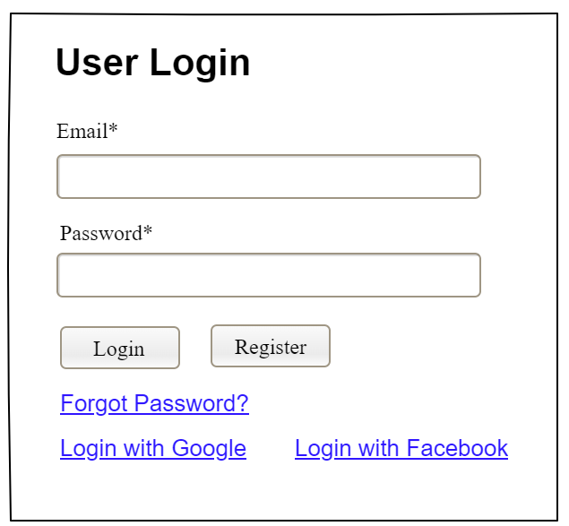

| **Field Name** | **Field Type** | **Description** |
| --- | --- | --- |
| Email* | Text Box | This is for user to input valid email address for logging in |
| Password* | Password Box | This is for user to input password for logging in |
| Login | Button | User clicks to authenticate him/herself into the system with provided email & password |
| Register | Button | User clicks to redirect to the User Register page for registering new user account to access the system |
| Forgot Password? | Hyperlink | User clicks to redirect to the Password Reset page for resetting his/her forgot password |
| Login with Google | Hyperlink | Allow user to login with his/her Google account |
| Login with Facebook | Hyperlink | Allow user to login with his/her Facebook account |

##### Database Access

| **Table** | **CRUD** | **Description** |
| --- | --- | --- |
| User | R | Verify UserName & Password information |
| Setting, User | R | Specify the authorizations of the logged-in user |

***SQL Commands:***

1/ Verify UserName & Password information

SELECT user_id, full_name, email, image_url, status

FROM user WHERE user_name = ? AND password = ?

2/ Specify the authorizations of the logged-in user

SELECT mapped_values FROM setting WHERE setting_id = ?

SELECT setting_name, mapped_values FROM setting WHERE setting_id IN (?)

#### b. Setting List

##### UI Design

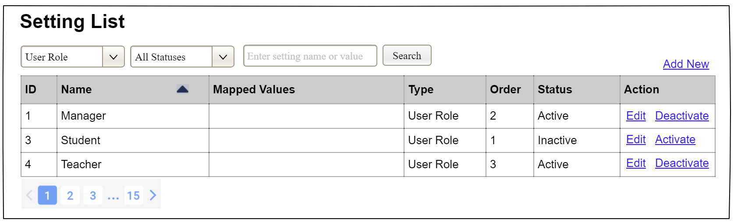

| **Field Name** | **Field Type** | **Description** |
| --- | --- | --- |
| ***Search Fields*** | | |
| Setting Type | Combo Box  Single-Choice | Filled with the list of current active setting types  Allow to filter the list by setting type;  Default value is “All Types” |
| Setting Status | Combo Box  Single-Choice | Values: All Statuses (default), Active, and Inactive  Allow to filter the list by status  Default value: “All Statuses” |
| Search Phase | Text Box  String (30) | Allow to search using the name or map values  Default value: blank |
| Search | Button | Click to refresh the list with the defined filter(s) and search phrase. |
| Add New | Hyperlink | Click to open the Setting Details page for adding new setting (master data) |
| ***Data Table*** | | |
| ID | Integer | Auto-increased identifier of the setting |
| Name | Text | Name of the setting |
| Mapped Values | Text | Supplementary information for the setting |
| Type | Text | Type of the setting |
| Order | Integer | Display order of the setting: the order of the setting type, displayed among the list of settings with the same type |
| ***Data Actions*** | | |
| Edit | icon | Click to open the Setting Details page for updating the relevant setting (master data) |
| Activate | icon | Shown when the data status is inactive. This is to activate the relevant setting (master data) |
| Deactivate | Ion | Shown when the data status is active. This is to deactivate the relevant setting (master data) |

##### Database Access

| **Table** | **CRUD** | **Description** |
| --- | --- | --- |
| Setting | RU | Query the list of current settings from the database  Update status of a specific setting |

***SQL Commands:***

1/ Query the list of current settings from the database

SELECT setting_id, setting_name, mapped_values, type_id, display_order, status

FROM setting WHERE (setting_type = ?) AND (status = ?) AND (setting_name LIKE ?)

2/ Update status of a specific setting

UPDATE setting SET status = ? WHERE setting_id = ?

#### c. Setting Details

##### UI Design

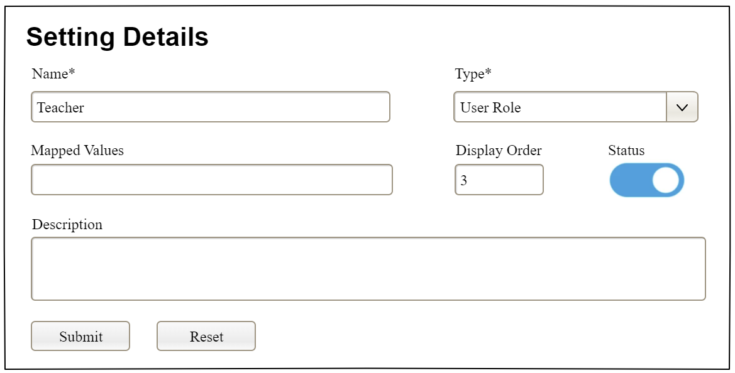

| **Field Name** | **Field Type** | **Description** |
| --- | --- | --- |
| Name* | Text Box  String (20) | Name of the setting |
| Type* | Combo Box  (Single Choice) | Type of the setting, filled with the list of setting types  Default value: the first type in the list |
| Mapped Values | Text Box  String (50) | Supplementary information for the setting (if any) |
| Order | Text Box  Integer (>=0) | Display order of the setting: the order of the setting type, displayed among the list of settings with the same type |
| Status | On/Off button | Status of the setting: Active or Inactive  Default value: Active |
| Description | Text Area  String (200) | Description of the setting |
| Submit | Button | Click to store new or updated setting details |
| Reset | Button | Click to reset the changes use has made on the screen fields back to the initial values when the screen is loaded |

##### Database Access

…

### 1.3 Google OAuth Integration

Users can log in to the system using their Google account for faster authentication without creating a new password.

##### UI Design

Screen 1: Login with Google Button

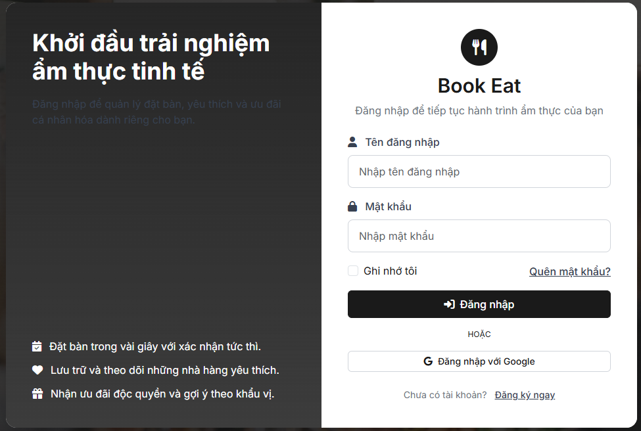

| **Field Name** | **Field Type** | **Description** |
| --- | --- | --- |
| Username | Textbox | Input field for username |
| Password | Password | Input field for password |
| Remember Me | Checkbox | Checkbox to remember login session |
| Forgot Password | Link | Link to password recovery page |
| Login Button | Button | Button to submit login form |

Screen 2: Account Type Selection (OAuth Account Type)

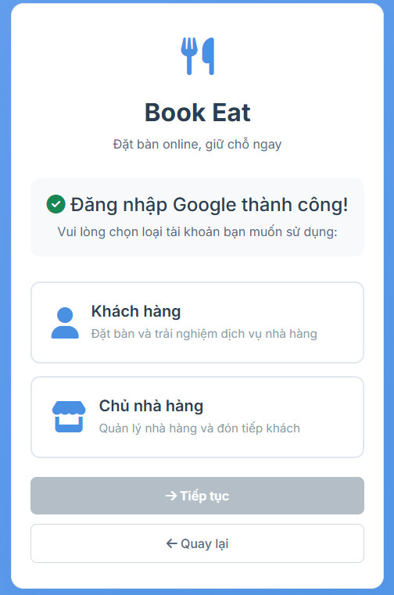

| **Field Name** | **Field Type** | **Description** |
| --- | --- | --- |
| Brand Icon | Icon | Displays the Book Eat utensils icon |
| Brand Title | Text | Displays text: "Book Eat" |
| Success Message | Text | Displays text: "Đăng nhập Google thành công!" |
| Instruction Text | Text | Displays text: "Vui lòng chọn loại tài khoản bạn muốn sử dụng:" |
| Customer Option | Card Button | Selectable card with user icon - option for "Khách hàng" (Customer) role |
| Customer Description | Text | Displays text: "Đặt bàn và trải nghiệm dịch vụ nhà hàng" |
| Restaurant Owner Option | Card Button | Selectable card with store icon - option for "Chủ nhà hàng" (Restaurant Owner) role |
| Restaurant Owner Description | Text | Displays text: "Quản lý nhà hàng và đón tiếp khách" |
| Account Type Hidden Input | Hidden Input | Stores selected account type value ("customer" or "restaurant_owner") |
| Continue Button | Button | Button with text "Tiếp tục" - submits the selected account type (disabled until selection is made) |
| Back Button | Button | Button with text "Quay lại" - returns to login page |

##### Database Access

##### 

| **Table** | **CRUD** | **Description** |
| --- | --- | --- |
| users | R | Read user by google_id to check if Google account already exists |
| users | R | Read user by email to link existing email account with Google |
| users | C | Create new user record with Google information (google_id, email, name) |
| users | U | Update existing user: link google_id, set email_verified = true, update last_login timestamp |
| users | U | Update user role based on account type selection (CUSTOMER or RESTAURANT_OWNER) |
| restaurant_owners | C | Create restaurant_owner record if user selects "Restaurant Owner" account type |

##### SQL Commands

- Find user by Google ID

SELECT * FROM users

WHERE google_id = ?

- Find user by email (for linking existing account)

SELECT * FROM users

WHERE LOWER(email) = LOWER(?)

- Create new Google user

INSERT INTO users (

username,

email,

password,

full_name,

google_id,

role,

email_verified,

last_login,

created_at,

updated_at

) VALUES (

?, -- email or google_id as username

?, -- normalized email

?, -- encrypted random UUID

?, -- name from Google

?, -- Google sub ID

?, -- CUSTOMER or RESTAURANT_OWNER

true, -- Google accounts are verified

CURRENT_TIMESTAMP,

CURRENT_TIMESTAMP,

CURRENT_TIMESTAMP

)

- Update existing user with Google account (link Google to existing email)

UPDATE users

SET google_id = ?,

email_verified = true,

last_login = CURRENT_TIMESTAMP,

updated_at = CURRENT_TIMESTAMP

WHERE LOWER(email) = LOWER(?)

- Update user last login (existing Google user)

UPDATE users

SET last_login = CURRENT_TIMESTAMP,

updated_at = CURRENT_TIMESTAMP

WHERE google_id = ?

- Update user role after account type selection

UPDATE users

SET role = ?, -- CUSTOMER or RESTAURANT_OWNER

updated_at = CURRENT_TIMESTAMP

WHERE id = ?

- Create restaurant owner record

INSERT INTO restaurant_owners (

user_id,

created_at,

updated_at

) VALUES (

?, -- user.id

CURRENT_TIMESTAMP,

CURRENT_TIMESTAMP

)

- Check if restaurant owner record exists

SELECT EXISTS(

SELECT 1 FROM restaurant_owners

WHERE user_id = ?

) AS record_exists

### 1.4 User Logout

Users can log out of the system to end their session and secure their account.

##### UI Design

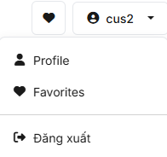

| Field name | Field type | Description |
| --- | --- | --- |
| User Avatar | Button | Display user's profile picture or default avatar icon in the header navigation |
| Dropdown Menu | Dropdown | Menu that appears when clicking on user avatar |
| Profile Link | Link | Link to user profile page with icon "Thông tin" or "Profile" |
| Favorites Link | Link | Link to favorites page (for Customer role only) |
| Restaurant Dashboard Link | Link | Link to restaurant dashboard (for Restaurant Owner role only) |
| Admin Dashboard Link | Link | Link to admin dashboard (for Admin role only) |
| Divider Line | Divider | Horizontal line separating menu items |
| Logout Button | Button/Link | Button with icon and text "Đăng xuất" or "Sign Out" - triggers logout action |

##### Database Access

| Table | CRUD | Description |
| --- | --- | --- |
| N/A | N/A | Logout does not require database operations. Session and cookies are cleared on the server side. |

##### SQL Commands

*Note: Logout functionality does not execute any SQL commands. The logout process is handled entirely by Spring Security framework.*

*Record user logout event*

*INSERT INTO activity_log (*

*user_id,*

*activity_type,*

*ip_address,*

*timestamp*

*) VALUES (*

*?,*

*'LOGOUT',*

*?,*

*CURRENT_TIMESTAMP*

*)*

*Update user's last activity timestamp*

*UPDATE users*

*SET last_activity = CURRENT_TIMESTAMP,*

*updated_at = CURRENT_TIMESTAMP*

*WHERE id = ?*

### 1.5 Password Reset

Users can reset their password by requesting a password reset link via email if they forget their password.

**UI Design**

Screen 1: Forgot Password Page

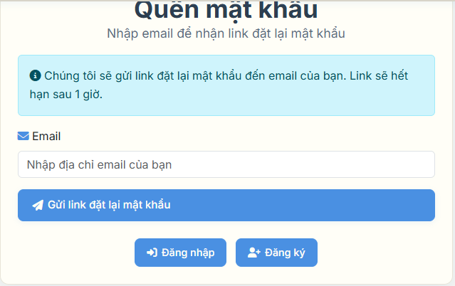

##### 

| Field name | Field type | Description |
| --- | --- | --- |
| Key Icon | Icon | Display key icon indicating password reset functionality |
| Page Title | Text | Display text: "Quên mật khẩu" |
| Page Subtitle | Text | Display text: "Nhập email để nhận link đặt lại mật khẩu" |
| Info Alert | Alert Box | Display information about password reset process and 1-hour expiry |
| Email Label | Label | Display text: "Email" with envelope icon |
| Email Input | Email Input | Input field for user's email address with placeholder "Nhập địa chỉ email của bạn" |
| Submit Button | Button | Button with text "Gửi link đặt lại mật khẩu" - submits the form |
| Login Link | Link Button | Link to login page with text "Đăng nhập" |
| Register Link | Link Button | Link to registration page with text "Đăng ký" |
| Success Message | Flash Message | Display message: "Nếu email tồn tại trong hệ thống, chúng tôi đã gửi link đặt lại mật khẩu đến email của bạn." |

##### 

##### Screen 2: Reset Password Page

##### 

| Field name | Field type | Description |
| --- | --- | --- |
| Lock Icon | Icon | Display lock icon indicating password security |
| Page Title | Text | Display text: "Đặt lại mật khẩu" |
| Page Subtitle | Text | Display text: "Nhập mật khẩu mới cho tài khoản của bạn" |
| Token Hidden Input | Hidden Input | Stores the password reset token from URL parameter |
| New Password Label | Label | Display text: "Mật khẩu mới" with required asterisk |
| New Password Input | Password Input | Input field for new password with placeholder "Nhập mật khẩu mới" |
| Password Hint | Small Text | Display password requirements: "Mật khẩu phải có ít nhất 8 ký tự, bao gồm chữ hoa, chữ thường, số và ký tự đặc biệt" |
| Confirm Password Label | Label | Display text: "Xác nhận mật khẩu" with required asterisk |
| Confirm Password Input | Password Input | Input field for password confirmation with placeholder "Nhập lại mật khẩu mới" |
| Submit Button | Button | Button with text "Đặt lại mật khẩu" - submits the new password |
| Login Link | Link Button | Link to login page with text "Đăng nhập" |
| Error Message | Flash Message | Display error if token is invalid or expired |
| Success Message | Flash Message | Display message: "Mật khẩu đã được đặt lại thành công! Bạn có thể đăng nhập với mật khẩu mới." |

##### Database Access

| Table | CRUD | Description |
| --- | --- | --- |
| users | R | Read user by email to check if user exists |
| users | U | Update user record with password_reset_token and password_reset_token_expiry (1 hour expiration) |
| users | R | Read user by valid password_reset_token (token must exist and not expired) |
| users | U | Update user password with new encrypted password and clear reset token fields |

##### SQL Commands

*Find user by email to check if user exists*

*SELECT * FROM users WHERE email = ?*

*Generate reset token and save to database with 1 hour expiry*

*UPDATE users SET password_reset_token = ?, password_reset_token_expiry = CURRENT_TIMESTAMP + INTERVAL '1 hour', updated_at = CURRENT_TIMESTAMP WHERE email = ?*

*Find user by valid password reset token (token exists and not expired)*

*SELECT * FROM users WHERE password_reset_token = ? AND password_reset_token_expiry > CURRENT_TIMESTAMP*

*Update password with new encrypted password and clear reset token*

*UPDATE users SET password = ?, password_reset_token = NULL, password_reset_token_expiry = NULL, updated_at = CURRENT_TIMESTAMP WHERE password_reset_token = ? AND password_reset_token_expiry > CURRENT_TIMESTAMP*

### 1.6 View Profile

Users can view their personal profile information including account details, contact information, and account status.

##### UI Design

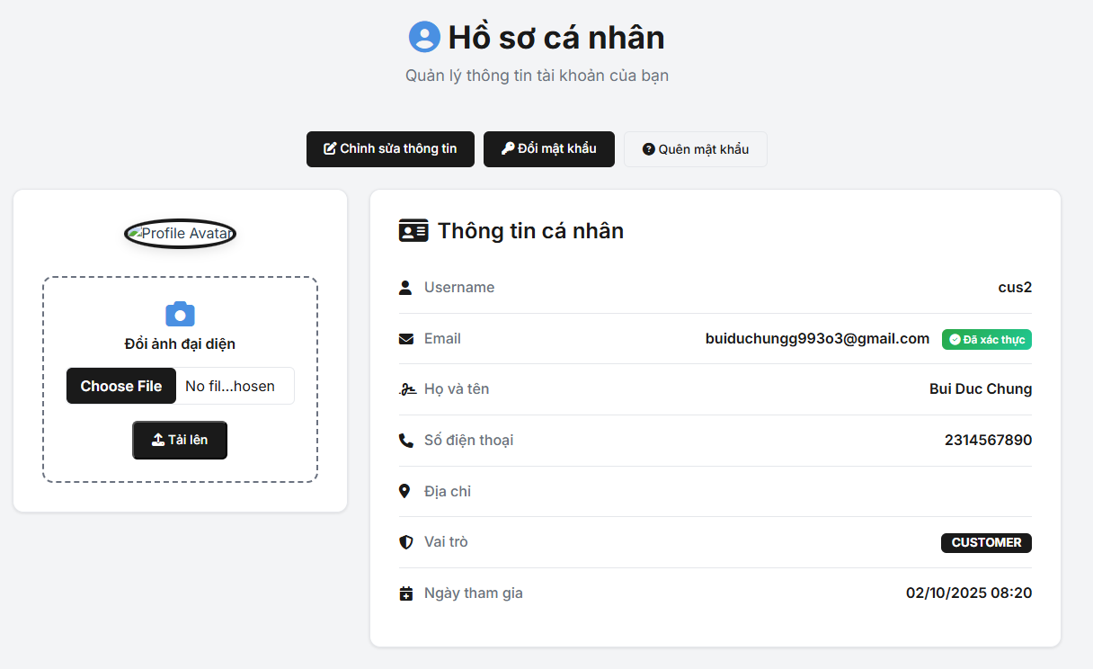

| Field name | Field type | Description |
| --- | --- | --- |
| Page Title | Text | Display text: "Hồ sơ cá nhân" with user icon |
| Page Subtitle | Text | Display text: "Quản lý thông tin tài khoản của bạn" |
| Edit Profile Button | Button | Button with text "Chỉnh sửa thông tin" - redirects to profile edit page |
| Change Password Button | Button | Button with text "Đổi mật khẩu" - redirects to change password page |
| Profile Avatar | Image | Display user's profile picture or default avatar icon |
| Username Label | Label | Display text: "Username" with user icon |
| Username Value | Text | Display user's username |
| Email Label | Label | Display text: "Email" with envelope icon |
| Email Value | Text | Display user's email address |
| Email Verification Badge | Badge | Display "Đã xác thực" (green) or "Chưa xác thực" (red) based on email verification status |
| Full Name Label | Label | Display text: "Họ và tên" with signature icon |
| Full Name Value | Text | Display user's full name |
| Phone Number Label | Label | Display text: "Số điện thoại" with phone icon (conditional display) |
| Phone Number Value | Text | Display user's phone number (conditional display) |
| Address Label | Label | Display text: "Địa chỉ" with location icon (conditional display) |
| Address Value | Text | Display user's address (conditional display) |
| Role Label | Label | Display text: "Vai trò" with shield icon |
| Role Value | Badge | Display user's role (CUSTOMER, RESTAURANT_OWNER, ADMIN) |
| Join Date Label | Label | Display text: "Ngày tham gia" with calendar icon |
| Join Date Value | Text | Display user's account creation date in format "dd/MM/yyyy HH:mm" |
| Last Login Label | Label | Display text: "Đăng nhập cuối" with clock icon (conditional display) |
| Last Login Value | Text | Display user's last login date in format "dd/MM/yyyy HH:mm" (conditional display) |

##### Database Access

| Table | CRUD | Description |
| --- | --- | --- |
| users | R | Read user information by user ID from authentication context |

##### SQL Commands

*Get current user information by user ID*

*SELECT * FROM users WHERE id = ?*

*Get user profile with all details*

*SELECT id, username, email, full_name, phone_number, address, role, email_verified, created_at, last_login, profile_image_url FROM users WHERE id = ?*

2. Restaurant Discovery & Information

### 2.1 Restaurant Search

##### UI Design

##### 

##### Database Access

| **Table** | **CRUD** | **Description** |
| --- | --- | --- |
| restaurant_profile | R | Read restaurant data with filters |
| restaurant_media | R | Read restaurant images |
| review | R | Read reviews for rating calculation |
| customer_favorite | R | Read user favorites status |

##### SQL Commands

*SELECT r.restaurant_id, r.restaurant_name, r.cuisine_type, r.average_price, r.address,*

*COALESCE(AVG(rv.rating), 0) as average_rating,*

*rm.url as main_image_url*

*FROM restaurant_profile r*

*LEFT JOIN review rv ON r.restaurant_id = rv.restaurant_id*

*LEFT JOIN restaurant_media rm ON r.restaurant_id = rm.restaurant_id AND rm.type = 'main'*

*WHERE r.approval_status = 'APPROVED'*

*AND (:search IS NULL OR LOWER(r.restaurant_name) LIKE LOWER(CONCAT('%', :search, '%')))*

*AND (:cuisine_type IS NULL OR r.cuisine_type = :cuisine_type)*

*AND (:min_price IS NULL OR r.average_price >= :min_price)*

*AND (:max_price IS NULL OR r.average_price <= :max_price)*

*GROUP BY r.restaurant_id, r.restaurant_name, r.cuisine_type, r.average_price, r.address, rm.url*

*HAVING (:min_rating IS NULL OR COALESCE(AVG(rv.rating), 0) >= :min_rating)*

*ORDER BY average_rating DESC, r.restaurant_name ASC;*

### 2.2 View Restaurant List

##### UI Design

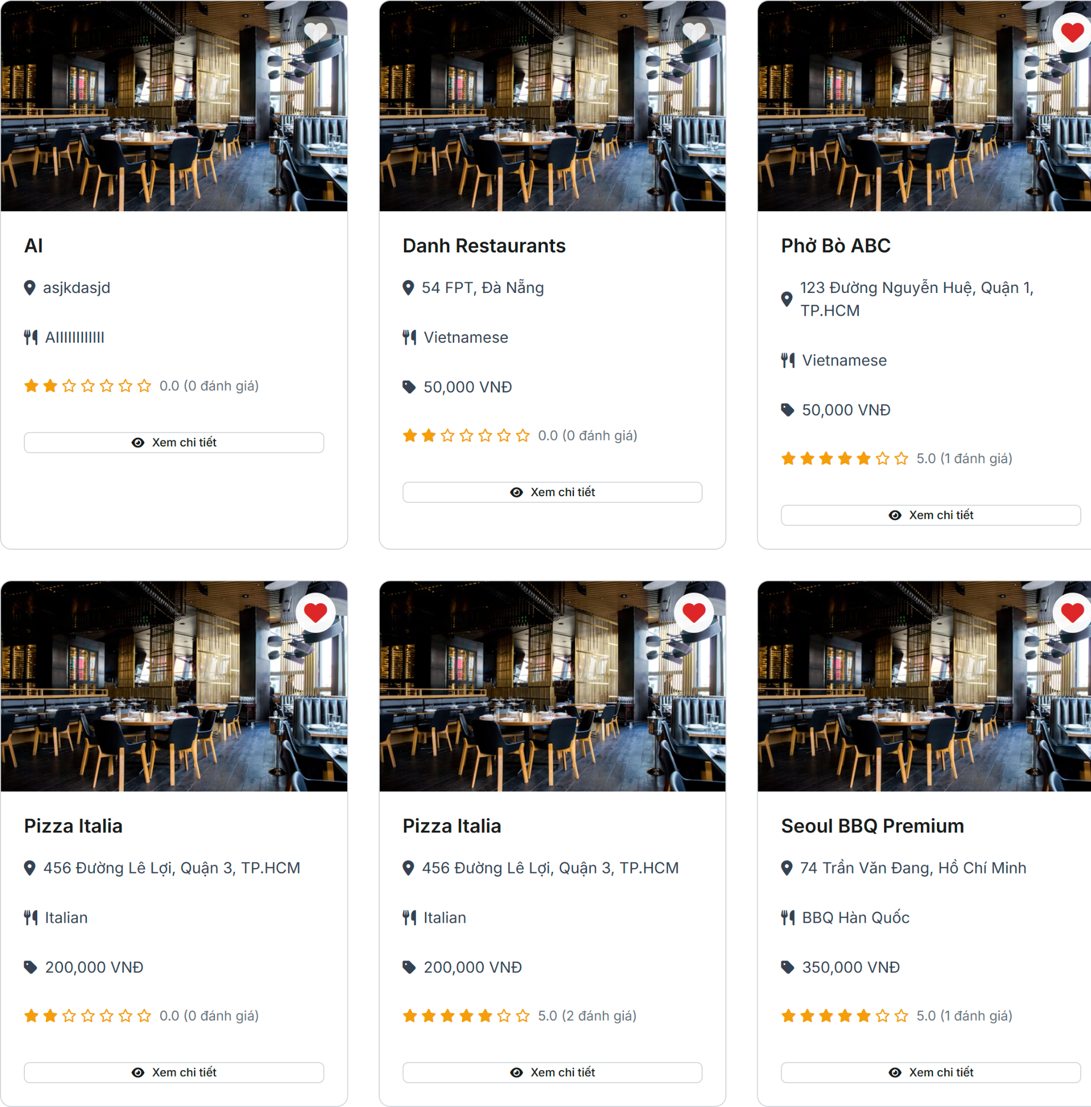

##### 

##### Database Access

| **Table** | **CRUD** | **Description** |
| --- | --- | --- |
| restaurant_profile | R | Read paginated restaurant data |
| restaurant_media | R | Read restaurant images |
| review | R | Read reviews for rating calculation |
| customer_favorite | R | Read user favorites status |

##### SQL Commands

*SELECT r.restaurant_id, r.restaurant_name, r.cuisine_type, r.average_price, r.address,*

*COALESCE(AVG(rv.rating), 0) as average_rating,*

*COUNT(rv.review_id) as review_count,*

*rm.url as main_image_url*

*FROM restaurant_profile r*

*LEFT JOIN review rv ON r.restaurant_id = rv.restaurant_id*

*LEFT JOIN restaurant_media rm ON r.restaurant_id = rm.restaurant_id AND rm.type = 'main'*

*WHERE r.approval_status = 'APPROVED'*

*GROUP BY r.restaurant_id, r.restaurant_name, r.cuisine_type, r.average_price, r.address, rm.url*

*ORDER BY*

*CASE WHEN :sort_by = 'rating' THEN COALESCE(AVG(rv.rating), 0) END DESC,*

*CASE WHEN :sort_by = 'price' THEN r.average_price END ASC,*

*CASE WHEN :sort_by = 'name' THEN r.restaurant_name END ASC*

*LIMIT :page_size OFFSET :offset;*

*SELECT COUNT(DISTINCT r.restaurant_id)*

*FROM restaurant_profile r*

*WHERE r.approval_status = 'APPROVED';*

### 2.3 View Restaurant Detail

##### UI Design

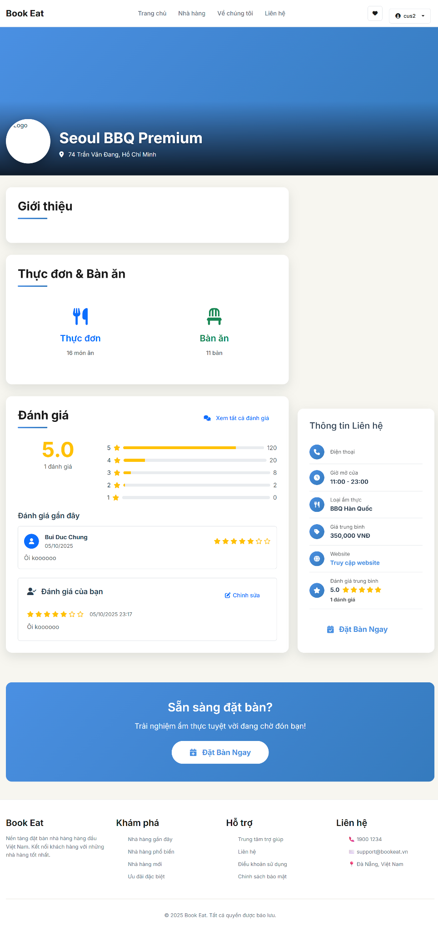

##### Database Access

| **Table** | **CRUD** | **Description** |
| --- | --- | --- |
| restaurant_profile | R | Read detailed restaurant information |
| restaurant_media | R | Read all restaurant images |
| dish | R | Read restaurant menu items |
| restaurant_service | R | Read restaurant services |
| restaurant_table | R | Read available tables |
| review | R | Read restaurant reviews |
| customer_favorite | R/U | Read/Update user favorite status |

##### SQL Commands

-- Get restaurant details

*SELECT r.*,*

*COALESCE(AVG(rv.rating), 0) as average_rating,*

*COUNT(rv.review_id) as review_count*

*FROM restaurant_profile r*

*LEFT JOIN review rv ON r.restaurant_id = rv.restaurant_id*

*WHERE r.restaurant_id = :restaurant_id*

*GROUP BY r.restaurant_id;*

-- Get restaurant images

*SELECT * FROM restaurant_media*

*WHERE restaurant_id = :restaurant_id*

*ORDER BY created_at ASC;*

-- Get restaurant menu

*SELECT * FROM dish*

*WHERE restaurant_id = :restaurant_id AND status = 'available'*

*ORDER BY category, name;*

-- Get restaurant services

*SELECT * FROM restaurant_service*

*WHERE restaurant_id = :restaurant_id AND status = 'available'*

*ORDER BY name;*

-- Get available tables

*SELECT * FROM restaurant_table*

*WHERE restaurant_id = :restaurant_id AND status = 'available'*

*ORDER BY capacity;*

-- Get restaurant reviews

*SELECT rv.*, c.user_id, u.full_name as customer_name*

*FROM review rv*

*JOIN customer c ON rv.customer_id = c.customer_id*

*JOIN users u ON c.user_id = u.id*

*WHERE rv.restaurant_id = :restaurant_id*

*ORDER BY rv.created_at DESC*

*LIMIT 10;*

### 2.4 Restaurant Review

##### UI Design

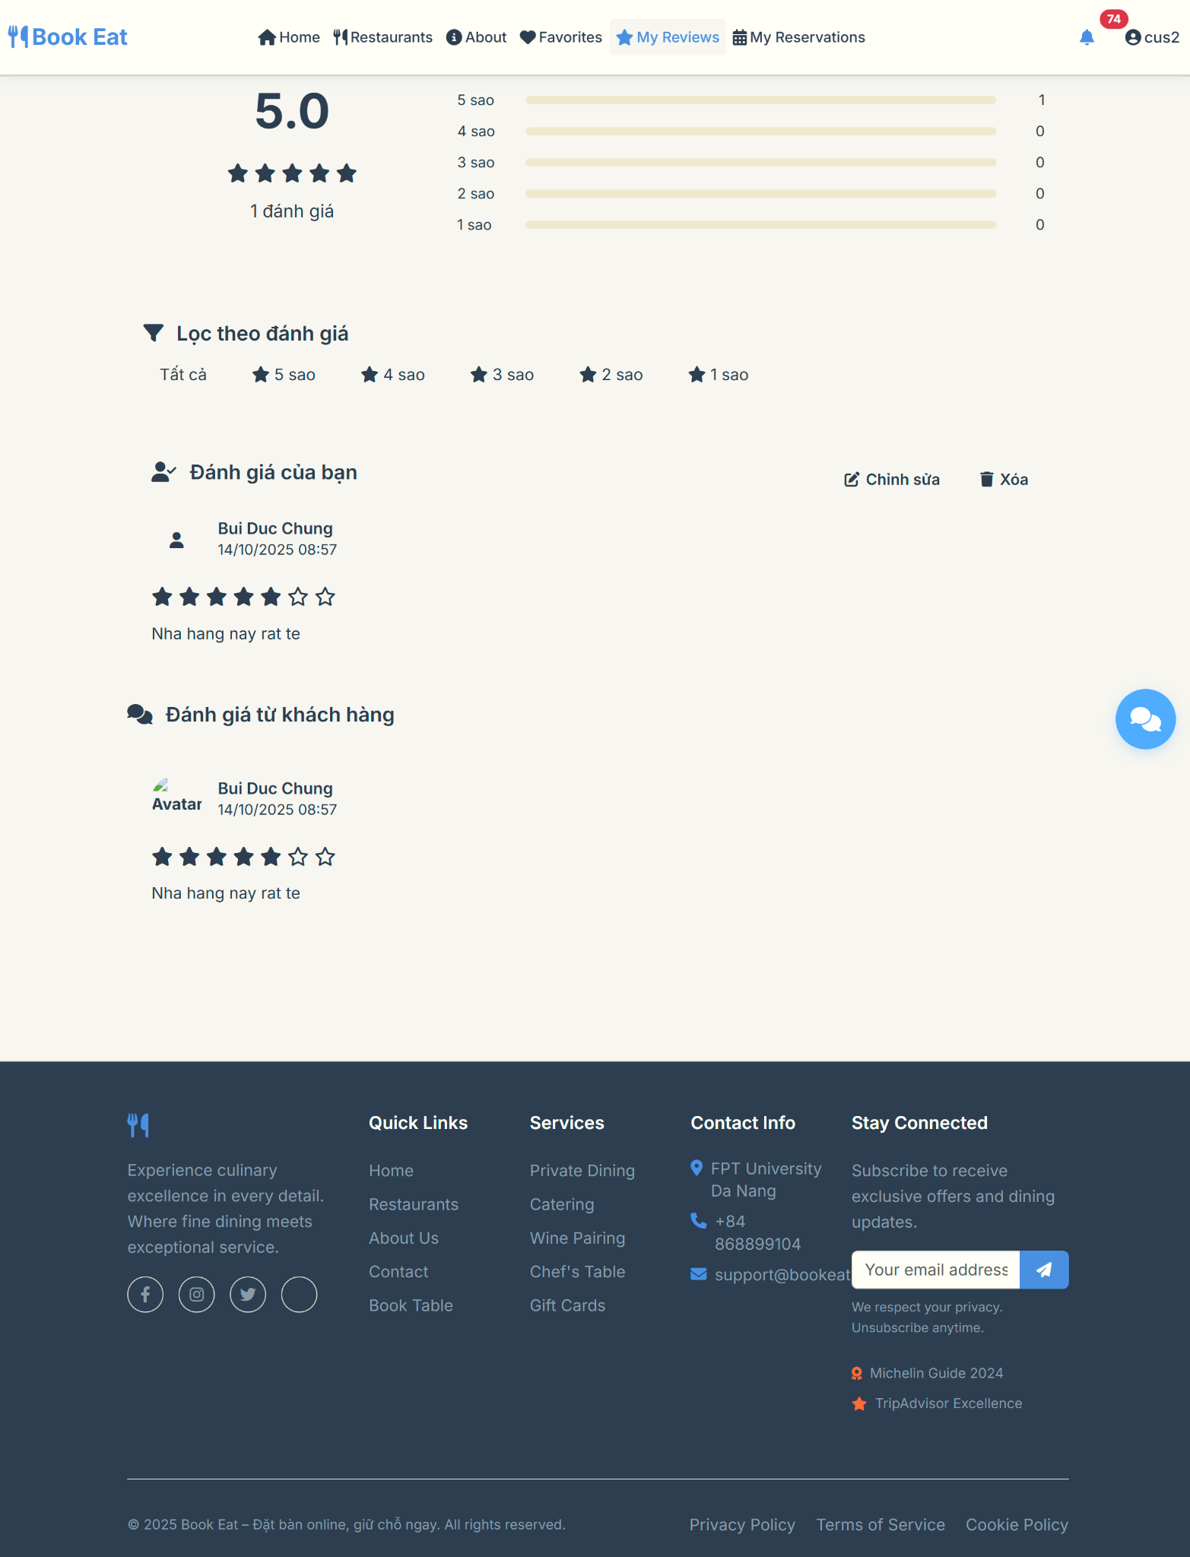

##### Database Access

| **Table** | **CRUD** | **Description** |
| --- | --- | --- |
| review | C | Create new review |
| review_report | C | Create report if review is inappropriate |
| restaurant_profile | R | Read restaurant info for context |
| customer | R | Read customer info for review |

##### SQL Commands

-- Create new review

*INSERT INTO review (customer_id, restaurant_id, rating, comment, created_at)*

*VALUES (:customer_id, :restaurant_id, :rating, :comment, NOW());*

-- Check if customer has already reviewed this restaurant

*SELECT COUNT(*) FROM review*

*WHERE customer_id = :customer_id AND restaurant_id = :restaurant_id;*

-- Get customer's booking history for this restaurant

*SELECT COUNT(*) FROM booking b*

*WHERE b.customer_id = :customer_id*

*AND b.restaurant_id = :restaurant_id*

*AND b.status = 'COMPLETED';*

-- Report inappropriate review

*INSERT INTO review_report (review_id, restaurant_id, owner_id, reason_text, status, created_at)*

*VALUES (:review_id, :restaurant_id, :owner_id, :reason_text, 'PENDING', NOW());*

### 2.5 Manage Favorites

##### UI Design

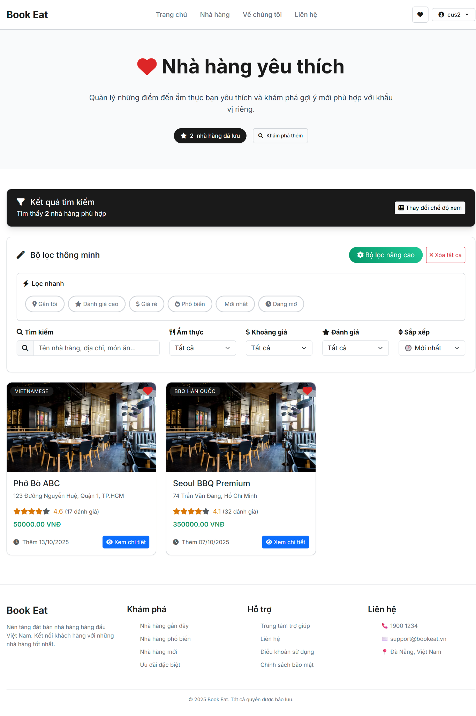

##### Database Access

| **Table** | **CRUD** | **Description** |
| --- | --- | --- |
| customer_favorite | C/R/D | Create, Read, Delete favorite entries |
| restaurant_profile | R | Read restaurant information |
| restaurant_media | R | Read restaurant images |
| review | R | Read ratings for display |

##### 

##### SQL Commands

-- Add restaurant to favorites

*INSERT INTO customer_favorite (customer_id, restaurant_id, created_at)*

*VALUES (:customer_id, :restaurant_id, NOW());*

-- Remove restaurant from favorites

*DELETE FROM customer_favorite*

*WHERE customer_id = :customer_id AND restaurant_id = :restaurant_id;*

-- Get user's favorites with restaurant details

*SELECT cf.*, r.restaurant_name, r.cuisine_type, r.average_price, r.address,*

*COALESCE(AVG(rv.rating), 0) as average_rating,*

*rm.url as main_image_url*

*FROM customer_favorite cf*

*JOIN restaurant_profile r ON cf.restaurant_id = r.restaurant_id*

*LEFT JOIN review rv ON r.restaurant_id = rv.restaurant_id*

*LEFT JOIN restaurant_media rm ON r.restaurant_id = rm.restaurant_id AND rm.type = 'main'*

*WHERE cf.customer_id = :customer_id*

*GROUP BY cf.favorite_id, r.restaurant_id, r.restaurant_name, r.cuisine_type, r.average_price, r.address, rm.url*

*ORDER BY cf.created_at DESC;*

-- Check if restaurant is favorited

*SELECT COUNT(*) FROM customer_favorite*

*WHERE customer_id = :customer_id AND restaurant_id = :restaurant_id;*

-- Clear all favorites

*DELETE FROM customer_favorite WHERE customer_id = :customer_id;*

3. Table Browsing & Management

### 3.1 View Table Availability

##### UI Design

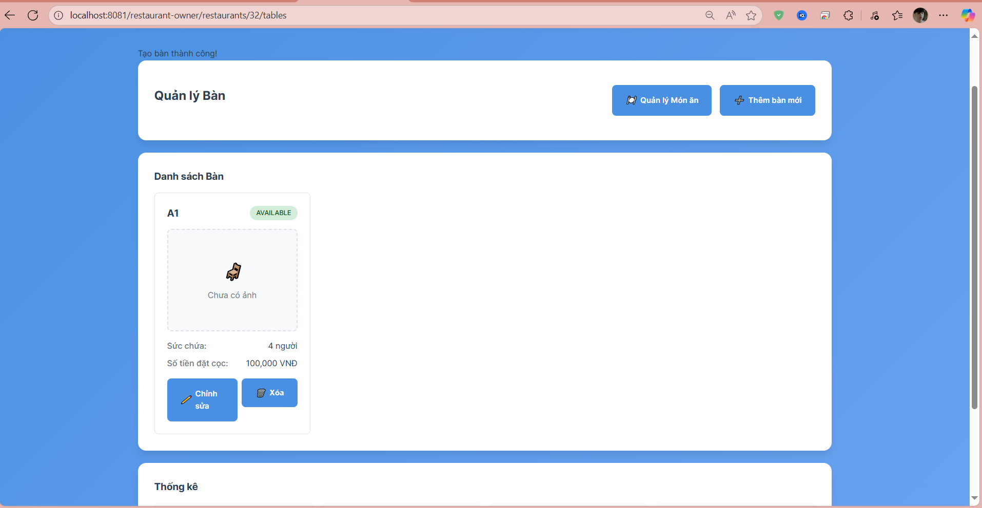

##### Database Access

| **Table** | **CRUD** | **Description** |
| --- | --- | --- |
| restaurant_profile | R | Read restaurant information by owner_id to display restaurant list |
| restaurant_table | R | Read table information with status by restaurant_id |
| restaurant_media | R | Read table images from media table by restaurant_id and type 'table' |
| booking_table | R | Read booking information to check if table is currently booked |
| booking | R | Read booking details to determine table availability status |
| users | R | Read user information to authenticate restaurant owner |

##### SQL Commands

*Read tables by restaurant_id*

SELECT rt.table_id, rt.table_name, rt.capacity, rt.status, rt.depositamount,

rt.restaurant_id, rp.restaurant_name

FROM restaurant_table rt

JOIN restaurant_profile rp ON rt.restaurant_id = rp.restaurant_id

WHERE rp.restaurant_id = ? AND rp.owner_id = ?

ORDER BY rt.table_name;

*Read table images by restaurant_id*

SELECT rm.media_id, rm.url, rm.type, rm.created_at

FROM restaurant_media rm

WHERE rm.restaurant_id = ? AND rm.type = 'table'

ORDER BY rm.created_at ASC;

*Check table booking status*

SELECT b.booking_id, b.booking_date, b.booking_time, b.status as booking_status, bt.table_id

FROM booking b

JOIN booking_table bt ON b.booking_id = bt.booking_id

WHERE bt.table_id = ? AND b.booking_date = CURRENT_DATE

AND b.booking_time BETWEEN CURRENT_TIME - INTERVAL '2 hours'

AND CURRENT_TIME + INTERVAL '2 hours'

AND b.status IN ('PENDING', 'CONFIRMED', 'CHECKED_IN');

*Update table status*

UPDATE restaurant_table

SET status = ?

WHERE table_id = ? AND restaurant_id IN (

SELECT restaurant_id FROM restaurant_profile WHERE owner_id = ?

);

*Get table statistics by status*

SELECT rt.status, COUNT(*) as table_count

FROM restaurant_table rt

JOIN restaurant_profile rp ON rt.restaurant_id = rp.restaurant_id

WHERE rp.restaurant_id = ? AND rp.owner_id = ?

GROUP BY rt.status

ORDER BY rt.status;

### 3.2 Add Table

##### UI Design

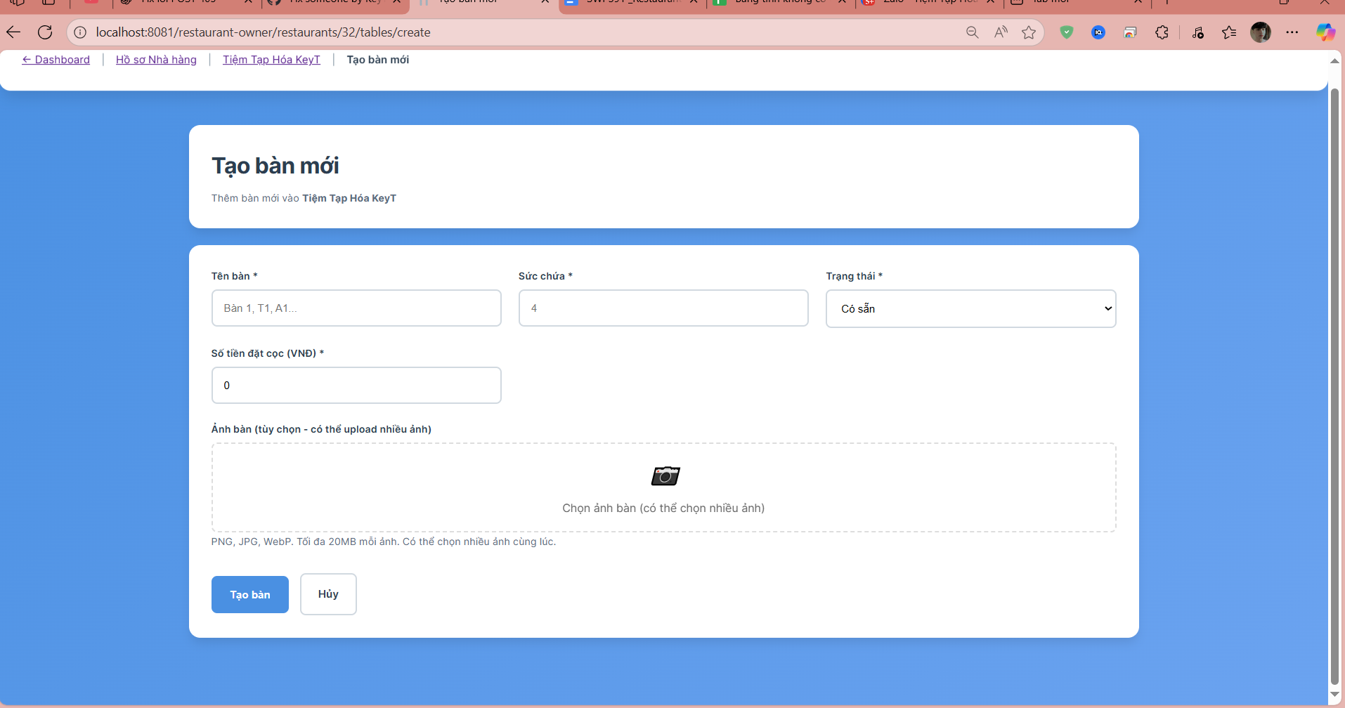

##### Database Access

| **Table** | **CRUD** | **Description** |
| --- | --- | --- |
| restaurant_profile | R | Read restaurant information by restaurant_id to validate ownership |
| restaurant_table | C | Create new table record with table information |
| restaurant_media | C | Create media records for uploaded table images |
| users | R | Read user information to authenticate restaurant owner |

##### SQL Commands

Read restaurant by restaurant_id

SELECT restaurant_id, restaurant_name, owner_id

FROM restaurant_profile

WHERE restaurant_id = ? AND owner_id = ?;

Create new table

INSERT INTO restaurant_table (restaurant_id, table_name, capacity, status, depositamount)

VALUES (?, ?, ?, ?, ?);

Create table images in media

INSERT INTO restaurant_media (restaurant_id, url, type, created_at)

VALUES (?, ?, 'table', CURRENT_TIMESTAMP);

Get newly created table ID

SELECT table_id FROM restaurant_table

WHERE restaurant_id = ? AND table_name = ?

ORDER BY table_id DESC LIMIT 1;

Validate table name uniqueness

SELECT COUNT() FROM restaurant_table

WHERE restaurant_id = ? AND table_name = ?;

Get table images after creation

SELECT rm.media_id, rm.url, rm.type, rm.created_at

FROM restaurant_media rm

WHERE rm.restaurant_id = ? AND rm.type = 'table'

AND rm.url LIKE '%/table_' || ? || '%'

ORDER BY rm.created_at ASC;

### 3.3 Update Table

##### UI Design

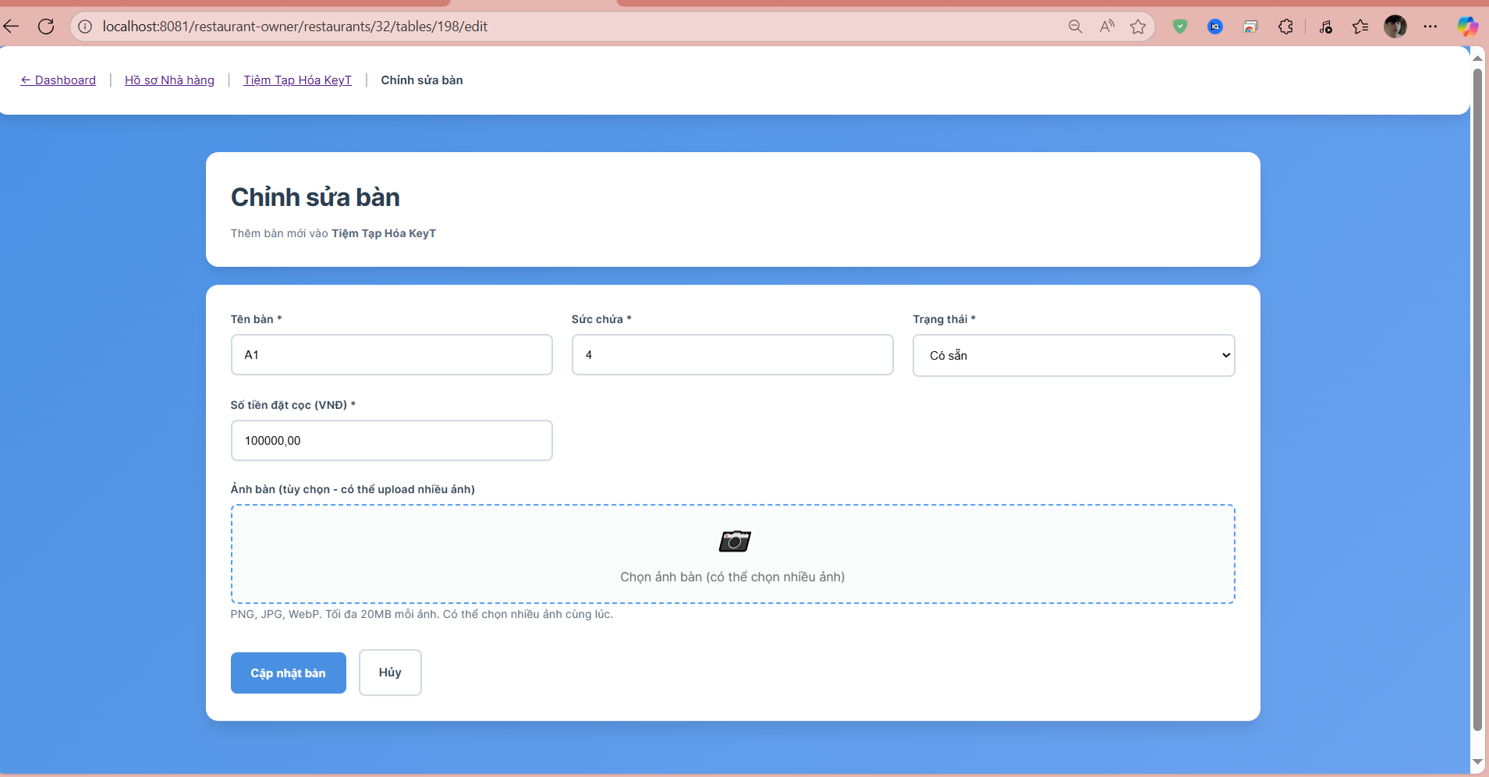

##### Database Access

| **Table** | **CRUD** | **Description** |
| --- | --- | --- |
| restaurant_profile | R | Read restaurant information by restaurant_id to validate ownership |
| restaurant_table | R | Read existing table information by table_id |
| restaurant_table | U | Update table record with new table information |
| restaurant_media | R | Read existing table images from media table |
| restaurant_media | C | Create new media records for additional table images |
| restaurant_media | D | Delete specific table images from media table |
| users | R | Read user information to authenticate restaurant owner |

##### SQL Commands

Read restaurant by restaurant_id

SELECT restaurant_id, restaurant_name, owner_id

FROM restaurant_profile

WHERE restaurant_id = ? AND owner_id = ?;

Read existing table information

SELECT table_id, restaurant_id, table_name, capacity, status, depositamount

FROM restaurant_table

WHERE table_id = ? AND restaurant_id = ?;

Update table information

UPDATE restaurant_table

SET table_name = ?, capacity = ?, status = ?, depositamount = ?

WHERE table_id = ? AND restaurant_id = ?;

Read existing table images

SELECT rm.media_id, rm.url, rm.type, rm.created_at

FROM restaurant_media rm

WHERE rm.restaurant_id = ? AND rm.type = 'table'

AND rm.url LIKE '%/table_' || ? || '%'

ORDER BY rm.created_at ASC;

Add new table images

INSERT INTO restaurant_media (restaurant_id, url, type, created_at)

VALUES (?, ?, 'table', CURRENT_TIMESTAMP);

Delete specific table image

DELETE FROM restaurant_media

WHERE media_id = ? AND restaurant_id = ? AND type = 'table';

Validate table name uniqueness (excluding current table)

SELECT COUNT() FROM restaurant_table

WHERE restaurant_id = ? AND table_name = ? AND table_id != ?;

Check if table is currently booked

SELECT COUNT() FROM booking_table bt

JOIN booking b ON bt.booking_id = b.booking_id

WHERE bt.table_id = ? AND b.status IN ('PENDING', 'CONFIRMED', 'CHECKED_IN');

### 3.4 View Table List

##### UI Design

##### Database Access

| **Table** | **CRUD** | **Description** |
| --- | --- | --- |
| restaurant_profile | R | Read restaurant information by restaurant_id to validate ownership |
| restaurant_table | R | Read all table information for the restaurant with status and details |
| restaurant_media | R | Read table images from media table for display |
| booking_table | R | Read booking information to determine table availability status |
| booking | R | Read booking details to check current table usage |
| users | R | Read user information to authenticate restaurant owner |

##### SQL Commands

Read restaurant by restaurant_id

SELECT restaurant_id, restaurant_name, owner_id

FROM restaurant_profile

WHERE restaurant_id = ? AND owner_id = ?;

Read all tables for restaurant

SELECT rt.table_id, rt.table_name, rt.capacity, rt.status, rt.depositamount, rt.restaurant_id

FROM restaurant_table rt

WHERE rt.restaurant_id = ?

ORDER BY rt.table_name;

Count total tables by restaurant

SELECT COUNT() as total_tables

FROM restaurant_table

WHERE restaurant_id = ?;

Calculate total capacity

SELECT SUM(capacity) as total_capacity

FROM restaurant_table

WHERE restaurant_id = ?;

Count available tables

SELECT COUNT() as available_count

FROM restaurant_table

WHERE restaurant_id = ? AND status = 'AVAILABLE';

Count occupied tables

SELECT COUNT() as occupied_count

FROM restaurant_table

WHERE restaurant_id = ? AND status = 'OCCUPIED';

Read table images for display

SELECT rm.media_id, rm.url, rm.type, rm.created_at

FROM restaurant_media rm

WHERE rm.restaurant_id = ? AND rm.type = 'table'

ORDER BY rm.created_at ASC;

Check table booking status

SELECT bt.table_id, COUNT(b.booking_id) as booking_count

FROM booking_table bt

JOIN booking b ON bt.booking_id = b.booking_id

WHERE bt.table_id IN (SELECT table_id FROM restaurant_table WHERE restaurant_id = ?)

AND b.status IN ('PENDING', 'CONFIRMED', 'CHECKED_IN')

GROUP BY bt.table_id;

Filter tables by status

SELECT table_id, table_name, capacity, status, depositamount

FROM restaurant_table

WHERE restaurant_id = ? AND status = ?

ORDER BY table_name;

Search tables by name

SELECT table_id, table_name, capacity, status, depositamount

FROM restaurant_table

WHERE restaurant_id = ? AND table_name ILIKE '%' || ? || '%'

ORDER BY table_name;

4. Menu Management

### 4.1 View Menu

##### UI Design

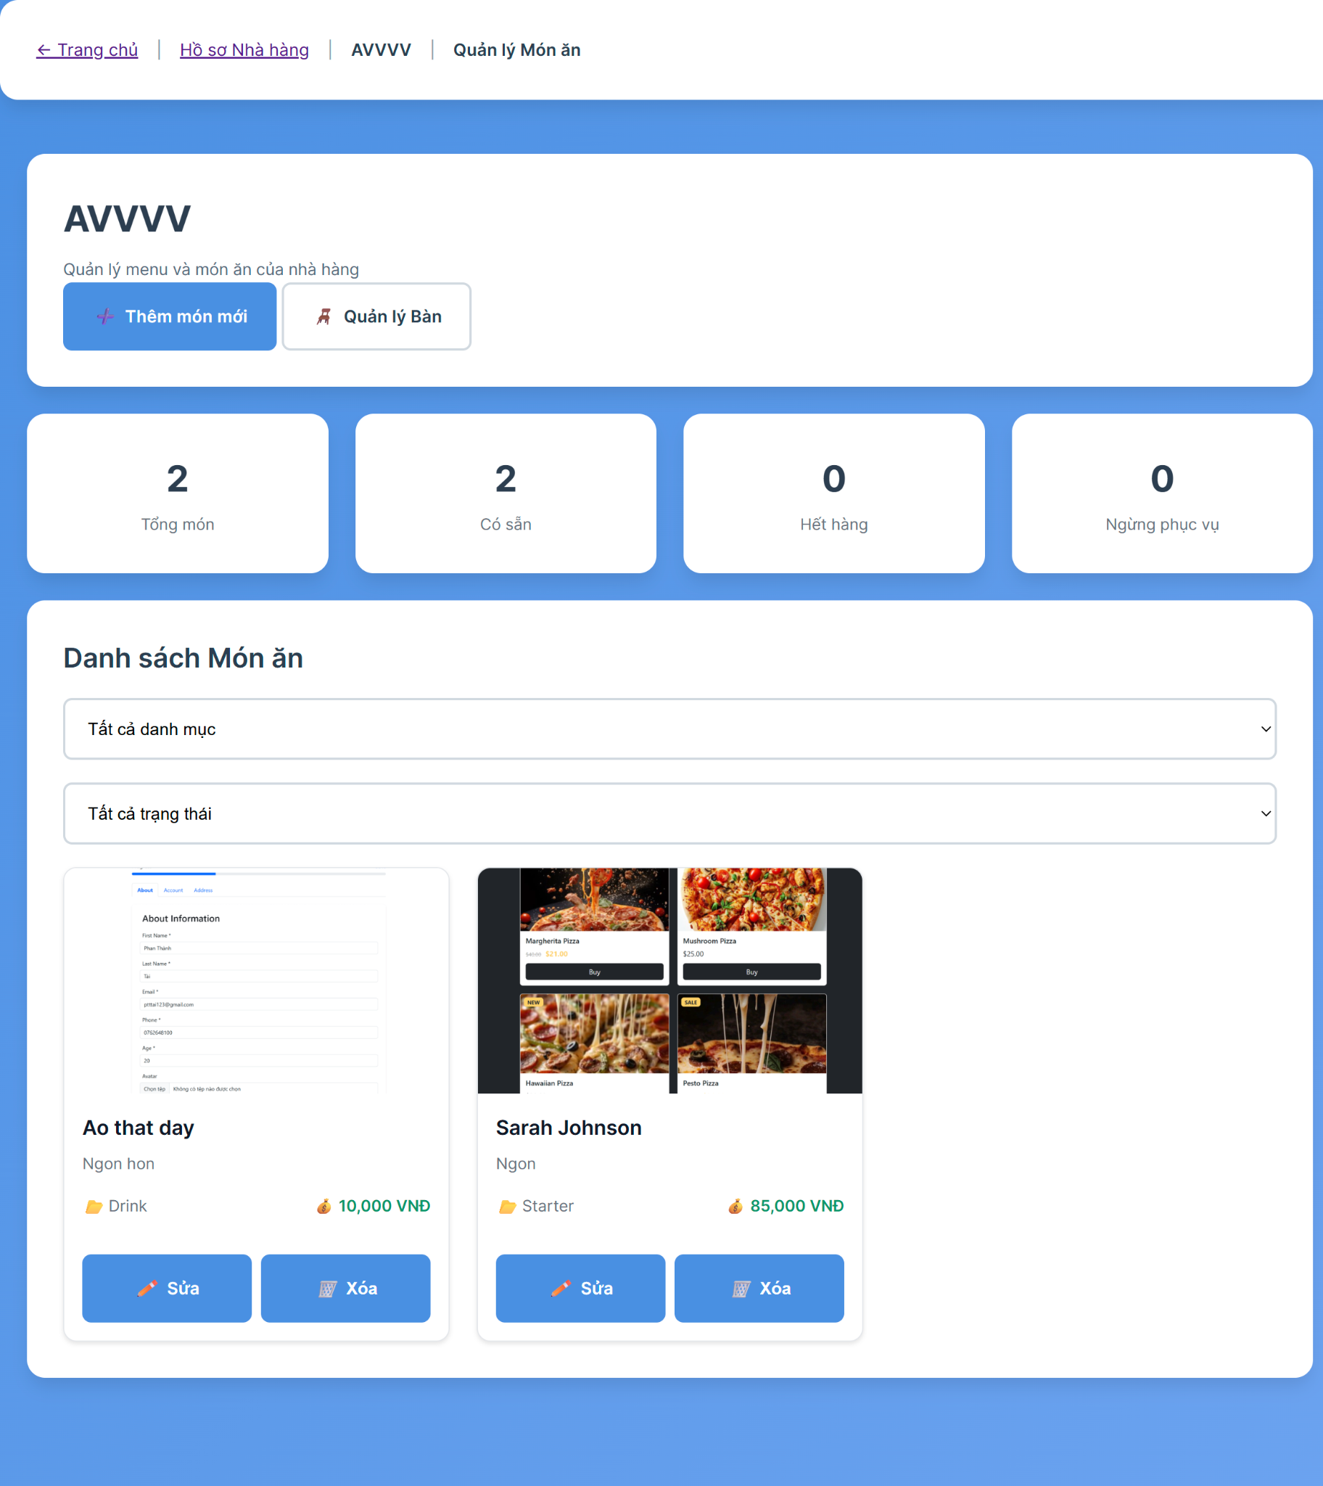

##### 

##### Database Access

| **Table** | **CRUD** | **Description** |
| --- | --- | --- |
| dish | R | Read all dishes for restaurant |
| restaurant_media | R | Read dish images |
| restaurant_profile | R | Read restaurant information |

##### SQL Commands

-- Get all dishes for restaurant with images

*SELECT d.dish_id, d.name, d.description, d.price, d.category, d.status,*

*rm.url as image_url, rm.type as image_type*

*FROM dish d*

*LEFT JOIN restaurant_media rm ON d.dish_id = rm.restaurant_id AND rm.type = 'dish'*

*WHERE d.restaurant_id = :restaurant_id*

*ORDER BY d.category, d.name;*

-- Get dish statistics

*SELECT*

*COUNT(*) as total_dishes,*

*COUNT(CASE WHEN status = 'AVAILABLE' THEN 1 END) as available_dishes,*

*COUNT(CASE WHEN status = 'OUT_OF_STOCK' THEN 1 END) as out_of_stock_dishes,*

*COUNT(CASE WHEN status = 'DISCONTINUED' THEN 1 END) as discontinued_dishes*

*FROM dish*

*WHERE restaurant_id = :restaurant_id;*

-- Search dishes by name

*SELECT d.*, rm.url as image_url*

*FROM dish d*

*LEFT JOIN restaurant_media rm ON d.dish_id = rm.restaurant_id AND rm.type = 'dish'*

*WHERE d.restaurant_id = :restaurant_id*

*AND LOWER(d.name) LIKE LOWER(CONCAT('%', :search_term, '%'))*

*ORDER BY d.name;*

### 4.2 Update Menu

##### UI Design

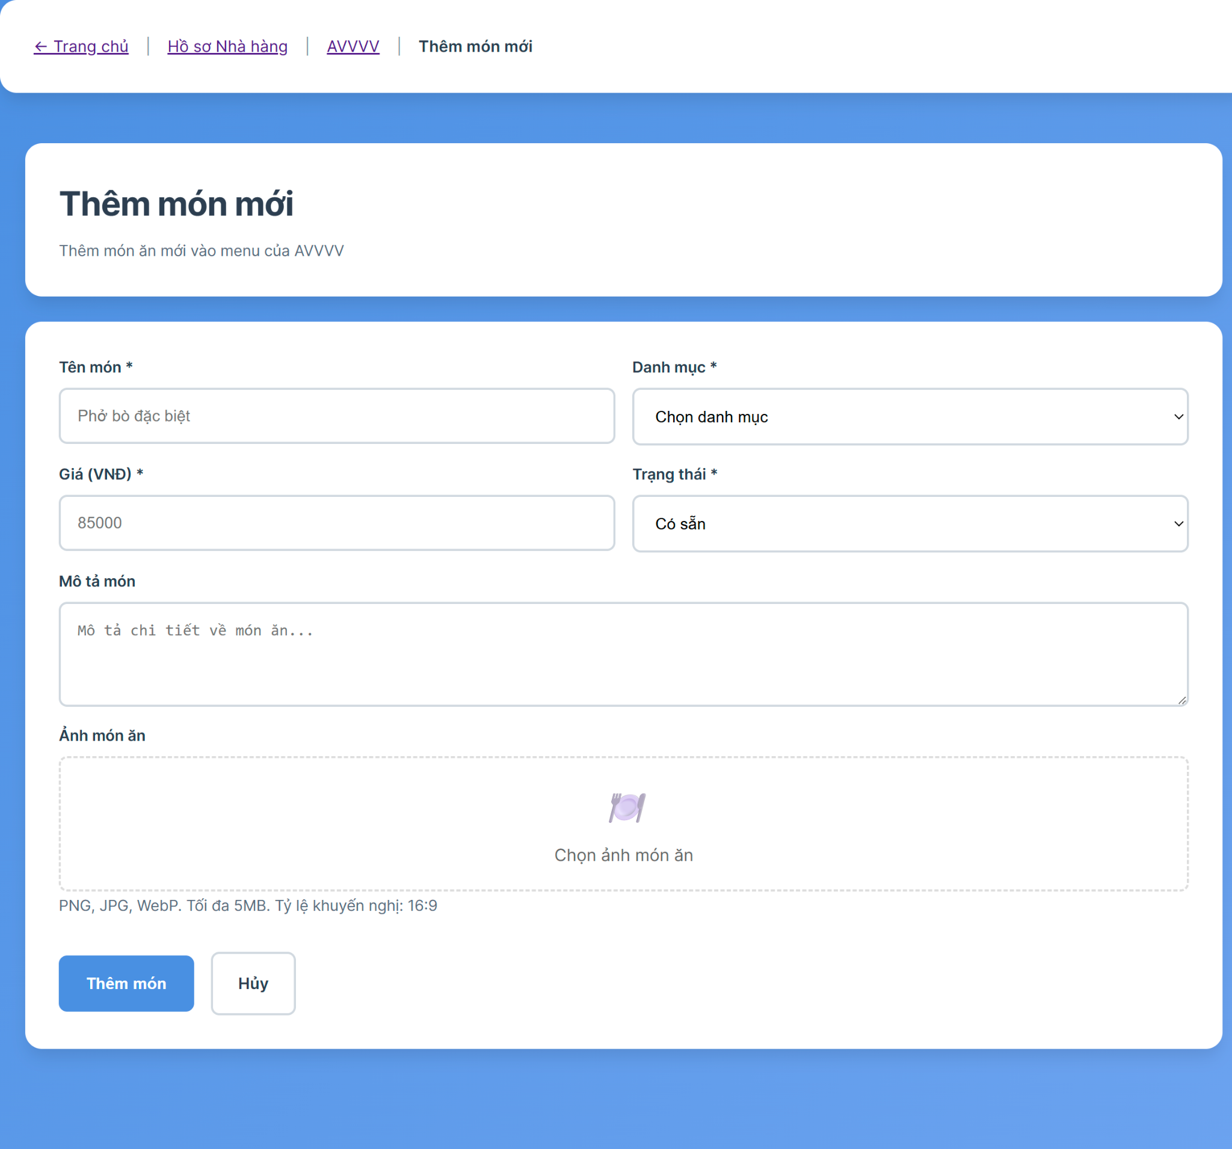

##### Database Access

| **Table** | **CRUD** | **Description** |
| --- | --- | --- |
| dish | C/U/D | Create, Update, Delete dish records |
| restaurant_media | C/U/D | Create, Update, Delete dish images |
| restaurant_profile | R | Read restaurant information |

##### SQL Commands

-- Create new dish

*INSERT INTO dish (restaurant_id, name, description, price, category, status, created_at)*

*VALUES (:restaurant_id, :name, :description, :price, :category, :status, NOW());*

-- Update dish information

*UPDATE dish*

*SET name = :name,*

*description = :description,*

*price = :price,*

*category = :category,*

*status = :status,*

*updated_at = NOW()*

*WHERE dish_id = :dish_id AND restaurant_id = :restaurant_id;*

-- Delete dish

*DELETE FROM dish WHERE dish_id = :dish_id AND restaurant_id = :restaurant_id;*

-- Save dish image

*INSERT INTO restaurant_media (restaurant_id, type, url, created_at)*

*VALUES (:restaurant_id, 'dish', :image_url, NOW());*

-- Update dish image

*UPDATE restaurant_media*

*SET url = :new_image_url, updated_at = NOW()*

*WHERE restaurant_id = :restaurant_id AND type = 'dish' AND url = :old_image_url;*

-- Delete dish image

*DELETE FROM restaurant_media*

*WHERE restaurant_id = :restaurant_id AND type = 'dish' AND url = :image_url;*

-- Get dish with image

*SELECT d.*, rm.url as image_url*

*FROM dish d*

*LEFT JOIN restaurant_media rm ON d.dish_id = rm.restaurant_id AND rm.type = 'dish'*

*WHERE d.dish_id = :dish_id AND d.restaurant_id = :restaurant_id;*

5. Booking Management

### 5.1 Create Booking

##### UI Design

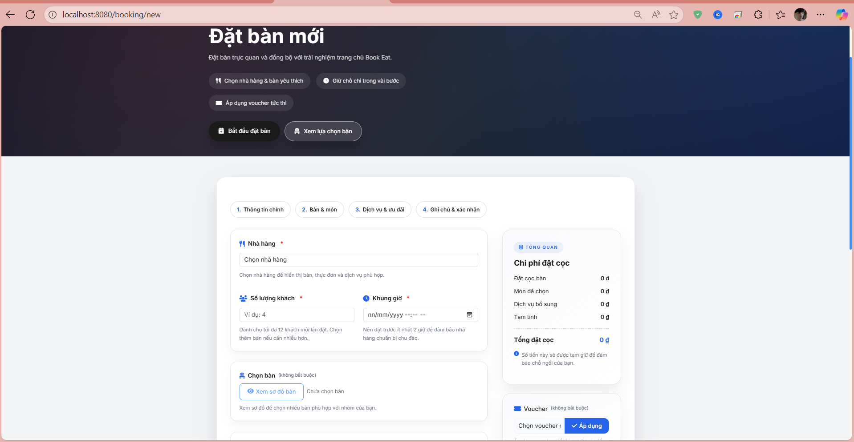

##### Database Access

| **Table** | **CRUD** | **Description** |
| --- | --- | --- |
| restaurant_profile | R | Read restaurant information to display available restaurants |
| restaurant_table | R | Read available tables for the selected restaurant |
| booking | C | Create new booking record with customer and booking details |
| booking_table | C | Create booking-table relationship records |
| booking_dish | C | Create booking-dish relationship records for selected dishes |
| booking_service | C | Create booking-service relationship records for selected services |
| customer | R | Read customer information from authentication |
| dish | R | Read available dishes for the selected restaurant |
| restaurant_service | R | Read available services for the selected restaurant |
| voucher | R | Read voucher information for discount validation |

##### SQL Commands

Read available restaurants

SELECT restaurant_id, restaurant_name, address, phone_number

FROM restaurant_profile

WHERE status = 'ACTIVE'

ORDER BY restaurant_name;

Read available tables for restaurant

SELECT table_id, table_name, capacity, status, depositamount

FROM restaurant_table

WHERE restaurant_id = ? AND status = 'AVAILABLE'

ORDER BY table_name;

Read customer by user_id

SELECT customer_id, user_id, phone_number, email

FROM customer

WHERE user_id = ?;

Create new booking

INSERT INTO booking (customer_id, restaurant_id, booking_date, booking_time, number_of_guests,

deposit_amount, note, status, created_at)

VALUES (?, ?, ?, ?, ?, ?, ?, 'PENDING', CURRENT_TIMESTAMP);

Create booking-table relationship

INSERT INTO booking_table (booking_id, table_id, created_at)

VALUES (?, ?, CURRENT_TIMESTAMP);

Create booking-dish relationship

INSERT INTO booking_dish (booking_id, dish_id, quantity, created_at)

VALUES (?, ?, ?, CURRENT_TIMESTAMP);

Create booking-service relationship

INSERT INTO booking_service (booking_id, service_id, quantity, created_at)

VALUES (?, ?, ?, CURRENT_TIMESTAMP);

Validate table availability

SELECT COUNT() FROM booking_table bt

JOIN booking b ON bt.booking_id = b.booking_id

WHERE bt.table_id = ? AND b.booking_date = ?

AND b.booking_time BETWEEN ? AND ?

AND b.status IN ('PENDING', 'CONFIRMED', 'CHECKED_IN');

Read available dishes for restaurant

SELECT dish_id, dish_name, price, description

FROM dish

WHERE restaurant_id = ? AND status = 'ACTIVE'

ORDER BY dish_name;

Read available services for restaurant

SELECT service_id, service_name, price, description

FROM restaurant_service

WHERE restaurant_id = ? AND status = 'ACTIVE'

ORDER BY service_name;

Validate voucher code

SELECT voucher_id, discount_percentage, discount_amount, expiry_date, usage_limit

FROM voucher

WHERE voucher_code = ? AND status = 'ACTIVE'

AND expiry_date > CURRENT_DATE AND usage_count < usage_limit;

Get newly created booking ID

SELECT booking_id FROM booking

WHERE customer_id = ? AND restaurant_id = ?

ORDER BY created_at DESC LIMIT 1;

### 5.2 Update Booking

##### UI Design

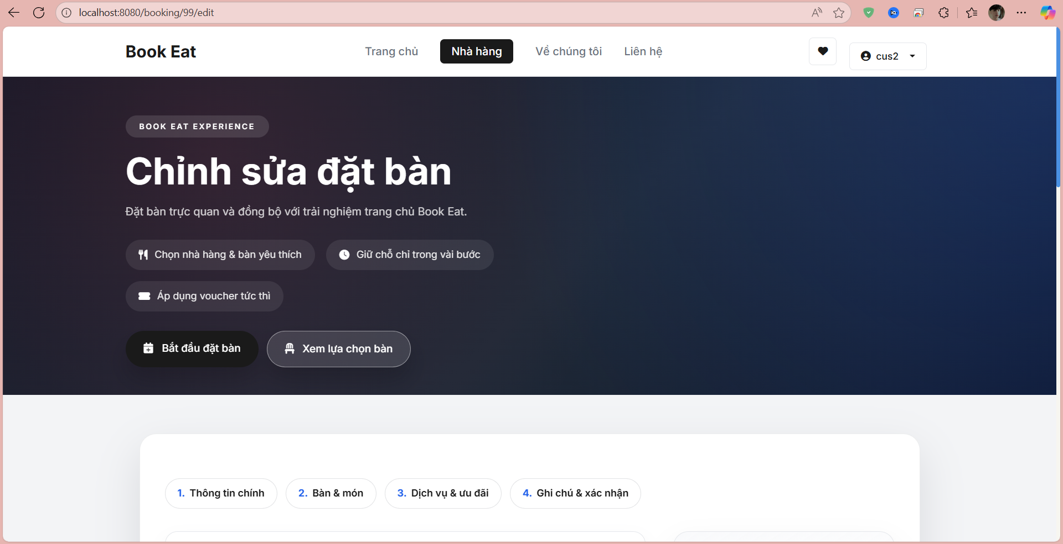

##### Database Access

| **Table** | **CRUD** | **Description** |
| --- | --- | --- |
| booking | R | Read existing booking information by booking_id |
| booking | U | Update booking record with new booking details |
| booking_table | R | Read current booking-table relationships |
| booking_table | D | Delete existing booking-table relationships |
| booking_table | C | Create new booking-table relationships |
| booking_dish | R | Read current booking-dish relationships |
| booking_dish | D | Delete existing booking-dish relationships |
| booking_dish | C | Create new booking-dish relationships |
| booking_service | R | Read current booking-service relationships |
| booking_service | D | Delete existing booking-service relationships |
| booking_service | C | Create new booking-service relationships |
| restaurant_profile | R | Read restaurant information for dropdown |
| restaurant_table | R | Read available tables for the selected restaurant |
| customer | R | Read customer information for authentication |
| dish | R | Read available dishes for the restaurant |
| restaurant_service | R | Read available services for the restaurant |

##### SQL Commands

Read existing booking information

SELECT b.booking_id, b.customer_id, b.restaurant_id, b.booking_date, b.booking_time,

b.number_of_guests, b.deposit_amount, b.note, b.status, b.created_at

FROM booking b

WHERE b.booking_id = ?;

Read current booking-table relationships

SELECT bt.booking_id, bt.table_id, t.table_name, t.capacity

FROM booking_table bt

JOIN restaurant_table t ON bt.table_id = t.table_id

WHERE bt.booking_id = ?;

Read current booking-dish relationships

SELECT bd.booking_id, bd.dish_id, bd.quantity, d.dish_name, d.price

FROM booking_dish bd

JOIN dish d ON bd.dish_id = d.dish_id

WHERE bd.booking_id = ?;

Read current booking-service relationships

SELECT bs.booking_id, bs.service_id, bs.quantity, s.service_name, s.price

FROM booking_service bs

JOIN restaurant_service s ON bs.service_id = s.service_id

WHERE bs.booking_id = ?;

Update booking information

UPDATE booking

SET restaurant_id = ?, booking_date = ?, booking_time = ?, number_of_guests = ?,

deposit_amount = ?, note = ?, updated_at = CURRENT_TIMESTAMP

WHERE booking_id = ?;

Delete existing booking-table relationships

DELETE FROM booking_table WHERE booking_id = ?;

Create new booking-table relationships

INSERT INTO booking_table (booking_id, table_id, created_at)

VALUES (?, ?, CURRENT_TIMESTAMP);

Delete existing booking-dish relationships

DELETE FROM booking_dish WHERE booking_id = ?;

Create new booking-dish relationships

INSERT INTO booking_dish (booking_id, dish_id, quantity, created_at)

VALUES (?, ?, ?, CURRENT_TIMESTAMP);

Delete existing booking-service relationships

DELETE FROM booking_service WHERE booking_id = ?;

Create new booking-service relationships

INSERT INTO booking_service (booking_id, service_id, quantity, created_at)

VALUES (?, ?, ?, CURRENT_TIMESTAMP);

Validate booking can be edited

SELECT status FROM booking WHERE booking_id = ? AND status IN ('PENDING', 'CONFIRMED');

Check table availability for update

SELECT COUNT() FROM booking_table bt

JOIN booking b ON bt.booking_id = b.booking_id

WHERE bt.table_id = ? AND b.booking_date = ?

AND b.booking_time BETWEEN ? AND ?

AND b.status IN ('PENDING', 'CONFIRMED', 'CHECKED_IN')

AND b.booking_id != ?;

Calculate updated total amount

SELECT

COALESCE(SUM(d.price * bd.quantity), 0) as dish_total,

COALESCE(SUM(s.price * bs.quantity), 0) as service_total

FROM booking b

LEFT JOIN booking_dish bd ON b.booking_id = bd.booking_id

LEFT JOIN dish d ON bd.dish_id = d.dish_id

LEFT JOIN booking_service bs ON b.booking_id = bs.booking_id

LEFT JOIN restaurant_service s ON bs.service_id = s.service_id

WHERE b.booking_id = ?;

### 5.3 Cancel Booking

##### UI Design

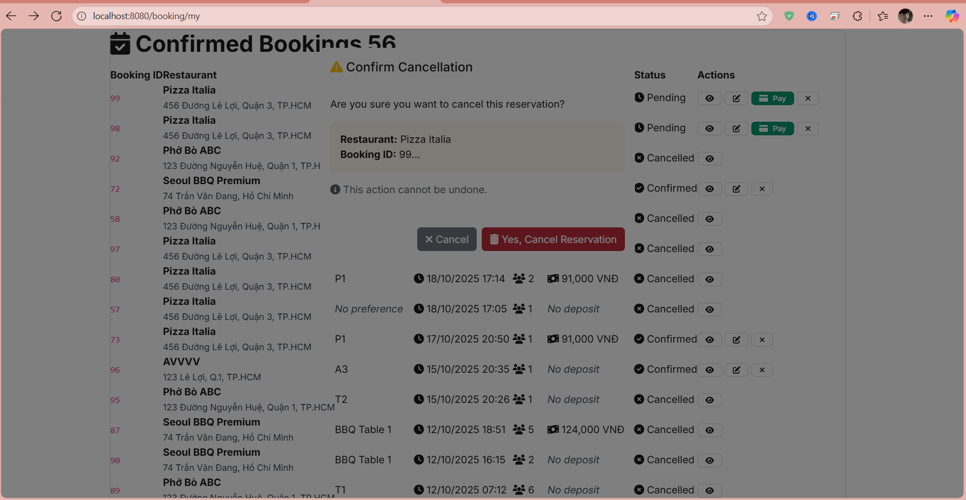

##### Database Access

| **Table** | **CRUD** | **Description** |
| --- | --- | --- |
| booking | R | Read existing booking information to validate cancellation eligibility |
| booking | U | Update booking status to CANCELLED |
| booking_table | R | Read booking-table relationships to release table assignments |
| booking_dish | R | Read booking-dish relationships for cancellation records |
| booking_service | R | Read booking-service relationships for cancellation records |
| customer | R | Read customer information to validate booking ownership |
| restaurant_profile | R | Read restaurant information for cancellation policy |
| payment | R | Read payment information for refund processing |
| refund | C | Create refund record if applicable based on cancellation policy |

##### SQL Commands

Read existing booking information

SELECT b.booking_id, b.customer_id, b.restaurant_id, b.booking_date, b.booking_time,

b.number_of_guests, b.deposit_amount, b.note, b.status, b.created_at

FROM booking b

WHERE b.booking_id = ?;

Read current booking-table relationships

SELECT bt.booking_id, bt.table_id, t.table_name, t.capacity

FROM booking_table bt

JOIN restaurant_table t ON bt.table_id = t.table_id

WHERE bt.booking_id = ?;

Read current booking-dish relationships

SELECT bd.booking_id, bd.dish_id, bd.quantity, d.dish_name, d.price

FROM booking_dish bd

JOIN dish d ON bd.dish_id = d.dish_id

WHERE bd.booking_id = ?;

Read current booking-service relationships

SELECT bs.booking_id, bs.service_id, bs.quantity, s.service_name, s.price

FROM booking_service bs

JOIN restaurant_service s ON bs.service_id = s.service_id

WHERE bs.booking_id = ?;

Update booking information

UPDATE booking

SET restaurant_id = ?, booking_date = ?, booking_time = ?, number_of_guests = ?,

deposit_amount = ?, note = ?, updated_at = CURRENT_TIMESTAMP

WHERE booking_id = ?;

Delete existing booking-table relationships

DELETE FROM booking_table WHERE booking_id = ?;

Create new booking-table relationships

INSERT INTO booking_table (booking_id, table_id, created_at)

VALUES (?, ?, CURRENT_TIMESTAMP);

Delete existing booking-dish relationships

DELETE FROM booking_dish WHERE booking_id = ?;

Create new booking-dish relationships

INSERT INTO booking_dish (booking_id, dish_id, quantity, created_at)

VALUES (?, ?, ?, CURRENT_TIMESTAMP);

Delete existing booking-service relationships

DELETE FROM booking_service WHERE booking_id = ?;

Create new booking-service relationships

INSERT INTO booking_service (booking_id, service_id, quantity, created_at)

VALUES (?, ?, ?, CURRENT_TIMESTAMP);

Validate booking can be edited

SELECT status FROM booking WHERE booking_id = ? AND status IN ('PENDING', 'CONFIRMED');

Check table availability for update

SELECT COUNT() FROM booking_table bt

JOIN booking b ON bt.booking_id = b.booking_id

WHERE bt.table_id = ? AND b.booking_date = ?

AND b.booking_time BETWEEN ? AND ?

AND b.status IN ('PENDING', 'CONFIRMED', 'CHECKED_IN')

AND b.booking_id != ?;

Calculate updated total amount

SELECT

COALESCE(SUM(d.price * bd.quantity), 0) as dish_total,

COALESCE(SUM(s.price * bs.quantity), 0) as service_total

FROM booking b

LEFT JOIN booking_dish bd ON b.booking_id = bd.booking_id

LEFT JOIN dish d ON bd.dish_id = d.dish_id

LEFT JOIN booking_service bs ON b.booking_id = bs.booking_id

LEFT JOIN restaurant_service s ON bs.service_id = s.service_id

WHERE b.booking_id = ?;

### 5.4 View Booking List

##### UI Design

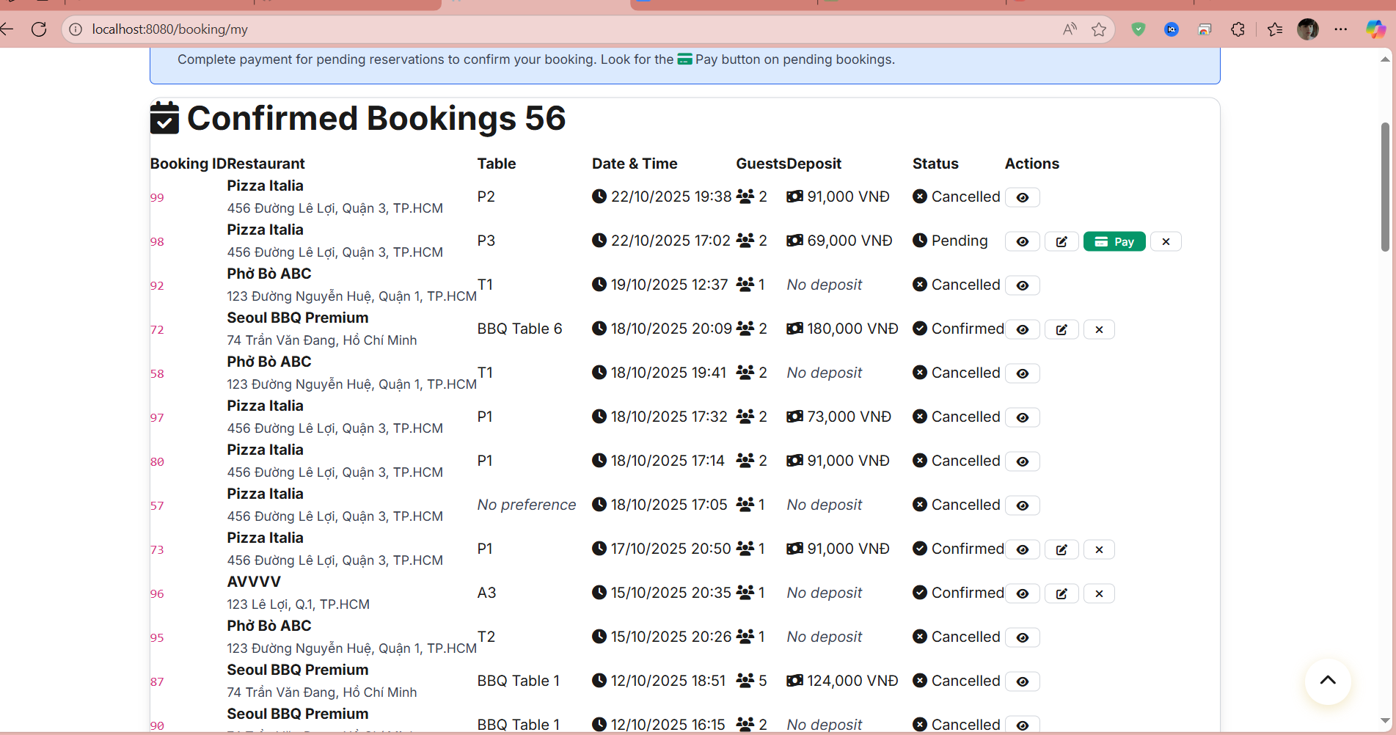

##### Database Access

| **Table** | **CRUD** | **Description** |
| --- | --- | --- |
| booking | R | Read all bookings for the authenticated customer |
| customer | R | Read customer information for authentication |
| restaurant_profile | R | Read restaurant information for display |
| restaurant_table | R | Read table information for each booking |
| booking_table | R | Read booking-table relationships |
| booking_dish | R | Read booking-dish relationships for item details |
| booking_service | R | Read booking-service relationships for service details |
| payment | R | Read payment information for each booking |
| waitlist | R | Read waitlist entries for the customer |
| dish | R | Read dish information for booking items |
| restaurant_service | R | Read service information for booking services |

##### SQL Commands

*Read customer bookings*

*SELECT b.booking_id, b.restaurant_id, b.booking_date, b.booking_time,*

*b.number_of_guests, b.deposit_amount, b.status, b.note, b.created_at, b.updated_at*

*FROM booking b*

*JOIN customer c ON b.customer_id = c.customer_id*

*WHERE c.user_id = ?*

*ORDER BY b.booking_time DESC;*

*Read restaurant information for bookings*

*SELECT r.restaurant_id, r.restaurant_name, r.address, r.phone_number*

*FROM restaurant_profile r*

*WHERE r.restaurant_id IN (*

*SELECT DISTINCT restaurant_id FROM booking WHERE customer_id = ?*

*);*

*Read booking-table relationships*

*SELECT bt.booking_id, bt.table_id, t.table_name, t.capacity*

*FROM booking_table bt*

*JOIN restaurant_table t ON bt.table_id = t.table_id*

*WHERE bt.booking_id IN (*

*SELECT booking_id FROM booking WHERE customer_id = ?*

*);*

*Read booking-dish relationships*

*SELECT bd.booking_id, bd.dish_id, bd.quantity, d.dish_name, d.price*

*FROM booking_dish bd*

*JOIN dish d ON bd.dish_id = d.dish_id*

*WHERE bd.booking_id IN (*

*SELECT booking_id FROM booking WHERE customer_id = ?*

*);*

*Read booking-service relationships*

*SELECT bs.booking_id, bs.service_id, bs.quantity, s.service_name, s.price*

*FROM booking_service bs*

*JOIN restaurant_service s ON bs.service_id = s.service_id*

*WHERE bs.booking_id IN (*

*SELECT booking_id FROM booking WHERE customer_id = ?*

*);*

*Read payment information for bookings*

*SELECT p.payment_id, p.booking_id, p.amount, p.payment_method, p.status, p.created_at*

*FROM payment p*

*WHERE p.booking_id IN (*

*SELECT booking_id FROM booking WHERE customer_id = ?*

*);*

*Read waitlist entries for customer*

*SELECT w.waitlist_id, w.restaurant_id, w.number_of_guests, w.status, w.created_at, w.estimated_wait_time*

*FROM waitlist w*

*WHERE w.customer_id = ?*

*ORDER BY w.created_at DESC;*

*Filter bookings by status*

*SELECT b.booking_id, b.restaurant_id, b.booking_date, b.booking_time,*

*b.number_of_guests, b.status, b.created_at*

*FROM booking b*

*JOIN customer c ON b.customer_id = c.customer_id*

*WHERE c.user_id = ? AND b.status = ?*

*ORDER BY b.booking_time DESC;*

*Search bookings by restaurant name*

*SELECT b.booking_id, b.restaurant_id, b.booking_date, b.booking_time,*

*b.number_of_guests, b.status*

*FROM booking b*

*JOIN customer c ON b.customer_id = c.customer_id*

*JOIN restaurant_profile r ON b.restaurant_id = r.restaurant_id*

*WHERE c.user_id = ? AND r.restaurant_name ILIKE '%' || ? || '%'*

*ORDER BY b.booking_time DESC;*

*Count total bookings by status*

*SELECT status, COUNT() as count*

*FROM booking b*

*JOIN customer c ON b.customer_id = c.customer_id*

*WHERE c.user_id = ?*

*GROUP BY status;*

## 6. Payment & Deposits

### 6.1 Pay Deposit

##### a. UI Design

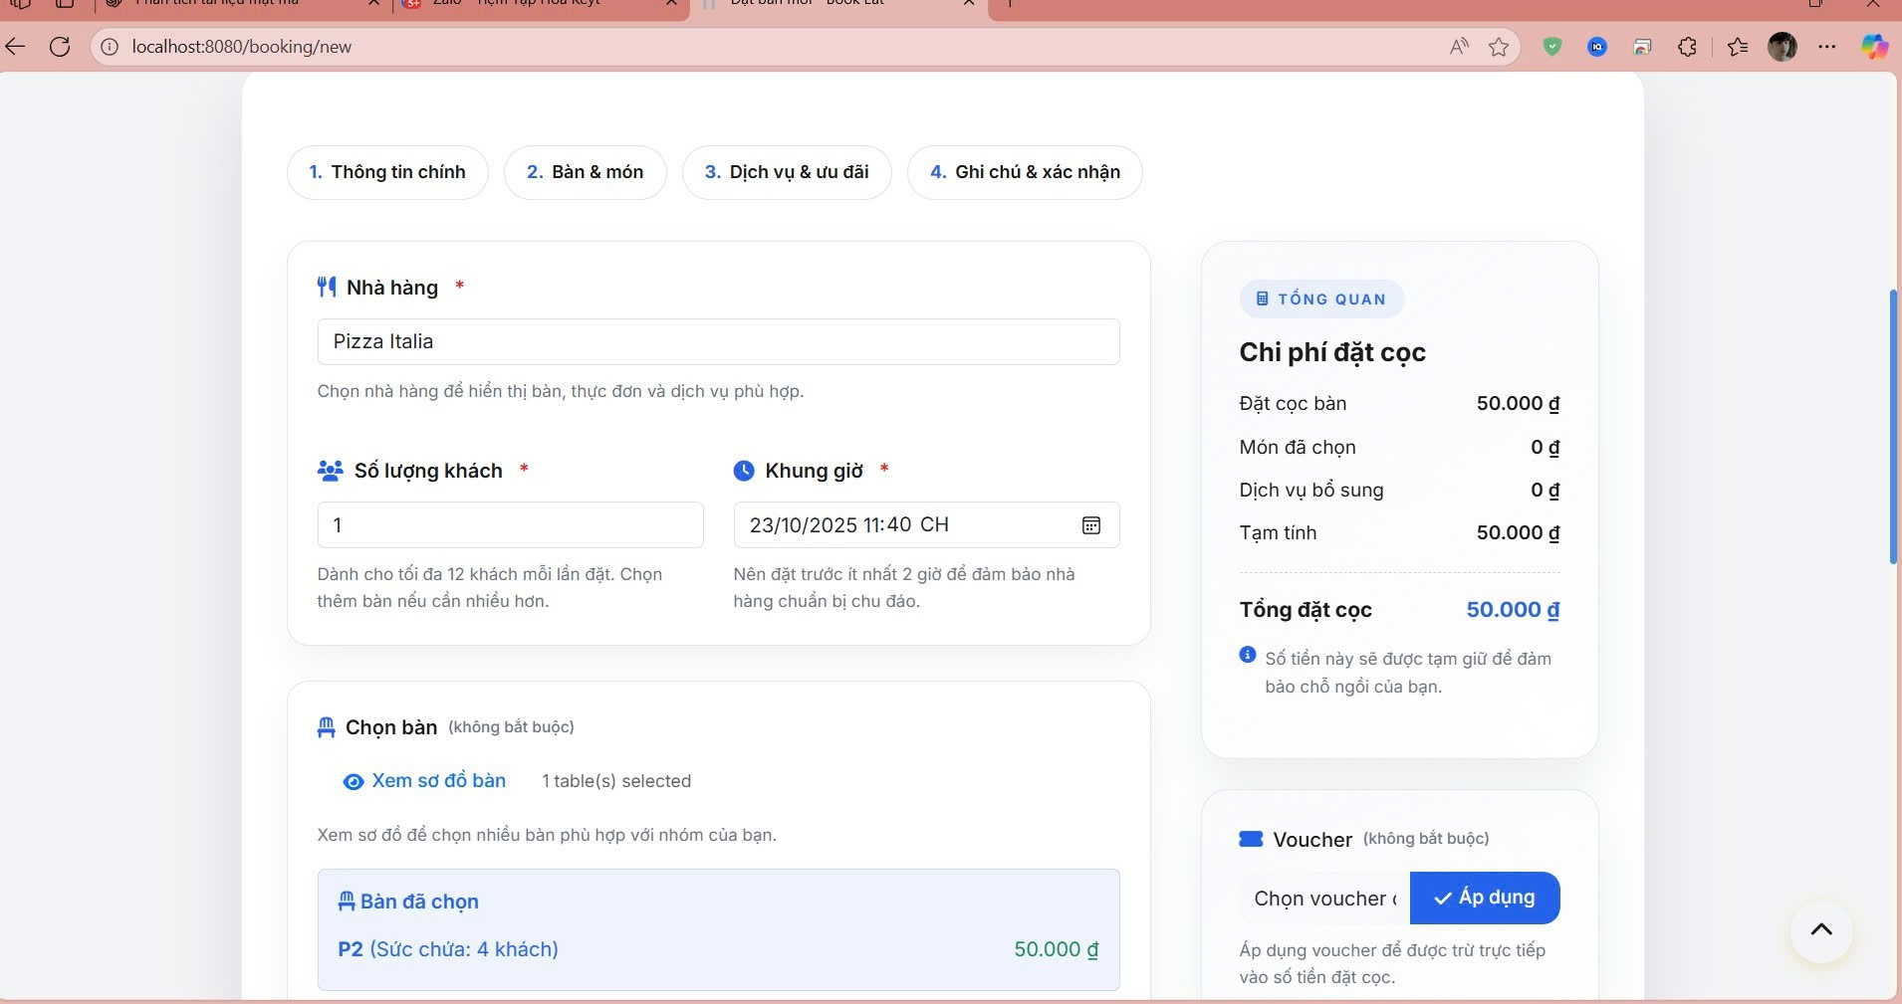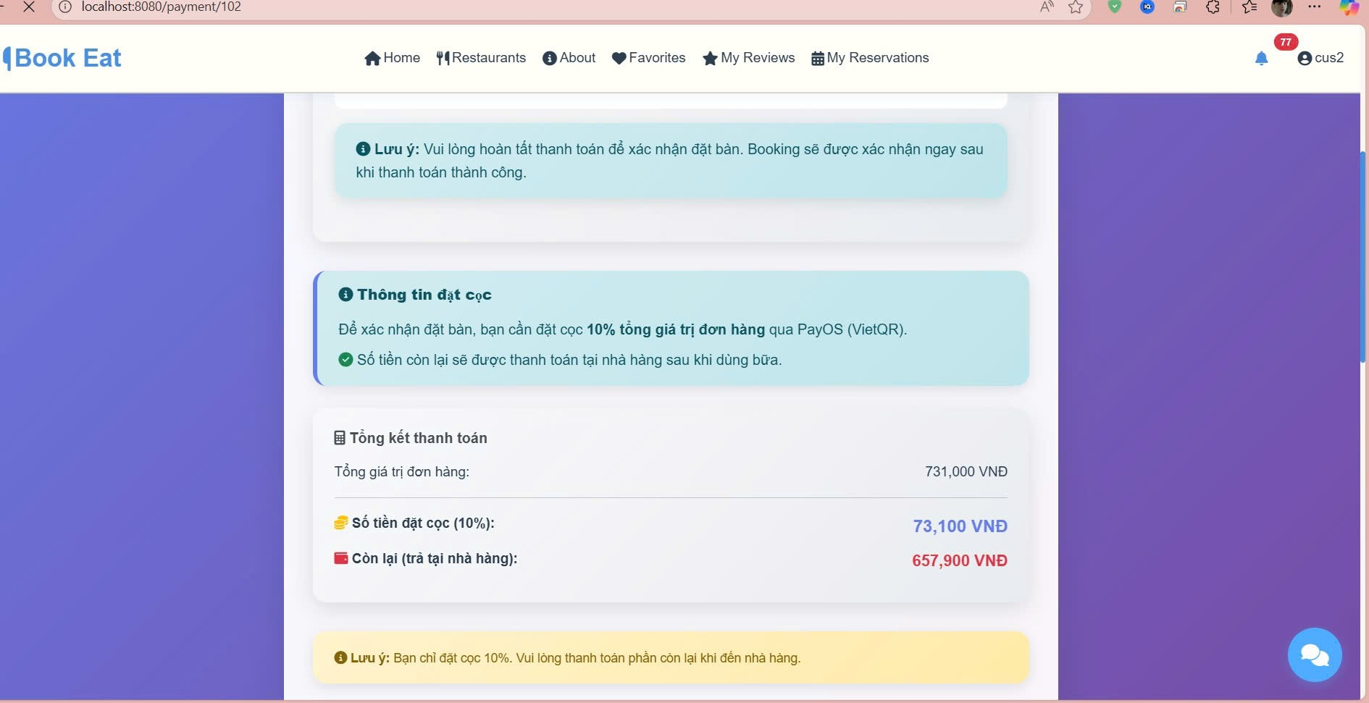

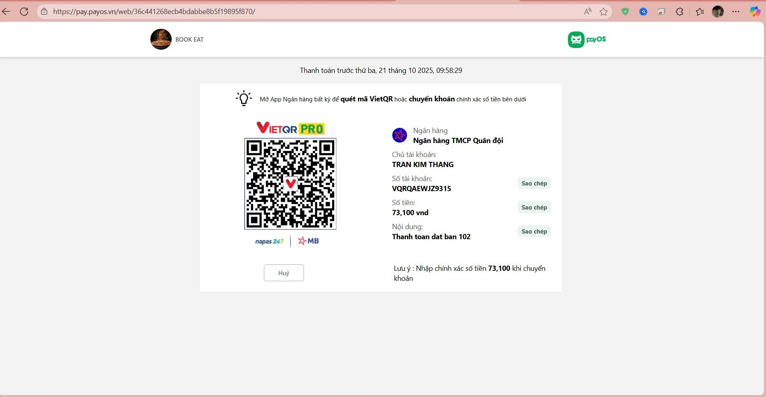

##### b. Database Access

| **Table** | **CRUD** | **Description** |
| --- | --- | --- |
| payment | C,R,U | Create, read, and update payment records |
| booking | R,U | Read booking details and update status |
| customer | R | Read customer information |
| restaurant_profile | R | Read restaurant information |
| voucher | R | Read voucher information for discount |
| customer_voucher | R,U | Read and update voucher usage |

##### c. SQL Commands

*Create payment record  
 INSERT INTO payment (booking_id, customer_id, amount, payment_method, status, paid_at, payment_type, order_code)  
 VALUES (?, ?, ?, 'PAYOS', 'PENDING', NOW(), 'DEPOSIT', ?);*

*Update payment status  
 UPDATE payment  
 SET status = ?, paid_at = NOW(), updated_at = NOW()  
 WHERE payment_id = ?;*

*Get payment by booking  
 SELECT p.payment_id, p.amount, p.payment_method, p.status, p.order_code, p.paid_at,  
 b.booking_id, b.booking_time, b.guest_count  
 FROM payment p  
 JOIN booking b ON p.booking_id = b.booking_id  
 WHERE p.booking_id = ? AND p.payment_type = 'DEPOSIT';*

*Calculate deposit amount  
 SELECT  
 COALESCE(SUM(rt.deposit_amount), 0) AS table_deposit,  
 COALESCE(SUM(bd.quantity * d.price), 0) AS dishes_total,  
 COALESCE(SUM(bs.price), 0) AS services_total  
 FROM booking b  
 LEFT JOIN booking_table bt ON b.booking_id = bt.booking_id  
 LEFT JOIN restaurant_tables rt ON bt.table_id = rt.table_id  
 LEFT JOIN booking_dish bd ON b.booking_id = bd.booking_id  
 LEFT JOIN dish d ON bd.dish_id = d.dish_id  
 LEFT JOIN booking_service bs ON b.booking_id = bs.booking_id  
 WHERE b.booking_id = ?;*

*Update booking status after payment  
 UPDATE booking  
 SET status = 'CONFIRMED', updated_at = NOW()  
 WHERE booking_id = ? AND status = 'PENDING';*

*Check voucher validity  
 SELECT v.voucher_id, v.discount_type, v.discount_value, v.minimum_amount, v.expiry_date  
 FROM voucher v  
 JOIN customer_voucher cv ON v.voucher_id = cv.voucher_id  
 WHERE v.voucher_code = ?  
 AND cv.customer_id = ?  
 AND cv.used = FALSE  
 AND v.expiry_date > NOW();*

*Update voucher usage  
 UPDATE customer_voucher  
 SET used = TRUE, used_at = NOW()  
 WHERE customer_id = ? AND voucher_id = ?;*

*Get booking details for payment  
 SELECT b.booking_id, b.booking_time, b.guest_count, b.note,  
 rp.restaurant_name, rp.address,  
 c.full_name, c.phone_number  
 FROM booking b  
 JOIN restaurant_profile rp ON b.restaurant_id = rp.restaurant_id  
 JOIN customer c ON b.customer_id = c.customer_id  
 WHERE b.booking_id = ?;*

### 6.2 View Transaction History

##### a. UI Design

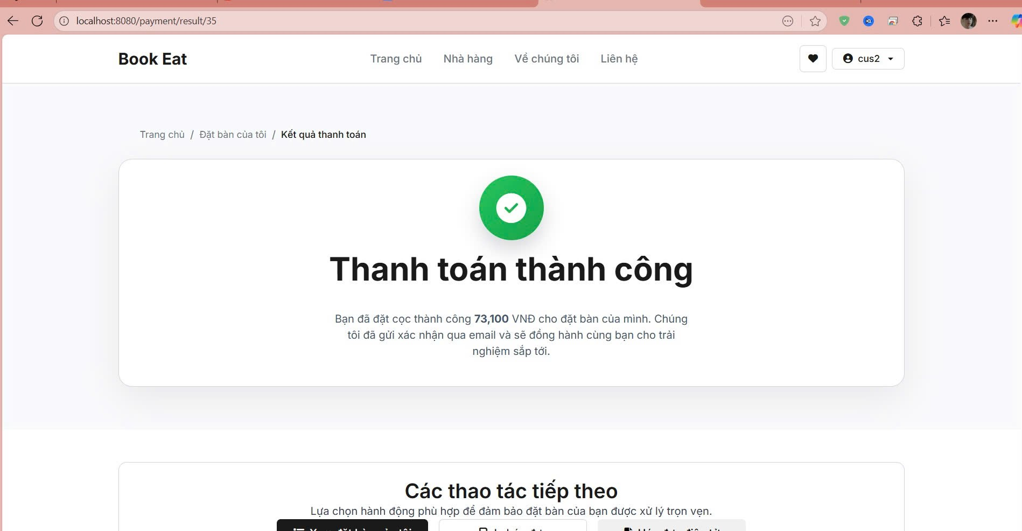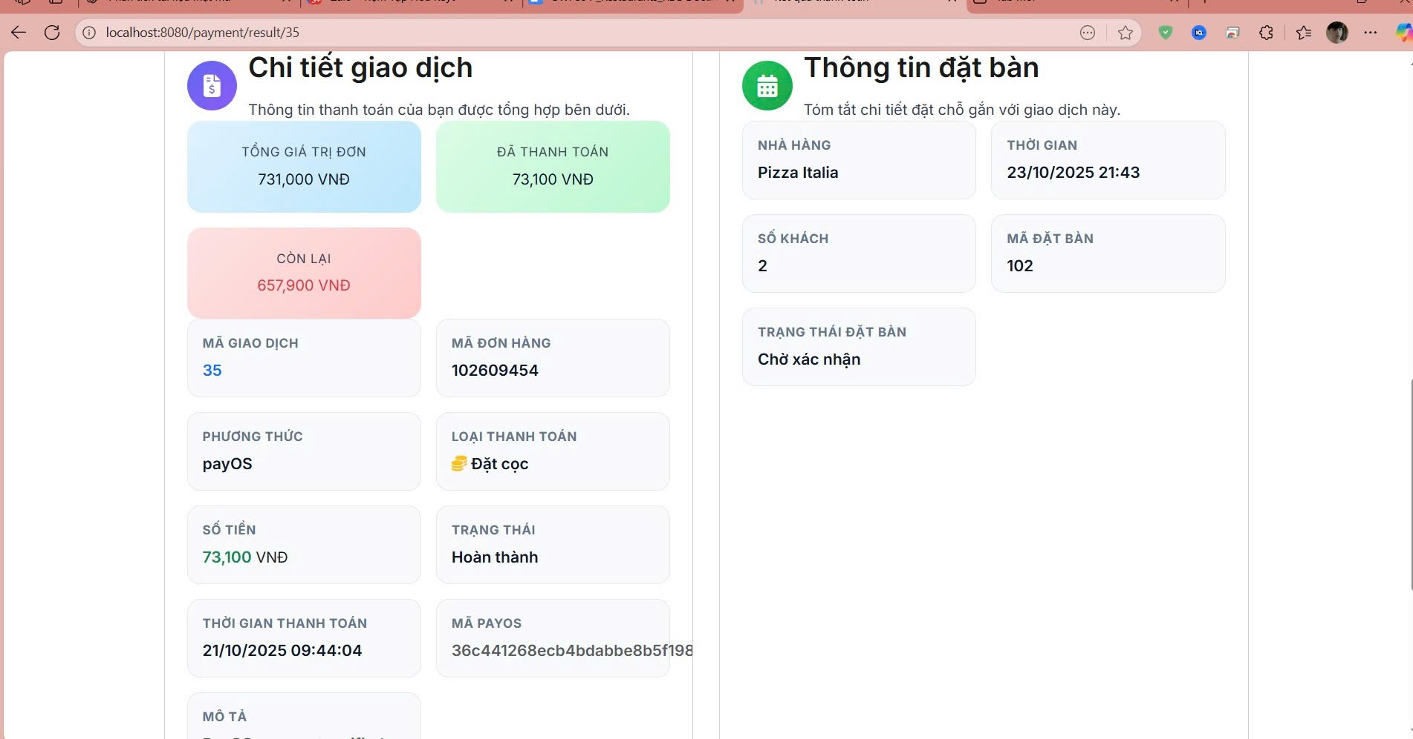

##### b. Database Access

| **Table** | **CRUD** | **Description** |
| --- | --- | --- |
| payment | R | Read payment transaction records |
| booking | R | Read booking transaction records |
| customer | R | Read customer information |
| restaurant_profile | R | Read restaurant information |
| audit_log | R | Read transaction audit trail |
| voucher | R | Read voucher usage in transactions |

##### c. SQL Commands

*Get customer transaction history  
 SELECT b.booking_id, b.restaurant_id, b.booking_date, b.booking_time, b.number_of_guests, b.deposit_amount, b.status, b.note, b.created_at, b.updated_at  
 FROM booking b  
 JOIN customer c ON b.customer_id = c.customer_id  
 WHERE c.user_id = ?  
 ORDER BY b.booking_time DESC;*

*Get payment history for customer  
 SELECT p.payment_id, p.amount, p.payment_method, p.status, p.paid_at, p.order_code, b.booking_id, rp.restaurant_name  
 FROM payment p  
 JOIN booking b ON p.booking_id = b.booking_id  
 JOIN restaurant_profile rp ON b.restaurant_id = rp.restaurant_id  
 WHERE p.customer_id = ?  
 ORDER BY p.paid_at DESC;*

*Get restaurant information for transactions  
 SELECT r.restaurant_id, r.restaurant_name, r.address, r.phone_number  
 FROM restaurant_profile r  
 WHERE r.restaurant_id IN (  
 SELECT DISTINCT restaurant_id FROM booking WHERE customer_id = ?  
 );*

*Get transaction statistics  
 SELECT COUNT(*) AS total_transactions, SUM(amount) AS total_amount, COUNT(CASE WHEN status = 'COMPLETED' THEN 1 END) AS completed_count  
 FROM payment  
 WHERE customer_id = ?;*

*Get recent transactions  
 SELECT b.booking_id, b.booking_time, b.status, rp.restaurant_name, p.amount, p.payment_method  
 FROM booking b  
 LEFT JOIN payment p ON b.booking_id = p.booking_id  
 JOIN restaurant_profile rp ON b.restaurant_id = rp.restaurant_id  
 WHERE b.customer_id = ?  
 ORDER BY b.created_at DESC  
 LIMIT 10;*

*Filter transactions by status  
 SELECT b.booking_id, b.booking_time, b.status, rp.restaurant_name, p.amount  
 FROM booking b  
 LEFT JOIN payment p ON b.booking_id = p.booking_id  
 JOIN restaurant_profile rp ON b.restaurant_id = rp.restaurant_id  
 WHERE b.customer_id = ? AND b.status = ?  
 ORDER BY b.booking_time DESC;*

*Search transactions by restaurant  
 SELECT b.booking_id, b.booking_time, b.status, rp.restaurant_name, p.amount  
 FROM booking b  
 LEFT JOIN payment p ON b.booking_id = p.booking_id  
 JOIN restaurant_profile rp ON b.restaurant_id = rp.restaurant_id  
 WHERE b.customer_id = ? AND rp.restaurant_name ILIKE ?  
 ORDER BY b.booking_time DESC;*

*Get transaction audit trail  
 SELECT al.action_type, al.resource_type, al.resource_id, al.created_at, al.details  
 FROM audit_log al  
 WHERE al.user_id = ? AND al.resource_type IN ('BOOKING', 'PAYMENT')  
 ORDER BY al.created_at DESC;*

### 6.3 Request Withdrawal

##### a. UI Design

##### b. Database Access

| **Table** | **CRUD** | **Description** |
| --- | --- | --- |
| withdrawal_request | C,R,U | Create, read, and update withdrawal requests |
| restaurant_bank_account | R | Read bank account information |
| restaurant_profile | R | Read restaurant information |
| restaurant_balance | R | Read restaurant balance |
| users | R | Read admin user information for review |
| audit_log | C | Create audit log for withdrawal requests |

##### 

##### c. SQL Commands

*Create withdrawal request*

*INSERT INTO withdrawal_request (restaurant_id, bank_account_id, amount, description, status, commission_amount, net_amount, created_at, updated_at)*

*VALUES (?, ?, ?, ?, 'PENDING', ?, ?, NOW(), NOW());*

*Get restaurant balance*

*SELECT available_balance, total_balance, frozen_balance*

*FROM restaurant_balance*

*WHERE restaurant_id = ?;*

*Get bank accounts for restaurant*

*SELECT account_id, account_holder_name, account_number, bank_name, bank_code, is_primary*

*FROM restaurant_bank_account*

*WHERE restaurant_id = ? AND is_active = TRUE*

*ORDER BY is_primary DESC, created_at DESC;*

*Get withdrawal history*

*SELECT wr.request_id, wr.amount, wr.status, wr.created_at, wr.reviewed_at, wr.rejection_reason,*

*rba.account_holder_name, rba.bank_name*

*FROM withdrawal_request wr*

*JOIN restaurant_bank_account rba ON wr.bank_account_id = rba.account_id*

*WHERE wr.restaurant_id = ?*

*ORDER BY wr.created_at DESC;*

*Update withdrawal status*

*UPDATE withdrawal_request*

*SET status = ?, reviewed_by_user_id = ?, reviewed_at = NOW(), rejection_reason = ?, admin_notes = ?, updated_at = NOW()*

*WHERE request_id = ?;*

*Check minimum withdrawal amount*

*SELECT COUNT(*)*

*FROM withdrawal_request*

*WHERE restaurant_id = ? AND status = 'PENDING' AND amount >= 100000;*

*Get withdrawal statistics*

*SELECT COUNT(*) AS total_requests,*

*SUM(CASE WHEN status = 'SUCCEEDED' THEN amount ELSE 0 END) AS total_withdrawn,*

*COUNT(CASE WHEN status = 'PENDING' THEN 1 END) AS pending_requests*

*FROM withdrawal_request*

*WHERE restaurant_id = ?;*

*Validate withdrawal amount*

*SELECT CASE*

*WHEN ? <= (SELECT available_balance FROM restaurant_balance WHERE restaurant_id = ?)*

*AND ? >= 100000 THEN TRUE*

*ELSE FALSE END AS is_valid;*

### 6.4 Approve Withdrawal

##### a. UI Design

##### b. Database Access

| **Table** | **CRUD** | **Description** |
| --- | --- | --- |
| withdrawal_request | R,U | Read and update withdrawal requests |
| restaurant_profile | R | Read restaurant information |
| restaurant_bank_account | R | Read bank account information |
| restaurant_balance | R,U | Read and update restaurant balance |
| users | R | Read admin user information |
| audit_log | C | Create audit log for approval actions |

##### c. SQL Commands

*Get pending withdrawal requests*

*SELECT wr.request_id, wr.amount, wr.description, wr.created_at, wr.status, rp.restaurant_name, rba.account_holder_name, rba.bank_name*

*FROM withdrawal_request wr*

*JOIN restaurant_profile rp ON wr.restaurant_id = rp.restaurant_id*

*JOIN restaurant_bank_account rba ON wr.bank_account_id = rba.account_id*

*WHERE wr.status = 'PENDING'*

*ORDER BY wr.created_at ASC;*

*Approve withdrawal request*

*UPDATE withdrawal_request*

*SET status = 'APPROVED', reviewed_by_user_id = ?, reviewed_at = NOW(), admin_notes = ?, updated_at = NOW()*

*WHERE request_id = ?;*

*Reject withdrawal request*

*UPDATE withdrawal_request*

*SET status = 'REJECTED', reviewed_by_user_id = ?, reviewed_at = NOW(), rejection_reason = ?, updated_at = NOW()*

*WHERE request_id = ?;*

*Update restaurant balance after approval*

*UPDATE restaurant_balance*

*SET pending_withdrawal = pending_withdrawal + ?, available_balance = available_balance - ?, updated_at = NOW()*

*WHERE restaurant_id = ?;*

*Get withdrawal statistics*

*SELECT COUNT(*) AS total_requests,*

*SUM(CASE WHEN status = 'APPROVED' THEN amount ELSE 0 END) AS total_approved,*

*COUNT(CASE WHEN status = 'PENDING' THEN 1 END) AS pending_count*

*FROM withdrawal_request*

*WHERE created_at >= ?;*

*Get withdrawal request details*

*SELECT wr.*, rp.restaurant_name, rp.phone, rba.account_holder_name, rba.account_number, rba.bank_name*

*FROM withdrawal_request wr*

*JOIN restaurant_profile rp ON wr.restaurant_id = rp.restaurant_id*

*JOIN restaurant_bank_account rba ON wr.bank_account_id = rba.account_id*

*WHERE wr.request_id = ?;*

*Check restaurant balance before approval*

*SELECT available_balance, total_balance*

*FROM restaurant_balance*

*WHERE restaurant_id = ?;*

*Get admin user information*

*SELECT id, username, full_name, email*

*FROM users*

*WHERE id = ? AND role = 'ADMIN';*

## 7. Voucher & Promotions

### 7.1 Create Voucher

##### a. UI Design

##### b. Database Access

| **Table** | **CRUD** | **Description** |
| --- | --- | --- |
| voucher | C,R,U | Create, read, and update voucher records |
| restaurant_profile | R | Read restaurant information |
| users | R | Read user information (creator) |
| customer_voucher | C,R | Create and read customer voucher assignments |
| audit_log | C | Create audit log for voucher creation |

##### c. SQL Commands

*Create voucher*

*INSERT INTO voucher (code, description, discount_type, discount_value, start_date, end_date, global_usage_limit, per_customer_limit, min_order_amount, max_discount_amount, restaurant_id, created_by_user_id, status, created_at, updated_at)*

*VALUES (?, ?, ?, ?, ?, ?, ?, ?, ?, ?, ?, ?, ?, NOW(), NOW());*

*Check voucher code uniqueness*

*SELECT COUNT(*)*

*FROM voucher*

*WHERE code = ?;*

*Get restaurants for dropdown*

*SELECT restaurant_id, restaurant_name*

*FROM restaurant_profile*

*WHERE status = 'APPROVED'*

*ORDER BY restaurant_name ASC;*

*Get admin users*

*SELECT id, username, full_name*

*FROM users*

*WHERE role = 'ADMIN'*

*ORDER BY username ASC;*

*Create customer voucher assignment*

*INSERT INTO customer_voucher (customer_id, voucher_id, assigned_at, used, used_at)*

*VALUES (?, ?, NOW(), FALSE, NULL);*

*Get voucher by code*

*SELECT voucher_id, code, description, discount_type, discount_value, start_date, end_date, global_usage_limit, per_customer_limit, min_order_amount, max_discount_amount, restaurant_id, status*

*FROM voucher*

*WHERE code = ?;*

*Update voucher status*

*UPDATE voucher*

*SET status = ?, updated_at = NOW()*

*WHERE voucher_id = ?;*

*Get voucher usage statistics*

*SELECT COUNT(*) AS total_usage, COUNT(CASE WHEN used = TRUE THEN 1 END) AS used_count*

*FROM customer_voucher*

*WHERE voucher_id = ?;*

### 7.2 View Voucher List

##### a. UI Design

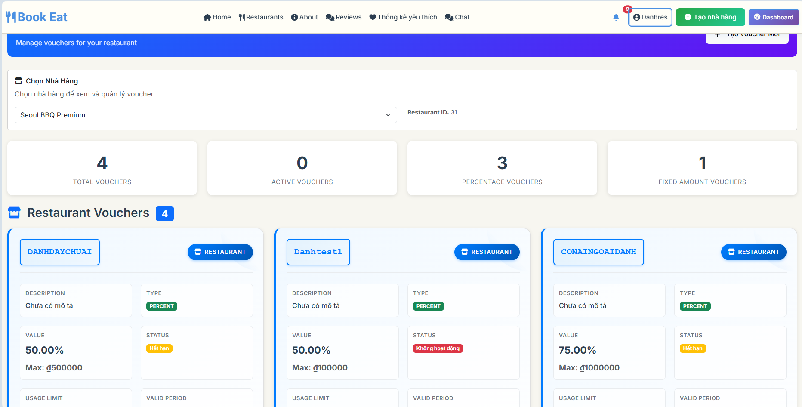

##### b. Database Access

| **Table** | **CRUD** | **Description** |
| --- | --- | --- |
| voucher | R | Read voucher records |
| restaurant_profile | R | Read restaurant information |
| customer_voucher | R | Read voucher usage statistics |
| users | R | Read user information |
| audit_log | R | Read voucher audit trail |

##### 

##### c. SQL Commands

*Get all vouchers  
 SELECT v.voucher_id, v.code, v.description, v.discount_type, v.discount_value, v.start_date, v.end_date, v.status, v.global_usage_limit, v.per_customer_limit, v.min_order_amount, v.max_discount_amount, rp.restaurant_name  
 FROM voucher v  
 LEFT JOIN restaurant_profile rp ON v.restaurant_id = rp.restaurant_id  
 ORDER BY v.created_at DESC;*

*Get vouchers by restaurant  
 SELECT v.voucher_id, v.code, v.description, v.discount_type, v.discount_value, v.start_date, v.end_date, v.status, v.global_usage_limit, v.per_customer_limit  
 FROM voucher v  
 WHERE v.restaurant_id = ?  
 ORDER BY v.created_at DESC;*

*Get voucher usage statistics  
 SELECT COUNT(*) AS total_usage, COUNT(CASE WHEN used = TRUE THEN 1 END) AS used_count  
 FROM customer_voucher  
 WHERE voucher_id = ?;*

*Search vouchers by code  
 SELECT v.voucher_id, v.code, v.description, v.discount_type, v.discount_value, v.status, rp.restaurant_name  
 FROM voucher v  
 LEFT JOIN restaurant_profile rp ON v.restaurant_id = rp.restaurant_id  
 WHERE v.code ILIKE ?  
 ORDER BY v.created_at DESC;*

*Filter vouchers by status  
 SELECT v.voucher_id, v.code, v.description, v.discount_type, v.discount_value, v.status, rp.restaurant_name  
 FROM voucher v  
 LEFT JOIN restaurant_profile rp ON v.restaurant_id = rp.restaurant_id  
 WHERE v.status = ?  
 ORDER BY v.created_at DESC;*

*Get voucher statistics  
 SELECT COUNT(*) AS total_vouchers,  
 COUNT(CASE WHEN status = 'ACTIVE' THEN 1 END) AS active_count,  
 COUNT(CASE WHEN restaurant_id IS NULL THEN 1 END) AS global_count  
 FROM voucher;*

*Get vouchers with pagination  
 SELECT v.voucher_id, v.code, v.description, v.discount_type, v.discount_value, v.status, rp.restaurant_name  
 FROM voucher v  
 LEFT JOIN restaurant_profile rp ON v.restaurant_id = rp.restaurant_id  
 ORDER BY v.created_at DESC  
 LIMIT ? OFFSET ?;*

*Get expired vouchers  
 SELECT v.voucher_id, v.code, v.description, v.end_date  
 FROM voucher v  
 WHERE v.end_date < NOW() AND v.status = 'ACTIVE'  
 ORDER BY v.end_date ASC;*

### 7.3 Update Voucher

##### a. UI Design

##### b. Database Access

| **Table** | **CRUD** | **Description** |
| --- | --- | --- |
| voucher | R,U | Read and update voucher records |
| restaurant_profile | R | Read restaurant information |
| customer_voucher | R | Read voucher usage statistics |
| users | R | Read user information (updater) |
| audit_log | C | Create audit log for voucher updates |

##### c. SQL Commands

*Get voucher by ID*

*SELECT v.voucher_id, v.code, v.description, v.discount_type, v.discount_value, v.start_date, v.end_date, v.global_usage_limit, v.per_customer_limit, v.min_order_amount, v.max_discount_amount, v.status, rp.restaurant_name*

*FROM voucher v*

*LEFT JOIN restaurant_profile rp ON v.restaurant_id = rp.restaurant_id*

*WHERE v.voucher_id = ?;*

*Update voucher*

*UPDATE voucher*

*SET description = ?, discount_value = ?, start_date = ?, end_date = ?, global_usage_limit = ?, per_customer_limit = ?, min_order_amount = ?, max_discount_amount = ?, status = ?, updated_at = NOW()*

*WHERE voucher_id = ?;*

*Get voucher usage statistics*

*SELECT COUNT(*) AS total_usage, COUNT(CASE WHEN used = TRUE THEN 1 END) AS used_count*

*FROM customer_voucher*

*WHERE voucher_id = ?;*

*Check voucher code uniqueness*

*SELECT COUNT(*)*

*FROM voucher*

*WHERE code = ? AND voucher_id != ?;*

*Get voucher redemption history*

*SELECT cv.used, cv.used_at, c.user_id, u.full_name*

*FROM customer_voucher cv*

*JOIN customer c ON cv.customer_id = c.customer_id*

*JOIN users u ON c.user_id = u.id*

*WHERE cv.voucher_id = ?*

*ORDER BY cv.used_at DESC;*

*Update voucher status only*

*UPDATE voucher*

*SET status = ?, updated_at = NOW()*

*WHERE voucher_id = ?;*

*Get voucher validation rules*

*SELECT min_order_amount, max_discount_amount, global_usage_limit, per_customer_limit*

*FROM voucher*

*WHERE voucher_id = ?;*

*Check if voucher can be updated*

*SELECT CASE*

*WHEN status = 'EXPIRED' OR end_date < NOW() THEN FALSE*

*ELSE TRUE END AS can_update*

*FROM voucher*

*WHERE voucher_id = ?;*

### 7.4 Apply Voucher

##### a. UI Design

##### b. Database Access

| **Table** | **CRUD** | **Description** |
| --- | --- | --- |
| voucher | R | Read voucher information for validation |
| customer_voucher | R,U | Read and update customer voucher usage |
| voucher_redemption | C,R | Create and read voucher redemption records |
| booking | R | Read booking information |
| customer | R | Read customer information |
| restaurant_profile | R | Read restaurant information |

##### c. SQL Commands

*Validate voucher  
 SELECT v.voucher_id, v.code, v.discount_type, v.discount_value, v.start_date, v.end_date, v.global_usage_limit, v.per_customer_limit, v.min_order_amount, v.max_discount_amount, v.status  
 FROM voucher v  
 WHERE v.code = ? AND v.status = 'ACTIVE';*

*Check voucher usage limits  
 SELECT COUNT(*) AS global_usage  
 FROM voucher_redemption  
 WHERE voucher_id = ?;*

*Check customer usage limit  
 SELECT COUNT(*) AS customer_usage  
 FROM voucher_redemption  
 WHERE voucher_id = ? AND customer_id = ?;*

*Create voucher redemption  
 INSERT INTO voucher_redemption (voucher_id, customer_id, discount_amount, original_amount, final_amount, redeemed_at)  
 VALUES (?, ?, ?, ?, ?, NOW());*

*Update customer voucher usage  
 UPDATE customer_voucher  
 SET used = TRUE, used_at = NOW()  
 WHERE customer_id = ? AND voucher_id = ?;*

*Get available vouchers for customer  
 SELECT v.voucher_id, v.code, v.description, v.discount_type, v.discount_value, v.start_date, v.end_date  
 FROM voucher v  
 LEFT JOIN customer_voucher cv ON v.voucher_id = cv.voucher_id  
 WHERE v.status = 'ACTIVE'  
 AND (v.restaurant_id = ? OR v.restaurant_id IS NULL)  
 AND (cv.customer_id = ? OR v.restaurant_id IS NULL)  
 ORDER BY v.created_at DESC;*

*Check voucher assignment  
 SELECT cv.used, cv.used_at  
 FROM customer_voucher cv  
 WHERE cv.customer_id = ? AND cv.voucher_id = ?;*

*Get voucher redemption history  
 SELECT vr.discount_amount, vr.original_amount, vr.final_amount, vr.redeemed_at, v.code  
 FROM voucher_redemption vr  
 JOIN voucher v ON vr.voucher_id = v.voucher_id  
 WHERE vr.customer_id = ?  
 ORDER BY vr.redeemed_at DESC;*

## 8. Reviews & Feedback

### 8.1 Submit Review

##### a. UI Design

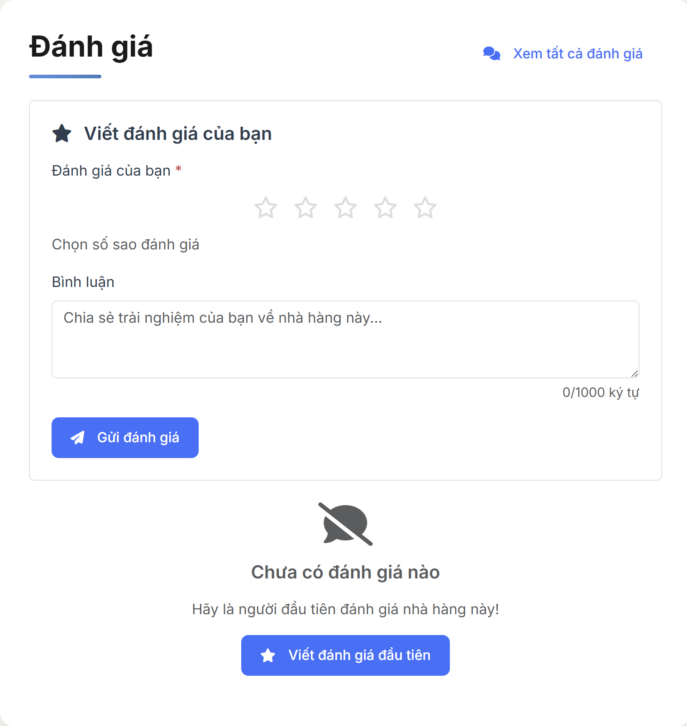

##### b. Database Access

| **Table** | **CRUD** | **Description** |
| --- | --- | --- |
| review | C | Create new review record |
| restaurant_profile | R | Read restaurant information |
| customer | R | Read customer information |
| booking | R | Verify customer booking history |

##### c. SQL Commands

-- Create new review

INSERT INTO review (customer_id, restaurant_id, rating, comment, created_at)

VALUES (:customer_id, :restaurant_id, :rating, :comment, NOW());

-- Check if customer has already reviewed this restaurant

SELECT COUNT(*) FROM review

WHERE customer_id = :customer_id AND restaurant_id = :restaurant_id;

-- Verify customer has completed booking at this restaurant

SELECT COUNT(*) FROM booking b

WHERE b.customer_id = :customer_id

AND b.restaurant_id = :restaurant_id

AND b.status = 'COMPLETED';

-- Get restaurant information for review context

SELECT restaurant_id, restaurant_name, address, cuisine_type

FROM restaurant_profile

WHERE restaurant_id = :restaurant_id;

### 8.2 View Feedback List

##### a. UI Design

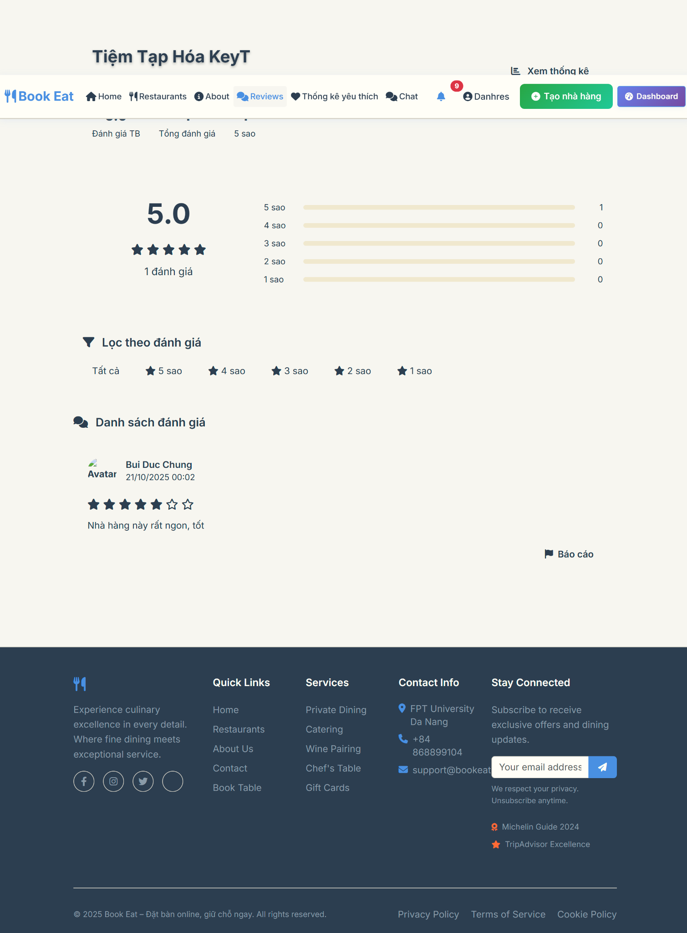

##### b. Database Access

| **Table** | **CRUD** | **Description** |
| --- | --- | --- |
| review | R | Read all reviews for restaurant |
| customer | R | Read customer information |
| users | R | Read user profile information |
| restaurant_profile | R | Read restaurant information |

##### c. SQL Commands

-- Get all reviews for restaurant with customer info

SELECT r.review_id, r.rating, r.comment, r.created_at,

c.customer_id, u.full_name as customer_name, u.profile_image_url

FROM review r

JOIN customer c ON r.customer_id = c.customer_id

JOIN users u ON c.user_id = u.id

WHERE r.restaurant_id = :restaurant_id

ORDER BY r.created_at DESC;

-- Get restaurant average rating and total reviews

SELECT

COALESCE(AVG(rating), 0) as average_rating,

COUNT(*) as total_reviews,

COUNT(CASE WHEN rating = 5 THEN 1 END) as five_star_count,

COUNT(CASE WHEN rating = 4 THEN 1 END) as four_star_count,

COUNT(CASE WHEN rating = 3 THEN 1 END) as three_star_count,

COUNT(CASE WHEN rating = 2 THEN 1 END) as two_star_count,

COUNT(CASE WHEN rating = 1 THEN 1 END) as one_star_count

FROM review

WHERE restaurant_id = :restaurant_id;

-- Filter reviews by rating

SELECT r.*, c.customer_id, u.full_name as customer_name

FROM review r

JOIN customer c ON r.customer_id = c.customer_id

JOIN users u ON c.user_id = u.id

WHERE r.restaurant_id = :restaurant_id

AND r.rating = :rating_filter

ORDER BY r.created_at DESC;

-- Search reviews by content

SELECT r.*, c.customer_id, u.full_name as customer_name

FROM review r

JOIN customer c ON r.customer_id = c.customer_id

JOIN users u ON c.user_id = u.id

WHERE r.restaurant_id = :restaurant_id

AND LOWER(r.comment) LIKE LOWER(CONCAT('%', :search_term, '%'))

ORDER BY r.created_at DESC;

### 8.3 Report Review

##### a. UI Design

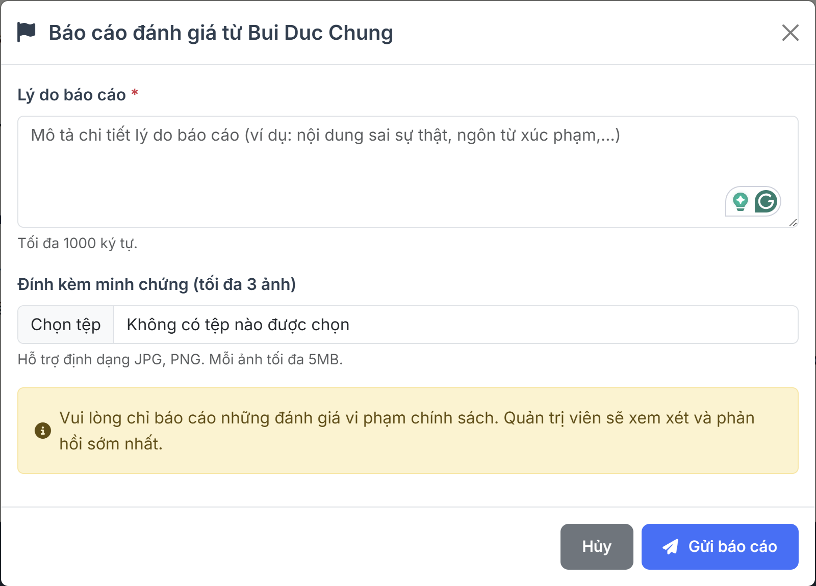

##### b. Database Access

| **Table** | **CRUD** | **Description** |
| --- | --- | --- |
| review_report | C | Create new review report |
| review | R | Read review information |
| restaurant_profile | R | Read restaurant information |
| restaurant_owner | R | Read owner information |
| review_report_evidence | C | Create evidence attachments |

##### c. SQL Commands

-- Create review report

INSERT INTO review_report (review_id, restaurant_id, owner_id, reason_text, status, created_at)

VALUES (:review_id, :restaurant_id, :owner_id, :reason_text, 'PENDING', NOW());

-- Get review information for reporting

SELECT r.*, c.customer_id, u.full_name as customer_name

FROM review r

JOIN customer c ON r.customer_id = c.customer_id

JOIN users u ON c.user_id = u.id

WHERE r.review_id = :review_id;

-- Create evidence attachment

INSERT INTO review_report_evidence (report_id, file_url, content_type, file_size, created_at)

VALUES (:report_id, :file_url, :content_type, :file_size, NOW());

-- Check if review has already been reported

SELECT COUNT(*) FROM review_report

WHERE review_id = :review_id AND restaurant_id = :restaurant_id;

-- Get restaurant owner information

SELECT ro.owner_id, u.full_name as owner_name

FROM restaurant_owner ro

JOIN users u ON ro.user_id = u.id

WHERE ro.owner_id = :owner_id;

## 9. Communication

### 9.1 Customer-Restaurant Chat

##### a. UI Design

##### b. Database Access

| **Table** | **CRUD** | **Description** |
| --- | --- | --- |
| chat_room | C,R,U | Create, read and update chat rooms |
| message | C,R | Create and read chat messages |
| customer | R | Read customer information |
| restaurant_profile | R | Read restaurant information |
| restaurant_owner | R | Read restaurant owner information |
| users | R | Read user information |
| booking | R | Read booking information for context |

##### c. SQL Commands

*Create customer-restaurant chat room  
 INSERT INTO chat_room (room_id, customer_id, restaurant_id, created_at, is_active)  
 VALUES (?, ?, ?, NOW(), true);*

*Get chat room by participants  
 SELECT cr.room_id, cr.customer_id, cr.restaurant_id, cr.created_at, cr.last_message_at  
 FROM chat_room cr  
 WHERE cr.customer_id = (SELECT customer_id FROM customer WHERE user_id = ?)  
 AND cr.restaurant_id = ?  
 AND cr.is_active = true;*

*Send message  
 INSERT INTO message (room_id, sender_id, content, message_type, sent_at, customer_id, owner_id)  
 VALUES (?, ?, ?, ?, NOW(), ?, ?);*

*Get message history  
 SELECT m.message_id, m.sender_id, m.content, m.message_type, m.sent_at, u.full_name AS sender_name  
 FROM message m  
 JOIN users u ON m.sender_id = u.id  
 WHERE m.room_id = ?  
 ORDER BY m.sent_at ASC  
 LIMIT ? OFFSET ?;*

*Update last message time  
 UPDATE chat_room  
 SET last_message_at = NOW()  
 WHERE room_id = ?;*

*Get customer chat rooms  
 SELECT cr.room_id, cr.restaurant_id, cr.last_message_at, rp.restaurant_name, ro.user_id AS owner_id  
 FROM chat_room cr  
 JOIN restaurant_profile rp ON cr.restaurant_id = rp.restaurant_id  
 JOIN restaurant_owner ro ON rp.restaurant_id = ro.restaurant_id  
 WHERE cr.customer_id = ?  
 AND cr.is_active = true  
 ORDER BY cr.last_message_at DESC;*

*Get restaurant chat rooms  
 SELECT cr.room_id, cr.customer_id, cr.last_message_at, c.user_id, u.full_name AS customer_name  
 FROM chat_room cr  
 JOIN customer c ON cr.customer_id = c.customer_id  
 JOIN users u ON c.user_id = u.id  
 WHERE cr.restaurant_id = ?  
 AND cr.is_active = true  
 ORDER BY cr.last_message_at DESC;*

*Mark messages as read  
 UPDATE message  
 SET read_at = NOW()  
 WHERE room_id = ?  
 AND sender_id != ?  
 AND read_at IS NULL;*

### 9.2 Support Chat

##### a. UI Design

##### b. Database Access

| **Table** | **CRUD** | **Description** |
| --- | --- | --- |
| chat_room | C,R,U | Create, read and update admin-restaurant chat rooms |
| message | C,R | Create and read support chat messages |
| users | R | Read admin and restaurant owner information |
| restaurant_profile | R | Read restaurant information |
| restaurant_owner | R | Read restaurant owner information |
| customer | R | Read customer information (if applicable) |
| booking | R | Read booking information for context |

##### c. SQL Commands

## 11. History & Reports

### 11.1 View Booking History

Users can view their booking history including confirmed bookings and waitlist entries with filtering options and detailed information.

##### a. UI Design

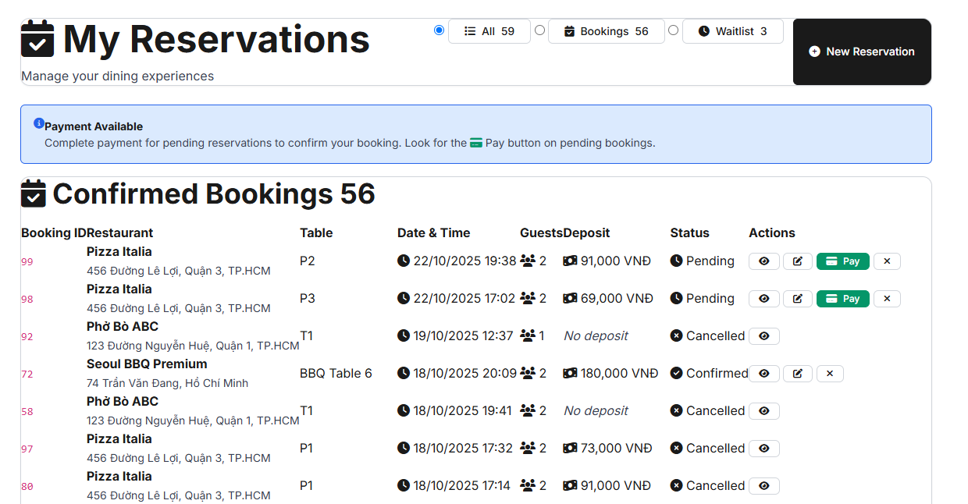

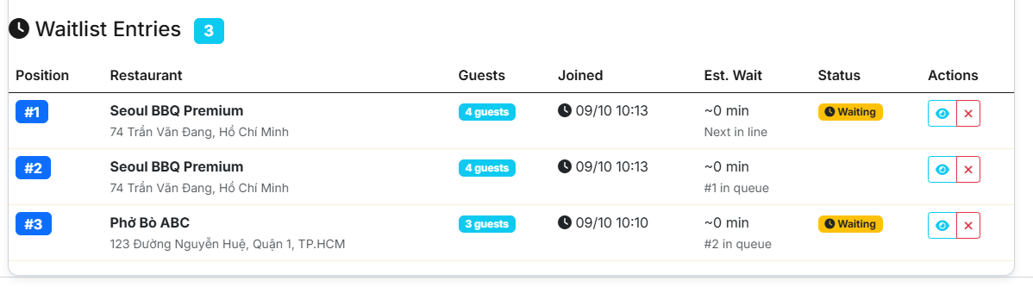

| Field name | Field type | Description |
| --- | --- | --- |
| Page Title | Text | Display text: "My Reservations" with calendar icon |
| Page Subtitle | Text | Display text: "Manage your dining experiences" |
| All Filter Button | Radio Button | Button with text "All" and total count badge showing combined bookings and waitlist entries |
| Bookings Filter Button | Radio Button | Button with text "Bookings" and count badge showing confirmed bookings only |
| Waitlist Filter Button | Radio Button | Button with text "Waitlist" and count badge showing waitlist entries only |
| New Reservation Button | Button | Button with text "New Reservation" - redirects to booking form |
| Payment Info Alert | Alert Box | Display information about payment availability for pending bookings |
| Booking ID Column | Text | Display truncated booking ID with code styling |
| Restaurant Column | Text | Display restaurant name and address |
| Table Column | Badge | Display table name or "No preference" |
| Date Time Column | Text | Display booking date and time in format "dd/MM/yyyy HH:mm" |
| Guests Column | Text | Display number of guests with users icon |
| Deposit Column | Badge | Display deposit amount in VNĐ or "No deposit" |
| Status Column | Badge | Display booking status (Pending, Confirmed, Cancelled, No Show) with appropriate colors |
| View Details Button | Button | Button with eye icon to show booking details modal |
| Edit Button | Button | Button with edit icon to edit booking (if editable) |
| Pay Button | Button | Button with credit card icon for pending bookings with deposit |
| Cancel Button | Button | Button with times icon to cancel booking (if cancellable) |
| Waitlist Position Column | Badge | Display waitlist position number |
| Waitlist Restaurant Column | Text | Display restaurant name and address |
| Waitlist Guests Column | Badge | Display party size with guests text |
| Waitlist Join Time Column | Text | Display join time in format "dd/MM HH:mm" |
| Waitlist Est Wait Column | Text | Display estimated wait time in minutes |
| Waitlist Status Column | Badge | Display waitlist status (Waiting, Called, Cancelled) |
| Waitlist View Details Button | Button | Button with eye icon to show waitlist details modal |
| Waitlist Cancel Button | Button | Button with times icon to cancel waitlist entry |
| Booking Details Modal | Modal | Modal showing detailed booking information including dishes and services |
| Cancel Confirmation Modal | Modal | Modal for confirming booking cancellation |
| Waitlist Details Modal | Modal | Modal showing detailed waitlist information |

##### b. Database Access

| Table | CRUD | Description |
| --- | --- | --- |
| bookings | R | Read all bookings for current customer ordered by booking time descending |
| waitlist | R | Read all waitlist entries for current customer |
| restaurants | R | Read restaurant information for each booking and waitlist entry |
| tables | R | Read table information for bookings |
| dishes | R | Read dish information for bookings and waitlist entries |
| services | R | Read service information for bookings and waitlist entries |

##### c. SQL Commands

*Get all bookings for customer ordered by booking time descending*

*SELECT b., r.restaurant_name, r.address, t.table_name FROM bookings b LEFT JOIN restaurants r ON b.restaurant_id = r.restaurant_id LEFT JOIN tables t ON b.table_id = t.table_id WHERE b.customer_id = ? ORDER BY b.booking_time DESC*

*Get all waitlist entries for customer*

*SELECT w., r.restaurant_name, r.address FROM waitlist w JOIN restaurants r ON w.restaurant_id = r.restaurant_id WHERE w.customer_id = ? ORDER BY w.join_time DESC*

*Get booking details with dishes and services*

*SELECT b., r.restaurant_name, r.address, t.table_name, d.dish_name, d.price, d.quantity, s.service_name, s.price as service_price FROM bookings b LEFT JOIN restaurants r ON b.restaurant_id = r.restaurant_id LEFT JOIN tables t ON b.table_id = t.table_id LEFT JOIN booking_dishes bd ON b.booking_id = bd.booking_id LEFT JOIN dishes d ON bd.dish_id = d.dish_id LEFT JOIN booking_services bs ON b.booking_id = bs.booking_id LEFT JOIN services s ON bs.service_id = s.service_id WHERE b.booking_id = ?*

*Get waitlist details with dishes and services*

*SELECT w., r.restaurant_name, r.address, d.dish_name, d.price, d.quantity, s.service_name, s.price as service_price FROM waitlist w JOIN restaurants r ON w.restaurant_id = r.restaurant_id LEFT JOIN waitlist_dishes wd ON w.waitlist_id = wd.waitlist_id LEFT JOIN dishes d ON wd.dish_id = d.dish_id LEFT JOIN waitlist_services ws ON w.waitlist_id = ws.waitlist_id LEFT JOIN services s ON ws.service_id = s.service_id WHERE w.waitlist_id = ?*

*Cancel booking by booking ID*

*UPDATE bookings SET status = 'CANCELLED', updated_at = CURRENT_TIMESTAMP WHERE booking_id = ? AND customer_id = ?*

*Cancel waitlist entry by waitlist ID*

*UPDATE waitlist SET status = 'CANCELLED', updated_at = CURRENT_TIMESTAMP WHERE waitlist_id = ? AND customer_id = ?*

### 11.2 View Revenue Analytics

##### a. UI Design

Chưa xong

| Field Name | Field Type | Description |
| --- | --- | --- |
| Date Range Selector | Date Input | This field allows restaurant owners to select date range for analytics (from date, to date, predefined periods) |
| Time Period Dropdown | Select | This field displays options: Today, This Week, This Month, This Quarter, This Year, Custom |
| Comparison Dropdown | Select | This field displays options: No Comparison, Previous Period, Same Period Last Year |
| Total Revenue Card | Display | This field displays text: Total revenue amount with percentage change from previous period |
| Total Bookings Card | Display | This field displays text: Number of completed bookings with percentage change |
| Average Guests Card | Display | This field displays text: Average number of guests per booking with percentage change |
| Occupancy Rate Card | Display | This field displays text: Table occupancy percentage with percentage change |
| Revenue Chart | Chart | This field displays line chart showing daily revenue trends over selected period |
| Bookings Chart | Chart | This field displays bar chart showing booking distribution by hour |
| Customer Group Chart | Chart | This field displays doughnut chart showing customer group distribution (1-2 people, 3-4 people, etc.) |
| Cancellation Rate Chart | Chart | This field displays line chart showing cancellation rate trends |
| Report Tabs | Tab Navigation | This field displays tabs: Revenue, Bookings, Customers, Tables for detailed reports |
| Revenue Report Table | Table | This field displays detailed daily revenue data with comparisons |
| Bookings Report Table | Table | This field displays hourly booking statistics with occupancy rates |
| Customer Report Table | Table | This field displays customer group analysis with average revenue per group |
| Table Performance Table | Table | This field displays individual table usage statistics and revenue |
| Export Excel Button | Button | This button allows exporting analytics data to Excel format |
| Export PDF Button | Button | This button allows exporting analytics data to PDF format |
| Send Email Button | Button | This button allows sending analytics report via email |

##### b. Database Access

| Table | CRUD | Description |
| --- | --- | --- |
| restaurant_balance | R | Read total revenue, commission, and balance data for analytics |
| booking | R | Read booking data for revenue calculations and booking statistics |
| restaurant_table | R | Read table data for occupancy rate calculations |
| restaurant_profile | R | Read restaurant information for analytics context |
| withdrawal_request | R | Read withdrawal history for financial analytics |
| payout_transaction | R | Read payout transaction history for financial tracking |

##### c. SQL Commands

*SELECT rb.total_revenue, rb.total_bookings_completed, rb.available_balance, rb.total_commission FROM restaurant_balance rb WHERE rb.restaurant_id = ? AND rb.created_at >= ? AND rb.created_at <= ?*

*SELECT COUNT() as total_bookings, SUM(deposit_amount) as total_revenue, AVG(guest_count) as avg_guests FROM booking b WHERE b.restaurant_restaurant_id = ? AND b.status = 'COMPLETED' AND b.booking_time >= ? AND b.booking_time <= ?*

*SELECT DATE(booking_time) as booking_date, COUNT() as daily_bookings, SUM(deposit_amount) as daily_revenue FROM booking b WHERE b.restaurant_restaurant_id = ? AND b.status = 'COMPLETED' AND b.booking_time >= ? AND b.booking_time <= ? GROUP BY DATE(booking_time) ORDER BY booking_date*

*SELECT EXTRACT(HOUR FROM booking_time) as hour, COUNT() as bookings_count FROM booking b WHERE b.restaurant_restaurant_id = ? AND b.status = 'COMPLETED' AND b.booking_time >= ? AND b.booking_time <= ? GROUP BY EXTRACT(HOUR FROM booking_time) ORDER BY hour*

*SELECT CASE WHEN guest_count <= 2 THEN '1-2 people' WHEN guest_count <= 4 THEN '3-4 people' WHEN guest_count <= 6 THEN '5-6 people' ELSE '7+ people' END as customer_group, COUNT() as group_count, AVG(deposit_amount) as avg_revenue FROM booking b WHERE b.restaurant_restaurant_id = ? AND b.status = 'COMPLETED' AND b.booking_time >= ? AND b.booking_time <= ? GROUP BY customer_group ORDER BY group_count DESC*

*SELECT rt.table_name, COUNT(b.booking_id) as usage_count, SUM(b.deposit_amount) as table_revenue FROM restaurant_table rt LEFT JOIN booking b ON rt.table_id = b.table_table_id AND b.status = 'COMPLETED' AND b.booking_time >= ? AND b.booking_time <= ? WHERE rt.restaurant_restaurant_id = ? GROUP BY rt.table_id, rt.table_name ORDER BY usage_count DESC*

*SELECT COUNT() as total_tables, COUNT(CASE WHEN rt.status = 'AVAILABLE' THEN 1 END) as available_tables FROM restaurant_table rt WHERE rt.restaurant_restaurant_id = ?*

*SELECT wr.amount, wr.status, wr.created_at FROM withdrawal_request wr WHERE wr.restaurant_restaurant_id = ? AND wr.created_at >= ? AND wr.created_at <= ? ORDER BY wr.created_at DESC*

*SELECT pt.amount, pt.status, pt.created_at FROM payout_transaction pt WHERE pt.restaurant_restaurant_id = ? AND pt.created_at >= ? AND pt.created_at <= ? ORDER BY pt.created_at DESC*

## 12. User & Restaurant Governance

### 12.1 View User List

##### a. UI Design

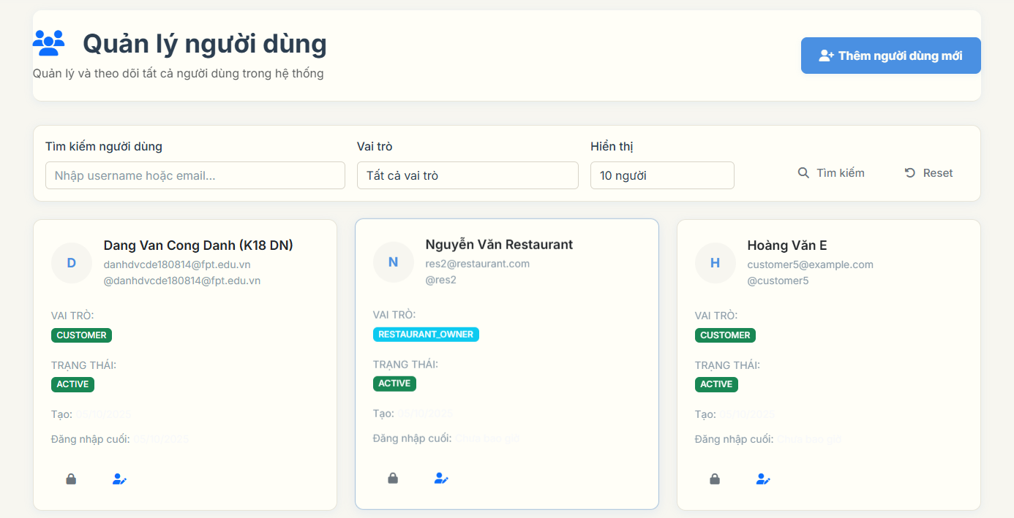

| Field Name | Field Type | Description |
| --- | --- | --- |
| Page Title | Display | This field displays text: "Quản lý người dùng - BookEat Admin" |
| Add User Button | Button | This button allows admin to create new user account |
| Search Input | Input | This field allows admin to search users by username or email |
| Role Filter | Select | This field displays options: All Roles, Admin, Customer, Restaurant Owner |
| Page Size Select | Select | This field displays options: 10, 20, 50 users per page |
| Search Button | Button | This button triggers user search with current filters |
| Reset Button | Button | This button clears all filters and shows all users |
| User Avatar | Display | This field displays user's first letter of name as avatar |
| User Name | Display | This field displays text: User's full name or username |
| User Email | Display | This field displays text: User's email address |
| User Username | Display | This field displays text: User's username with @ prefix |
| Role Badge | Display | This field displays text: User's role (ADMIN, CUSTOMER, RESTAURANT_OWNER) with color coding |
| Status Badge | Display | This field displays text: User's status (ACTIVE, INACTIVE) with color coding |
| Created Date | Display | This field displays text: User's account creation date |
| Last Login | Display | This field displays text: User's last login date or "Never" |
| Toggle Active Button | Button | This button allows admin to activate/deactivate user account |
| Edit Button | Button | This button allows admin to edit user information |
| Restore Button | Button | This button allows admin to restore deleted user account |
| Pagination | Navigation | This field displays page numbers for navigating through user list |
| Empty State | Display | This field displays text: "No users found" when no users match criteria |

##### b. Database Access

| Table | CRUD | Description |
| --- | --- | --- |
| users | R | Read all user records with pagination, filtering, and sorting |
| users | C | Create new user account with admin privileges |
| users | U | Update user information, role, and status |
| users | D | Soft delete user account (set deletedAt timestamp) |

##### c. SQL Commands

*SELECT * FROM users WHERE (username ILIKE '%search_term%' OR email ILIKE '%search_term%') AND role = 'CUSTOMER' ORDER BY created_at DESC LIMIT 20 OFFSET 0*

*SELECT * FROM users WHERE role = 'ADMIN' ORDER BY created_at DESC LIMIT 10 OFFSET 0*

*SELECT * FROM users WHERE active = true AND email_verified = true ORDER BY last_login DESC LIMIT 20 OFFSET 0*

*SELECT COUNT() FROM users WHERE role = 'CUSTOMER' AND active = true*

*SELECT * FROM users WHERE deleted_at IS NULL ORDER BY created_at DESC LIMIT 20 OFFSET 0*

*SELECT * FROM users WHERE role = 'RESTAURANT_OWNER' AND active = false ORDER BY created_at DESC*

*UPDATE users SET active = false, email_verified = false WHERE id = 'user_uuid' AND deleted_at IS NULL*

*UPDATE users SET active = true, email_verified = true WHERE id = 'user_uuid' AND deleted_at IS NULL*

*UPDATE users SET username = 'new_username', email = 'new_email@example.com', full_name = 'New Full Name', phone_number = '0123456789', address = 'New Address', role = 'CUSTOMER' WHERE id = 'user_uuid'*

*INSERT INTO users (id, username, email, password, full_name, phone_number, address, role, active, email_verified, created_at, updated_at) VALUES (gen_random_uuid(), 'new_user', 'user@example.com', 'encoded_password', 'Full Name', '0123456789', 'Address', 'CUSTOMER', true, false, now(), now())*

### 12.2 View User Profile

##### a. UI Design

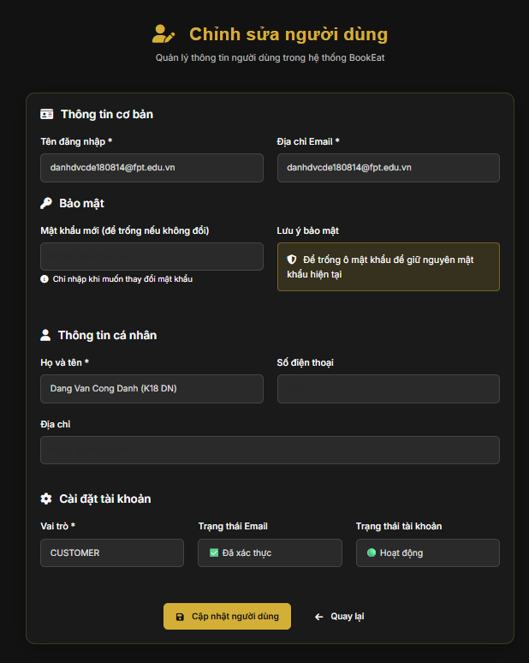

| Field Name | Field Type | Description |
| --- | --- | --- |
| Page Title | Display | This field displays text: "User Form - BookEat Admin" |
| Back to Users Button | Button | This button navigates back to user list page |
| User Avatar | Display | This field displays user's first letter of name as avatar |
| Username Input | Input | This field allows admin to edit user's username |
| Email Input | Input | This field allows admin to edit user's email address |
| Full Name Input | Input | This field allows admin to edit user's full name |
| Phone Number Input | Input | This field allows admin to edit user's phone number |
| Address Input | Input | This field allows admin to edit user's address |
| Role Select | Select | This field displays options: ADMIN, CUSTOMER, RESTAURANT_OWNER |
| Email Verified Checkbox | Checkbox | This field allows admin to set email verification status |
| Active Status Checkbox | Checkbox | This field allows admin to set user active status |
| New Password Input | Input | This field allows admin to set new password for user |
| Confirm Password Input | Input | This field allows admin to confirm new password |
| Save Changes Button | Button | This button saves all user profile changes |
| Cancel Button | Button | This button cancels changes and returns to user list |
| User ID Display | Display | This field displays text: User's unique identifier |
| Created Date Display | Display | This field displays text: User's account creation date |
| Last Modified Display | Display | This field displays text: User's last modification date |
| Current Status Display | Display | This field displays text: User's current active and email verification status |

##### b. Database Access

| Table | CRUD | Description |
| --- | --- | --- |
| users | R | Read specific user record by ID for editing |
| users | U | Update user profile information, role, and status |
| users | R | Read user creation and modification timestamps |

##### c. SQL Commands

*SELECT * FROM users WHERE id = 'user_uuid' AND deleted_at IS NULL*

*SELECT username, email, full_name, phone_number, address, role, active, email_verified, created_at, updated_at FROM users WHERE id = 'user_uuid'*

*UPDATE users SET username = 'new_username', email = 'new_email@example.com', full_name = 'Updated Full Name', phone_number = '0123456789', address = 'Updated Address', role = 'CUSTOMER', active = true, email_verified = true, updated_at = now() WHERE id = 'user_uuid'*

*UPDATE users SET password = 'new_encoded_password', updated_at = now() WHERE id = 'user_uuid'*

*SELECT COUNT() FROM users WHERE username = 'new_username' AND id != 'user_uuid'*

*SELECT COUNT() FROM users WHERE email = 'new_email@example.com' AND id != 'user_uuid'*

*SELECT created_at, updated_at, last_login FROM users WHERE id = 'user_uuid'*

*UPDATE users SET active = false, email_verified = false, updated_at = now() WHERE id = 'user_uuid'*

*UPDATE users SET active = true, email_verified = true, updated_at = now() WHERE id = 'user_uuid'*

### 12.3 Ban/UnBan User

##### a. UI Design

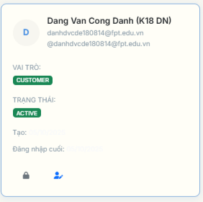

| Field Name | Field Type | Description |
| --- | --- | --- |
| Toggle Active Button | Button | This button allows admin to ban/unban user account with lock/unlock icon |
| User Status Badge | Display | This field displays text: User's current status (ACTIVE/INACTIVE) with color coding |
| Ban Confirmation | Modal | This field displays confirmation dialog when admin clicks ban button |
| Unban Confirmation | Modal | This field displays confirmation dialog when admin clicks unban button |
| Status Change Message | Toast | This field displays success/error message after ban/unban action |
| Loading Spinner | Display | This field displays loading animation during ban/unban process |
| User Avatar | Display | This field displays user's first letter of name as avatar |
| User Name | Display | This field displays text: User's full name or username |
| Current Status | Display | This field displays text: User's current active and email verification status |
| Ban Reason Input | Input | This field allows admin to enter reason for banning user |
| Ban Notes Input | Input | This field allows admin to enter additional notes for ban action |
| Confirm Ban Button | Button | This button confirms ban action and deactivates user account |
| Cancel Ban Button | Button | This button cancels ban action and keeps user account active |
| Restore Button | Button | This button allows admin to restore deleted user account |
| Ban History | Display | This field displays text: History of ban/unban actions for user |
| Ban Date | Display | This field displays text: Date and time when user was banned |
| Ban Reason | Display | This field displays text: Reason provided for banning user |
| Banned By | Display | This field displays text: Admin who performed ban action |

##### b. Database Access

| Table | CRUD | Description |
| --- | --- | --- |
| users | R | Read user's current active and email verification status |
| users | U | Update user's active status and email verification for ban/unban |
| users | R | Read user's ban history and modification timestamps |
| users | U | Restore deleted user account by clearing deleted_at timestamp |

##### c. SQL Commands

*SELECT active, email_verified, updated_at FROM users WHERE id = 'user_uuid' AND deleted_at IS NULL*

*UPDATE users SET active = false, email_verified = false, updated_at = now() WHERE id = 'user_uuid' AND deleted_at IS NULL*

*UPDATE users SET active = true, email_verified = true, updated_at = now() WHERE id = 'user_uuid' AND deleted_at IS NULL*

*SELECT COUNT() FROM users WHERE id = 'user_uuid' AND active = false AND email_verified = false*

*SELECT COUNT() FROM users WHERE id = 'user_uuid' AND active = true AND email_verified = true*

*SELECT username, email, full_name, active, email_verified, created_at, updated_at FROM users WHERE id = 'user_uuid'*

*UPDATE users SET deleted_at = NULL, active = true, email_verified = true, updated_at = now() WHERE id = 'user_uuid' AND deleted_at IS NOT NULL*

*SELECT u.username, u.email, u.active, u.email_verified, u.updated_at FROM users u WHERE u.id = 'user_uuid' AND u.deleted_at IS NULL*

*UPDATE users SET active = false, email_verified = false, updated_at = now() WHERE id = 'user_uuid' AND active = true AND email_verified = true*

*UPDATE users SET active = true, email_verified = true, updated_at = now() WHERE id = 'user_uuid' AND active = false AND email_verified = false*

### 12.4 View Restaurant List (chưa có trang này)

##### a. UI Design

##### b. Database Access

##### c. SQL Commands

### 12.5 View Restaurant Detail (chưa có trang này)

##### a. UI Design

##### b. Database Access

##### c. SQL Commands

### 12.6 Approve Restaurant Registration

Chưa có ảnh

##### a. UI Design

| Field Name | Field Type | Description |
| --- | --- | --- |
| Page Title | Display | This field displays text: "Duyệt và Quản lý Đăng ký Nhà hàng |
| Restaurant Name | Display | This field displays text: Restaurant's business name |
| Restaurant Owner | Display | This field displays text: Restaurant owner's name and contact information |
| Restaurant Address | Display | This field displays text: Restaurant's physical address |
| Restaurant Phone | Display | This field displays text: Restaurant's contact phone number |
| Restaurant Email | Display | This field displays text: Restaurant's business email |
| Cuisine Type | Display | This field displays text: Type of cuisine served |
| Opening Hours | Display | This field displays text: Restaurant's operating hours |
| Average Price | Display | This field displays text: Average price range |
| Website URL | Display | This field displays text: Restaurant's website URL |
| Registration Date | Display | This field displays text: Date when restaurant registered |
| Status Badge | Display | This field displays text: Restaurant's current approval status |
| Approval Reason Input | Input | This field allows admin to enter reason for approval |
| Rejection Reason Input | Input | This field allows admin to enter reason for rejection |
| Approve Button | Button | This button approves restaurant registration |
| Reject Button | Button | This button rejects restaurant registration |
| Suspend Button | Button | This button suspends approved restaurant |
| View Details Button | Button | This button opens detailed restaurant information |
| Back to List Button | Button | This button returns to restaurant requests list |
| Success Message | Toast | This field displays success message after approval |
| Error Message | Toast | This field displays error message if approval fails |

##### b. Database Access

| Table | CRUD | Description |
| --- | --- | --- |
| restaurant_profile | R | Read restaurant profile details for approval review |
| restaurant_profile | U | Update restaurant approval status to APPROVED |
| restaurant_profile | U | Update restaurant approval status to REJECTED |
| restaurant_profile | U | Update restaurant approval status to SUSPENDED |
| restaurant_profile | U | Update approval reason, approved by, and approval date |
| restaurant_owner | R | Read restaurant owner information |
| user | R | Read restaurant owner user details |

c. SQL Commands

*SELECT rp., ro.full_name as owner_name, u.email as owner_email FROM restaurant_profile rp LEFT JOIN restaurant_owner ro ON rp.restaurant_id = ro.restaurant_restaurant_id LEFT JOIN user u ON ro.user_id = u.id WHERE rp.restaurant_id = 'restaurant_id'*

*UPDATE restaurant_profile SET approval_status = 'APPROVED', approval_reason = 'Approved by admin', approved_by = 'admin_username', approved_at = now(), updated_at = now() WHERE restaurant_id = 'restaurant_id'*

*UPDATE restaurant_profile SET approval_status = 'REJECTED', rejection_reason = 'Rejected by admin', rejected_by = 'admin_username', rejected_at = now(), updated_at = now() WHERE restaurant_id = 'restaurant_id'*

*UPDATE restaurant_profile SET approval_status = 'SUSPENDED', suspension_reason = 'Suspended by admin', suspended_by = 'admin_username', suspended_at = now(), updated_at = now() WHERE restaurant_id = 'restaurant_id'*

*SELECT approval_status, approval_reason, approved_by, approved_at FROM restaurant_profile WHERE restaurant_id = 'restaurant_id'*

*SELECT COUNT() FROM restaurant_profile WHERE approval_status = 'PENDING'*

*SELECT COUNT() FROM restaurant_profile WHERE approval_status = 'APPROVED'*

*SELECT COUNT() FROM restaurant_profile WHERE approval_status = 'REJECTED'*

*SELECT COUNT() FROM restaurant_profile WHERE approval_status = 'SUSPENDED'*

*UPDATE restaurant_profile SET approval_status = 'APPROVED', approval_reason = 'Restaurant meets all requirements', approved_by = 'admin', approved_at = now(), updated_at = now() WHERE restaurant_id = 'restaurant_id' AND approval_status = 'PENDING'*

## 13. Restaurant Operations

### 13.1 Register Restaurant

##### a. UI Design

##### b. Database Access

| **Table** | **CRUD** | **Description** |
| --- | --- | --- |
| restaurant_profile | C | Create restaurant profile |
| restaurant_owner | C,R | Create and read restaurant owner |
| users | R,U | Read and update user information |
| restaurant_media | C | Create restaurant media records |
| restaurant_notification | C | Create notification for admin |
| audit_log | C | Create audit log for registration |

##### c. SQL Commands

*Create restaurant profile  
 INSERT INTO restaurant_profile (restaurant_name, phone, website_url, address, cuisine_type, average_price, description, operating_hours, capacity, amenities, payment_methods, owner_id, status, created_at, updated_at)  
 VALUES (?, ?, ?, ?, ?, ?, ?, ?, ?, ?, ?, ?, 'PENDING', NOW(), NOW());*

*Create restaurant owner  
 INSERT INTO restaurant_owner (user_id, business_license, tax_code, bank_account, created_at, updated_at)  
 VALUES (?, ?, ?, ?, NOW(), NOW());*

*Get user by ID  
 SELECT user_id, username, email, full_name, phone_number, address, role, active, email_verified  
 FROM users  
 WHERE user_id = ?;*

*Check if user is restaurant owner  
 SELECT ro.owner_id  
 FROM restaurant_owner ro  
 WHERE ro.user_id = ?;*

*Upload restaurant logo  
 INSERT INTO restaurant_media (restaurant_id, type, url, created_at)  
 VALUES (?, 'logo', ?, NOW());*

*Upload restaurant cover  
 INSERT INTO restaurant_media (restaurant_id, type, url, created_at)  
 VALUES (?, 'cover', ?, NOW());*

*Create registration notification  
 INSERT INTO restaurant_notification (restaurant_id, type, title, message, created_at, is_read)  
 VALUES (?, 'REGISTRATION', 'New Restaurant Registration', 'A new restaurant has been registered and requires approval', NOW(), false);*

*Check restaurant name uniqueness  
 SELECT COUNT(*)  
 FROM restaurant_profile  
 WHERE restaurant_name = ?  
 AND status != 'REJECTED';*

*Get restaurant by owner  
 SELECT rp.restaurant_id, rp.restaurant_name, rp.status, rp.created_at  
 FROM restaurant_profile rp  
 WHERE rp.owner_id = ?  
 ORDER BY rp.created_at DESC;*

*Update restaurant status  
 UPDATE restaurant_profile  
 SET status = ?, updated_at = NOW()  
 WHERE restaurant_id = ?;*

### 13.2 Manage Restaurant Profile

##### a. UI Design

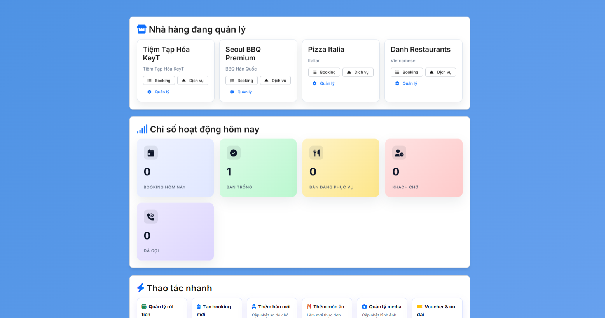

##### b. Database Access

| **Table** | **CRUD** | **Description** |
| --- | --- | --- |
| restaurant_profile | R,U | Read and update restaurant profile |
| restaurant_owner | R | Read restaurant owner information |
| restaurant_media | C,R,U,D | Create, read, update and delete media |
| users | R | Read user information |
| restaurant_table | R | Read restaurant tables |
| booking | R | Read booking statistics |
| audit_log | C | Create audit log for changes |

##### c. SQL Commands

##### 

##### *Get restaurant profile by ID*

##### *SELECT rp.restaurant_id, rp.restaurant_name, rp.address, rp.phone, rp.description, rp.cuisine_type, rp.opening_hours, rp.average_price, rp.website_url, rp.status, rp.created_at, rp.updated_at*

##### *FROM restaurant_profile rp*

##### *WHERE rp.restaurant_id = ?;*

##### 

##### *Update restaurant profile*

##### *UPDATE restaurant_profile*

##### *SET restaurant_name = ?, address = ?, phone = ?, description = ?, cuisine_type = ?, opening_hours = ?, average_price = ?, website_url = ?, updated_at = NOW()*

##### *WHERE restaurant_id = ?;*

##### 

##### *Get restaurant media*

##### *SELECT rm.media_id, rm.type, rm.url, rm.created_at*

##### *FROM restaurant_media rm*

##### *WHERE rm.restaurant_id = ?*

##### *ORDER BY rm.created_at DESC;*

##### 

##### *Upload restaurant logo*

##### *INSERT INTO restaurant_media (restaurant_id, type, url, created_at)*

##### *VALUES (?, 'logo', ?, NOW());*

##### 

##### *Upload restaurant cover*

##### *INSERT INTO restaurant_media (restaurant_id, type, url, created_at)*

##### *VALUES (?, 'cover', ?, NOW());*

##### 

##### *Upload gallery image*

##### *INSERT INTO restaurant_media (restaurant_id, type, url, created_at)*

##### *VALUES (?, 'gallery', ?, NOW());*

##### 

##### *Delete restaurant media*

##### *DELETE FROM restaurant_media*

##### *WHERE media_id = ? AND restaurant_id = ?;*

##### 

##### *Get restaurant statistics*

##### *SELECT COUNT(*) AS total_tables,*

##### *COUNT(CASE WHEN status = 'AVAILABLE' THEN 1 END) AS available_tables,*

##### *COUNT(CASE WHEN status = 'OCCUPIED' THEN 1 END) AS occupied_tables*

##### *FROM restaurant_table*

##### *WHERE restaurant_id = ?;*

##### 

##### *Get booking statistics*

##### *SELECT COUNT(*) AS total_bookings,*

##### *COUNT(CASE WHEN status = 'CONFIRMED' THEN 1 END) AS confirmed_bookings,*

##### *COUNT(CASE WHEN status = 'COMPLETED' THEN 1 END) AS completed_bookings*

##### *FROM booking*

##### *WHERE restaurant_id = ?;*

##### 

##### *Check restaurant ownership*

##### *SELECT COUNT(*)*

##### *FROM restaurant_profile rp*

##### *JOIN restaurant_owner ro ON rp.owner_id = ro.owner_id*

##### *WHERE rp.restaurant_id = ? AND ro.user_id = ?;*

# IV. Appendix

## 1. Assumptions & Dependencies

## Assumptions

| **ID** | **Assumption** | **Description** |
| --- | --- | --- |
| AS-01 | Internet Connectivity | Users have stable internet connection when accessing the restaurant booking system and making reservations. |
| AS-02 | Restaurant Operating Hours | Restaurants maintain consistent operating hours and update their availability in real-time through the system. |
| AS-03 | Payment Gateway Availability | PayOS payment gateway maintains stable service availability and API uptime for processing deposits and refunds. |
| AS-04 | Email Service Reliability | SMTP email service (Gmail) remains available for sending verification emails, booking confirmations, and notifications. |
| AS-05 | Google OAuth Service | Google OAuth service maintains stable authentication endpoints and user profile data access. |
| AS-06 | Cloudinary Image Storage | Cloudinary service provides reliable image storage and CDN delivery for restaurant photos and user avatars. |
| AS-07 | Database Performance | PostgreSQL database maintains adequate performance for handling concurrent booking requests and user operations. |
| AS-08 | User Device Compatibility | Users access the system through modern web browsers with JavaScript enabled and responsive design support. |
| AS-09 | Restaurant Owner Cooperation | Restaurant owners actively manage their profiles, update table availability, and respond to booking requests promptly. |
| AS-10 | Admin Availability | System administrators are available to approve restaurant registrations and handle withdrawal requests within reasonable timeframes. |
| AS-11 | Business License Validity | Restaurant owners provide valid business licenses and maintain compliance with local regulations. |
| AS-12 | Review Authenticity | Customer reviews reflect genuine dining experiences and are not manipulated for competitive advantage. |
| AS-13 | Currency Stability | Vietnamese Dong (VND) remains the primary currency with stable exchange rates for pricing calculations. |
| AS-14 | Legal Compliance | System operations comply with Vietnamese data protection laws and online payment regulations. |
| AS-15 | Scalability Requirements | System can handle expected user growth and restaurant expansion without major architectural changes. |

## Dependencies

| **ID** | **Dependency** | **Description** |
| --- | --- | --- |
| DE-01 | PayOS Payment Gateway | System depends on PayOS API for processing customer deposits, handling refunds, and managing restaurant payouts. Any changes to PayOS API or service disruption will impact payment functionality. |
| DE-02 | Google OAuth Service | User authentication depends on Google OAuth 2.0 service for social login functionality. Changes to Google's OAuth policies or API endpoints will require system updates. |
| DE-03 | SMTP Email Service | Email notifications depend on Gmail SMTP service for sending verification emails, booking confirmations, password reset links, and system notifications. |
| DE-04 | Cloudinary Image Service | Restaurant and user image storage depends on Cloudinary service for upload, processing, and CDN delivery. Service changes or outages will affect image functionality. |
| DE-05 | PostgreSQL Database | All system data persistence depends on PostgreSQL database. Database performance, availability, and backup procedures are critical for system operation. |
| DE-06 | Spring Boot Framework | System architecture depends on Spring Boot 3.x framework for web application development, security, and data access layers. |
| DE-07 | Thymeleaf Template Engine | Frontend rendering depends on Thymeleaf template engine for server-side HTML generation and dynamic content display. |
| DE-08 | Bootstrap 5 CDN | UI responsiveness and styling depend on Bootstrap 5 CDN for consistent cross-browser compatibility and mobile responsiveness. |
| DE-09 | Font Awesome CDN | Icon display depends on Font Awesome CDN for consistent iconography across the user interface. |
| DE-10 | WebSocket Service | Real-time chat functionality depends on WebSocket implementation for customer-restaurant communication and admin support chat. |
| DE-11 | Rate Limiting Service | API security depends on Bucket4j rate limiting service to prevent abuse and ensure system stability. |
| DE-12 | Java 17+ Runtime | System execution depends on Java 17 or higher runtime environment for application deployment and operation. |
| DE-13 | Maven Build Tool | Project build and dependency management depends on Maven for compiling, packaging, and deploying the application. |
| DE-14 | Hosting Infrastructure | System deployment depends on reliable hosting infrastructure (Render.com) for application availability and performance. |
| DE-15 | Domain and SSL Certificate | Web application access depends on valid domain registration and SSL certificate for secure HTTPS communication. |

## 2. Limitations & Exclusions

*Limitations*

| **ID** | **Category** | **Limitation** |
| --- | --- | --- |
| LI-01 | Functionality | The system supports only online table reservations; walk-in customers are not managed within this system. |
| LI-02 | Scope | The system manages only one restaurant per restaurant owner account. Multi-restaurant management for a single owner is not supported. |
| LI-03 | Integration | The system does not guarantee real-time synchronization with external POS (Point of Sale) systems or third-party restaurant management software. |
| LI-04 | Payment | The system only supports PayOS payment gateway for deposits and withdrawals. Alternative payment methods are not integrated. |
| LI-05 | Geography | The system is designed for Vietnamese market with VND currency and Vietnamese business regulations. International expansion is not considered. |
| LI-06 | Language | The system interface is primarily in Vietnamese with limited English support. Multi-language functionality is not implemented. |
| LI-07 | Capacity | The system supports maximum 20 guests per table reservation. Large group bookings beyond this limit require special handling. |
| LI-08 | Time Range | Restaurant booking time slots are limited to 30-minute intervals. Custom time slots are not supported. |
| LI-09 | Advance Booking | Maximum advance booking period is 30 days. Long-term reservations beyond this period are not supported. |
| LI-10 | File Upload | Image uploads are limited to 5MB per file with support for JPG, PNG, and GIF formats only. |
| LI-11 | Session Management | User sessions expire after 24 hours of inactivity. Longer session persistence is not supported. |
| LI-12 | Rate Limiting | API requests are limited to 5 attempts per minute per IP address to prevent abuse. |
| LI-13 | Email Domains | User registration is restricted to specific email domains (@gmail.com, @outlook.com.vn, @yahoo.com, @hotmail.com, @student.ctu.edu.vn, @ctu.edu.vn). |
| LI-14 | Phone Numbers | Vietnamese phone numbers must start with 03, 05, 07, 08, or 09. International phone numbers are not supported. |
| LI-15 | Password Reset | Password reset tokens expire after 1 hour. Longer validity periods are not supported. |

Exclusions

| **ID** | **Category** | **Exclusion** |
| --- | --- | --- |
| EX-01 | Mobile Application | No native mobile application (iOS/Android) is developed. Only responsive web application is provided. |
| EX-02 | Loyalty Program | No customer loyalty program, membership points, or reward system is implemented. |
| EX-03 | Staff Management | Staff payroll, attendance tracking, or employee management features are not included. |
| EX-04 | Inventory Management | Restaurant inventory management, stock tracking, or supply chain features are out of scope. |
| EX-05 | Food Delivery | Food delivery service integration or delivery tracking functionality is not provided. |
| EX-06 | Online Menu Ordering | Online food ordering and menu item selection for takeaway is not supported. |
| EX-07 | Multi-Branch Support | Chain restaurant management with multiple branches under single ownership is not implemented. |
| EX-08 | Franchise Management | Franchise management features for restaurant chains are not included. |
| EX-09 | Financial Reporting | Advanced financial reporting, tax calculations, or accounting integration is not provided. |
| EX-10 | Marketing Tools | Email marketing campaigns, promotional tools, or customer segmentation features are not implemented. |
| EX-11 | Social Media Integration | Social media login (Facebook, Twitter) or sharing features are not included. |
| EX-12 | Offline Mode | The system does not support offline functionality when internet connectivity is lost. |
| EX-13 | Voice Integration | Voice commands or voice-based booking features are not implemented. |
| EX-14 | Video Chat | Video call functionality between customers and restaurant staff is not provided. |
| EX-15 | Advanced Analytics | Business intelligence, predictive analytics, or machine learning features are not included. |
| EX-16 | Third-Party Integrations | Integration with external booking platforms (OpenTable, Resy) is not supported. |
| EX-17 | Multi-Currency | Support for multiple currencies or international payment methods is not implemented. |
| EX-18 | White-Label Solution | White-label or customizable branding options for restaurant owners are not provided. |
| EX-19 | API for Third Parties | Public API for third-party developers is not exposed in this version. |
| EX-20 | Advanced Search | AI-powered restaurant recommendations or advanced search algorithms are not implemented. |

## 3. Business Rules

Constraints

| **ID** | **Category** | **Business Rule** | **Description** |
| --- | --- | --- | --- |
| BR-01 | Constraints | Username Validation | Username must be between 3-50 characters, containing only alphanumeric characters and underscores. |
| BR-02 | Constraints | Password Complexity | Password must be at least 8 characters with uppercase, lowercase, digit, and special character. |
| BR-03 | Constraints | Email Domain Validation | Email must belong to allowed domains: @gmail.com, @outlook.com.vn, @yahoo.com, @hotmail.com, @student.ctu.edu.vn, @ctu.edu.vn. |
| BR-04 | Constraints | Phone Number Format | Vietnamese phone numbers must be 10 digits starting with 03, 05, 07, 08, or 09. |
| BR-05 | Constraints | Account Lock Policy | Account is locked after 6 consecutive failed login attempts for 30 minutes. |
| BR-06 | Constraints | Rate Limiting Policy | Maximum 5 login attempts allowed per minute per IP address. |
| BR-07 | Constraints | Email Verification Requirement | Users must verify email address before successful login. |
| BR-08 | Constraints | Booking Time Validation | Reservation time must be at least 30 minutes in the future. |
| BR-09 | Constraints | Guest Count Limit | Party size must be between 1-20 guests per reservation. |
| BR-10 | Constraints | Table Conflict Prevention | No overlapping reservations allowed for the same table within 2-hour time slots. |
| BR-11 | Constraints | Note Length Limit | Special requests/notes limited to maximum 500 characters. |
| BR-12 | Constraints | Booking Approval Timeout | Restaurant owners must approve/reject bookings within 2 hours. |
| BR-13 | Constraints | Auto Cancel Policy | Bookings automatically cancelled if not approved within 24 hours. |
| BR-14 | Constraints | Admin Approval Deadline | Admin must approve restaurant registrations within 3 business days. |
| BR-15 | Constraints | Resubmission Policy | Rejected restaurant owners can resubmit applications after 30 days. |
| BR-16 | Constraints | Rating Scale | Review ratings must be between 1-5 stars. |
| BR-17 | Constraints | Voucher Usage Limit | Each voucher has maximum usage limits (per customer and global). |
| BR-18 | Constraints | Minimum Withdrawal | Minimum withdrawal amount is 100,000 VND. |
| BR-19 | Constraints | Withdrawal Processing Time | Admin must process withdrawal requests within 24 business hours. |
| BR-20 | Constraints | File Upload Limits | Image uploads limited to 5MB with JPG, PNG, GIF formats only. |
| BR-21 | Constraints | Session Expiration | User sessions expire after 24 hours of inactivity. |
| BR-22 | Constraints | Advance Booking Period | Maximum advance booking period is 30 days. |
| BR-23 | Constraints | Time Slot Intervals | Booking time slots are limited to 30-minute intervals. |
| BR-24 | Constraints | Password Reset Token Expiry | Password reset tokens expire after 1 hour. |

Facts

| **ID** | **Category** | **Business Rule** | **Description** |
| --- | --- | --- | --- |
| BR-25 | Facts | Restaurant Approval Status | Only restaurants with APPROVED status are visible to customers. |
| BR-26 | Facts | Role-Based Access Control | System has three main roles: CUSTOMER, RESTAURANT_OWNER, ADMIN. |
| BR-27 | Facts | Booking Status Flow | Booking status follows: PENDING → APPROVED/REJECTED → COMPLETED/CANCELLED. |
| BR-28 | Facts | Payment Gateway Integration | All payments processed through PayOS payment gateway only. |
| BR-29 | Facts | Currency Standard | All monetary transactions conducted in Vietnamese Dong (VND). |
| BR-30 | Facts | Business License Requirement | Restaurant owners must provide valid business license for approval. |
| BR-31 | Facts | One Restaurant Per Owner | Each restaurant owner account manages only one restaurant. |
| BR-32 | Facts | Customer Review Authenticity | Only customers who completed bookings can leave reviews. |
| BR-33 | Facts | Email Notification Requirement | All booking confirmations and updates sent via email. |
| BR-34 | Facts | Vietnamese Market Focus | System designed specifically for Vietnamese restaurant market. |
| BR-35 | Facts | Business Hours Standard | Restaurant operating hours typically 08:00-23:00 daily. |

Computations

| **ID** | **Category** | **Business Rule** | **Description** |
| --- | --- | --- | --- |
| BR-36 | Computations | Deposit Calculation | Deposit = 10% of total if > 500k VND, otherwise = 10k VND minimum. |
| BR-37 | Computations | Commission Rate | Admin commission = 3% of each successful booking transaction. |
| BR-38 | Computations | Restaurant Revenue | Restaurant revenue = Total booking amount - Admin commission (3%). |
| BR-39 | Computations | Average Rating Calculation | Restaurant rating = Sum of all ratings ÷ Number of reviews. |
| BR-40 | Computations | Voucher Discount Application | Final amount = Original amount - Voucher discount (if applicable). |
| BR-41 | Computations | Refund Calculation | Refund amount = Original deposit - Processing fees (if any). |
| BR-42 | Computations | Withdrawal Processing Fee | Withdrawal fee = 0% (no fees for restaurant owners). |
| BR-43 | Computations | Booking Total Amount | Total = (Party size × Average price) + Additional services - Voucher discount. |
| BR-44 | Computations | Waitlist Position | Position = Number of customers ahead + 1. |

Permissions

| **ID** | **Category** | **Business Rule** | **Description** |
| --- | --- | --- | --- |
| BR-45 | Permissions | Admin Restaurant Approval | Only ADMIN role can approve/reject restaurant registrations. |
| BR-46 | Permissions | Restaurant Booking Management | Only RESTAURANT_OWNER can approve/reject bookings for their restaurant. |
| BR-47 | Permissions | Customer Booking Creation | Only CUSTOMER role can create new table reservations. |
| BR-48 | Permissions | Admin User Management | Only ADMIN can ban/unban user accounts and manage system users. |
| BR-49 | Permissions | Restaurant Profile Management | Only RESTAURANT_OWNER can edit their restaurant profile and menu. |
| BR-50 | Permissions | Customer Profile Access | Users can only view and edit their own profile information. |
| BR-51 | Permissions | Review Submission | Only authenticated customers can submit restaurant reviews. |
| BR-52 | Permissions | Withdrawal Request Access | Only RESTAURANT_OWNER can request withdrawals from their earnings. |
| BR-53 | Permissions | Admin Financial Management | Only ADMIN can process withdrawal requests and manage financial transactions. |
| BR-54 | Permissions | Voucher Creation | Only RESTAURANT_OWNER can create vouchers for their restaurant. |
| BR-55 | Permissions | Chat Access | Customers can chat with restaurant owners, admins can access all chats. |

Validations

| **ID** | **Category** | **Business Rule** | **Description** |
| --- | --- | --- | --- |
| BR-56 | Validations | Booking Date Validation | Reservation date cannot be in the past. |
| BR-57 | Validations | Voucher Expiry Check | Vouchers cannot be used after expiration date. |
| BR-58 | Validations | Duplicate Username Prevention | Username must be unique across the system. |
| BR-59 | Validations | Duplicate Email Prevention | Email address must be unique across the system. |
| BR-60 | Validations | Restaurant Name Uniqueness | Restaurant name must be unique within the system. |
| BR-61 | Validations | Business License Validation | Business license number must be unique and valid format. |
| BR-62 | Validations | Withdrawal Amount Validation | Withdrawal amount cannot exceed available balance. |
| BR-63 | Validations | Table Capacity Validation | Party size cannot exceed table maximum capacity. |
| BR-64 | Validations | Review Authenticity Check | Customers can only review restaurants they have booked. |
| BR-65 | Validations | Voucher Usage Limit Check | Voucher usage cannot exceed per-customer or global limits. |
| BR-66 | Validations | Image Format Validation | Only JPG, PNG, GIF image formats are accepted. |
| BR-67 | Validations | File Size Validation | Uploaded files cannot exceed 5MB size limit. |
| BR-68 | Validations | Restaurant Status Check | Only active restaurants can accept new bookings. |